

**STAND FIRM**

IN CHALLENGES

ANNUAL REPORT 2019

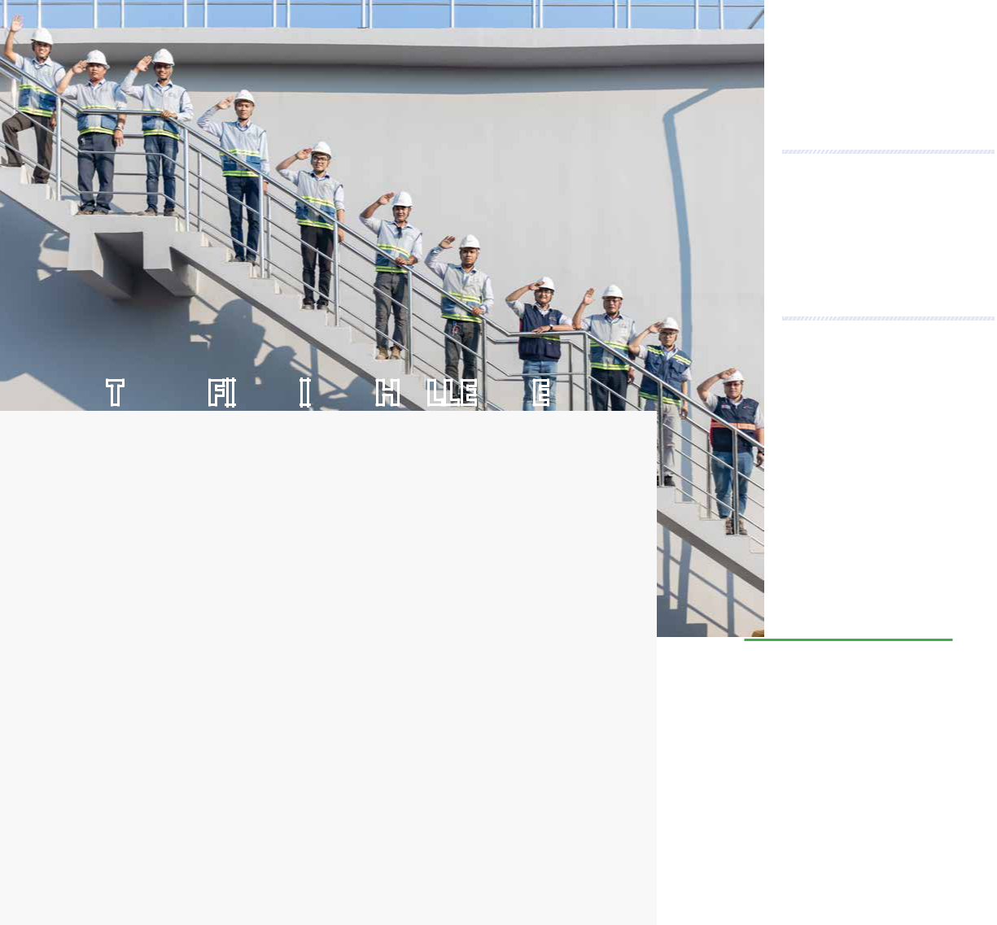

**STAND FIRM IN CHALLENGES**

In 2019, the real estate market faced many difficulties, reflected in a 10-year market cycle since the last time the real estate market was in crisis.. First of all, the authorities at all levels have focused on reviewing all the licensing of construction investment projects; Many construction sites have been temporarily suspended; The State Bank of Vietnam has tightened credit on real estate... Being not afraid of difficulties, Coteccons has continued to implement the strategy of innovating and improving the operation system, optimizing the operational structure, reducing costs and maintaining the business principle which is to best meet the customers’ requirements on construction schedule and quality. Those are the factors for Coteccons to stabilize business activities during last year and sustain the development in the following years.

2020 will continue to be a challenging year within the real estate market as bottlenecks remain within public policy. In addition, the COVID-19 pandemic had a significant impact on econo-mies worldwide, including Vietnam. With the goal of “**Stand Firm in Challenges**”, Coteccons wants to deliver the message that the Company is always ready to adapt with any fluctuation of the market, continue focusing on core competencies, expand market share and “spear-head the attacks” into new markets and customers.

The 15-year journey of establishment and development (2004-2019) confirmed Coteccons’ to-day success comes from to the loyalty of Shareholders, the enthusiastic support of partners, customers and the determination and unity of the Board of Management and the entire staff. We will continue to unite **firmly** to overcome all difficulties and **challenges**, to conquer new heights, and to maintain the position as the leading construction company in Vietnam.

|  |  |
| --- | --- |
|  |  |

2 STAND FIRM IN CHALLENGES 3

 **CHAIRMAN’S FOREWORD**

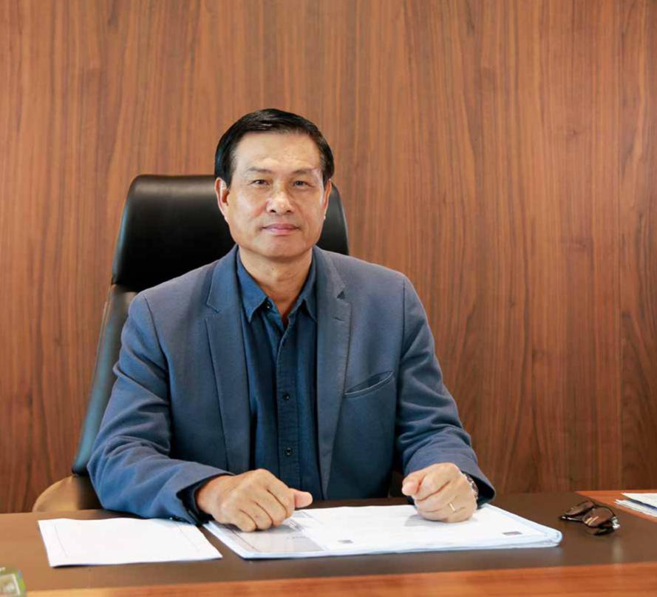

**Dear Shareholders,**

The year 2019 was the second consecutive year that the real estate market and con-struction contractors faced many challenges. In Ho Chi Minh City, only 04 commercial housing projects were approved for investment policy and recognized as an investor, and 16 commercial housing projects were approved for investment, down by 85% and 80% compared to 2018 respectively. In context, the number of construction and real es-tate businesses that had to temporarily suspend operations or to dissolve reached nearly 1,300 companies, the highest figure in recent years (according to the data of the Business Registration Management Agency - Ministry of Planning and Investment).

Coteccons, as a construction company, is no exception. Last year, the Company had very few new projects carried out, as many construction projects were suspended or pro-longed, this has significantly affected Coteccons’ revenue. At the same time, increased costs caused profits to decline. However, we have made great efforts to overcome diffi-culties and still maintain our position of a leading enterprise while being the developer’s first choice for mega projects such as Golden Hill, The Spirit of Saigon, The Marq and others. Coteccons continues to lead construction contractors nationwide (for the 9th consecutive year) and is among the top 20 largest private enterprises in Vietnam.

**To Our Dearest Shareholders,**

As we enter into 2020, in the complicated and unpredictable situation of the Covid-19 pandemic, the national economy will be negatively affected, increasing difficulties for construction companies. However, I think that the market is a mix of challenges and opportunities. Therefore, Coteccons needs a suitable business strategy. We will not em-phasize in growth at all costs, but will select good projects and focus on debt collection. Also, the Board of Management has been taking drastic measures to optimize the man-agement organization and improve labour productivity to increase profit margins.

To realize the goal set by the Party and Government of Vietnam to become a prosperous country by 2045 the investment in facilities (especially in capital construction) is going to be increasingly focused to maintain the country’s growth rate. Thus, there will be oppor-tunities for the construction industry to develop. Coteccons, with its prestige reputation and ability, shown through many of its regional mega projects and the young team of employees and enthusiastic leaders, will overcome this difficult period in the market and will move towards an era of sustainable development.

On behalf of the Board of Directors, I would like to express my sincere thanks to Share-holders, Customers and Partners who supported us throughout the years. I hope that all of you will continue to stand together with the Board of Management to create and develop Coteccons to become stronger and resilient.

Your faithfully!

**The Chairman of the Board of Directors**

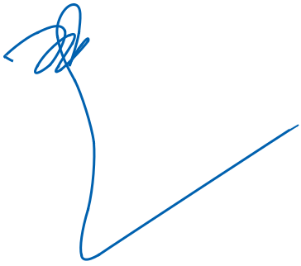

**NGUYEN BA DUONG**

4 STAND FIRM IN CHALLENGES 5

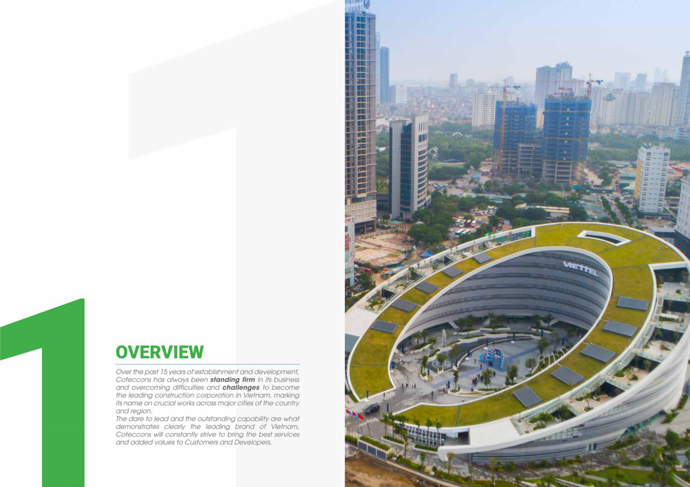

**Viettel Military-run Industry and Telecommunications Group Headquarters**

|  |  |  |  |
| --- | --- | --- | --- |
| 6 | STAND FIRM IN CHALLENGES | Hanoi |  |
| 7 |  |

**COMPANY INFORMATION**

|  |  |
| --- | --- |
| **Vietnamese name:** | Công ty Cổ phần Xây dựng Coteccons |
| **English name:** | COTECCONS CONSTRUCTION JOINT STOCK COMPANY |
| **Name in short:** | COTECCONS |
| **Business Registration** |  |
| **Certificate:** | 0303443233 issued for the 1st time by Ho Chi Minh City Department of |
|  | Planning and Investment on August 24, 2004 |
| **Chartered capital:** | VND 792,550,000,000 (Seven hundred ninety-two billion five hundred fifty |
|  | million Vietnam Dong) |
| **Address:** | 236/6 Dien Bien Phu, Ward 17, Binh Thanh District, HCMC |
| **Telephone:** | (84 - 28) 3 5142255/66 |
| **Fax:** | (84 - 28) 3 5142277 |
| **Email:** | contact@coteccons.vn |
| **Website:** | www.coteccons.vn |
| **Name of trading stock:** | Share of Coteccons Construction Joint Stock Company |
| **Code of trading stock:** | CTD |

8 STAND FIRM IN CHALLENGES

**CORE BUSINESS**



|  |  |  |  |  |  |  |  |  |  |  |  |  |  |  |  |  |  |  |  |  |  |  |
| --- | --- | --- | --- | --- | --- | --- | --- | --- | --- | --- | --- | --- | --- | --- | --- | --- | --- | --- | --- | --- | --- | --- |
| »» Main | | activities: | | | Construction | | | all |  | vacuum system, | | | sound | | system, | |  | financing, accounting and law). | | | |  |
|  | kinds (main). | | |  |  |  |  |  |  | equipment for entertainment. | | | | | |  | »» Production of concrete and products | | | | | |
| »» | Building | | and | | repairing | | | civil | »» | Installation | | of | water | | supply, | |  | from cement and plaster. | | | |  |
|  | and | industrial | | | works, | | technical | |  | drainage, | | heating | | and | | air | »» | Production | of | mining | | and |
|  | infrastructure of urban and industrial | | | | | | | |  | conditioning. | | |  |  |  |  |  | construction machinery. | | | |  |
|  | areas, traffic works, irrigating works. | | | | | | | | »» | Building public works. | | | | |  |  | »» Wholesale and retail of construction | | | | | |
| »» | Construction | | | | of | railway | | and | »» | Demolition, site preparation. | | | | | |  |  | machinery, equipment, spare parts, | | | | |
|  | infrastructures. | | | |  |  |  |  | »» | Constructional finishing. | | | | |  |  |  | technology chain | | for | construction | |
| »» | Electrical | |  | system | | installation. | | | »» | Interior decoration. | | | |  |  |  |  | or construction material production. | | | | |
|  | Installation | |  | of | lines, transformer | | | | »» | The | overall | | layout | | design; | | »» | Leasing of construction machinery, | | | | |
|  | stations and industrial equipment. | | | | | | | |  | Architectural design of civil and | | | | | | |  | equipment, | spare | | parts | and |
| »» | Installation | |  | of | | non-electrical | | |  | industrial | | projects; | | Interior | | and |  | technology | for | construction | | or |
|  | equipment, | | | irrigation | | | systems, | |  | exterior design; Design of heat | | | | | | |  | construction material production. | | | | |
|  | heating or air conditioning systems | | | | | | | |  | supply, ventilation, air conditioning | | | | | | | »» Import and export of iron, steel, | | | | | |
|  | or industrial machinery for the | | | | | | | |  | system for civil and industrial works; | | | | | | |  | constructional | frameworks, materials, | | | |
|  | construction and for civil facilities; | | | | | | | |  | Mechanical and electrical system; | | | | | | |  | constructional | equipment | | | and |
|  | Installation of industrial equipment | | | | | | | |  | Design of civil and industrial | | | | | | |  | machineries, machinery | | | spare parts, | |
|  | for the construction and for civil | | | | | | | |  | projects; Design of urban technical | | | | | | |  | plant and machinery for producing | | | | |
|  | facilities such as elevator, escalator, | | | | | | | |  | infrastructure. | | |  |  |  |  |  | construction equipment and materials. | | | | |
|  | automatic doors, lighting system, | | | | | | | | »» Investment consultancy (except for | | | | | | | |  |  |  |  |  |  |

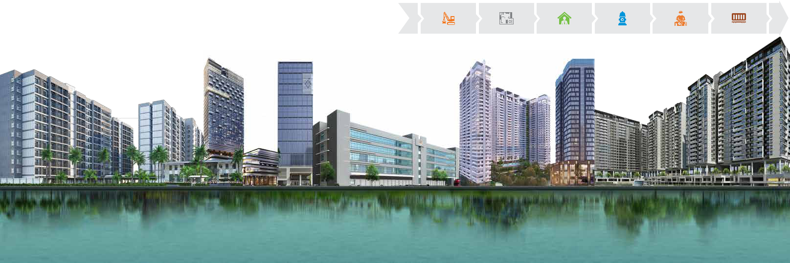

9

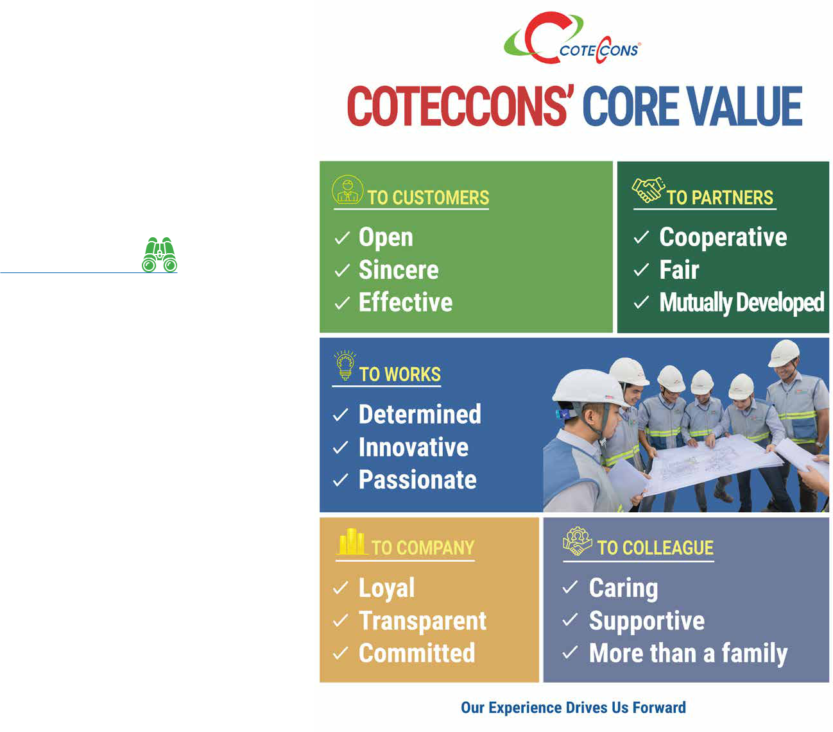

**VISION**

To become a world class engineering & construction group of Vietnam in the 21st century.



**MISSION**

Based on the reputation, quality and customer satisfaction for brand value, Coteccons commits to deliver to our clients’ state-of-the-art projects at competitive cost as well as contribute to the growth and development of society through these projects.

|  |  |
| --- | --- |
| 10 STAND FIRM IN CHALLENGES | 11 |

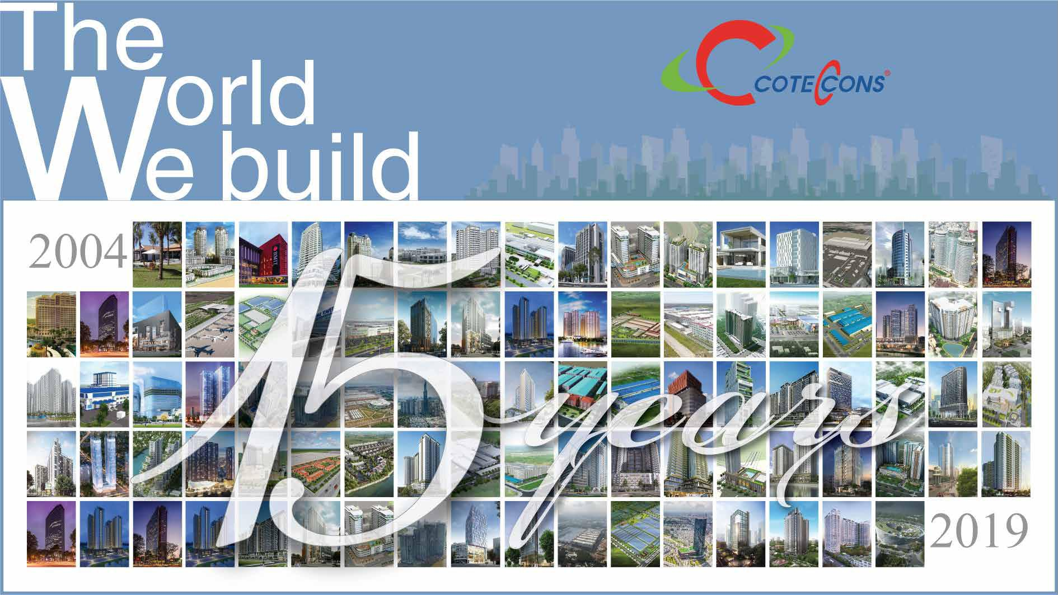

|  |  |
| --- | --- |
| 12 STAND FIRM IN CHALLENGES | 13 |

**HISTORY OF ESTABLISHMENT AND**



**DEVELOPMENT**

**2004 2006 2007 2009** **2010 2011** **2012**



**TRANSFERRING TO JOINT STOCK COMPANY**

Coteccons transformed its operating model into a joint stock company in accordance with Decision No.1242/QD-BXD dated 30 July 2004 of the Ministry of Construction with authorized capital of 15.2 billion.

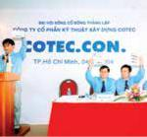

**UNICONS BRANCH**

**ESTABLISHED**

Coteccons pushes its strategy to focus on the large segment of projects while maintaining and enhancing its market share in the mid-size segment through capital contribution to establishing U y N a m I nve s t m e n t Construction Joint Stock Company (Unicons).

Coteccons holds 27% of Unicons’ total initial charter capital.

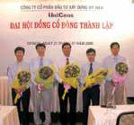

**INITIAL PUBLIC**

**OFFERING (IPO)**

In order to improve corporate image and raise more capital for implementing big projects, Coteccons has issued shares to the public attracting many big foreign investors such as Dragon Capital, Indochina Capital, Tainan Spinning Co...

Coteccons is a Vietnamese pioneer in researching and applying successfully the Top-down advanced construction method to accelerate progress while still maintaining good quality of the whole works.

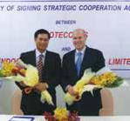

**COTECCONS’**

**SHARES WERE**

**OFFICIALLY LISTED**

In compliance with the

Decision No. 155 / QD-

SGDHCM dated December

9, 2009, Coteccons’ shares

were officially listed on the

Ho Chi Minh City Stock

Exchange (HOSE) marking a

new milestone in the history

of Coteccons’ operation. The

number of shares initially

listed was 12 million. Stock

code: CTD.

Coteccons invested 100%

for the Commencement

and Construction of

Coteccons Office Building at

236/6 Dien Bien Phu Street,

Ward 17, Binh Thanh District,

Ho Chi Minh City.



**COTECCONS OFFICE**

**BUILDING PUT INTO**

**OPERATION**

Coteccons Office Building was constructionally completed and put into operation. The new office meets the needs for premises and operation facilities, bringing Coteccons a new position in the market.

Moreover, Coteccons’ Representative Office was also opened in Ha Noi, creating an outstanding step into the Northern Viet Nam market.

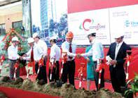

**GOLDEN CUP FOR THE VIET NAM CONSTRUCTION QUALITY**

It was a great honour for Coteccons to receive the Golden Cup for the Viet Nam Construction Quality - Ministry of Construction.

Signing contract for General Contractor of the Grand Ho Tram – Casino Project, the largest complex resort project in Viet Nam and in the region with 100% foreign-invested capital from Asian Coast Development Limited ACDL – Canada). Coteccons was the first ever Vietnamese General Contractor to be in charge of building and managing other overseas subcontractors from Japan, Singapore, China...



**2ND PRIVATE PLACEMENT OFFERING FOR STRATEGIC SHAREHOLDERS**

Shares were issued to strategic shareholders for the second time. Despite the economic downturn and the stock market decline, Coteccons still succeeded in negotiating and signing a strategic cooperation agreement with Kustocem Pte.Ltd (Singapore) and issued 10.43 million shares. The total raised capital in the issuance is equivalent to VND 500 billion.



14 STAND FIRM IN CHALLENGES 15

**LỊCH SỬ HÌNH THÀNH**



**VÀ PHÁT TRIỂN**

**2013 2014 2015 2016** **2017 2018** **2019**



**INCREASE IN EQUITY AT** **LEADING IN DESIGN &**

**UNICONS UP TO 51.24%** **BUILD PROJECTS**

**MOMENTUM FOR MERGER AND ACQUISTION STRATEGY**

**REMARKABLE GROWTH AND RAISING OF CAPITAL FOR SUSTAINABLE**

**CHANGING THE**

**MANAGEMENT MODEL AND**

**INVESTMENT EXPANSION**

**MANAGEMENT SYSTEM**

**IMPROVEMENTS**

**MARKING 15 YEARS OF ESTABLISHMENT AND DEVELOPMENT**

Coteccons’ equity in Uy Nam Investment Construction JSC (Unicons) rose considerably to 51.24%.

Signing contract for

international project contractor: SC VivoCity - District 7 by Saigon Co.op

Investment Corporation (Viet Nam) and Mapletree (Singapore) as the Employer. The total contract value was around VND 1,200 billion.

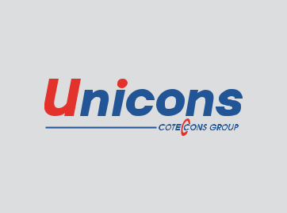

Undertaking design and build projects as general contractor. Masteri Thao Dien, worth more than VND 3,300 billion, established Coteccons with a strong and large scale foundation, creating trust for others to appoint further D&B models such as Regina factory phase 1,2,3 (approximately VND 1,250 billion).



3,604,530 shares were issued to swap the entire number of shares of Uy Nam Investment Construction Joint Stock Company (Unicons) so that the percentage of Coteccons’ ownership in Unicons has reached 100%.

2015 marked the highest growth rate in terms of revenue and within 11 years of operation, reaching a growth rate of nearly 100% over 2014.

Many substantial D & B contracts signed and executed with new Employers such as: The Gold View, T & T Vinh Hung, Duc Viet Resort ...

Many large project contracts valued at over VND 1,000 billion were consecutively signed: TimesCity ParkHill, Vinhomes Central Park, Worldon ...

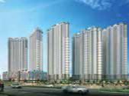

**DEVELOPMENT**

The year of 2016 continued to be a milestone in economic development of Coteccons.

Coteccons surpassed many foreign contractors to win the bid of The Landmark 81 project, the highest building in Vietnam and the 8th highest building in the world.

Many D&B projects were signed, accounting for 40% of the Company’s total revenue. Successfully issued shares for strategic shareholders and raised VND 1,762 billion, increasing the Company’s charter capital by VND 770.5 billion.

In terms of technical development, Coteccons has achieved remarkable improvements with the completion of many challenging projects, including base construction packages for The Landmark 81 and The Spirit of Saigon.

In particular, the application of BIM into the transfer beam construction for the Landmark 81 project was highly successful.

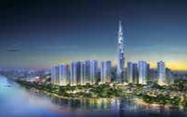

Coteccons contributed capital to set up Covestcons Co., Ltd (chartered capital of VND 1,872 billion) for the purpose of investing in real estate, hence making the business more diversified as well as increasing the Company’s profit.

The Company elected the new Board of Directors and Board of Supervisors for the term of 2017 – 2022 and changed the management model following the international standards, in which the Chairman no longer holds the position of CEO of the Company.

In terms of operation, there were many the memorable milestones marked in the Company history such as winning contract of Nam Hoi An Complex Project, Vinfast Factory...

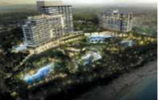

Adjusted the organizational model of the Company according to each function to enhance professional efficiency, ability to coordinate and streamline the Company.

Completed The Landmark 81 project, a national symbol and one of the Top 10 highest towers in the world. Completed Vinfast automobile production complex with a record time of 12 months of construction - the first automobile production brand of Vietnam and the third largest automobile production complex in the world.

The only representative of Vietnam to become Asian runner-up in the 2018 Tekla BIM Awards Asia. Coteccons continues to affirm that it is the leader in BIM application.

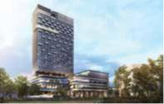

15-year anniversary of Coteccons’ establishment (2004-2019)

Coteccons continues to maintain its position as the No. 1 private enterprise in the construction industry, marking the 7th consecutive year that Coteccons has lead this ranking and Coteccons is also honoured in the Top 50 most excellent and largest enterprises in Vietnam in 2019 - Top 50 Vietnam The Best 2019.

With the typical contributions to the urban planning and development, Coteccons and Mr. Nguyen Ba Duong

* Chairman of the Board of Directors were honoured as the excellent business and individual who involved in the urban construction and development of the whole country. The award is organized by the Vietnam Association of Urban Development.

Coteccons continues to explore and expand its business areas to Southeast Asia (Myanmar market).

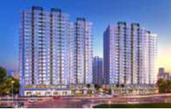

16 STAND FIRM IN CHALLENGES 17

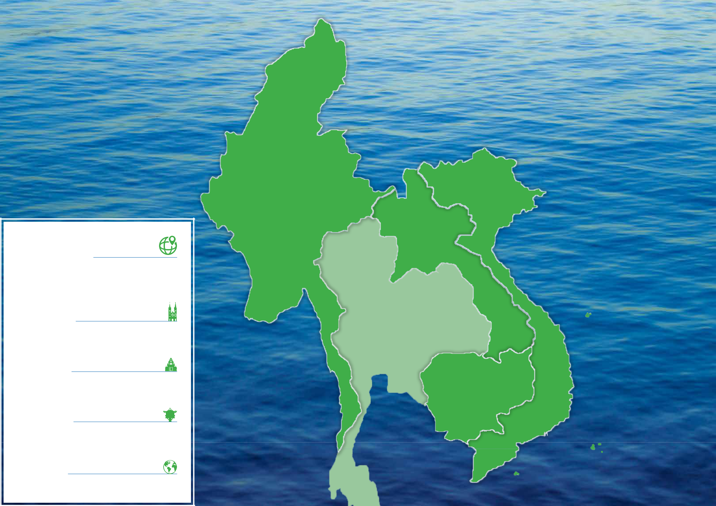

**MYANMAR**

**BUSINESS AREAS**

**Coteccons focuses on the following areas:**

**SOUTHERN VIETNAM**

Ho Chi Minh City, Hau Giang, Long An, Binh Duong, Vung Tau, Tay

Ninh, Dong Nai, Binh Phuoc, Phu Quoc, Can Tho, Kien Giang ...

**CENTRAL VIETNAM**

Da Nang, Quang Nam, Nghe An, Quang Ngai, Khanh Hoa, Phu Yen,

Hue, Ha Tinh...

**NORTHERN VIETNAM**

Hanoi, Bac Ninh, Ha Nam, Quang Ninh, Hai Phong, Lao Cai, Hung

Yen, Thai Binh, Nam Dinh, Bac Giang, Hai Duong...

**FOREIGN MARKET**

Since 2012, Coteccons has expanded its business to Southeast Asia.

In 2019, the company continues to win projects in Myanmar and

18 STAND FIRM IN CHALLENGES

Cambodia

**VIETNAM**

**LAOS**

**CAMBODIA**

19

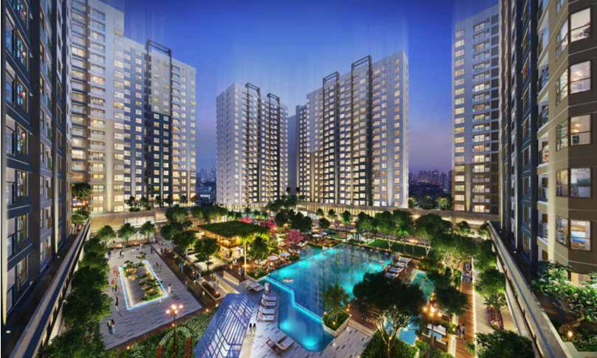

 **SHAREHOLDER STRUCTURE**

According to the list of shareholders closed on 15th January 2019



|  |  |  |  |  |  |  |  |  |  |  |  |  |  |
| --- | --- | --- | --- | --- | --- | --- | --- | --- | --- | --- | --- | --- | --- |
|  |  | CHARTERED CAPITAL | NUMBER OF LISTED STOCKS | | |  |  |  |  |  |  |  |  |
|  |  | 792.55 | 79,255,000 | | |  |  |  |  |  |  |  |  |
|  |  | BILLION VND | SHARES | |  |  |  |  |  |  |  |  |  |
|  |  | NUMBER OF | TREASURY STOCKS | | |  |  |  |  |  |  |  |  |
|  |  | OUTSTANDING STOCKS |  |  |  |  |  |  |  |  |
|  |  | 76,292,573 | 2,962,427 | | |  |  |  |  | **Render of Akari City project** | | |  |
|  |  | SHARES | SHARES | |  |  |  |  |  |  |
|  |  |  |  |  |  |  |  | Ho Chi Minh City | |  |
|  |  |  |  |  |  |  |  |  |  |  |  |
| **SHAREHOLDERS STRUCTURE BY NATIONALITY AND SIZE** | | | |  |  |  |  |  |  |  |  |  |  |
|  |  |  |  | **Local** |  |  |  | **Foreign** |  | **Total number of** | **Total ownership** | |  |
|  | **No.** | **Type of shareholder** | **Number of** |  |  | **Ownership** | **Number of** |  |  |  |
|  | **Number of shares** | | **Number of shares** | **Ownership ratio (%)** | **shares** | **ratio (%)** | |  |
|  |  |  | **shareholders** | **ratio (%)** | **shareholders** |  |
|  |  |  |  |  |  |  |  |  |  |  |
| 1 | | State | - |  | - | 0% | - | - | 0% | - | 0% |  |  |
| 2 | | Owner of 5% or above | 1 |  | 11,192,652 | 14.12% | 2 | 22,163,166 | 27.96% | 33,355,818 | 42.08% |  |  |
| 3 | | Owner of 1-5% | 5 |  | 8,928,059 | 11.26% | 7 | 11,567,796 | 14.60% | 20,495,855 | 25.86% |  |  |
| 4 | | Owner of below 1% | 3,514 |  | 18,450,921 | 23.28% | 289 | 3,989,979 | 5.04% | 22,440,900 | 28.32% |  |  |
| 5 | | Treasury stocks | 1 |  | 2,962,427 | 3.74% | - | - | 0% | 2,962,427 | 3.74% |  |  |
|  |  |  |  |  |  |  |  |  |  |  |  |  |  |
|  |  | **TOTAL** | **3,521** |  | **41,534,059** | **52.40%** | **298** | **37,720,941** | **47.60%** | **79,255,000** | **100%** |  |  |
|  |  | | | |  |  |  | |  | | |  |  |
| **SHAREHOLDERS STRUCTURE BY INSTITUTIONAL AND INDIVIDUAL** | | | | |  |  | **SHAREHOLDERS STRUCTURE BY SIZE** | | **SHAREHOLDERS STRUCTURE BY NATIONALITY** | | | |  |
|  |  |  |  |  |  |  | **3.74%** |  |  |  |  |  |  |

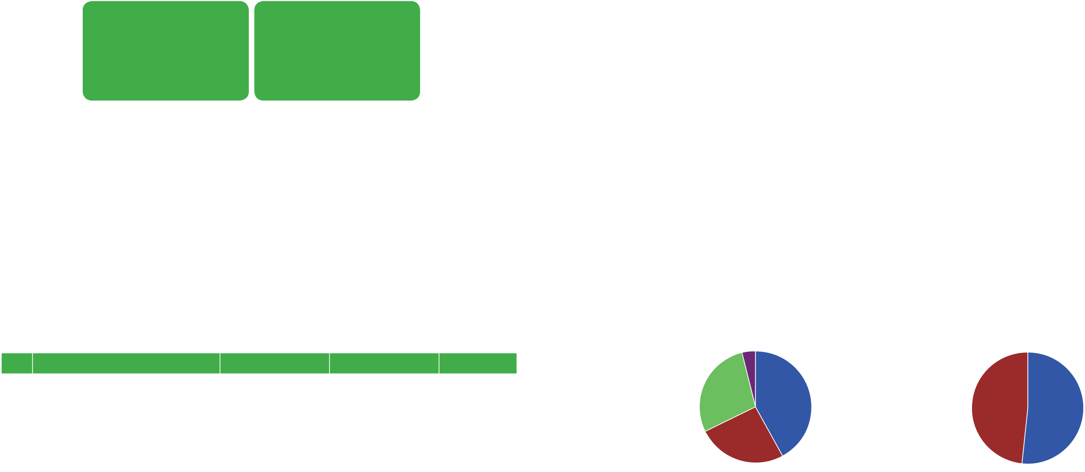

|  |  |  |  |  |
| --- | --- | --- | --- | --- |
| **No.** | **Shareholder structure** | **Number** | **Number of stocks** | **Percentage** |
| **1** | **Domestic shareholders** | **3,521** | **41,534,059** | **52.40%** |
| 1.1 | Organizations | 58 | 11,923,312 | 15.04% |
| 1.2 | Individuals | 3,462 | 26,648,320 | 33.62% |
| 1.3 | Treasury stocks | 1 | 2,962,427 | 3.74% |
| **2** | **Foreign shareholders** | **298** | **37,720,941** | **47.60%** |
| 2.1 | Organizations | 75 | 35,559,628 | 44.87% |
| 2.2 | Individuals | 223 | 2,161,313 | 2.73% |
|  |  |  |  |  |
| **\*** | **TOTAL** | **3,819** | **79,255,000** | **100%** |
|  |  |  |  |  |



|  |  |
| --- | --- |
| **42.08%** | **52.40%** |
| **28.32%** |  |
|  | **47.60%** |

|  |  |  |  |
| --- | --- | --- | --- |
| **25.86%** |  |  |  |
| Owner of 5% or above | **42.08%** | Domestic shareholders | **52.40%** |
| Owner of 1-5% | **25.86%** | Foreign shareholders | **47.60%** |
| Owner of below 1% | **28.32%** |  |  |
| Treasury stocks | **3.74%** |  |  |

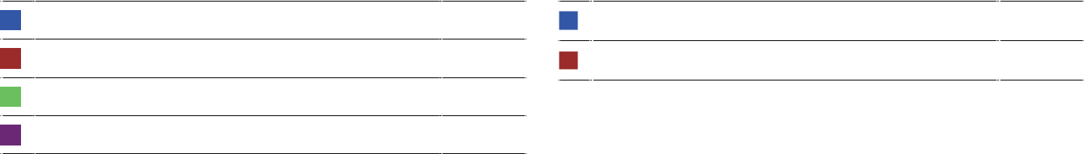

20 STAND FIRM IN CHALLENGES 21

 **SHAREHOLDERS STRUCTURE**

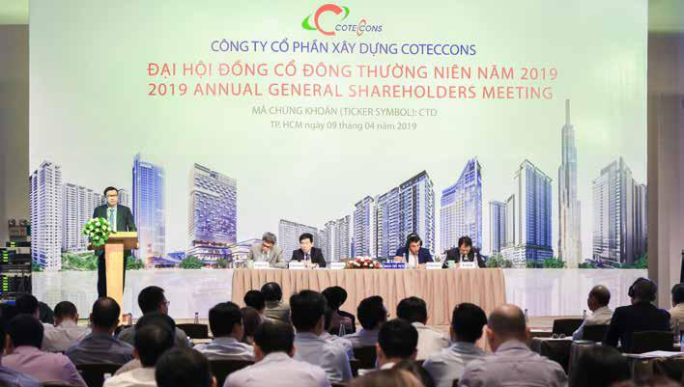

**MAJOR SHAREHOLDERS**



|  |  |  |  |  |  |
| --- | --- | --- | --- | --- | --- |
| **No.** | **Name** | **Address** | **Number of** | **Percentage** |  |
| **shares** |  |
|  |  |  |  |  |
| 1 | Nguyen Ba Duong | 68A Hoang Hoa Tham Street, Ward 7, Binh | 3,901,754 | 4.92% |  |
| Thanh District, HCMC |  |
|  |  |  |  |  |
|  | Success Investment and Business | Officetel No. CA-3A.02, Tower T3, No. 1, |  |  |  |
| 2 | Street No. 104-BTT, KP3, Binh Trung Tay | 11,192,652 | 14.12% |  |
| One Member Company Limited |  |
|  | Ward, District 2, HCMC |  |  |  |
|  |  |  |  |  |
| 3 | Kustocem Pte. Ltd. | 80 Raffles Place, #32-01 UOB Plaza 1 | 13,906,666 | 17.55% |  |
| Singapore 048624 |  |
|  |  |  |  |  |
| 4 | THE8TH Pte. Ltd. | 7 Ridley Park, Singapore 248482 | 8,256,500 | 10.42% |  |

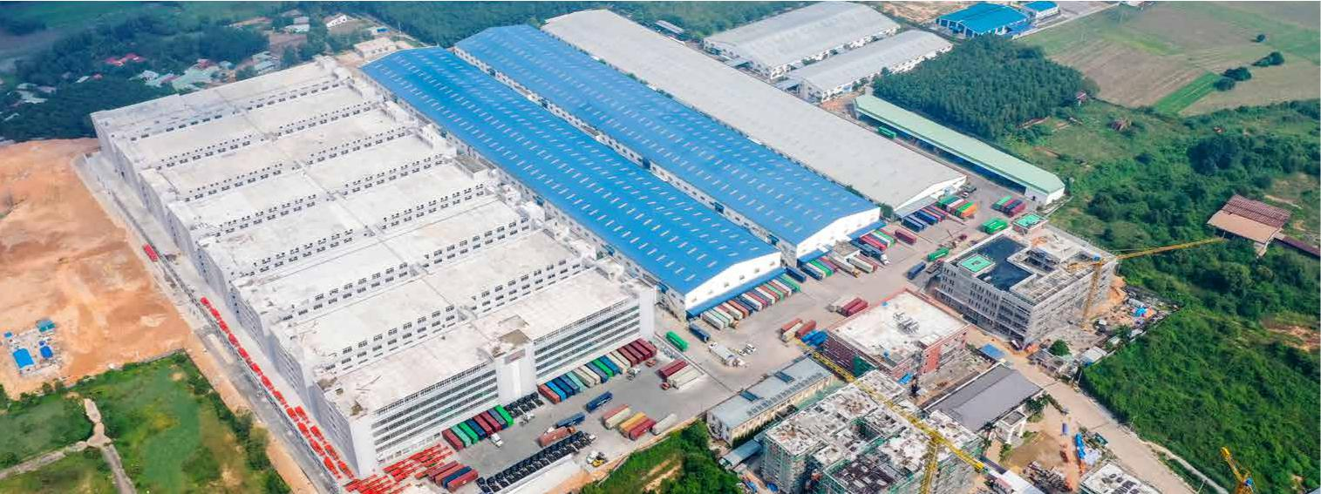

**Timberland Manwah factory**

Binh Duong

|  |  |
| --- | --- |
| 22 STAND FIRM IN CHALLENGES | 23 |

 **SUBSIDIARIES AND ASSOCIATES**



ONE OF THE COMPETITIVE ADVANTAGES OF COTECCONS WHEN HANDLING MEGA PROJECTS IS THE EFFECTIVE SUPPORT FROM ITS SUBSIDIARIES AND ASSOCIATES. WITH THE GOAL OF CONTINUAL IMPROVEMENT, COTECCONS AND ITS SUBSIDIARIES AND ASSOCIATES SHARE EXPERIENCES, KNOWLEDGE AND NEW TECHNOLOGIES. IN ADDITION, INVESTMENTS INTO SUBSIDIARIES, JOINT VENTURES AND MARKET SHARE ALLOWS US TO MAINTAIN DIVERSITY, WHICH IS AN IMPORTANT FACTOR FOR MAINTAINING THE CURRENT POSITION OF COTECCONS AS WELL AS FOR THE SUSTAINABLE DEVELOPMENT OF COTECCONS IN THE FUTURE.



**COVESTCONS CO., LTD.**

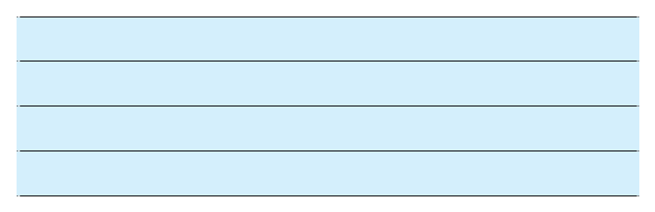

**The 2019 business results**

Profit before tax: **VND 47.7 billion**

Total assets: **VND 1,953 billion**

Owners’ equity: **VND 1,913 billion**

**Coteccons**

**Ownership Ratio**

**100%**

Covestcons was established in mid-2017 with initial chartered capital of VND 26 billion for the purpose of researching and implementing investment activities for Coteccons, thereby diversifying Coteccons businesses and increasing Coteccons profit. In August 2017, the Coteccons Board of Directors decided to raise Covestcons’ chartered capital to VND 1,872 billion.

**UNICONS INVESTMENT**

**CONSTRUCTION CO., LTD.**

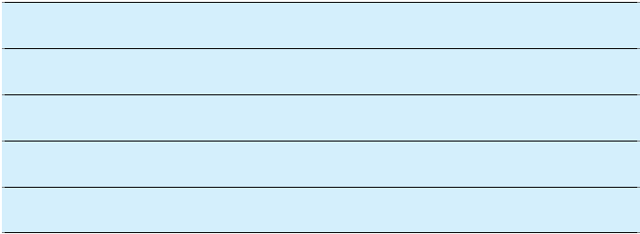

**The 2019 business results**

Revenue: **VND 5,663 billion**

Profit before tax: **VND 226 billion**

Total assets: **VND 3,166 billion**

Owners’ equity: **VND 1,552 billion**

**Coteccons**

**Ownership Ratio**

**100%**

Unicons was established in 2006 as a Joint Stock Company. In 2015, Unicons became a One-member Limited Liability Company with 100% charter capital owned by Coteccons. Unicons operates in a wide range of construction markets with full services: Design and Build, General Contractor, Mechanical Electrical & Plumbing Installations.

Uniccons have a large and stable workforce with professional capabilities after many years operating in construction business and is always ranked among top construction companies in Vietnam. Currently, Unicons is ranked in the top 3 largest private construction companies in Vietnam (according to the VNR500 ranking in 2019). Not only inheriting and promoting achievements from Coteccons, Unicons continues to improve its management system and model to increase the value for Coteccons.

In 2019, Unicons continues to affirm its prestige and position in the industrial factory segment by becoming the General contractor of the next phases of large-scale industrial projects such as Marigot Vietnam Factory - Phase 2, Gain Lucky factory, Drying tower Phase II - AFI Company, Vinfast Hai Phong factory...

Furthermore, Unicons deployed many key civil projects such as Vin University, Ha Long Sea Stars Hotel, Vinhomes Oceans Park Project, Vinhomes Grand Park... Under the volatile situation of the market in 2019, Unicons, with the available solid foundation, has quickly improved the entire human resources, enhanced the management system, increased the labor productivity which creating a premise for the strong development of Unicons and contribution to the future growth of Coteccons.

Ricons Investment Construction Joint Stock Company was established in 2004 with the main activities of investment

* real estate business through two outstanding projects Botanic Towers and Saigon Pavillon. After four years of operation, Ricons expanded into construction. In 2008, Ricons expanded into construction business. Over the last 15 years Ricons has affirmed its reputation through a series of high-rise projects, resorts, hotels, schools, hospitals and large-scale industrial factories. It is also the strength that brought Ricons into the Top 5 largest private construction contractors in Vietnam.

In recent years, Ricons has continuously improved the management system, updated modern equipment and constantly trained and developed highly qualified staff. At the same time, new breakthroughs in improving management, operation and organization models to bring to customers and partners outstanding products and services will always be the strategic goal of Ricons.

With the mission of “Building prosperity – Fulfilling Aspiration”, Ricons believes that the values that are being nurtured today will be the most solid foundation for Ricons to step forward and maintain the brand as one of the leading construction contractors in Vietnam.

**RICONS INVESTMENT**

**CONSTRUCTION JSC.**

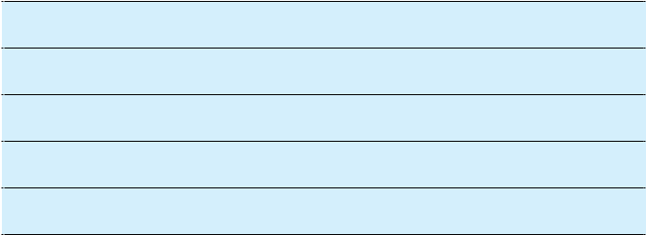

**The 2019 business results**

Consolidated net revenue: **VND 8,752 billion**

Consolidated profit before tax: **VND 444 billion**

Consolidated total assets: **VND 5,780 billion**

Consolidated owners’ equity: **VND 2,146 billion**

**Coteccons**

**Ownership Ratio**

**14.3%**

24 STAND FIRM IN CHALLENGES 25

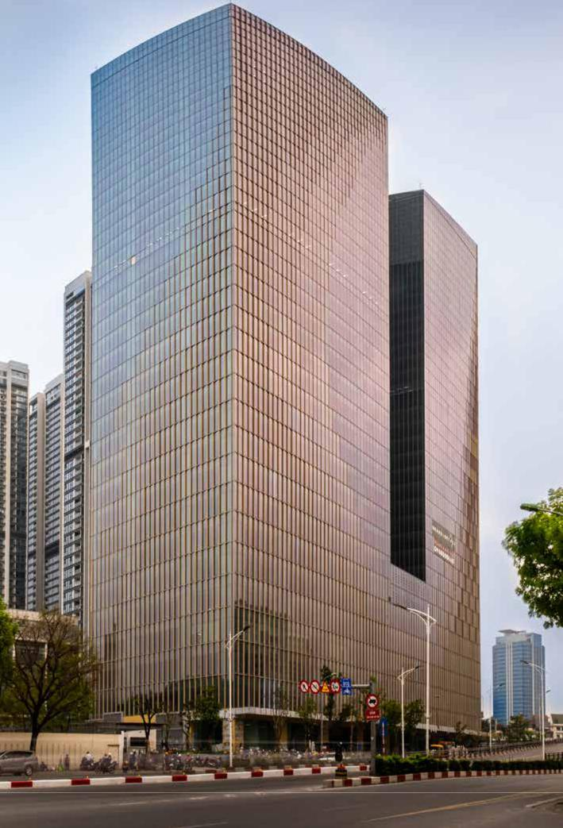 **SUBSIDIARIES AND ASSOCIATES**



**FCC INFRASTRUCTURE INVESTMENT JSC**

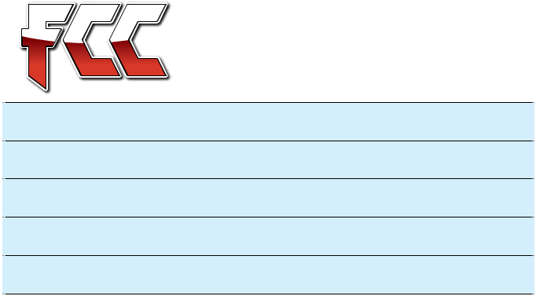

**The 2019 business results**

Revenue: **VND 85 billion**

Profit before tax: **VND (59) billion**

Total assets: **VND 1,400 billion**

Owners’ equity: **VND 212 billion**

**Coteccons**

**Ownership Ratio**

**42.36%**

Established in 2014. By the end of 2018, the amount of investment Coteccons contributed amounted to VND 98 billion. Based on Resolution No. 01 of the Board of Directors dated 10/01/2019, Coteccons made an additional contribution of VND 61.6 billion. Currently, Coteccons’ contribution to FCC is VND 159.6 billion.

FCC’s main business is to build infrastructure, civil and industrial works, road construction and public utility.

**Capital Palace Office Tower**

Hanoi

|  |  |
| --- | --- |
| 26 STAND FIRM IN CHALLENGES | 27 |

**ORGANIZATION STRUCTURE**

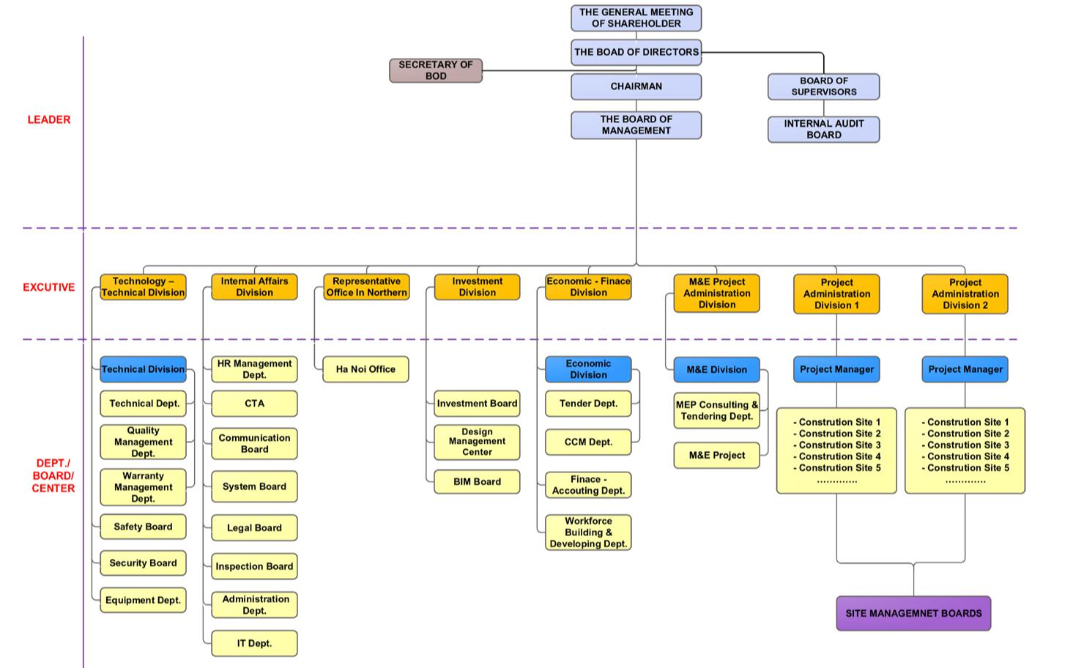

28 STAND FIRM IN CHALLENGES 29

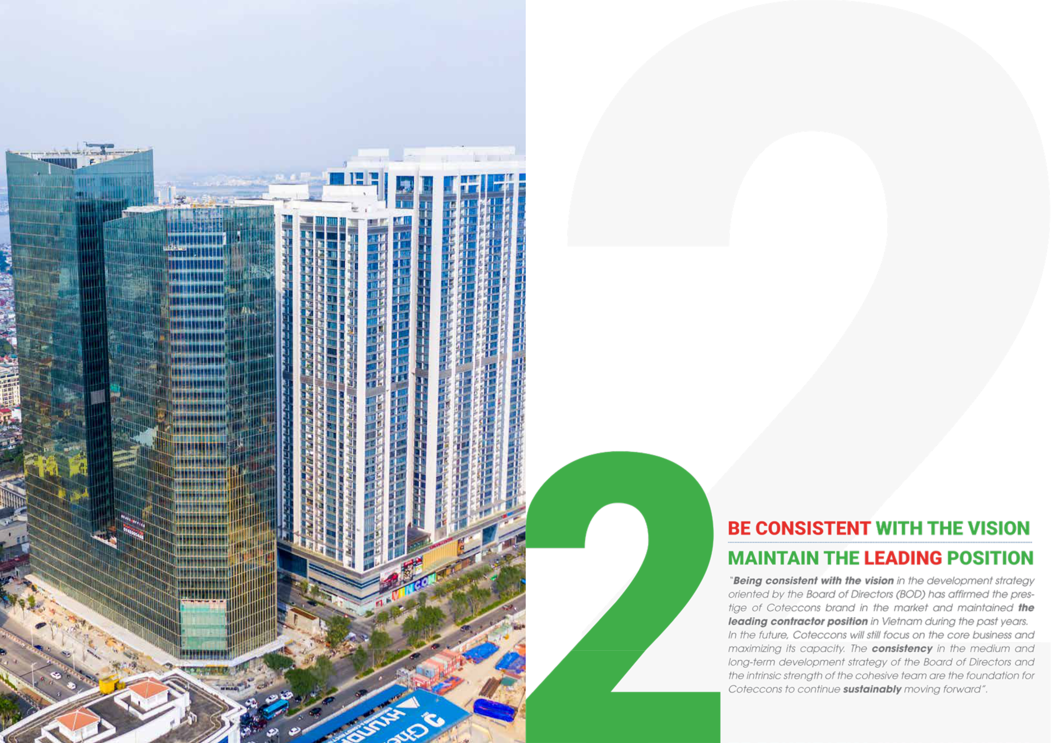

|  |  |  |  |
| --- | --- | --- | --- |
| 30 STAND FIRM IN CHALLENGES | **Vinhomes Metropolis** | 31 |  |
| Hanoi |  |
|  |  |  |

**REPORT OF THE BOARD**



**OF DIRECTORS**



**COMPOSITION OF THE BOARD OF DIRECTORS**

**COMPOSITION OF THE BOARD OF DIRECTORS FOR THE TERM OF 2017 – 2022 (AS OF 31ST DECEMBER 2019)**

The current Board of Directors of Coteccons is composed of 07 members (including the Chairman of the Board and 06 members), including 02 executive member, 02 non-executive members and 03 independent members.



|  |  |  |  |
| --- | --- | --- | --- |
| **No. Full name** | **Position** | **Duties in the Board** | **Note** |

He graduated with a Degree of Engineering from National

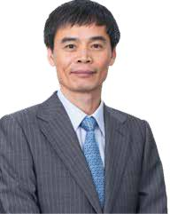

University of Civil Engineering. After graduation, he had

worked for domestic and international construction

companies as Chief Engineer, Site Manager, and Project

Manager. He has nearly 32 years of experience in

construction.

As one of the founding shareholders, he is an important

|  |  |  |  |
| --- | --- | --- | --- |
| 1 | Nguyen Ba Duong | Chairman of |  |
| the Board |  |
|  |  |  |
| 2 | Nguyen Sy Cong | Member |  |
| 3 | Tan Chin Tiong | Member |  |
| 4 | Talgat Turumbayev | Member |  |
| 5 | Yerkin Tatishev | Member |  |
| 6 | Nguyen Quoc Hiep | Member |  |
| 7 | Tran Quyet Thang | Member |  |



In charge of Board of Directors and Strategic Subcommittee.



Participate in Investment, Risk, Remuneration and Human Resource Subcommittee.



Participate in Strategic Subcommittee.



Participate in Risk, Remuneration and Human Resource Subcommittee.



In charge of Investment Subcommittee, participate in Strategic Subcommittee.



In charge of Risk Subcommittee, participate in Investment Subcommittee.



Member in charge of Remuneration and Human Resource Subcommittee.



Executive member



Cum General Director



Independent member



Non-executive member



Non-executive member



Independent member



Independent member



|  |  |  |  |
| --- | --- | --- | --- |
|  |  | contributor to the development process of Coteccons, |  |
|  |  | especially in the field of research and improvement |  |
|  |  | of construction methods, training of outstanding Site |  |
|  |  | Managers and Project Managers. |  |
|  |  | In 2006, he was appointed General Director of Unicons, |  |
|  |  | a subsidiary of Coteccons. With his management and |  |
|  |  | leadership ability, Unicons has always stood firmly in |  |
|  |  | the Top 10 leading construction companies in Vietnam |  |
| Mr. **NGUYEN SY CONG** |  |  |
|  | for many consecutive years. In 2017, with the trust and |  |
|  |  | credibility of the General Meeting of Shareholders, the |  |
| Member of the Board of Directors and General Director |  |  |
|  | Board of Directors, the Board of Management and all the |  |
| Year of birth: 1970 |  | employees, he was elected to the Board of Directors and |  |
| Nationality: Vietnamese |  | appointed as the General Director of the Company. |  |
|  |  |  |  |



 Mr. **NGUYEN BA DUONG**

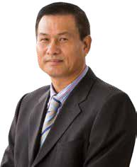

Chairman of the Board

Year of birth: 1959

Nationality: Vietnamese

**INTRODUCTION OF THE BOARD OF DIRECTORS IN 2019**

He graduated from Kiev University of Construction (Ukraine) with major in Architecture. He has more than 37 years of experience in the construction industry and held important management positions at popular construction companies. He is the founder and operator of Coteccons since 2002, previously called Cotec Construction Firm. In 2004, after privatization, Mr. Nguyen Ba Duong was appointed as General Director of the Company. In 2005, he elected Chairman of the Board and General Director of Coteccons until 2017. In July 2017, he resigned from the position of General Director to focus more on the role of Chairman of the Board.

Mr. Nguyen Ba Duong has received various certificates of merit from the Prime Minister and the Ministry of Construction for many achievements in promoting and developing Vietnam’s construction industry and contributing to elevating the outlook of the country. He was also named in the Top 50 outstanding business leaders of Vietnam by Forbes magazine and nominated by The Business Review magazine as one of the top 10 leaders in Vietnam for team development. In 2019, he was honoured as the excellent individual in the National Urban Planning Gold Award at the First National Urban Planning Awards ceremony.

Mr. Tan Chin Tiong completed his doctoral dissertation at the University of Pennsylvania in 1977 and has more than 42 years of marketing teaching at prestigious universities in Singapore such as NUS and SMU.

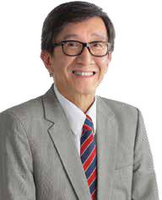

In 2017, he joined the Board of Directors for the term of 2017- 2022 as an independent member.

 Mr. **TAN CHIN TIONG**

Member of the Board of Directors

Year of birth: 1949

Nationality: Singaporean

32 STAND FIRM IN CHALLENGES 33

**REPORT OF THE BOARD**



**OF DIRECTORS**

Mr. Talgat Turumbayev graduated with a Master degree in Finance and Accounting and is a member of the British Association of Chartered Certified Accountants (ACCA). He has over 27 years of experience in finance and accounting - auditing.

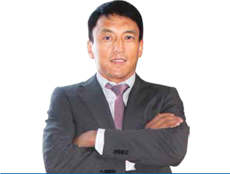

He joined the Coteccons Board of Directors term of 2012- 2017 as a representative of major shareholders (Kusto). In 2017, he was elected by General Meeting of Shareholders to the Board of Directors the 2017-2022 term.

 Mr. **TALGAT TURUMBAYEV**

Member of the Board of Directors

Year of birth: 1971

Nationality: Kazakhstani

Mr. Tatishev graduated in a Degree in Economics in 1999 in Russia, in Law in 2002 in Kazakhstan, and a Master’s degree in 2009 at Oxford University, England. For more than 22 years of his experience, he held important positions of Monetary Supervision, Deputy Investment Director, Executive Vice President, Chairman of the Board of Directors of large and small banks and investment funds in Eastern Europe and Singapore.



He is the Founder and President of Kusto Group, concurrently is the Chairman of Kusto Real Estate Capital Pte. Ltd. In 2017, he started to participate in Coteccons Board of Directors for 2017 – 2022 term.

 Mr. **YERKIN TATISHEV**

Member of the Board of Directors

Year of birth: 1976

Nationality: Kazakhstani

Mr. Tran Quyet Thang graduated with a Bachelor of Laws degree and has over 32 years of experience in law, securities and real estate.

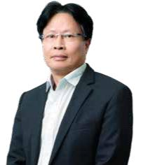

From 1990 - 1995, he was the founder and Deputy General Director of Investconsult Investment Consulting Company; in the period of 1997 - 1999, he joined the founding of T&A Law Office. In 2000 - 2003, he founded Saigon Securities Joint Stock Company and held the position of General Director; from 2004 up to now, he joined R.C Real Estate Development and Financing Joint Stock Company as Chairman of the Board and General Director.

|  |  |  |  |
| --- | --- | --- | --- |
|  |  | In April 2016, he was elected to the Board of Directors of |  |
|  |  | Coteccons for the 2012-2017 term as an independent member. |  |
|  |  | In 2017, Mr. Tran Quyet Thang was elected by the General |  |
| Mr. **TRAN QUYET THANG** |  |  |
|  | Meeting of Shareholders to the Board of Directors for the 2017 – |  |
|  |  |  |
|  |  | 2022 term. With strong management experience, he has actively |  |
| Member of the Board of Directors |  |  |
|  | participated in contributing deep and objective opinions in |  |
| Year of birth: 1962 |  | improving the management efficiency as well as the operation |  |
| Nationality: Vietnamese |  | of the Company. |  |



Mr. Nguyen Quoc Hiep held an Engineer Degree from Hanoi University of Science and Technology and has more than 41 years of experience in construction and real estate. Currently, he is the Chairman of the Board of Directors of Global Real Estate Investment Joint Stock Company (GP Invest) and Chairman of Vietnam Association of Civil Contractors (VACC).

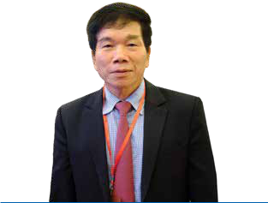

In 2017, he joined the Board of Directors for the 2017 – 2022 term as an independent member. In addition to contributing independent and objective opinions to the Board of Directors in corporate governance, with his reputation and experience, he also connects the Company with new investors and customers.

 Mr. **NGUYEN QUOC HIEP**

Member of the Board of Directors

Year of birth: 1946

Nationality: Vietnamese

34 STAND FIRM IN CHALLENGES 35

**REPORT OF THE BOARD**



**OF DIRECTORS**

**APPROVED CONTENTS OF THE BOARD OF DIRECTORS IN 2019** 



|  |  |  |
| --- | --- | --- |
| **No Resolution number** | **Date** | **Content** |

**MEETINGS OF THE BOARD OF DIRECTORS**



|  |  |  |  |  |  |  |  |
| --- | --- | --- | --- | --- | --- | --- | --- |
| **No.** | **Member of the Board of** | **Position** | **Date of** | **Number of** | **Meeting** | **Reason** |  |
|  | **Directors** |  | **Appointment** | **the Board** | **attendance** | **for absence** |  |
|  |  |  |  | **of Directors’** | **ratio** |  |  |
|  |  |  |  | **meetings** |  |  |  |
|  |  |  |  | **attended** |  |  |  |
| 1 | Mr. Nguyen Ba Duong | Chairman | 24th August, | 5/5 | 100% |  |  |
| 2004 |  |  |
|  |  |  |  |  |  |  |
| 2 | Prof. Tan Chin Tiong | Member | 29th June, 2017 | 5/5 | 100% |  |  |
| 3 | Mr. Talgat Turumbayev | Member | 29th June, 2017 | 5/5 | 100% |  |  |
| 4 | Mr. Yerkin Tatishev | Member | 29th June, 2017 | 5/5 | 100% |  |  |
| 5 | Mr. Nguyen Sy Cong | Member | 29th June, 2017 | 5/5 | 100% |  |  |
| 6 | Mr. Nguyen Quoc Hiep | Member | 29th June, 2017 | 5/5 | 100% |  |  |
| 7 | Mr. Tran Quyet Thang | Member | 30th March, | 5/5 | 100% |  |  |
| 2016 |  |  |
|  |  |  |  |  |  |  |



|  |  |  |
| --- | --- | --- |
| 1 | 01/2019/NQ-HĐQT | 04/01/2019 |
| 2 | 02/2019/NQ-HĐQT | 21/01/2019 |
| 3 | 03/2019/NQ-HĐQT | 21/01/2019 |
| 4 | 04/2019/NQ-HĐQT | 18/02/2019 |
| 5 | 05/2019/NQ-HĐQT | 22/02/2019 |
| 6 | 06/2019/NQ-HĐQT | 22/02/2019 |
| 7 | 07/2019/NQ-HĐQT | 30/05/2019 |
| 8 | 08/2019/NQ-HĐQT | 09/07/2019 |
| 9 | 09/2019/NQ-HĐQT | 31/07/2019 |
| 10 | 10/2019/NQ-HĐQT | 04/09/2019 |



Approving on executing the right issues of FCC Investment Infrastructure JSC.



Approving on budget of machinery and device investment in 2019



Approving on authorizing person to sign credit limit contract with commercial banks



Approving on results of ESOP issuance



Approving on the organization of the 2019 Annual General Meeting of Shareholders.



Approving on executing procedures after issuance of ESOP Approving on selection of 2019 Financial Report auditing firm



Approving on the resignation of Mr. Phan Huy Vinh, former Deputy General Director.



Approve on the withdrawal of ESOP from ex-employees Approving on 2018 dividend payment

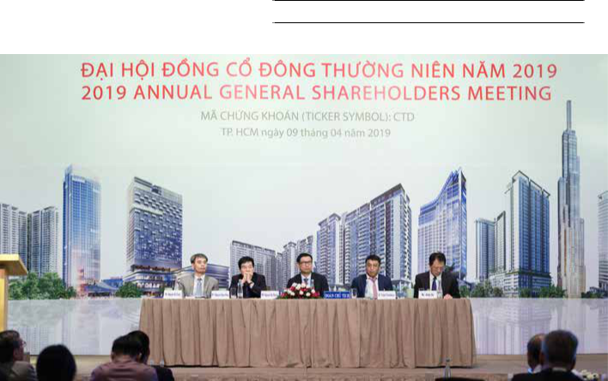

36 STAND FIRM IN CHALLENGES 37

**REPORT OF THE BOARD**



**OF DIRECTORS**



**ACTIVITIES OF SUBCOMMITTEES**

**OF THE BOARD OF DIRECTORS**

With the aim of maintaining sustainable development for the company and enhancing transparency in its operations, the Board of Directors of the 2017 – 2022 term has established many specialized subcommittees to advise and assist the Board of Directors. As of 31st December 2019, the Board of Directors has established following Subcommittees with their functions, duties and operational status specified as below:

1. THE STRATEGIC SUBCOMMITTEE
2. THE REMUNERATION & HUMAN RESOURCE SUBCOMMITTEE
3. THE INVESTMENT SUBCOMMITTEE
4. THE RISK SUBCOMMITTEE
5. THE SECRETARY OF BOARD OF DIRECTORS



**THE STRATEGIC SUBCOMMITTEE**

**Members**



|  |  |  |  |
| --- | --- | --- | --- |
| **No.** | **Full name** | **Position in the Company** | **Position in the Subcommittee** |
| 1 | Nguyen Ba Duong | Chairman | Head of the Subcommittee |
| 2 | Tan Chin Tiong | Independent Member of the Board | Member of the Subcommittee |
| 3 | Yerkin Tatishev | Member of the Board | Member of the Subcommittee |



**THE REMUNERATION & HUMAN RESOURCE SUBCOMMITTEE** 

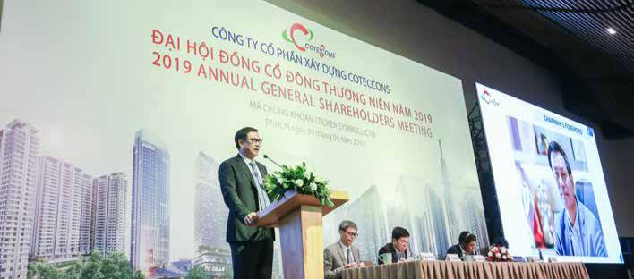

**Members**



|  |  |  |  |
| --- | --- | --- | --- |
| **No.** | **Full name** | **Position in the Company** | **Position in the Subcommittee** |
| 1 | Tran Quyet Thang | Independent Member of the Board | Head of the Subcommittee |
| 2 | Nguyen Sy Cong | Member of the Board cum General | Member of the Subcommittee |
|  |  | Director |  |
| 3 | Talgat Turumbayev | Member of the Board | Member of the Subcommittee |



|  |  |  |
| --- | --- | --- |
| **Functions and duties** |  |  |
| The Remuneration & Human Resource Subcommittee | positions. |  |
| would supervise the Company’s organizational structure, | »» Review the General Director’s recommendations |  |
| review policies and principles related to the selection |  |
| and retention of senior personnel. | regarding selection, promotion, transfer and |  |

**Functions and duties**

The Strategic Subcommittee was established to assist the Board of Directors in researching and proposing the Company’s development plan including but not limited to researching new projects. Its functions include Company development orientation, expanding or narrowing the business sectors, maintaining relationships with customers, functional agencies, and creating strategic development direction of the Company. At the same time, the Strategic Subcommittee also oversees activities related to the strategic development orientation of member companies, Divisions, Departments, and risk management as strategic planning process.

*The Subcommittee has the task of researching, discussing and reporting to the Board of Directors regarding:*

»» Evaluate the business environment, business lines,

and identify opportunities, challenges, strengths and weaknesses of the Company.

»» Orientate development strategic of the Company in the short and long term to develop the Company sustainably, increase value for shareholders.

»» Plan and build the organizational structure of the Company in accordance with the development needs and proposed strategy.

»» Identify risk in strategies implementation, compose

policies and measures to manage and prevent risk.

»» Prepare the development orientations of the Company; receive agreement within the Board of Directors before submitting to the Annual General Meeting of Shareholders for approval.

|  |  |  |  |
| --- | --- | --- | --- |
|  |  | suspension of senior personnel. |  |
| Implement plan to ensure successions for key positions in | | »» Review and propose remuneration regimes for all |  |
| the Company, for selection, training and optimal transfer, | |  |
| without affecting the Company’s operations. | | levels of managers of the Company (From the title |  |
|  |  | of Project Manager and above), report and offer the |  |
| Assist the Board of Directors in senior management | | Board of Directors for approval of bonus policies in |  |
| personnel development policies, including: | | shares or cash bonus (or other policies) based on |  |
| »» |  | annual business results. |  |
| Propose senior personnel development programs, | »» Propose to the Board of Directors the general |  |
|  | including training and rotation programs (domestic |  |
|  | and foreign). | remuneration policies of the Company for |  |
| »» |  | consideration prior submitting to the General |  |
| Recruit and mobilize more qualified and suitable | Meeting of Shareholders. |  |
|  | personnel to supplement the management team | »» Monitor and review the performance, key |  |
|  | according to the development strategy of the |  |
|  | Company. | performance indicators of managers to determine |  |
| »» |  | benefits outside salaries and preferred stock policies |  |
| Fairly evaluate the capacity and work results of | - ESOP. |  |
|  | managers, in order to align personnel with suitable |  |  |

38 STAND FIRM IN CHALLENGES 39

**REPORT OF THE BOARD**



**OF DIRECTORS**



|  |  |  |  |  |
| --- | --- | --- | --- | --- |
| **THE INVESTMENT SUBCOMMITTEE** | |  |  |  |
| **Members** | | |  |  |
| **No.** | **Full name** | | **Position in the Company** | **Position in the Subcommittee** |
| 1 | Yerkin Tatishev | | Member of the Board | Head of the Subcommittee |
| 2 | Nguyen Sy Cong | | Member of the Board cum General | Member of the Subcommittee |
|  |  |  | Director |  |
| 3 | Nguyen Quoc Hiep | | Independent Member of the Board | Member of the Subcommittee |



**THE SECRETARY OF BOARD OF DIRECTORS Members**



|  |  |  |
| --- | --- | --- |
| **No.** | **Full name** | **Position in the Board** |
| 1 | Vu Duy Lam | Chief Secretary |
| 2 | Vu Kien Hoa Nhan | Member |
| 3 | Tran Quy Viet Tuan | Member |



**Functions and duties**



The Secretary of BOD operates actively at the Company, responsible for coordinating activities of the Board of Directors and works as the connection between the Board of Directors and the Board of Management to solve related issues, provide information, advice, consult and support activities of the Board of Directors/General Meeting of Shareholders in accordance with the laws and Company’s Charter; Drafting documents, disclosing information and resolving other issues related to the activities of the Board of Directors/ General Meeting of Shareholders; Investor relations and shareholder care..

**Functions and duties**

Appraise and evaluate investment activities of the Company and propose options on the effectiveness and risks of investment activities to the Board of Directors.

Search and analyze investment opportunities (including investment in M&A, financial investment, equipment technology investment) in accordance with the strategic direction of the Company.

Compose regulations, policies related to investment activities and supervise compliance with those policies.

Provide options, analyze risks and propose preventive measures in the investment process for the Board of Directors for consideration and decision; supervise compliance with investment regulations in the Company’s Charter.

**REMUNERATION AND BENEFITS OF THE BOARD OF DIRECTORS, BOARD OF MANAGEMENT AND BOARD OF SUPERVISORS IN 2019**



|  |  |  |  |  |  |  |
| --- | --- | --- | --- | --- | --- | --- |
| **No.** | **Full name** | **Income from** | **Income from** | **Income from** | **Total** |  |
| **salary** | **bonus** | **Remuneration** |  |
|  |  |  |  |
| **I.** | **BOARD OF DIRECTORS** |  |  |  |  |  |



|  |  |  |  |  |
| --- | --- | --- | --- | --- |
| **THE RISK SUBCOMMITTEE** | |  |  |  |
|  |  |  |
| **Members** | |  |  |  |
| **No.** | **Full name** | **Position in the Company** | **Position in the Subcommittee** |  |
| 1 | Nguyen Quoc Hiep | Independent Member of the Board | Head of the Subcommittee |  |
| 2 | Nguyen Sy Cong | Member of the Board cum General Director | Member of the Subcommittee |  |
| 3 | Talgat Turumbayev | Member of the Board | Member of the Subcommittee |  |



**Functions and duties**

Identify and evaluate risks affecting business investment Be responsible for reviewing and deciding to change the

activities of the Company and propose preventive Company’s risk management organizational structure to

measures. comply with the requirements of risk management as

regulated in laws and updating risk management culture

Establish risk tolerance and preventive measures for the to all Departments, Divisions and Construction sites of

Company’s activities and supervise the implementation the Company.

of such methods.

|  |  |  |  |  |
| --- | --- | --- | --- | --- |
| Mr. Nguyen Ba Duong | 67.19% | 26.71% | 6.10% | 100.00% |
| Mr. Nguyen Sy Cong | 67.10% | 28.17% | 4.73% | 100.00% |
| Mr. Nguyen Quoc Hiep | 0.00% | 0.00% | 100.00% | 100.00% |
| Mr. Talgat Turumbayev | 0.00% | 0.00% | 100.00% | 100.00% |
| Mr. Tran Quyet Thang | 0.00% | 0.00% | 100.00% | 100.00% |
| Prof. Tan Chin Tiong | 0.00% | 0.00% | 100.00% | 100.00% |
| Mr. Yerkin Tatishev | 0.00% | 0.00% | 100.00% | 100.00% |
| **II. BOARD OF SUPERVISORS** |  |  |  |  |
| Mr. Luis Fernando Garcia Agraz | 0.00% | 0.00% | 100.00% | 100.00% |
| Mr. Dang Hoai Nam | 57.58% | 33.24% | 9.18% | 100.00% |
| Mr. Nguyen Minh Nhut (Jack) | 0.00% | 0.00% | 100.00% | 100.00% |



1. **BOARD OF MANAGEMENT**



|  |  |  |  |  |
| --- | --- | --- | --- | --- |
| Mr. Tran Quang Quan | 70.52% | 29.48% | 0.00% | 100.00% |
| Mr. Tu Dai Phuc | 69.56% | 30.44% | 0.00% | 100.00% |
| Mr. Phan Huy Vinh | 64.92% | 35.08% | 0.00% | 100.00% |
| Mr. Vo Thanh Liem | 68.35% | 31.65% | 0.00% | 100.00% |
| Mr. Tran Van Chinh | 70.88% | 29.12% | 0.00% | 100.00% |



40 STAND FIRM IN CHALLENGES 41

**REPORT OF THE BOARD**



**OF DIRECTORS**



**SHARES TRANSACTION OF INSIDERS AND**

**RELATED PARTIES**



|  |  |  |  |  |  |  |  |  |
| --- | --- | --- | --- | --- | --- | --- | --- | --- |
|  |  |  | **Number of shares owned** | | **Number of shares owned at** | | **Reason of** |  |
|  |  |  | **at the period beginning** | |  |
|  |  |  | **(from the time of starting to** | | **the end of the period** | | **increase.** |  |
| **STT** | **Transaction** | **Insider/ Related** | **become an insider)** | |  |  | **decrease** |  |
| **performer** | **party** |  |  |  |  | **(purchase, sell,** |  |
|  |  |  |  |  |  |
|  |  |  | **Amount of** |  | **Amount of** |  | **convert, reward,** |  |
|  |  |  | **Ratio** | **Ratio** | **etc.)** |  |
|  |  |  | **shares** | **shares** |  |
|  |  |  |  |  |  |  |
| 1 | Nguyen Ba Duong | Chairman | 3,831,654 | 4.89% | 3,901,754 | 4.92% | ESOP Purchase |  |
| 2 | Nguyen Sy Cong | General Director | 1,149,906 | 1.47% | 1,181,006 | 1.49% | ESOP Purchase |  |
| 3 | Tran Van Chinh | Deputy General | 144,300 | 0.18% | 154,700 | 0.19% | ESOP Purchase |  |
| Director |  |
|  |  |  |  |  |  |  |  |
| 4 | Tran Quang Quan | Deputy General | 1,149,507 | 1.47% | 1,180,107 | 1.49% | ESOP Purchase |  |
| Director |  |
|  |  |  |  |  |  |  |  |
| 5 | Tu Dai Phuc | Deputy General | 241,694 | 0.31% | 261,094 | 0.33% | ESOP Purchase |  |
| Director |  |
|  |  |  |  |  |  |  |  |
| 6 | Vo Thanh Liem | Deputy General | 132,350 | 0.17% | 151,750 | 0.19% | ESOP Purchase |  |
| Director |  |
|  |  |  |  |  |  |  |  |
| 7 | Vo Thanh Cang | Related Party | 27,501 | 0.04% | 33,001 | 0.04% | ESOP Purchase |  |
| 8 | Dang Hoai Nam | Member of BOS | 83,548 | 0.11% | 89,648 | 0.11% | ESOP Purchase |  |
| 9 | Ha Tieu Anh | Head of Financial | 605,910 | 0.77% | 618,510 | 0.78% | ESOP Purchase |  |
| Acounting Dept. |  |
|  |  |  |  |  |  |  |  |
| 10 | Vu Thi Hong Hanh | Chief Accountant | 632,014 | 0.81% | 641,014 | 0.81% | ESOP Purchase |  |



**EVALUATION OF THE BOARD OF DIRECTORS ON THE**  **OBJECTIVES OF THE GENERAL MEETING OF SHAREHOLDERS**



2019 is a challenging year for the real estate - construction industry as businesses had to deal with various procedural risks.

Following the direction of the Board of Directors and the Board of Management, the Company was assigned to complete objectives including revenue and profit plans, dividend payments, expanding client base, consolidating apparatus, improving technology, etc.

By the end of 2019, the Company has completed already and has not yet completed a number of targets, details as follows:

**** **The implementation of financial targets**

Total assets as of 31 December 2019 reached VND 16,198 billion, down nearly 4% compared to 2018. Consolidated revenue was VND 23,733 billion, profit after tax of shareholders of the Parent Company reached VND 711 billion, which did not complete the plan set out by the 2019 Annual General Meeting of Shareholders. The targets were not fully met could be explained by many objective and subjective factors, especially in the context of the market condition with more difficulties than 2018 as well as the limited contributions of some Board members.

**** **Dividend payment by cash**

In order to continue fulfilling the commitment to bring more value to the investors, in October 2019, the Company had paid cash dividends with the payment of VND 3,000/share (equivalent to 30% of par value).

ESOP revocation from ex-employees.

In 2019, the Company also proceeded to withdraw ESOP shares from employees who have quit their jobs. The total number of recovered stocks is as follows:



The number of revoked shares 86,300 shares



Price Equal to issuance price



**** **Evaluation of the Board of Directors in 2019**

As matter of fact, the Company failed to complete the Business Plan as stated in the Report of the Board of Management.

Therefore, the Board of Directors believed that these shortcomings should be put in consideration in the future:

* The level of contribution in management and support of production and business activities of some members in the Board of Directors toward the Board of Management is limited.
* Due to the characteristics of the Board of Directors’ members being in many different locations, a number of decisions requesting for approval of the Board of Management are delayed.
* The Subcommittees have not sufficiently demonstrated the role of advising the Board of Directors on specialized issues.

42 STAND FIRM IN CHALLENGES 43



**REPORT OF THE BOARD**



**OF DIRECTORS**



**SUPERVISION REPORT OF THE BOARD OF**  **DIRECTORS TO THE BOARD OF MANAGEMENT**



**ORGANIZATION STRUCTURE AND TRAINING PERSONNEL** 

The Board of Management consists of a General Director and 04 (four) Deputy General Directors. Since 2018, the business model that divides the Company into functional divisions, including Project Operations, M&E Project Operations, Economic - Finance, Investment, Technology - Technical and the Internal Affairs Division continues to show its efficiency in business management and productivity improvement.

Together with the recruitment, the Board of Management continue to focus on the training and development of human resource, which has the ability to take on large and technically complicated tasks.

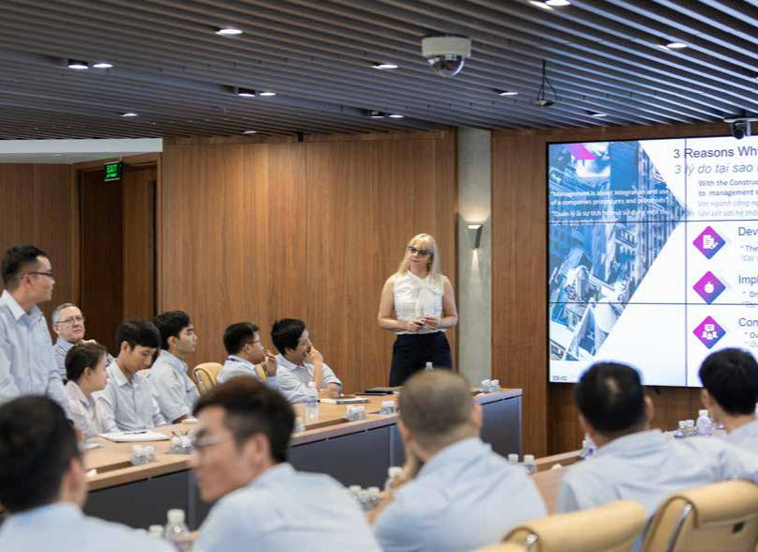

**TRANSPARENCY MANAGEMENT**



»» Improving the Company’s structural system did not only increase work efficiency, but also ensured transparency of Coteccons. The establishment of a centralized procurement - contracting team under the CCM Department has helped increase operational efficiency and transparency in procurement and contracting with suppliers and subcontractors. In addition, the Workforce Building and Development Department has also succeeded in transforming many construction teams into subcontractors in order to make the subcontractors transparent.

»» Information disclosure to the market in accordance with the law is also implemented accurately and promptly by the Board of Management. In addition to the financial information disclosed on a quarterly basis, the Company constantly updates the operation status of the signed contracts and the progress of projects under construction through the Company’s website. Press conferences and meetings with shareholders held regularly to provide information to the investors.

**SUMMARY**

The Board of Directors assessed that the Board of Management in 2019 had implemented the strategic objectives set by the General Meeting of Shareholders and the Board of Directors fairly well. Beside focusing on core business and promoting the strength of construction capacity, the Board of Management had always been dynamic and creative, constantly seeking for opportunities to boost sales, reduce costs and enhance operational efficiency. The Board of Management improved the model and the transparency in the Company’s operations.

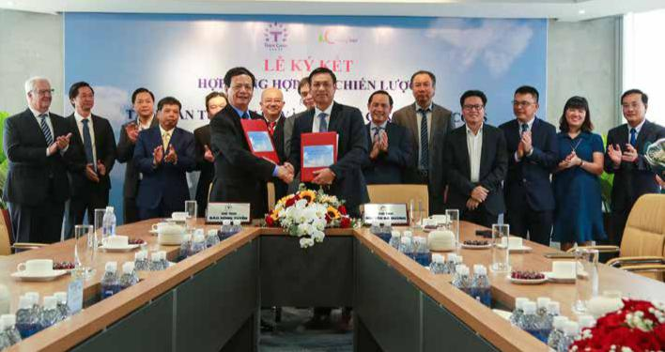

44 STAND FIRM IN CHALLENGES 45

**REPORT OF THE BOARD**



**OF DIRECTORS**

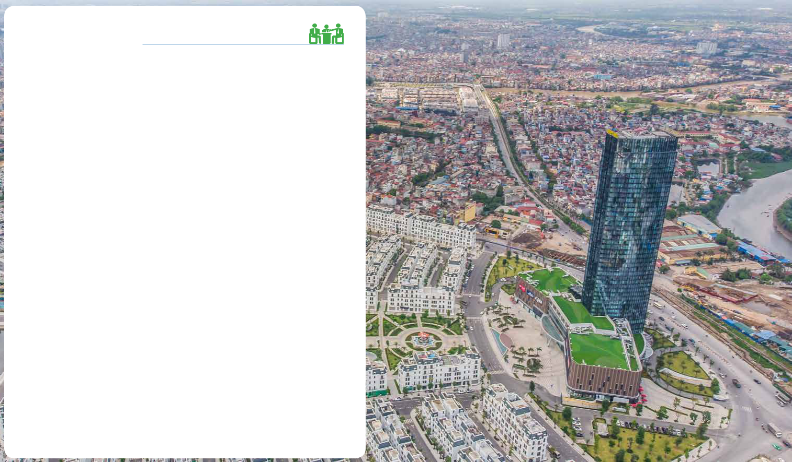

**THE 2020 STRATEGIC ORIENTATION PLAN OF THE**

**BOARD OF DIRECTORS**

In the context of general difficulties of the real estate market, very few new projects have been

implemented. Besides, many works under construction have been suspended and prolonged.

This is and will continue to make a major impact on Coteccons’ revenue and profit.

Based on the analysis of the challenges and advantages of the market as well as the

competitiveness of the Company, the Board of Directors sets out the strategy for 2020 and

the direction of operation as follows:

* Strengthen activities of Sub-Committees of the Board of Directors. The subcommittees shall make more efforts, looking in the same direction to support and advise the Executive Board.
* Optimize the management system and improve operational efficiency.
* Focus on risk control, market forecast in order to timely adjust the orientation of production and business strategies.
* Approve on policies to encourage employees, create maximum mechanisms for team development, additional resources for the Board of Management.
* Make the best effort to find more optimal solutions to improve profit margins, continue to maintain the position of the leading contractor in Vietnam market and ensure the best interests of all shareholders.

**Vinhomes Imperia**

Hai Phong

46 STAND FIRM IN CHALLENGES 47

**REPORT OF THE BOARD**



**OF DIRECTORS**



**RISK MANAGEMENT**



**OVERVIEW**

COTECCONS OPERATE IN CONSTRUCTION SECTOR WHICH IS AFFECTED BY MANY FACTORS SUCH AS LAW, FINANCE, MARKET, CUSTOMERS, GEOGRAPHIC LOCATION, MATERIALS, PERSONNEL, LABOUR AND SAFETY, LEADING TO POTENTIAL RISKS AT DIFFERENT LEVELS.

**THE INTERNAL AUDIT BOARD**



The Internal Audit Board has the responsibilities as an independent body of the company, which operates under following key objectives:



DURING THE PAST YEARS, COTECCONS HAS BUILT AND DEVELOPED THE ENTERPRISE RISK MANAGEMENT SYSTEM (ERM) WITH METHODS AND TOOLS DESIGNED TO ENSURE RISKS IDENTIFIED, CLASSIFIED, EVALUATED AND CONTROLLED WITH SUITABLE MEASURES. THE RISK MANAGEMENT SYSTEM OF COTECCONS IDENTIFIES AND ANALYSES KEY RISKS, THEREBY HELPING:



Direct operation activities according to the business targets and plans;



Maintain the values, assets and reputation of Coteccons;



Support decision-making processes and procedures;



Ensure operational strategies are consistent with core values



Share common evaluation on risks to all employees.

Evaluate and analyse the enterprise

risk management system;



Supervise the compliance process of

the internal control system;

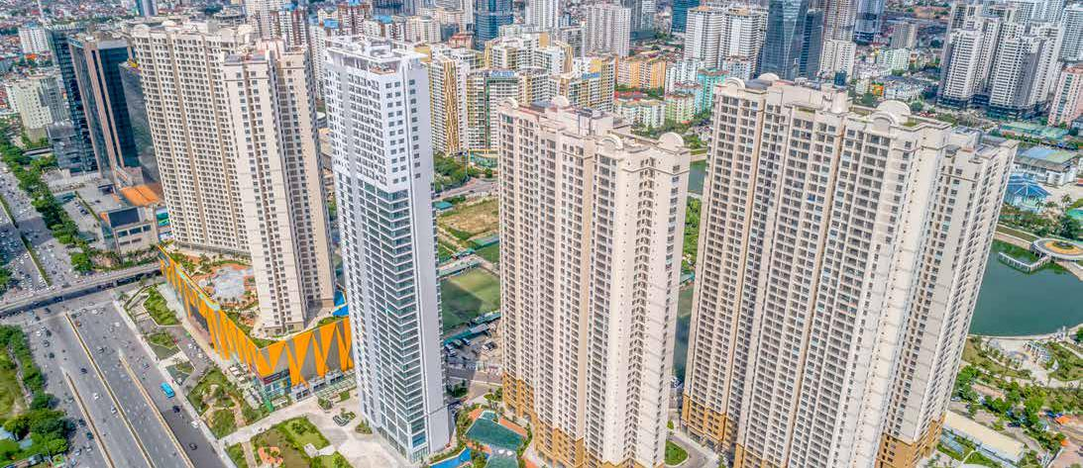

Evaluate, consult, complete processes, regulations and methods of internal operations;



Supervise the financial report process.

48 STAND FIRM IN CHALLENGES

**D’Capitale**

Hanoi

49

**REPORT OF THE BOARD**



**OF DIRECTORS**



**APPROACHING METHOD IN RISK MANAGEMENT OF COTECCONS**

**Risk management structure**

The risk management policies of Coteccons covers the management of every operating unit. The continuous implementation to identify risks ensures, updated, risk registers to facilitate the development of timely response plans.

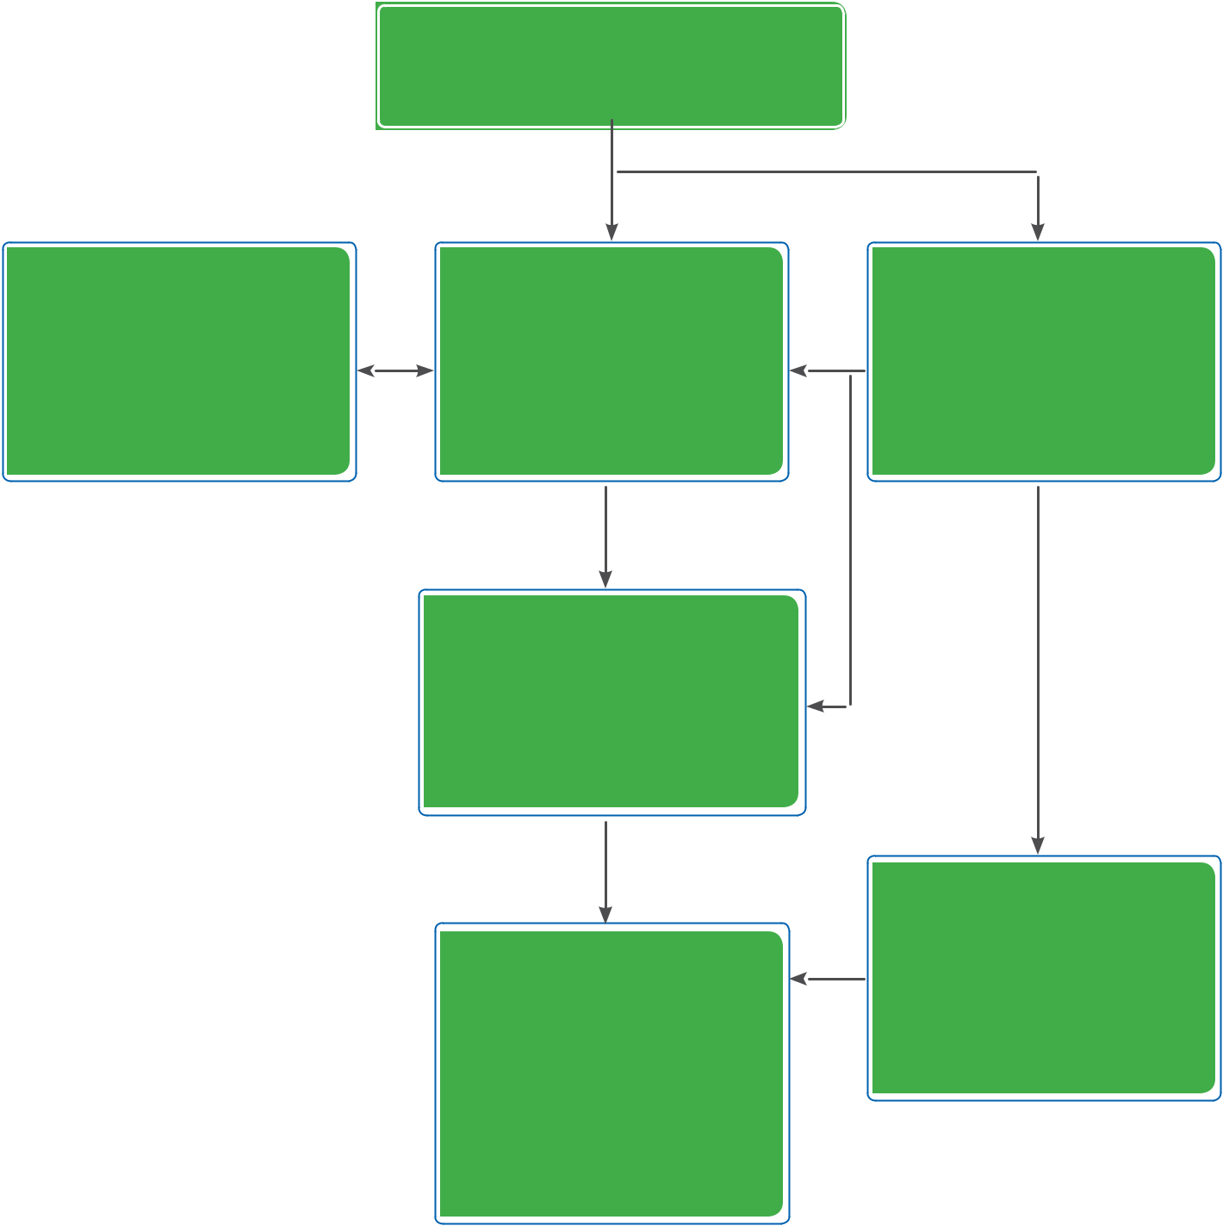

**Risk management method**

The risk management system of Coteccons based on the most advanced international knowledge and standards, including: ISO 31000:2009 and COSO risk management and enterprise risk management — integrating with strategy and performance (2017).

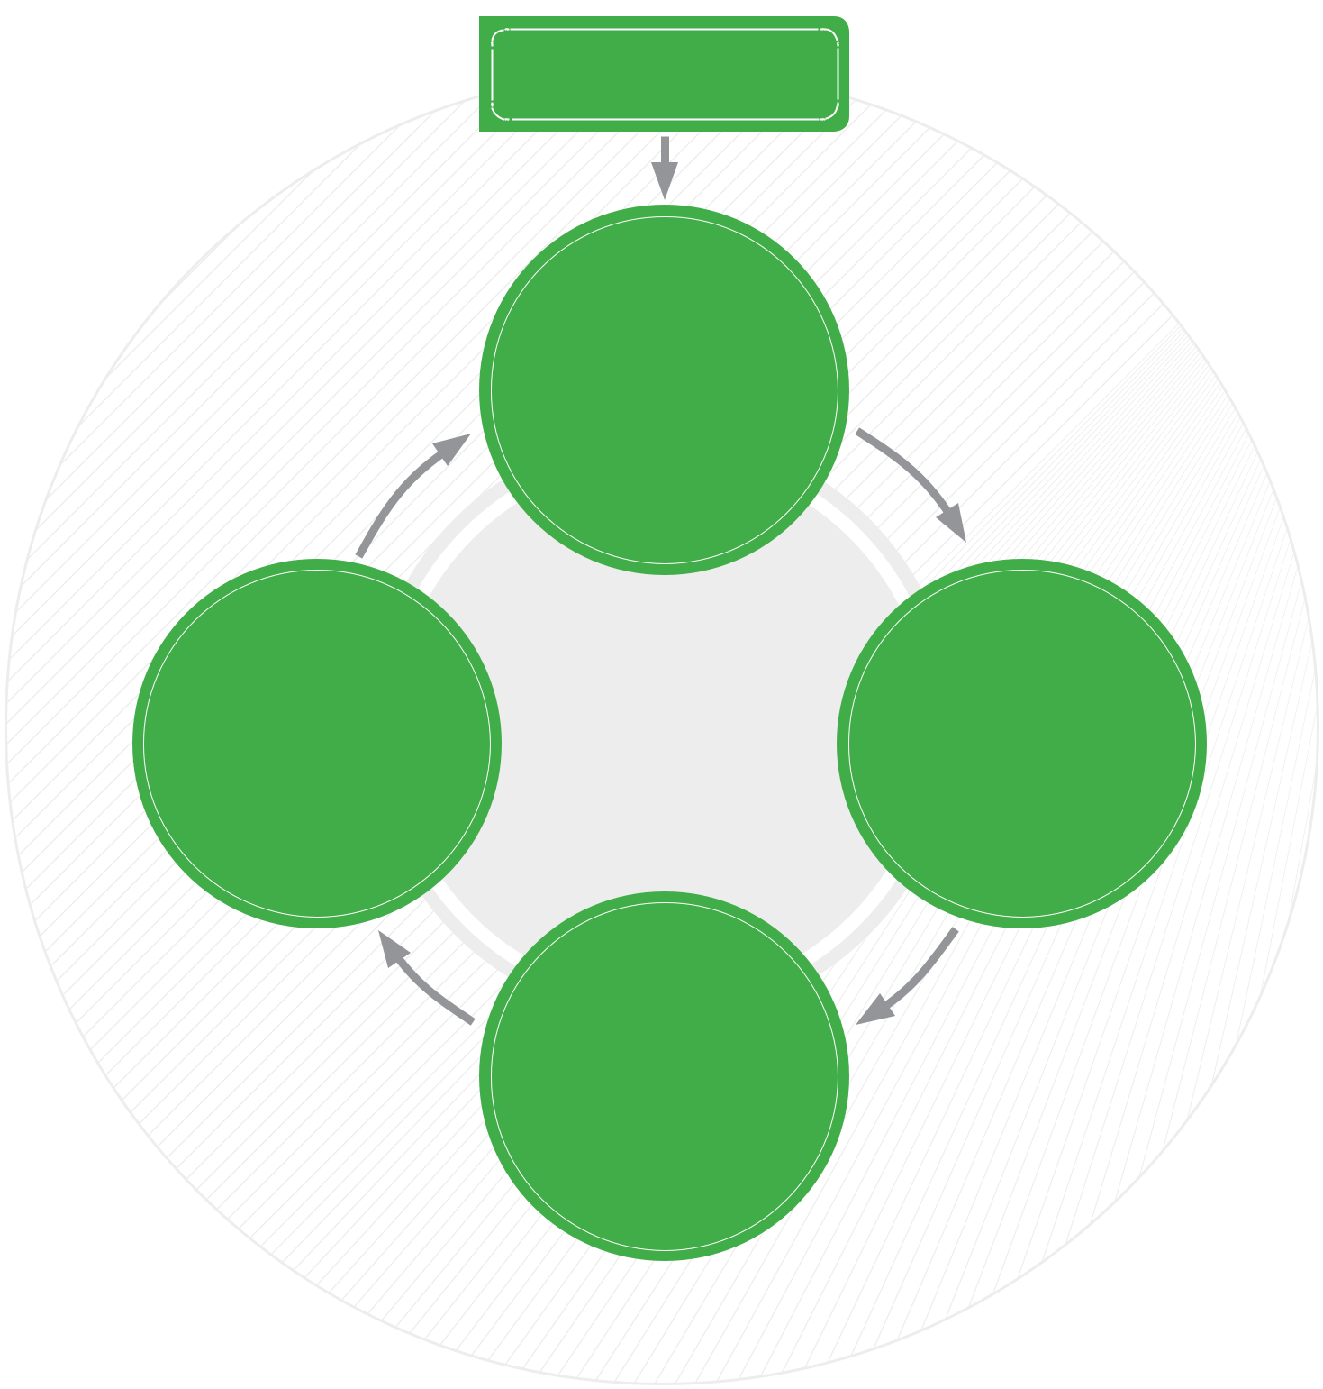

THE RISK

SUBCOMMITTEE

(THE BOD)

Identify critical risks during operation and notice to the BOD

**GENERAL MEETING OF**

**SHAREHOLDERS**

THE BOARD OF

DIRECTORS

Overall approval of policies related to risk management system and internal control system

THE BOARD OF

MANAGEMENT

Establish risk management

policie and propose internal

management and control

mechanisms

DEPARTMENTS/

DIVISIONS/

CONSTRUCTION

SITES/ CENTERS

THE BOARD OF

SUPERVISORS

Supervise compliance with

procedures related to risk

INTERNAL AUDIT

BOARD

Independently evaluate and

verify the effectiveness of the

risk management policies

**DUTIES AND COMMITMENTS FROM**

**THE MANAGERS**

**DESIGN RISK**

**MANAGEMENT FRAMEWORK**

»» Evaluate overview

of organization and

operating environment

»» Develop risk management

policies

|  |  |  |
| --- | --- | --- |
|  | **IMPLEMENTATION OF RISK** |  |
| **CONTINUOUSLY UPDATE** | **MANAGEMENT** |  |
| »» Enforce steps and |  |
| **AND IMPROVE THE** |  |
| **RISK MANAGEMENT** | procedures of risk |  |
| **FRAMEWORK** | management |  |
|  | »» Identify, evaluate, rank, |  |
|  | respond and assign |  |

**SUPERVISE AND**

**EVALUATE THE**

**IMPLEMENTATION**

Review, identify, evaluate

and manage risks directly.

Implement risk response

plans and update situations

**PROCESS**

50 STAND FIRM IN CHALLENGES 51

**REPORT OF THE BOARD OF**



**DIRECTORS**



**MAJOR RISKS**



RISKS ARE DIVIDED INTO FOUR MAIN AREAS INCLUDING STRATEGY, OPERATION, FINANCE, COMPLIANCE & LAW.



**STRATEGY**

**RISKS**

|  |  |  |
| --- | --- | --- |
| **RISKS** | **OPERATION** |  |
| **FROM NON-** |  |
| **RISKS** |  |
| **COMPLIANCE** |  |
|  |  |

**FINANCE**

**RISKS**

 **STRATEGY RISKS**



**RISKS FROM CONSTRUCTION AND REAL ESTATE MARKET**



|  |  |  |  |
| --- | --- | --- | --- |
| 2019 was a difficult year of the real estate | Focus on the factory-building segment with | | |
| market with changes in external macro | the transfer of foreign investment capital | | |
| factors, along with supply imbalances in many | into Vietnam. |  |  |
| segments. This has caused many difficulties |  |  |  |
| for enterprises operating in the construction | Strongly promote creativity and improvement | | |
| sector and affected the revenue and profit | in construction and management methods, | | |
| targets of the Company. In addition, the risk | build a closed supply chain in the construction | | |
| within the real estate market has affected | sector, strengthen the potential of Design & | | |
| the development of projects and finance | Build project models, aim to optimize costs | | |
| of the Investor, causing certain difficulties | for the Investors, create quality products | | |
| for the Company’s source of work, and debt | and be capable of attracting the market | | |
| collection. | consumption level. | |  |
| **Risk response** | Constantly explore and research long-term | | |
|  | sustainable | roadmap of | development. |
| Have regular analysis and evaluation of the | Finding and seizing new and effective | | |
| real estate market and construction sector | investment | opportunities. | Develop a |
| status in Vietnam. The Board of Directors | strong team with skills related to finance, | | |
| has early recognised potential market | investment, legal and economic to realise | | |
| segments for development and finding | these opportunities. | |  |
| comprehensive, optimal solutions to create |  |  |  |
| competitive advantages. |  |  |  |



|  |  |  |  |  |  |
| --- | --- | --- | --- | --- | --- |
| **REPUTATION RISKS** |  |  |  |  |  |
| Coteccons’ reputation may be directly affected | | **Risk response** | | | |
| by events from the Company itself, either | |  |  |  |  |
| indirectly from subsidiaries or affiliates, or from | | Strictly comply | with the provisions of | | |
| third-party audiences. Coteccons’ prestige | | the law, accelerate the control activities, | | | |
| has been affirmed for many years through a | | constantly improve and improve the | | | |
| professional and sincere working ethic towards | | work quality, fulfil commitments with | | | |
| customers and partners, ensuring quality | | customers is an effective way to build and | | | |
| and progress. However, in the course of its | | maintain the brand’s strength. Additionally, | | | |
| operation, inaccurate information may also | | it is also necessary to develop a robust | | | |
| affect the Company’s brand. | | communications | department enough | | |
|  |  | to control or mitigate against inaccurate | | | |
|  |  | information affecting the reputation and | | | |
|  |  | brand of the Company. | | | |



52 STAND FIRM IN CHALLENGES 53

**REPORT OF THE BOARD OF**



**DIRECTORS**



 **OPERATION RISKS**



**RISKS FROM WORK SAFETY**

The peculiarity of the construction industry requires workers to work in harsh conditions affected by factors such as environment conditions, heavy machinery, heavy use of labour, fast track construction schedule… These cause many potential safety risks if not strictly handled.

As there are many projects spread across the country, the management and prevention of occupational safety risks are always a concern.

**Risk response**



The spirit of “Safety first” always stays at the forefront of Coteccons. The company has issued a set of safety procedures which range from identification, assessment and control of risks to detailed tasks such as electrical equipment inspection, fire protection, instructions for working on height, working in confined spaces, equipment that requires strict safety in operation. Coteccons also develops a set of guidelines for handling emergencies to ensure the readiness in possible cases.

The construction equipment continues to be newly invested and controlled in terms

of safety. High-rise projects are equipped

with advanced sliding cover systems

which ensures a safe working space and

prevents falling objects. Lifting equipment

involving high risks of safety such as

tower cranes and hoist are periodically

supervised during operation.

Regularlycarryouttraining,groupmeetings,

safety assessment and inspection; periodic

maintain construction equipment; provide

adequate technical safety equipment for

all site staff and workers of subcontractors

and construction teams.

Coteccons also employs foreign experts with many years of safety experience. Their extensive knowledge and skills accumulated from working in hundreds of projects around the world are the necessary resources which contribute to the improvement of the Company’s safety procedure.

**TENDER RISKS**

Tender is the first step of the success of

Bid - Build construction projects. This is the

stage Coteccons demonstrates its strategy

and competitive advantage to competitors.

Therefore, the tender phase is always having

risks including: incorrect tender price from

competitors, unhealthy competition, lack

of input information, unfulfilled control of

items to be performed, inadequate drawing

design, inaccurate data estimates, fast pace

schedule... These are accompanied by a

resonance impact from the risk of decline in

the market and finance of developers. Thus,

strengthening tender process is one of the

top priorities at Coteccons.



**Risk response**



Link the strength of different internal departments, research information, analyse the strengths and weaknesses of competitors. Take advantage of internal resources and external partners to create price strategies that match the needs of customers, bringing the most reasonable tender value.

Build a software platform with strong statistical and data linking capabilities that aims to automate the BOQ calculation for projects, especially D&B projects. Thereby increase the schedule of making quotes, setting up tender measures and ensure full evaluation of necessary tendering items as a basis for closing the deal early with the developer.

54 STAND FIRM IN CHALLENGES 55

**REPORT OF THE BOARD**



**OF DIRECTORS**



 **FINANCE RISKS**



**EXTERNAL MARKET RISKS**

During the year, there have been strong fluctuations in prices of some construction materials (steel, sand, stone, petroleum, electrical equipment...) which deeply affects the construction industry and still tends to continue in the following years. The trend of developing large and complex projects that requires the import of specific machinery and equipment from foreign markets together with changes in exchange rates will also have certain effects on the profitability of projects.

Policies on salaries and insurance also have effects on direct and indirect labor costs which have a significant impact on the cost of sales.

**Risk response**



Implement the model of centralized procurement for

the main construction, taking financial advantages to

reduce the price of materials supply. Forecast market

prices, proactively sign contracts in early stages to buy

and import essential equipment and materials for the

project.

Strengthen negotiations and finalize terms to maintain

prices, control the rate of inflation with the developers;

thereby have plans to make early purchase to avoid

the risk of price fluctuations. Actively seek new sources

of quality products with reasonable prices, limiting the

monopoly of supply.

Improve labor productivity, apply construction machines to reduce manpower to cope with fluctuations in labor costs.



**RISKS FROM LATE PAYMENTS**

Capital recovery in construction activities is

an important issue that ensures the financial

efficiency of the project and preserves

capital. Delayed payment can originate

from many reasons including the delay

in clients’ sales of products, the difficulty

in raising clients’ capital, legal issues and

investment policy... These can make clients

extend payment time to exploit contractors’

cashflow. Additionally, the volatility of the

real estate market and banks’ credit policies

can potentially lead to clients’ delay of

payment to the Company.



**Risk response**



Studying and evaluating the clients’ financial situation and their ability to sell products to decide to tender. At the same time, the Company requires strict standards and careful negotiation of contract payment terms right in the quotation process.

The Financial Supervisory Board, the Department of Finance and Accounting, the CCM Department and the Legal Board periodically supervise the sites’ cashflow, outstanding receivables, payments and settlements in order to have timely interventions and solution.

**RISKS FROM HUMAN RESOURCE**

People are always the core value of the Company’s construction and development route. Building and training a succession of young employees is always a big target of the Company to promote growth and sustainable development. It is also a big challenge to attract potential talent with good attitude and learning spirit. Furthermore, young employees also need a lot of time to accumulate practical experience and develop themselves in line with Coteccons’ existing strong human resources.

At the same time, the continuous and intensive training and sharing of valuable internal experience are an important key to building a strong Coteccons apparatus with highly qualified employees, creating great assets of the Company.

**Risk response**



Continue to maintain and improve the welfare policies for all employees. Ensure salaries, bonuses and allowances commensurate with labor productivity and

work efficiency. Not only ensuring the source of income, the Company also takes care of the health and wellbeing through the health insurance policy for employees and their relatives, the education sponsorship policy...

The Coteccons Trade Union also regularly plans to visit, encourage and give gifts to construction sites to boost the morale of the site management committees to overcome difficulties. Staff at the office are also often involved in volunteer programs both to enhance social responsibility with the community and to connect members of the Coteccons family outside the stressful working hours.

The Coteccons Academy (CTA) has been in charge of training staffs for Coteccons, from the staff and middle levels such as supervisor, QS, deputy site manager to senior levels such as site manager, head and deputy head of departments. Professionally organized training programs include the development of soft skills, professional work knowledge and even support to enhance the Company’s culture, build work motivation and work ethics. Employees who successfully complete the course are awarded a certificate as an acknowledgment of the achievements of their continuous learning efforts while ensuring the quality and progress of their assigned working tasks.

56 STAND FIRM IN CHALLENGES 57

**REPORT OF THE BOARD OF**



**DIRECTORS**

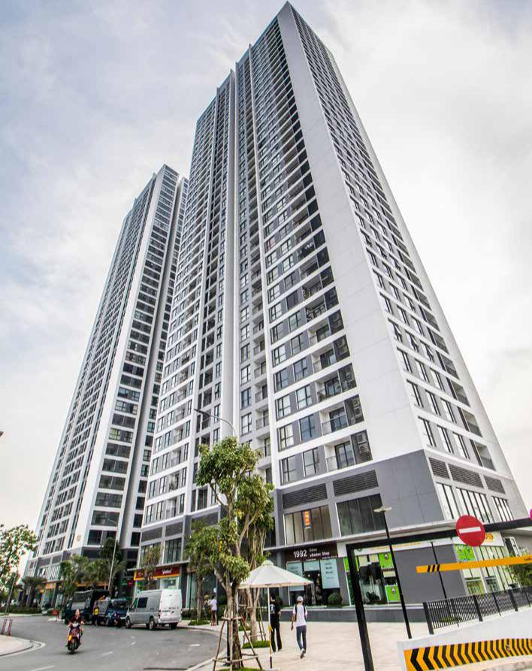

**Vinhomes Skylake**

Hanoi

58 STAND FIRM IN CHALLENGES

 **RISKS FROM NON-COMPLIANCE**



**RISKS FROM LEGAL POLICIES**

The business environment of Coteccons is regulated by many frameworks of legal provisions such as Law on Enterprises, Construction, Trade, Real Estate, Labor, Investment, Securities, Tax and Social Insurance. The process of developing and constantly updating legal documents requires the Company to always monitor, adapt and make necessary and timely adjustments. Coteccons always promotes the compliance with the law and commits to corporate social responsibility.

**Risk response**



Coteccons has built and recruited a team of professional legal personnel with knowledge and in-depth understanding of the legal system and economic policies. Coteccons Legal Board gradually develops the methodology of operation, not only to assess and solve current law issues but also to update, consult and forecast law changes through analysis of the government’s direction, the draft laws and from consulting with qualified lawyers who have many years of experience.



**RISKS FROM CONTRACTS**

The contract is the basis of all transactions of Coteccons from Clients, Suppliers, Subcontractors to Employees. If contract terms on project legal documents, advances, inflation, scope of work, payment term, etc., are not carefully assessed, this will lead to the risk of information shortage or unclear assigning responsibilities of related parties. The gaps in the contract will make it difficult to refer and handle the situation. This is also often the source of disagreements, disputes and litigation.

**Risk response**



Enhance contracts control through multiple assessment layers from the Tender Department, Cost and Contract Management Department, Finance and Accounting Department and Legal Board.

Develop a system of standardized contract samples with basic standard terms to serve as a premise for the negotiation process and comparison.

Establish a project legal risk assessment system on Clients, Consultants, Legality, Finance and Technicality and progress.

The Contract Body of the Economic Division constantly monitors and evaluates risks on contract terms. Any discrepancies with the provisions of the standard contract are discussed in order to limit the risks and to advise timely solutions to the Board of Management, Departments, Boards and Project Managers.

59

**REPORT OF THE BOARD**

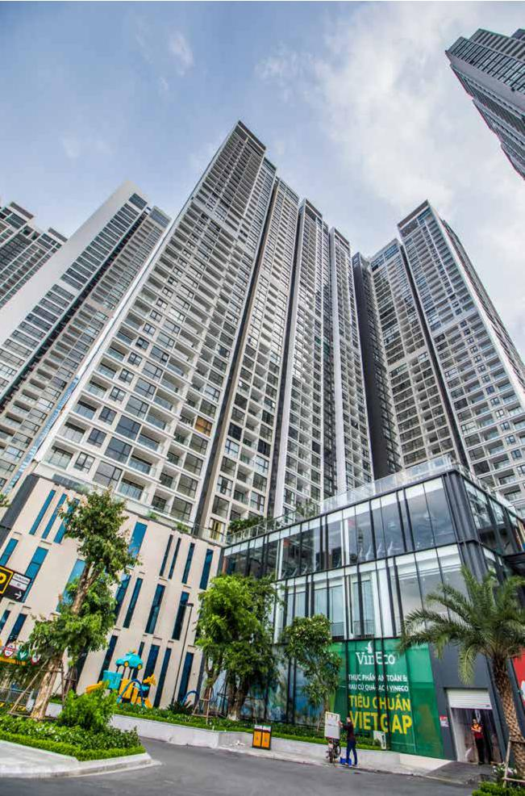

**OF DIRECTORS**



**ORIENTATIONS FOR 2020**

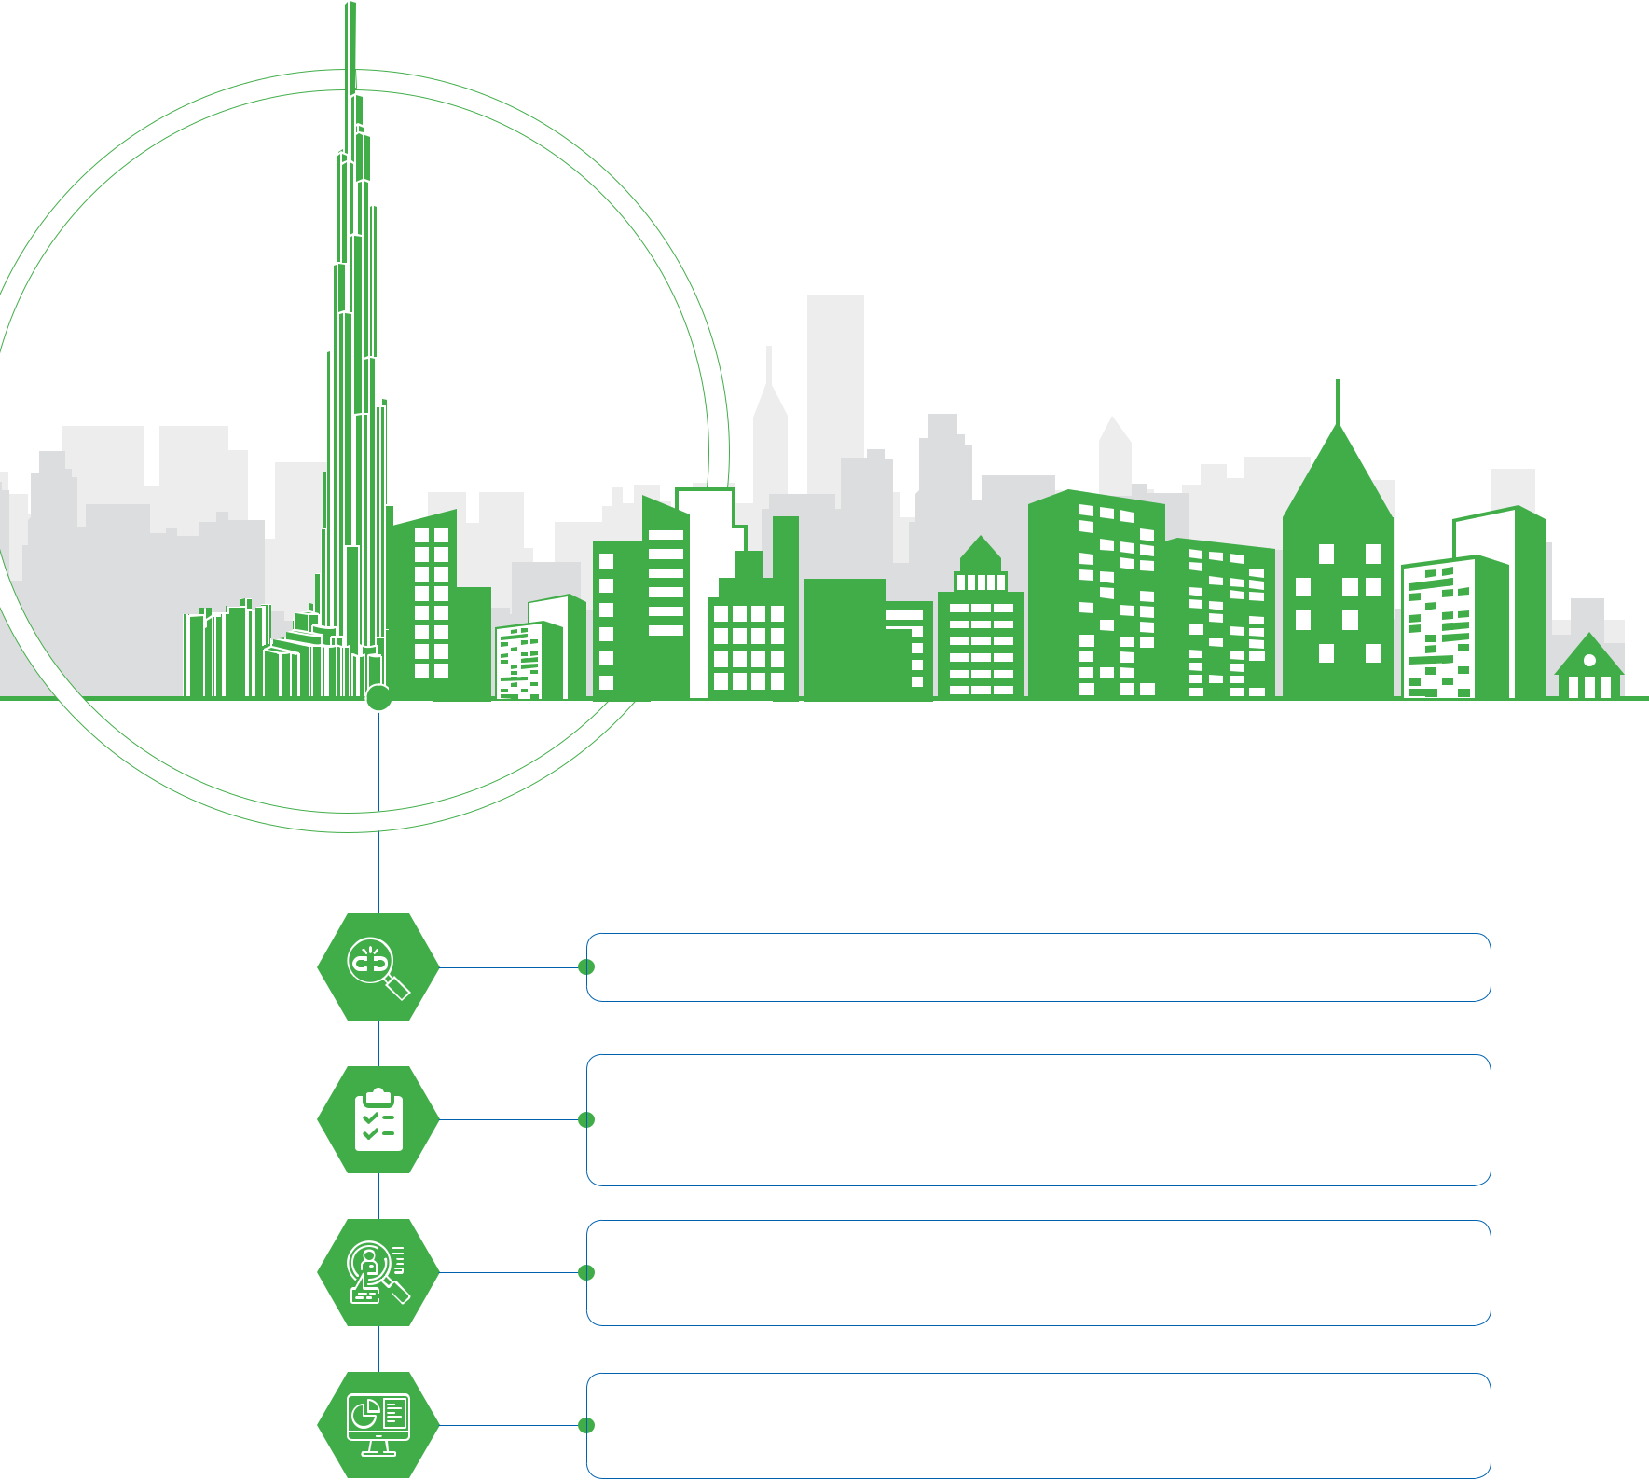

Continue to improve the risk management system of the Company.

Continuously update and develop the Company’s risks portfolio with in-

depth analysis and evaluation to support decision-making and proposing

response plans.

Research and develop the most advanced risk management skills and

training programs.

Update knowledge from risk management experts to identify points of

improvement.

**Vinhomes Greenbay**

Hanoi

60 STAND FIRM IN CHALLENGES 61

 **BOARD OF SUPERVISORS’ REPORT**



**MEMBERS OF BOARD OF SUPERVISOR** 

 Mr. **LUIS FERNANDO GARCIA AGRAZ**

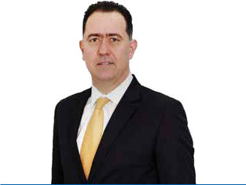

Head of Board of Supervisors

Year of birth: 1970

Nationality: Mexican

Graduated as a Master in Business Administration from the University of Texas in Austin, USA and has 26 years of experience in enterprise executive management.

2002 – 2014: He held many vital positions of world leading companies in the building materials production sector, including: Director of Strategic Business Development of Cemex Group, General manager of Puertas Acerostérmicas S.A. de C.V., Associate Director of Electronic Communication Technologies in Building Materials Corp., and Administrative and Planning VP of HT 360 Consortium S.A.

Since 2014, He has worked as the Director of Planning in Cement Holding and currently, as the Chief Operations Officer of Kusto Management Vietnam Co., Ltd.

In June 2017, Elected as the Head of Board of Supervisors of Coteccons for the term 2017 – 2022.

 Mr. **DANG HOAI NAM**

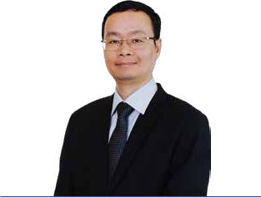

Member of the Board of Supervisors

Year of birth: 1976

Nationality: Vietnamese

Graduated as a Bachelor of Finance at the National Economics University – Hanoi and as a BA in English at the University of Languages and International Studies

– Hanoi. He has more than 21 years of experience in financial accounting management.

From 1998 to 2006, He worked as the Accountant Ba Ria – Vung Tau Petrolimex Company, FDC Company and COTEC Construction Company; from 2006 to 2015, He was the Chief accountant, Deputy General Director of Uy Nam Investment Construction JSC, later known as Unicons Investment Construction Co., Ltd.

From 2015, he moved to work at Coteccons, respectively, as the Head of Finance Board, Head of General Department and Head of Legal Board.

Since June 2017, Elected as the member of the Board of Supervisors of Coteccons for the term 2017 – 2022.

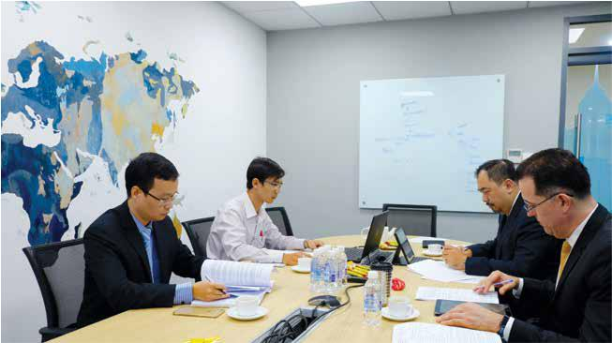

Graduated as a BA (Hons.) in Chartered Accountancy at the University of Waterloo, Canada and licensed with the Canadian Certificate of Chartered Accountant.

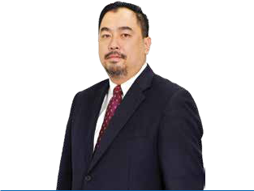

2012 – 2017: He held senior executive positions at the Institute of American Education and at VinaCapital, one the largest asset management corporation in Vietnam.

In June 2017, Elected as the member of the Board of Supervisors of Coteccons for the term 2017 – 2022.

 Mr. **NGUYEN MINH NHUT (JACK)**

Member of the Board of Supervisors

Year of birth: 1971

Nationality: Canadian

62 STAND FIRM IN CHALLENGES 63

 **BOARD OF SUPERVISORS’ REPORT**



**BOARD OF SUPERVISORS’ REPORT IN 2019**



There have appeared many signs of instability in the world economy in 2019, especially when there are increasing trade conflicts among the world’s major economies such as the US-China, Japan-Korea or geographic and political tensions in the Middle East. In 2019, Vietnam’s economy achieved positive results including stable interest rates and well-controlled capital. FDI, via exports, continues to be the main contributor to the economic growth.

For the construction sector, 2019 was a difficult year with over 60% of construction projects in Ho Chi Minh City area stalled. Vietnam’s construction industry is at the end of the Growth phase and is preparing to enter the Restructuring phase. This means that the construction growth rate is expected to slow down, leading to increased competition in the industry. In the short term, the main growth driver of Vietnam’s construction industry is non-residential products.

The Board of Supervisors agreed with the Company’s 2019 business results as shown in the Financial statements audited by PwC (Vietnam) Limited.

**THE OPERATION OF THE BOARD OF SUPERVISORS AND INTERNAL AUDIT BOARD** 

**The operation of the Board of Supervisors**



The membership of BOS elected in the Annual General Meeting of Shareholders for the term 2017-2022. The activities of BOS during the year are as follows:



|  |  |  |  |  |  |  |  |
| --- | --- | --- | --- | --- | --- | --- | --- |
| **No.** | **BOS’s member** | **Position** | **Appointed** | **Number of** | **Attendance** | **Reason** |  |
|  |  |  | **date/** | **attended** | **rate** | **for** |  |
|  |  |  | **resignation** | **meetings** |  | **absence** |  |
|  |  |  | **date** |  |  |  |  |
| 1 | Mr. Luis Fernando Garcia Agraz | Head of | 29/06/2017 | 6/6 | 100% |  |  |
| BOS |  |  |
|  |  |  |  |  |  |  |
| 2 | Mr. Dang Hoai Nam | Member | 29/06/2017 | 6/6 | 100% |  |  |
| 3 | Mr. Nguyen Minh Nhut (Jack) | Member | 29/06/2017 | 6/6 | 100% |  |  |



**Supervision of the activities of the Board of Directors, Board of Management and Shareholders**



In 2019, the BOS holds regular meetings to review and examine the resolutions and activities of the Board of Directors, the financial statements; and to review and submit to BOD for choosing the independent audit company for auditing the financial statements of the Company for the fiscal year 2019. Additionally, the BOS supervises the Internal Audit Board on performing risk management activities, and on assessing the financial performance, the effectiveness of processes and activities of important divisions, construction sites of the Company.



|  |  |  |
| --- | --- | --- |
| **No.** | **Date** | **Content** |
| 1 | 26th Mar 2019 | »» Discuss the working mechanism when sending information to the Board of Directors or |
|  |  | to third parties. |
|  |  | »» Discuss the audited financial statements for the year 2018. |
| 2 | 22nd May 2019 | »» Choose an independent audit company: The Board of Supervisors proposed PwC to |
|  |  | audit the Company’s financial statements for the fiscal year 2019. |
|  |  | »» Discuss the Quarter 1’s business results. |
| 3 | 25th Jul 2019 | »» Discuss the financial statements for the first six-month period of 2019 and reviewed the |
|  |  | Company’s business results. |
| 4 | 28th Aug 2019 | »» Discuss the contents of documents sent by a group of Coteccons’ shareholders. |
| 5 | 03rd Sep 2019 | »» Discuss the content of the fourth meeting of the BOS on 28th Aug 2019 and discuss the |
|  |  | content of the major shareholder’s letter. |
| 6 | 30th Nov 2019 | »» Discuss the contents of letters dated 15th Oct 2019 and 18th Oct 2019 sent by groups |
|  |  | of shareholders. |



**The operation of BOS and the risk management activities of BOS through the Internal Audit Board:**

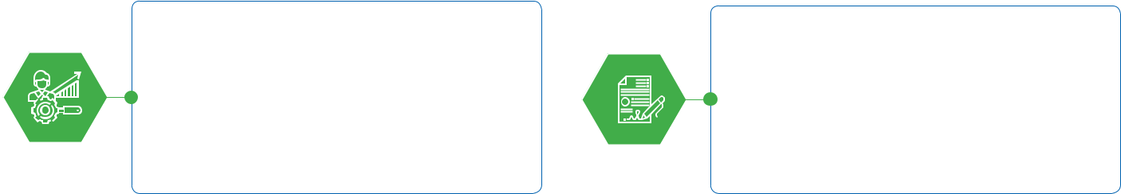

Review the implementation of the

2019 Annual General Meeting’s

resolution.



Supervise the business operation of

the Company and its opportunities

and challenges.

Review the consolidated financial



statements for the fiscal year 2019.



Check the relationship between

the Executive Board and some

companies within the supply chain:

The Board of Directors answered the

Board of Supervisors and gave clear

explanations about the relationships,

ownership and association based on

relevant legal documents.

Review and submit BOD for appointing

the independent auditor for the

financial statements of the year 2019

according to the 2019 General Meeting

of Shareholders: choosing PwC as the

independent auditor.



Meet with the Board of Management

to clarify the opinions of some

shareholders related to the corporate

governance and related party

transactions.

Assess microeconomic and microeconomic risks of the real estate

* construction industry in order to conduct an active monitoring on the company’s operations.

64 STAND FIRM IN CHALLENGES 65

 **BOARD OF SUPERVISORS’ REPORT**



**THE EVALUATION ON SOME PRIMARY FINANCIAL INDICATORS OF** **THE CONSOLIDATED FINANCIAL STATEMENTS**

**THE EVALUATION ON THE IMPLEMENTATION OF BOARD OF DIRECTORS’** **RESOLUTION AND ANNUAL GENERAL MEETING’S RESOLUTION**

|  |  |  |  |  |
| --- | --- | --- | --- | --- |
| **No.** | **Indicator** | **Unit** | **2018** | **2019** |
| **I** | **Profit margin** |  |  |  |
| 1 | Gross profit margin | % | 6.4% | 4.4% |
| 2 | Profit after tax/ Revenue ratio | % | 6.6% | 3.8% |
| 3 | Profit after tax/ Equity ratio | % | 19.8% | 8.7% |
| 4 | Profit before tax/ Total assets ratio | % | 9.2% | 4.3% |
| **II** | **Efficiency ratio** |  |  |  |
| 1 | Inventory turnover days | Day | 23 | 25 |
| 2 | Accounts receivable turnover days | Day | 99 | 135 |
| 3 | Accounts payable turnover days | Day | 72 | 83 |
| **III** | **Liquidity** |  |  |  |



* In accordance with the Annual General Meeting’s resolution, PwC (Vietnam) Limited appointed as the independent auditor for the financial statements of the year 2019. The Company has prepared and presented all consolidated financial statements in a timely manner in compliance with the current Vietnamese Accounting Standards and Vietnamese Accounting System for enterprises.
* Paid dividend of 2018 in cash with the rate of 30% of par value (VND 3,000/share)
* Completed the 22nd amendment of Company’s Business Registration Certificate.
* Investment activities and the efficient use of previously mobilized capital are matters that need to be discussed and implemented to increase the value of Shareholders.



|  |  |  |  |  |
| --- | --- | --- | --- | --- |
| 1 | Current ratio | Turn | 1.7 | 1.9 |
| 2 | Quick ratio | Turn | 1.6 | 1.7 |



**RECOMMENDATION**

|  |  |  |  |
| --- | --- | --- | --- |
| 3 Leverage | % | 53% | 48% |



»» In 2020, the real estate and construction market will have many unpredictable fluctuations. It is suggested that the Company needs to research, analyze and assess the impact of macro factors, markets, changes in the Government’s policies... to business activities,

»» At the same time, it is recommended that the Company continues to study long-term and sustainable development strategies such as corporate governance structuring, the welfare to ensure employees’ life, applying technology in business activities, promoting

In 2019, the revenue and profit of the Company was VND 23,733 billion and VND 711 billion respectively, which did not complete the business plan. Because some objective causes of the industry reduced the gross profit of the Company, leading to lower profit margins in this year compared to 2018.

The ratios of the efficiency of asset use also fluctuated

in a negative trend, especially the average number of days to collect cash is significantly stretched compared to the previous year. The company needs to pay special attention on controlling risks that may arise due to overdue receivables.

The liquidity ratios of the Company remained high and safe.



thereby developing scenarios and the appropriate action plans to respond.

»» Especially, as the Covid-19 pandemic is putting the world economy and society at an alarming level, the Company needs to focus on researching measures to cope with the disease as well as strictly abiding by the directives of the Government to ensure safety for employees in particular and for the whole society in general. In the period of potentially risky situation, it is proposed that the Company focuses on showing the social and community responsibility instead of pursuing financial gains at all costs.

risk management, protecting shareholders’ common interest and maintaining the sustainable development of the Company.

»» Based on those, the Board of Directors should study and agree on the development strategy and submit to the General Meeting of Shareholders for approval and to implement risk management measures and the development orientation.

»» Accounts receivable is still at a relatively high level, the Board of Directors and the Board of Management should focus on measures to manage and recover debts to minimize risks related to overdue receivables.

66 STAND FIRM IN CHALLENGES 67

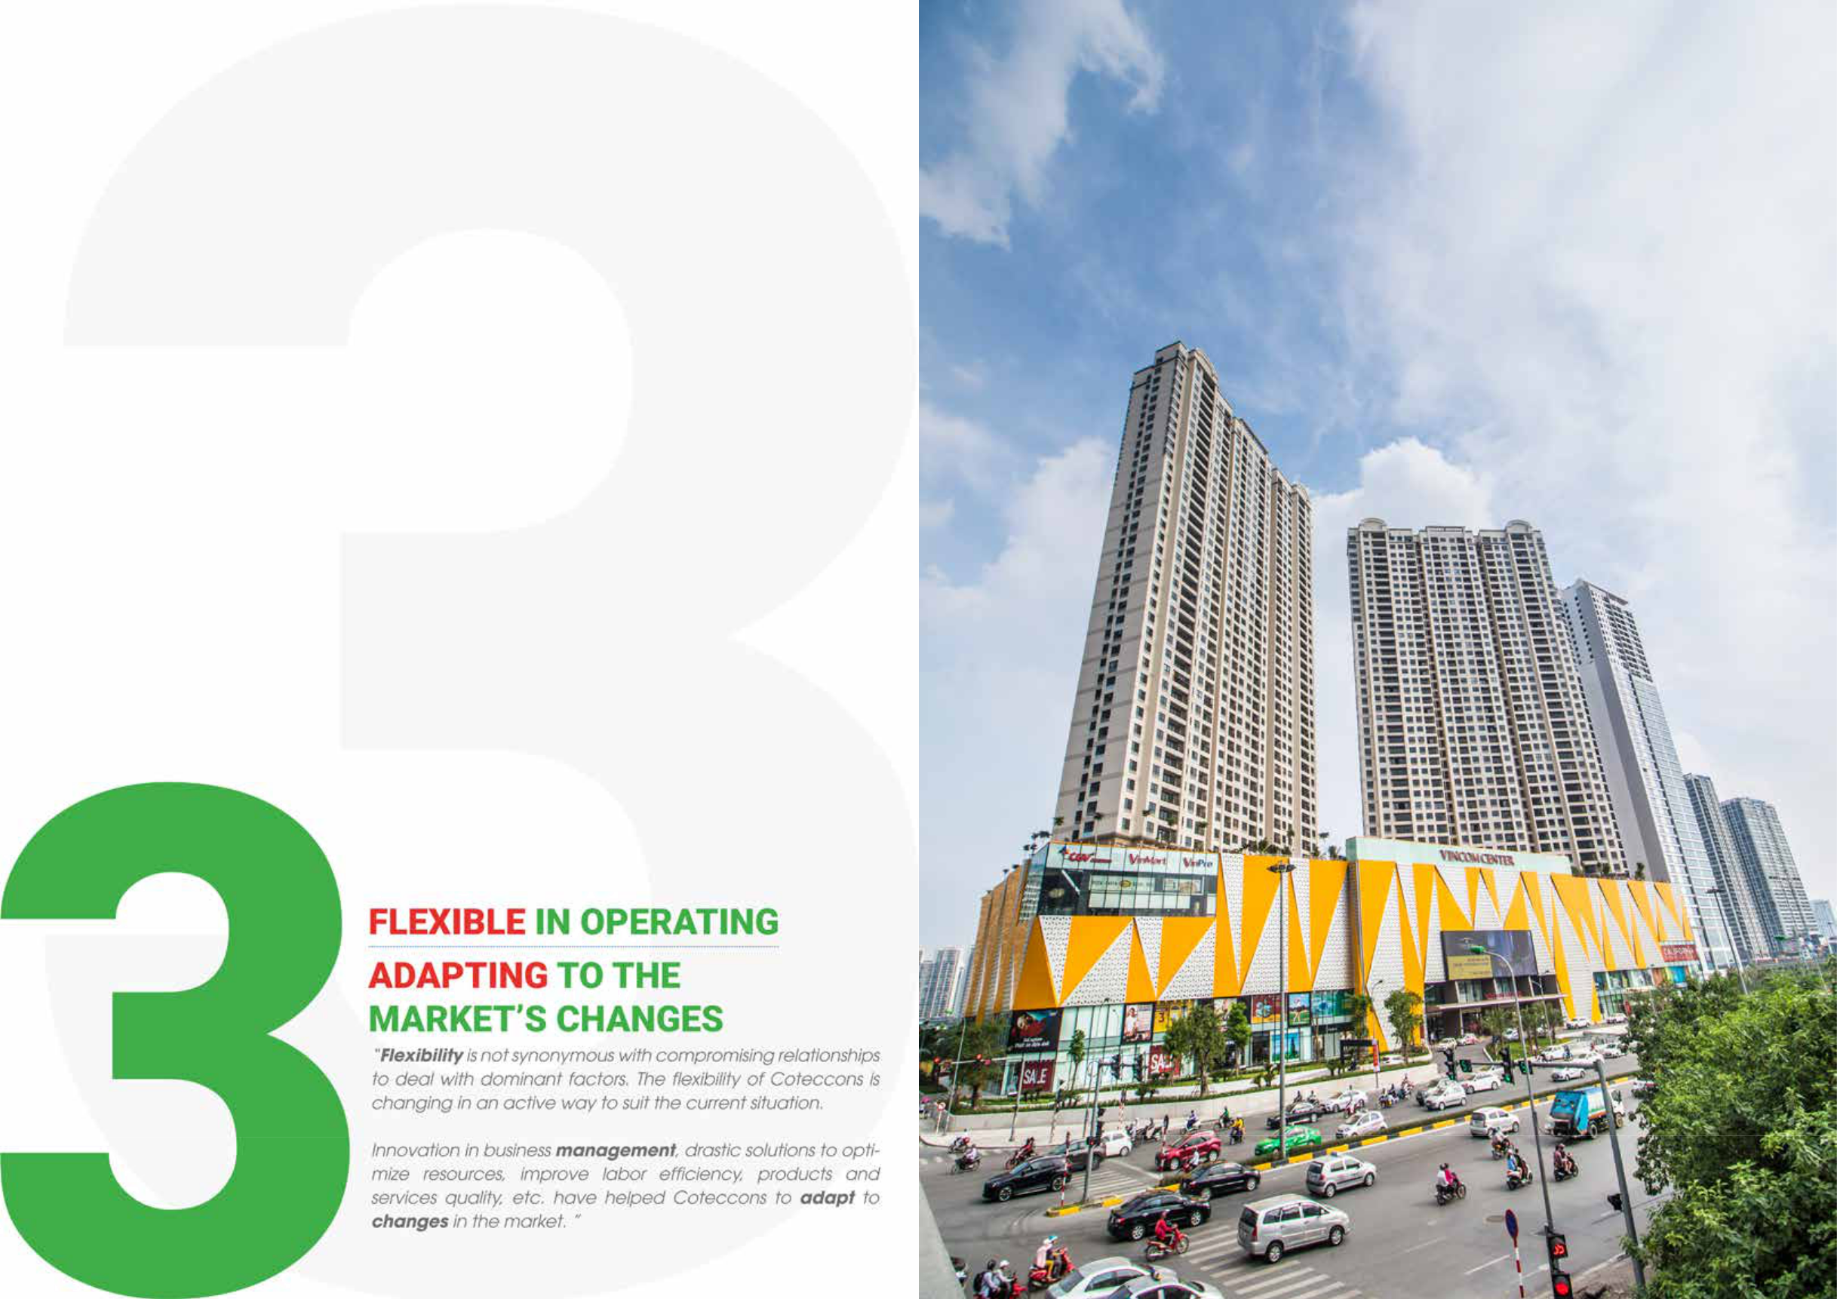

|  |  |  |
| --- | --- | --- |
|  | **D’Capitale** |  |
| 68 STAND FIRM IN CHALLENGES | Hanoi |  |
| 69 |  |

**THE REPORT OF**



**THE BOARD OF MANAGEMENT**



**INTRODUCTION OF THE BOARD OF MANAGEMENT**

The Board of Management includes 01 General Director and 04 Deputy General Directors.

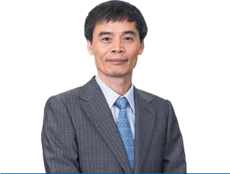

(See Introduction of the Board of Directors, page 33)

 Mr. **NGUYEN SY CONG**

General Director

Year of birth: 1970

Nationality: Vietnamese

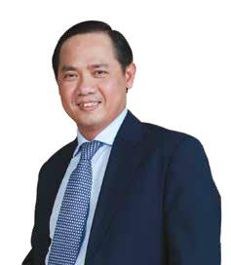

Graduated as Construction Engineer from the Hanoi University of Construction.

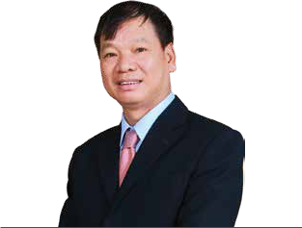

He has more than 35 years of experience in the construction industry. He held the position of Enterprise Director and Company Director at the units under Song Da Construction Corporation.

Moving to Coteccons in 2007 as Director of Construction, and in 2009, appointed Deputy General Director in charge of works in the North of Vietnam.

 Mr. **TRAN VAN CHINH**

Deputy General Director

Year of birth: 1959

Nationality: Vietnamese

 Mr. **TRAN QUANG QUAN**

Deputy General Director

Year of birth: 1973

Nationality: Vietnamese

Majored in Construction Engineering, University of Polytechnic-Ho Chi Minh City. After graduation, he worked for various international companies and secured key positions such as Site Manager and Project Manager. He has more than 21 years of experience in the construction industry.

Joined Coteccons since the first days, he played a key role not only in researching and improving construction methods, but also in training excellent teams of site managers and project managers.

In 2007, with a strong experience in operating and management, promoted to become the Deputy General Director of Construction, Assembly and Labour Safety. At present, he is also managing business development and partnership expansion with Investors, Foreign Partners and managers of different departments/ functions of the Company.

Graduated from the Faculty of Architecture, Ho Chi Minh City University of Architecture.

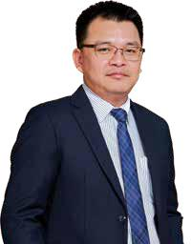

He worked at Southern Design Company A.S.C.A, then as Team Leader in Architectural Design at V.C.C.

From 2002, he moved to Coteccons and held positions as Project Manager, Head of Finishing Department, Assistant to General Director and Business Development Director. Since 3/2014 he has been in charge of Deputy General Director at Coteccons. At present, he takes charge of Investment activities and Design & Build projects of the Company.

 Mr. **TU DAI PHUC**

Deputy General Director

Year of birth: 1975

Nationality: Vietnamese

70 STAND FIRM IN CHALLENGES 71

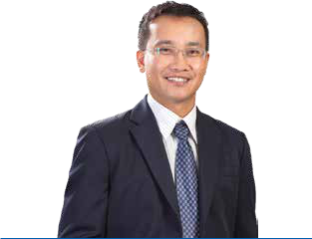

 Mr. **VO THANH LIEM**

Deputy General Director

Year of birth: 1977

Nationality: Vietnamese

Graduated from Ho Chi Minh City University of Technology.

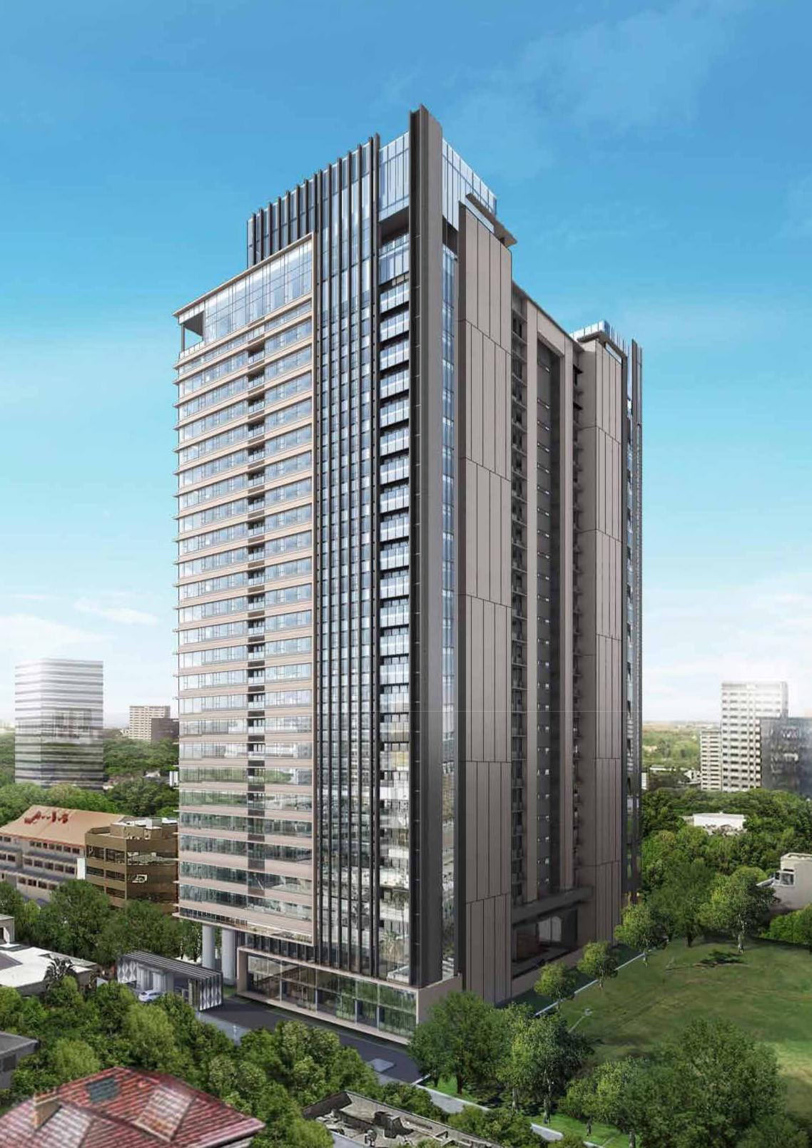

He has 18 years at Coteccons with different positions ranging from Site Manager, Project Director to Construction Division Director. Through a strong experience with megaprojects, specializing in industrial factories and high-rise buildings that required excellent deliverables, he has proved his competency and ability. Known as an out-going and passionate leader who kindles the fire of motivation for his employees, contributing to the success of various projects. On 28 Sept 2017, he officially became a Deputy General Director of Coteccons, in charge of construction, customers’ relation promotion and expansion and of the operation of Hanoi Office.

*\* Mr. Phan Huy Vinh – resigned as Deputy General Director of Coteccons following his personal resignation dated 9th July 2019*

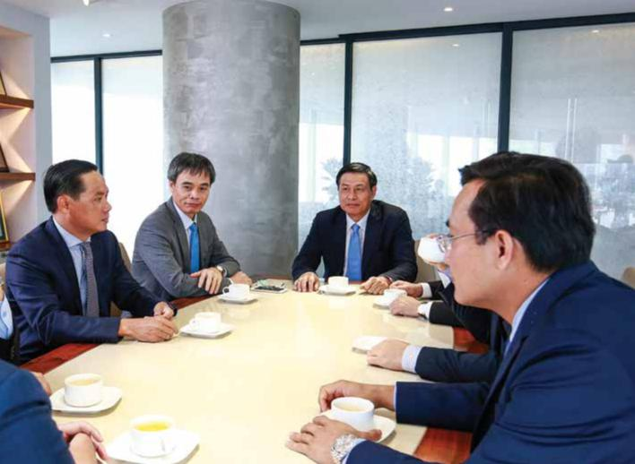

72 STAND FIRM IN CHALLENGES

**Render of The Marq project**

Ho Chi Minh City

73

**THE REPORT OF**



**THE BOARD OF MANAGEMENT**



**A HIGHLIGHT OF OUTSTANDING**

**EVENTS IN 2019**

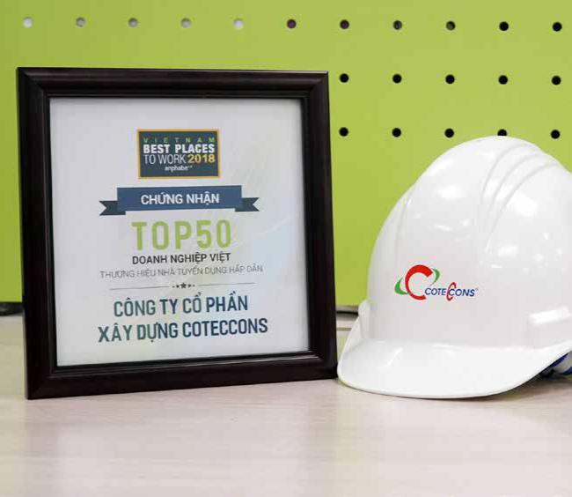

**25TH APR 2019**

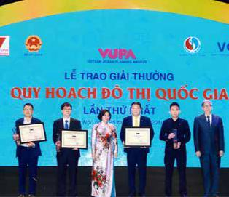

Mr. Nguyen Ba Duong -

Chairman of the Board of

Directors was honoured as

the excellent individual in

the urban construction and

development of the country

and The Landmark 81 won the

National Urban Planning Gold

Award at the First National

Urban Planning Awards

ceremony.

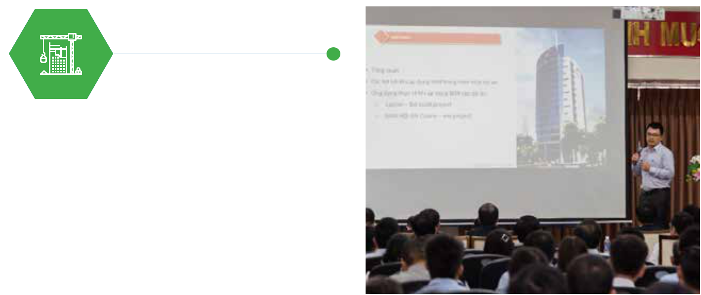

**29TH MAR 2019**



For the 4th consecutive year, Anphabe honored Coteccons Group as the Best Working Environment in Vietnam Construction Industry.

**15TH MAY 2019**

Ministry of Construction -

Southern Office, Ho Chi Minh

City University of Technology

and Coteccons jointly

organized a seminar on “BIM

application in construction

activities management”

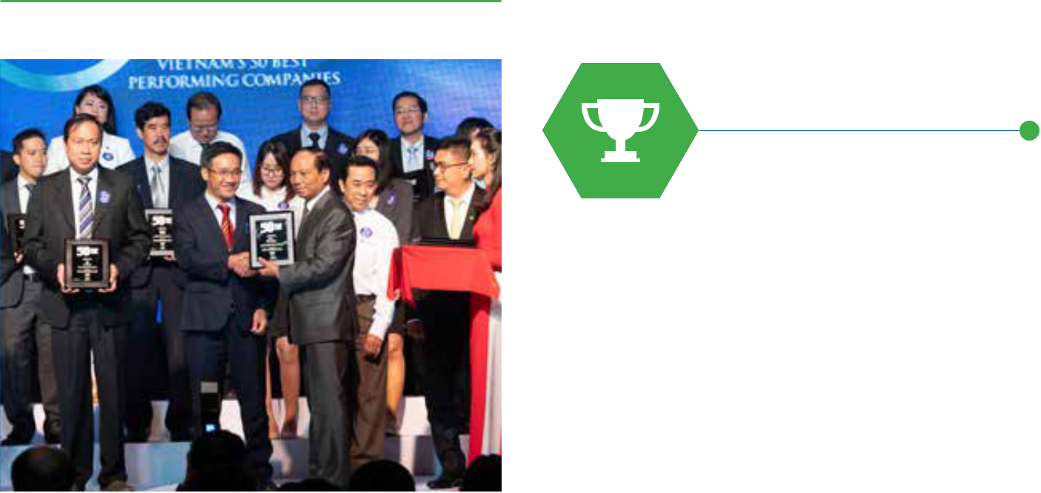

**27TH JUN 2019**

Awarded as “Vietnam’s 50 Best

Performing Companies” by

Nhip Cau Dau Tu magazine in

cooperation with Thien Viet

Securities for the sixth time in

a row

74 STAND FIRM IN CHALLENGES 75

**THE REPORT OF**



**THE BOARD OF MANAGEMENT**

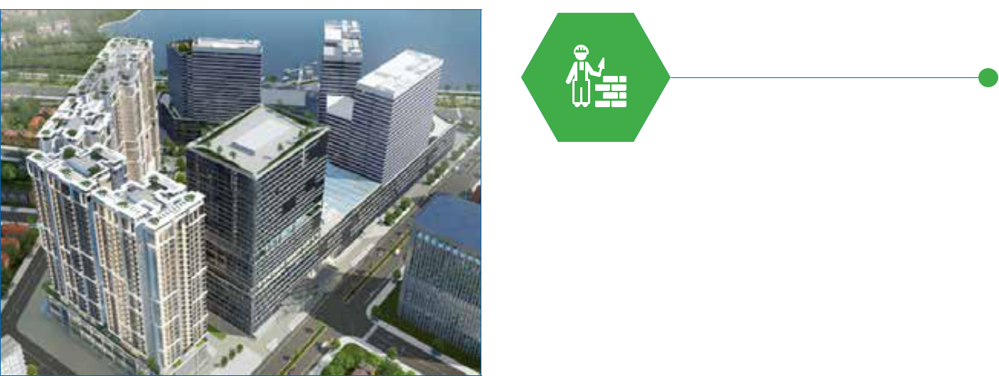

**AUG 2019**

First steps in researching

and expanding to markets in

Myanmar.

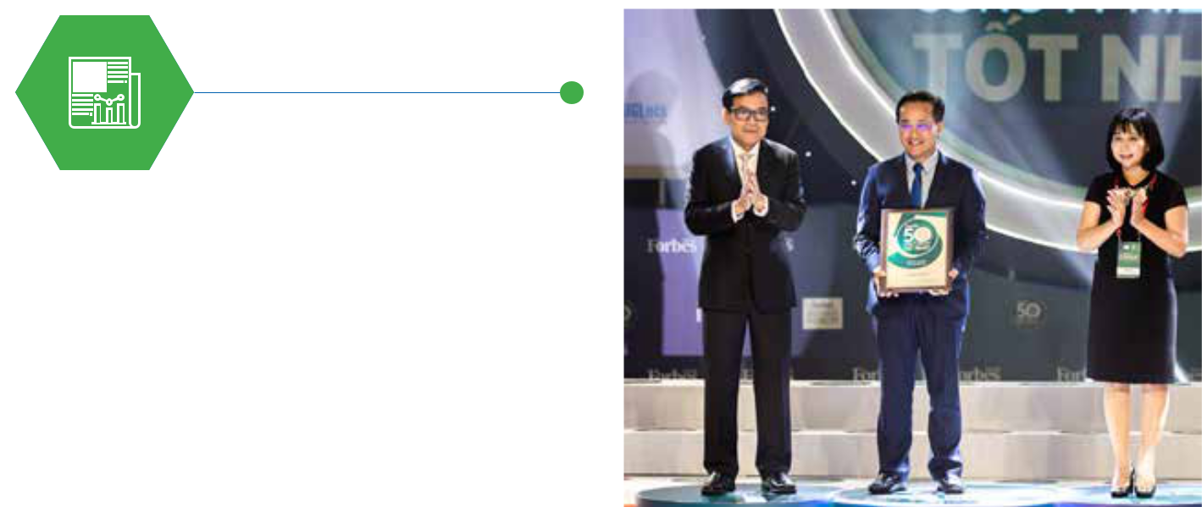

**15TH AUG 2019**

Continued to be in the Top

50 Listed Companies by

Forbes Magazine for the 7th

consecutive year.

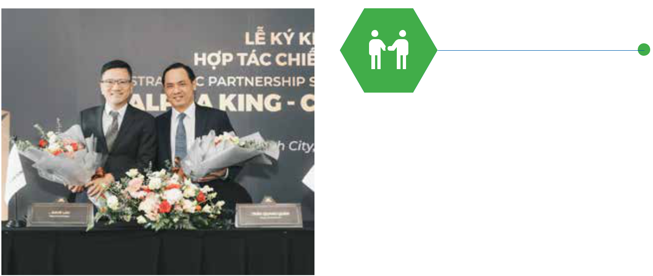

**15TH NOV 2019**

Alpha King and Coteccons

signed strategic cooperation

agreement to launch luxury

projects with iconic designs in

Ho Chi Minh City.

**NOV-DEC 2019**

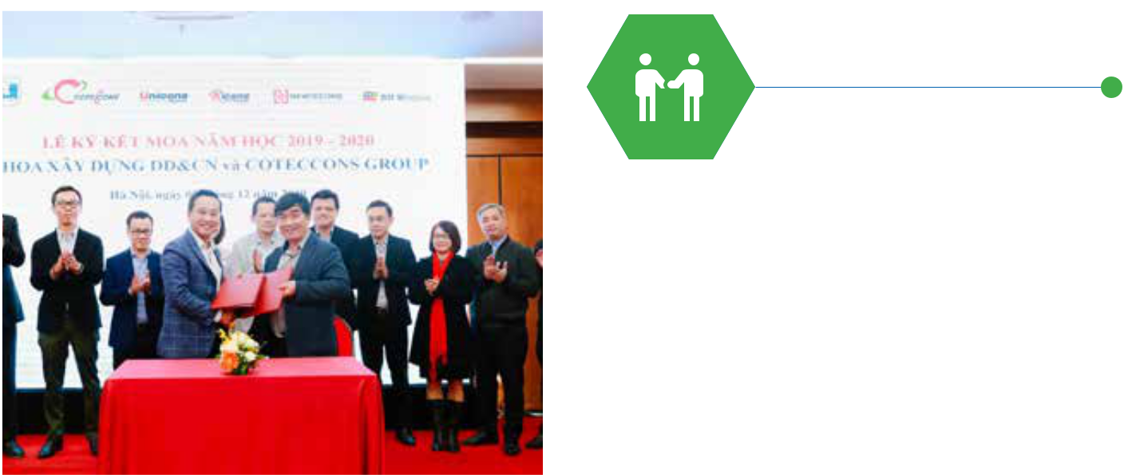

Coteccons Group has in

turn signed comprehensive

cooperation agreements

(MOU) for the 2019-2020

school year with the

University of Technology,

the National University of

Civil Engineering, and the

Ho Chi Minh City University

of Architecture.



**09TH JAN 2020**

Coteccons continued to maintain its position as the No. 1 Private Enterprise in the construction industry, marking the 7th consecutive year that Coteccons tops this ranking and Coteccons was also honoured in the Top 50 most excellent and largest enterprises in Vietnam in 2019 - Top 50 Vietnam The Best 2019 announced by Vietnam Report.

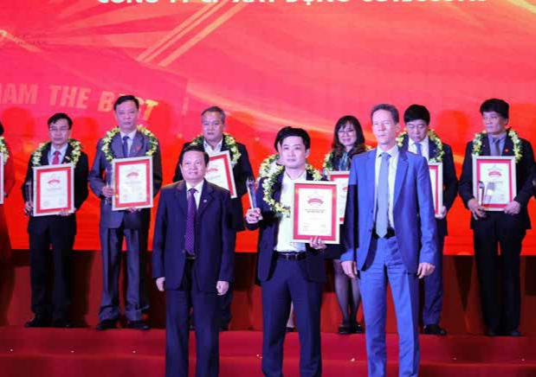

76 STAND FIRM IN CHALLENGES 77

**THE REPORT OF**



**THE BOARD OF MANAGEMENT**



**HIGHLIGHTED FINANCIAL INDICATORS**



**CONSOLIDATED BUSINESS RESULTS**

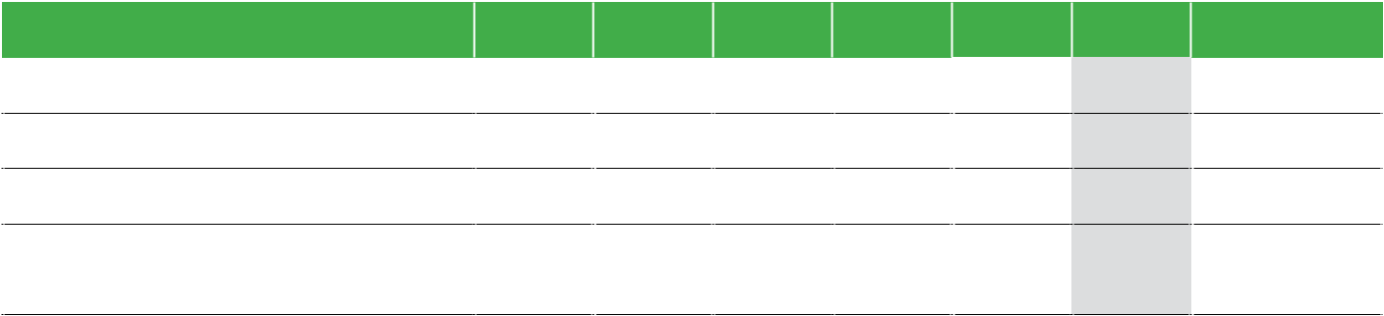

**CONSOLIDATED CASH FLOW STATEMENT**

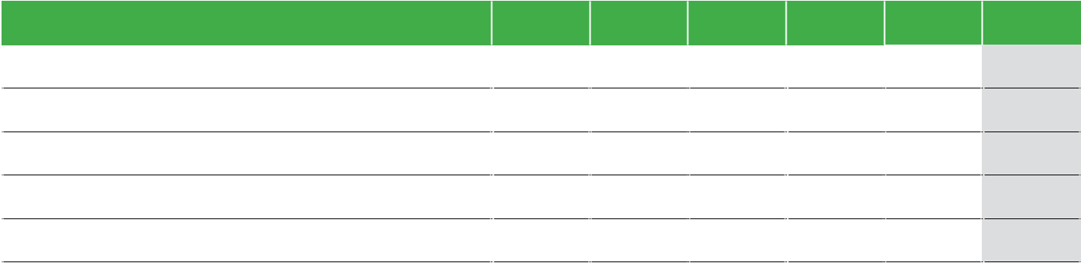

**Indicator (**VND billion**)**

Revenue

Profit before tax

Profit after tax

Profit after tax attributable to Shareholders of the Parent Company

|  |  |  |  |  |  |  |
| --- | --- | --- | --- | --- | --- | --- |
| **2014** | **2015** | **2016** | **2017** | **2018** | **2019** | **CAGR** |
| 7,634 | 13,699 | 20,783 | 27,177 | 28,561 | 23,733 | 25% |
| 464 | 927 | 1,762 | 2,060 | 1,873 | 891 | 14% |
| 357 | 733 | 1,422 | 1,653 | 1,510 | 711 | 15% |
| 327 | 666 | 1,422 | 1,653 | 1,510 | 711 | 17% |



|  |  |  |  |  |  |  |
| --- | --- | --- | --- | --- | --- | --- |
| **Indicator** (VND billion) | **2014** | **2015** | **2016** | **2017** | **2018** | **2019** |
| Cash-flow from operating activities | 131 | 1,229 | 901 | 1,108 | (934) | (339) |
| Cash-flows from investing activities | (209) | (114) | (1,984) | (1,059) | 1,021 | 769 |
| Cash-flows from financing activities | (72) | (121) | 1,618 | (404) | (756) | (182) |
| Net cash-flow | (150) | 993 | 535 | (356) | (668) | 248 |
| Cash and cash equivalents | 469 | 1,462 | 1,997 | 1,221 | 553 | 801 |



|  |  |  |  |  |  |  |  |  |  |
| --- | --- | --- | --- | --- | --- | --- | --- | --- | --- |
| **SHAREHOLDERS’ INCOME** |  |  |  |  |  |  |  |  |  |
| **Indicator** (VND billion) | | **2014** | **2015** | **2016** | **2017** | **2018** | **2019** | **CAGR** | |
| Earnings per share | | 7,769 | 10,708 | 20,669 | 20,436 | 18,357 | 8,859 | 3% | |
| Dividend in cash (%/ share capital) | | 50% | 55% | 50% | 50% | 30% |  |  |  |

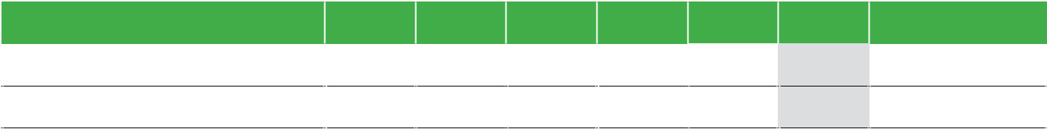

|  |  |  |  |  |  |  |  |  |  |
| --- | --- | --- | --- | --- | --- | --- | --- | --- | --- |
| **CONSOLIDATED BALANCE SHEET** | | |  |  |  |  |  |  |  |
| **Indicator** (VND billion) | | **2014** | | **2015** | **2016** | **2017** | **2018** | **2019** | **CAGR** |
| Total assets | | 4,863 | | 7,815 | 11,741 | 15,877 | 16,823 | 16,199 | 27% |
| »» | Current assets | 3,636 | | 6,486 | 9,943 | 14,323 | 15,323 | 14,727 | 32% |
| »» | Non-current assets | 1,227 | | 1,329 | 1,798 | 1,554 | 1,500 | 1,472 | 4% |
| Liabilities and Owners’ Equity | | 4,863 | | 7,815 | 11,741 | 15,877 | 16,823 | 16,199 | 27% |
| »» | Liabilities | 2,154 | | 4,573 | 5,507 | 8,571 | 8,861 | 7,729 | 29% |
| »» | Owners’ Equity | 2,527 | | 3,243 | 6,234 | 7,306 | 7,962 | 8,470 | 27% |

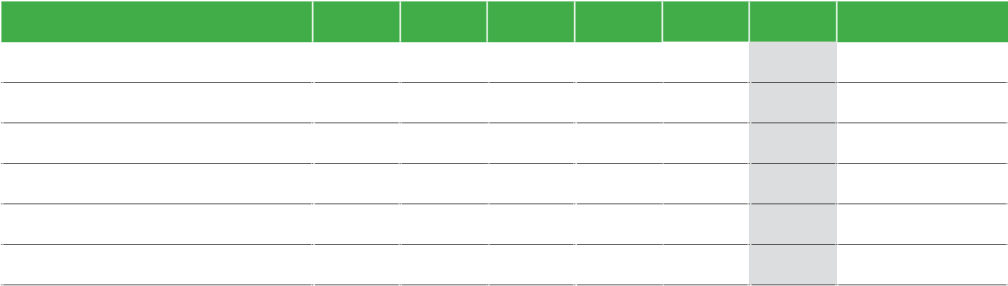

|  |  |  |
| --- | --- | --- |
| REVENUE | PROFIT BEFORE TAX | TOTAL ASSETS |
| 23,733 | 891 | 16,199 |
| BILLION VND | BILLION VND | BILLION VND |

|  |  |  |  |  |  |  |  |  |
| --- | --- | --- | --- | --- | --- | --- | --- | --- |
| **FINANCIAL RATIOS (%)** |  |  |  |  |  |  |  |  |
| **Indicator** | | **2014** | **2015** | **2016** | **2017** | **2018** | **2019** |  |
| **Gross profit margin** | |  |  |  |  |  |  |  |
| Ebitda/Revenue | | 7.3% | 8.1% | 8.7% | 7.5% | 6.4% | 4.4% |  |
| Profit before tax/Revenue | | 6.1% | 6.8% | 8.5% | 7.6% | 6.6% | 3.8% |  |
| Profit after tax/Revenue | | 4.7% | 5.4% | 6.8% | 6.1% | 5.3% | 3.0% |  |
| ROAA (EBIT/Average total assets) | | 7.2% | 11.8% | 15.3% | 11.7% | 9.2% | 4.3% |  |
| ROEA (Profit attributable to Shareholders of the | | 13.1% | 23.1% | 30.0% | 24.4% | 19.8% | 8.7% |  |
| Parent company/Average equity) | |  |
|  |  |  |  |  |  |  |
| **Liquidity** | |  |  |  |  |  |  |  |
| Current ratio | | 1.7x | 1.4x | 1.8x | 1.7x | 1.7x | 1.9x |  |
| Quick ratio | | 1.6x | 1.2x | 1.6x | 1.5x | 1.6x | 1.7x |  |
| **Financial leverage** | |  |  |  |  |  |  |  |
| Debt/Equity | | 85.2% | 141.0% | 88.3% | 117.3% | 111.3% | 91.8% |  |
| Bank loans/Equity | | 0.0% | 0.0% | 0.0% | 0.0% | 0.0% | 0.0% |  |
| Total assets/Equity | | 192.4% | 241.0% | 188.3% | 217.3% | 211.3% | 191.3% |  |
| (Cash + Short-term investments)/Total assets | | 22.6% | 30.6% | 39.8% | 36.5% | 26.5% | 25.0% |  |

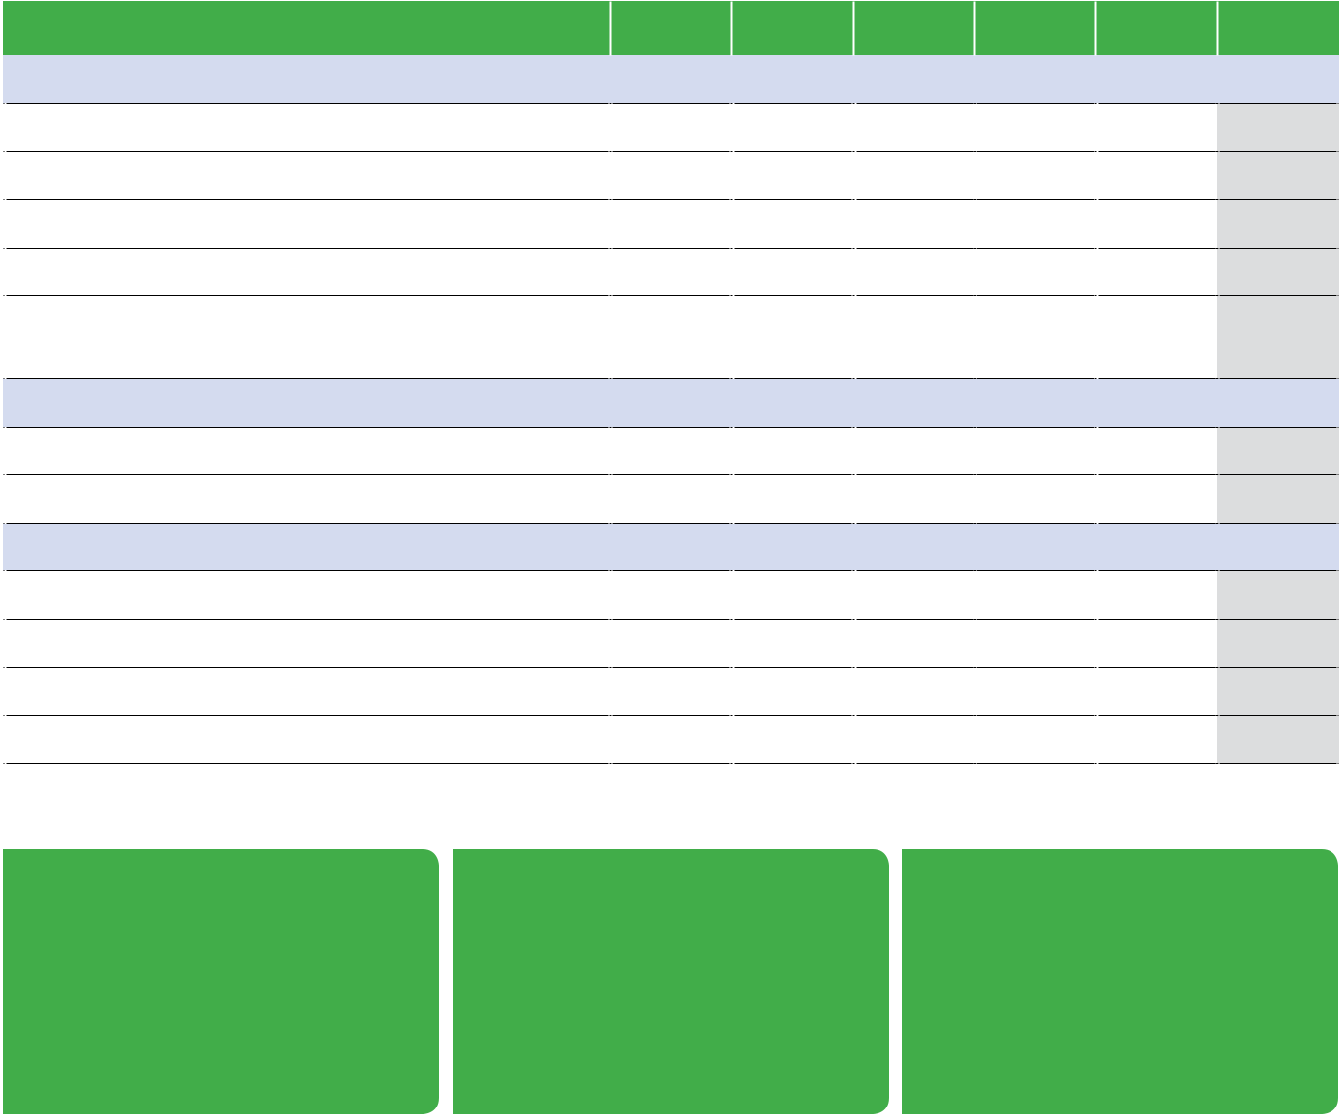

TOTAL ASSETS/EQUITY ROAA ROEA

191.3% 4.3% 8.7%

78 STAND FIRM IN CHALLENGES 79

**THE REPORT OF**



**THE BOARD OF MANAGEMENT**



**THE REPORT OF THE BOARD OF MANAGEMENT**



**OVERVIEW OF COMPANY’S MANAGEMENT IN 2019**

**EVALUATION OF FINANCIAL PERFORMANCE**



**CONSOLIDATED REVENUE**

During the last year, the Board of Management has made great efforts in management and operation. Although Coteccons is no exception in the current market situation and is more or less affected, Coteccons remains the leading construction company with the revenue and profit after tax of VND 23,733 billion and VND 711 billion respectively. Not only that, the construction sites of Coteccons are implemented and completed with the highest commitment of safety, quality and progress of the Developer.

The Company’s Board of Management has identified and anticipated risks of the real estate market cycle. This has been an appropriate time for Coteccons to focus on reviewing all company resources, strengthening the system and improving the internal capacity of the business to be ready when the market flourishes again, to

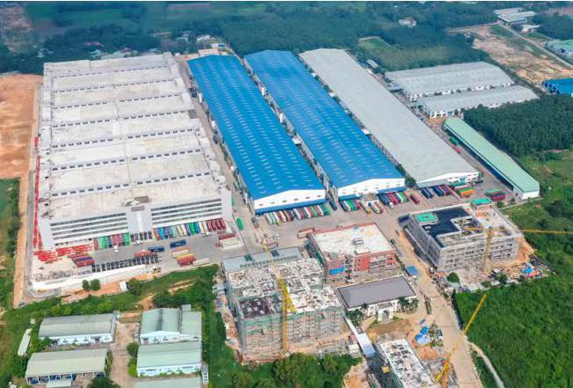

receive projects that are larger in size and demand higher levels of technical requirements. Innovation, Coteccons’ specialty, has been boosted like never before with a series of policies to streamline the organization and workflow, increase the labour productivity and the quality of work in all construction sites and departments.

Regardless of the circumstances, Coteccons’ core values are always nurtured and maintained: bringing the highest value and quality of the project to the Developer, cooperating sincerely and fairly with Suppliers and Subcontractors, securing jobs and take care of the lives of all employees in the group.

In fiscal year 2019, Coteccons exerted every effort to complete 88% of the revenue plan despite being greatly affected by the objective difficulties of the market. The consolidated revenue of Coteccons was VND 23,733 billion, in which the parent company’s revenue reached VND 18,720 billion, accounting for 79% of the consolidated revenue.



In order to sustain our position as a leading enterprise in construction industry, the Board of Management has to constantly assess the market to find out the right direction in broadening relationships, sourcing for quality works from trustworthy and earnest Developers.



**REVENUE STRUCTURE BY PROJECT**

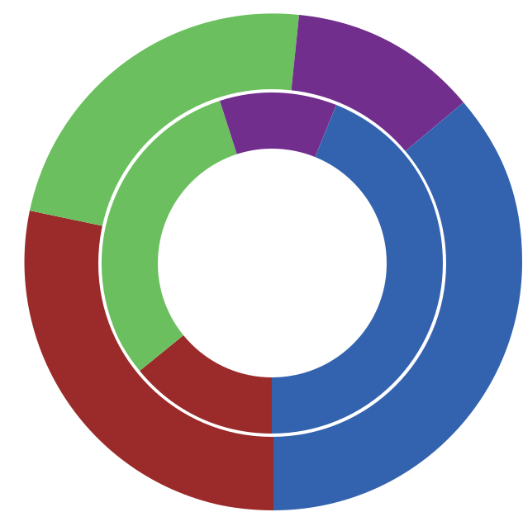

The situation of the real estate market in Vietnam can be reflected through the 2019 revenue structure by project, in which the proportion of revenue from residential projects decreased significantly from 44% in 2018 to 36% in 2019. In contrast, the revenue from hotel and resort projects has doubled its proportion from 14% in 2018 up to 28% in 2019. These mainly include projects which require the very high level of quality from long-term customers, such as Hoi An South Development developer who have great confidence in the ability, experience and reputation of Coteccons.

*Outer circle: 2019 - Inner circle: 2018*



Residential



24% 12%

|  |  |  |  |
| --- | --- | --- | --- |
| 11% |  |  |  |
| 31% | 44% |  |  |
|  | 36% |  |
|  |  |  |
| 14% |  |  |  |

28%

**Timberland Manwah factory**

Binh Duong

Industrial



Commercial



Hotel - Resort



80 STAND FIRM IN CHALLENGES 81

**THE REPORT OF**



**THE BOARD OF MANAGEMENT**



|  |  |  |  |  |  |  |  |  |  |  |
| --- | --- | --- | --- | --- | --- | --- | --- | --- | --- | --- |
| **REVENUE STRUCTURE BY CONTRACT TYPES** | | |  |  |  |  |  |  |  |  |
|  |  |  |  |  |  |  |  |  |  |  |
| Coteccons continues to be the leading contractor in | | |  |  |  |  | **VALUE OF CONTRACT BACKLOG** |  |  |  |
| Vietnam who specialises in the Design & Build model | | |  |  |  |  |  |  |  |
|  |  |  |  |  |  |  |  |
| with the great advantage of better comprehensive | | |  |  |  |  |  |  |  |  |
| optimization of all resources: from human resources, | | |  |  |  |  |  |  |  |  |
| progress, quality to cost compared to the traditional | | |  |  |  |  |  |  |  |  |
| construction method. In 2019, Design & Build projects | | |  |  |  |  | The value of the contracts signed by the end of 2019 to | | |  |
| still accounted for a relatively large portion of Coteccons’ | | |  |  | 36% |  |  |
| total construction revenue - 28% of total revenue. | | |  |  |  | be transferred to later years is estimated at about VND | | |  |
|  |  |  |  |  |
| Although the proportion of D&B revenue has decreased | | | 64% | | 28% | | 21,000 billion including consolidated data from Unicons. | | |  |
| due to legal issues associated directly to the design and | | |  |  | Approximately 60% of this value is expected to be realized | | |  |
| licensing procedures, the Design & Build model still plays | | | 72% | |  |  | and recorded in 2020 based on the progress | of the | |  |
| a very important role with many ongoing projects are | | |  |  | contracts, the rest will be implemented and recorded in | | |  |
|  |  |  |  |  |
| currently in the process of designing and negotiating. | | |  |  |  |  | subsequent years. In terms of structure, the value of backlog | | |  |
|  |  |  |  |  |  |  | in the Residential segment including apartments and villas | | |  |
| *Outer circle: 2019 - Inner circle: 2018* | | |  |  |  |  | still accounts for the highest proportion with 52% of total | | |  |
|  |  |  |  | backlog, followed by the Hotel and resort segment with | | |  |
|  |  |  |  |  |  |  |  |
|  | Bid Build | |  |  |  |  | 26%. Last year, Coteccons signed strategic cooperation with | | |  |
|  |  |  |  |  |  |
|  | Design & Build | |  |  |  |  | new prestigious developers such as Sonkim Land at the | | |  |
|  |  |  |  |  |  |  |  |  |
|  |  |  |  |  |  |  | 11% |  |  |  |
|  |  |  |  |  |  |  |  |  |  |
|  |  |  |  |  |  |  | 11% |  |  |  |
|  |  |  |  |  |  |  | 16% |  |  |  |
|  |  |  |  |  |  |  | 10% |  |  |  |
|  |  |  |  |  |  |  | 42% |  |  |  |
|  |  |  |  |  |  |  | 32% | 52% | |  |
|  |  |  |  |  |  |  | 26% |  |  |  |
|  |  |  |  |  |  |  |  |  |  |  |

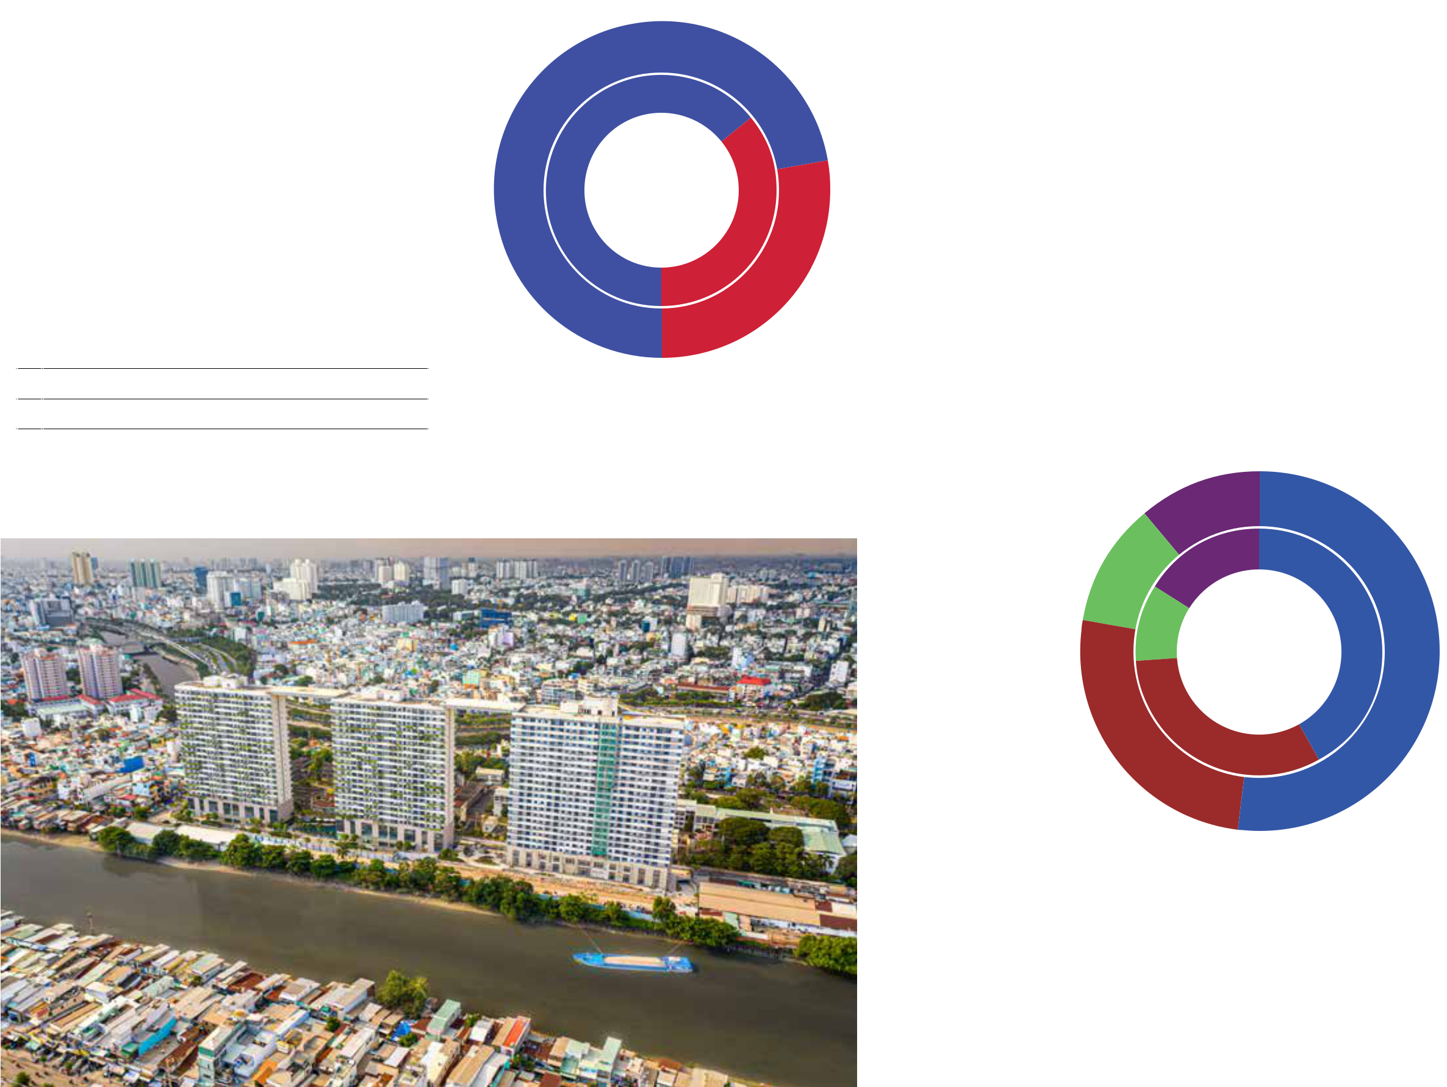

**Diamond Lotus Riverside**

Ho Chi Minh City

Metropole Thu Thiem project or Alpha King at the Golden Hill – Cong Quynh project in HCMC... Moreover, there are many signed contracts related to the expansion of existing projects whether on their scope of works or new phases. This proves the trust of customers after they directly witnessed the quality and value that Coteccons has brought.



LAST YEAR, COTECCONS SIGNED STRATEGIC COOPERATION WITH NEW PRESTIGIOUS DEVELOPERS SUCH AS SONKIM LAND AT THE METROPOLE THU THIEM PROJECT OR ALPHA KING AT THE GOLDEN HILL – CONG QUYNH PROJECT IN HCMC...

MOREOVER, THERE ARE MANY SIGNED CONTRACTS RELATED TO THE EXPANSION OF EXISTING PROJECTS WHETHER ON THEIR SCOPE OF WORKS OR NEW PHASES. THIS PROVES THE TRUST OF CUSTOMERS AFTER THEY DIRECTLY WITNESSED THE QUALITY AND VALUE THAT COTECCONS HAS BROUGHT.



*Outer circle: 2019 - Inner circle: 2018*



Residential



Industrial



Commercial



Hotel - Resort



82 STAND FIRM IN CHALLENGES 83

**THE REPORT OF**



**THE BOARD OF MANAGEMENT**



**ASSET STRUCTURE**



IT IS HIGHLY POSITIVE THAT COMPANY STILL PRESERVE ITS STABLE AMOUNT OF CASH AND CASH EQUIVALENTS FOR MANY YEARS AS THE COMPETITIVE ADVANTAGE TO PARTICIPATE IN MANY LARGE-SCALE PROJECTS, TO BE FINANCIALLY PROACTIVE IN INVESTING IN CONSTRUCTION EQUIPMENT AND IMPROVE THE CUSTOMERS’ CONFIDENCE IN COTECCONS’ FINANCIAL CAPACITY.



|  |  |  |  |  |  |  |  |
| --- | --- | --- | --- | --- | --- | --- | --- |
| **Indicator** (VND billion) | **2014** | **2015** | **2016** | **2017** | **2018** | **2019** | **CAGR** |
| **Current assets** | **3,636** | **6,486** | **9,944** | **14,323** | **15,323** | **14,727** | **32%** |
| Cash and cash equivalents | 469 | 1,462 | 1,997 | 1,221 | 553 | 801 | 11% |
| Short-term investment | 629 | 928 | 2,675 | 4,569 | 3,907 | 3,242 | 39% |
| Short-term receivables | 2,130 | 2,609 | 3,484 | 6,344 | 9,054 | 8,798 | 33% |
| Inventories | 270 | 1,051 | 1,241 | 1,874 | 1,443 | 1,626 | 43% |
| Other short-term assets | 139 | 436 | 547 | 315 | 366 | 261 | 13% |
| **Non-current assets** | **1,227** | **1,329** | **1,797** | **1,554** | **1,500** | **1,471** | **4%** |
| Fixed assets | 249 | 440 | 585 | 726 | 744 | 704 | 23% |
| Construction in progress | 6 | 48 | 18 | 0 | 1 | 161 | 93% |
| Investment properties | 105 | 92 | 78 | 50 | 52 | 50 | -14% |

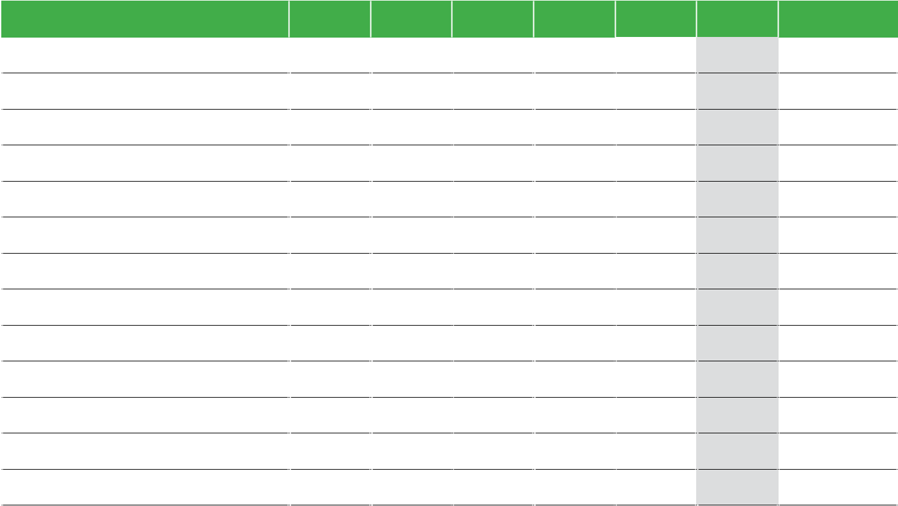

In addition to maintaining the revenue and profit in the downside period of the market, the Company’s total assets were also sustained at VND 16,199 billion as at 31 December 2019, equivalent to last year. In which, short-term assets still account for the majority of total assets, approximately 91%, equivalent to VND 14,727 billion. It is highly positive that Company still preserve its stable amount of cash and cash equivalents for many years as the competitive advantage to participate in many large-scale projects, to be financially proactive in investing in construction equipment and improve the customers’

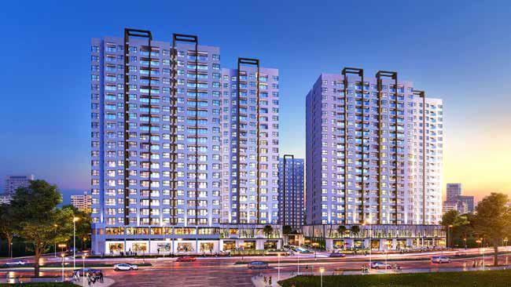

confidence in Coteccons’ financial capacity. The balance of cash and short-term investments including term deposits and corporate bonds was VND 4,042 billion, accounting for about 25% of total assets.

|  |  |  |  |  |  |  |  |
| --- | --- | --- | --- | --- | --- | --- | --- |
| Long-term financial investments | 781 | 493 | 715 | 377 | 351 | 394 | -13% |
| Other long-term assets | 87 | 257 | 401 | 401 | 352 | 162 | 13% |
| **Total** | **4,863** | **7,815** | **11,741** | **15,877** | **16,823** | **16,199** | **27%** |

**ASSETS STRUCTURE**

Unit: VND billion

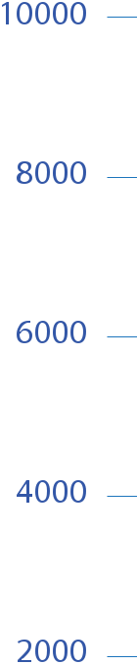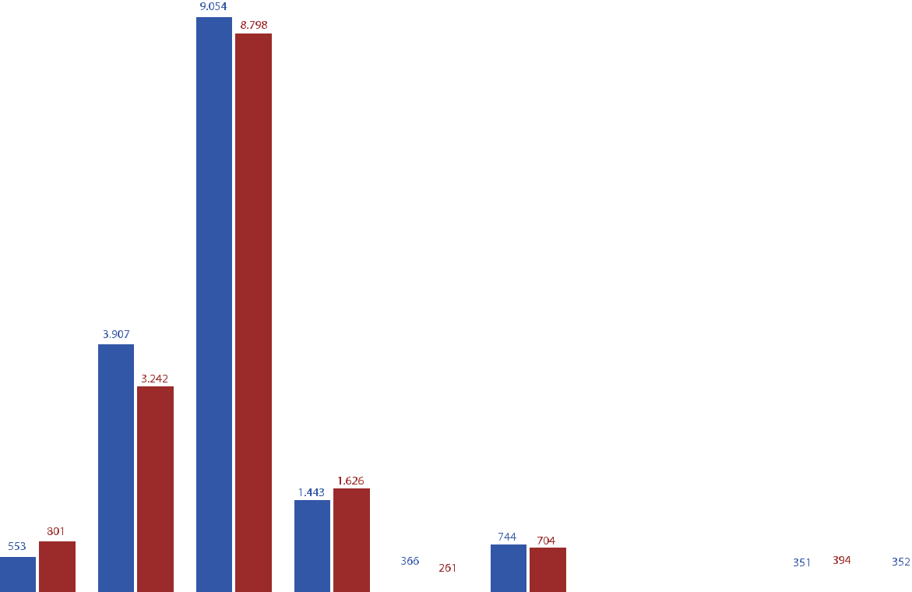

**Render of Akari City project**



Ho Chi Minh City

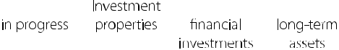

2018 2019



84 STAND FIRM IN CHALLENGES 85

**THE REPORT OF**



**THE BOARD OF MANAGEMENT**



**RECEIVABLES**

Receivables mostly come from projects that are being either implemented or under finalization process. For completed projects, receivables are mostly the money withheld for warranty. Short-term receivables decreased by VND 256 billion, down by 3% compared to 2018. Coteccons is still one of the companies with the high effectiveness in debt collection compared to the industry. The company evaluated and established doubtful debts and their provision in accordance with legal regulations. The Financial Supervisory Board of the Company also worked with each partner to provide a specific and reasonable roadmap for debt payment and project finalization, ensuring the recovery of construction capital for the Company.



**INVENTORIES**

Inventory is the unfinished cost of ongoing projects. Upon the confirmation and acceptance from the Site Management Board for the volume and invoices, the inventory value is transferred to the cost of sales corresponding to the revenue recorded. As at 31 December 2019, the balance of inventories was VND 1,626 billion, increased by 13% compared to the previous year.



**OWNERS’ EQUITY**

The equity increased by 6% compared to 2018, equivalent to VND 508 billion due to the main effects from:

* Increase of VND 711 billion from the profit after tax of 2019.
* Increase due to issuing ESOP share of VND 50 billion according to the 2018 AGM Resolution.
* Increase of VND 54 billion from acquisition of a subsidiary (Non-controlling interests).
* Dividend payment for shareholders (VND 229 billion) and appropriation to Bonus and welfare fund (VND 76 billion).
* Decrease of VND 4 billion from ESOP shares repurchases.
* Decrease of VND 75.5 billion in Bonus and welfare fund

**One Verandah**

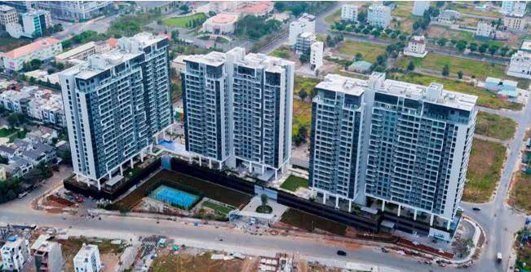

Ho Chi Minh City



**LIABILITIES STRUCTURE**

Corresponding to the revenue in 2019, liabilities decreased by VND 1,132 billion, equivalent to 13% compared to 2018. This reflects that the Company always respect for the rights of Suppliers and Subcontractors who join the value chain of Coteccons. Maintaining the prestige, fairness and transparency is the key to be able to mobilize construction workforces when Coteccons needs to implement projects with particularly large scales and tight schedule.

The company continues a strong financial position with absolutely no bank loans. Liabilities mainly consist of payables to suppliers, subcontractors and other accrued expenses.

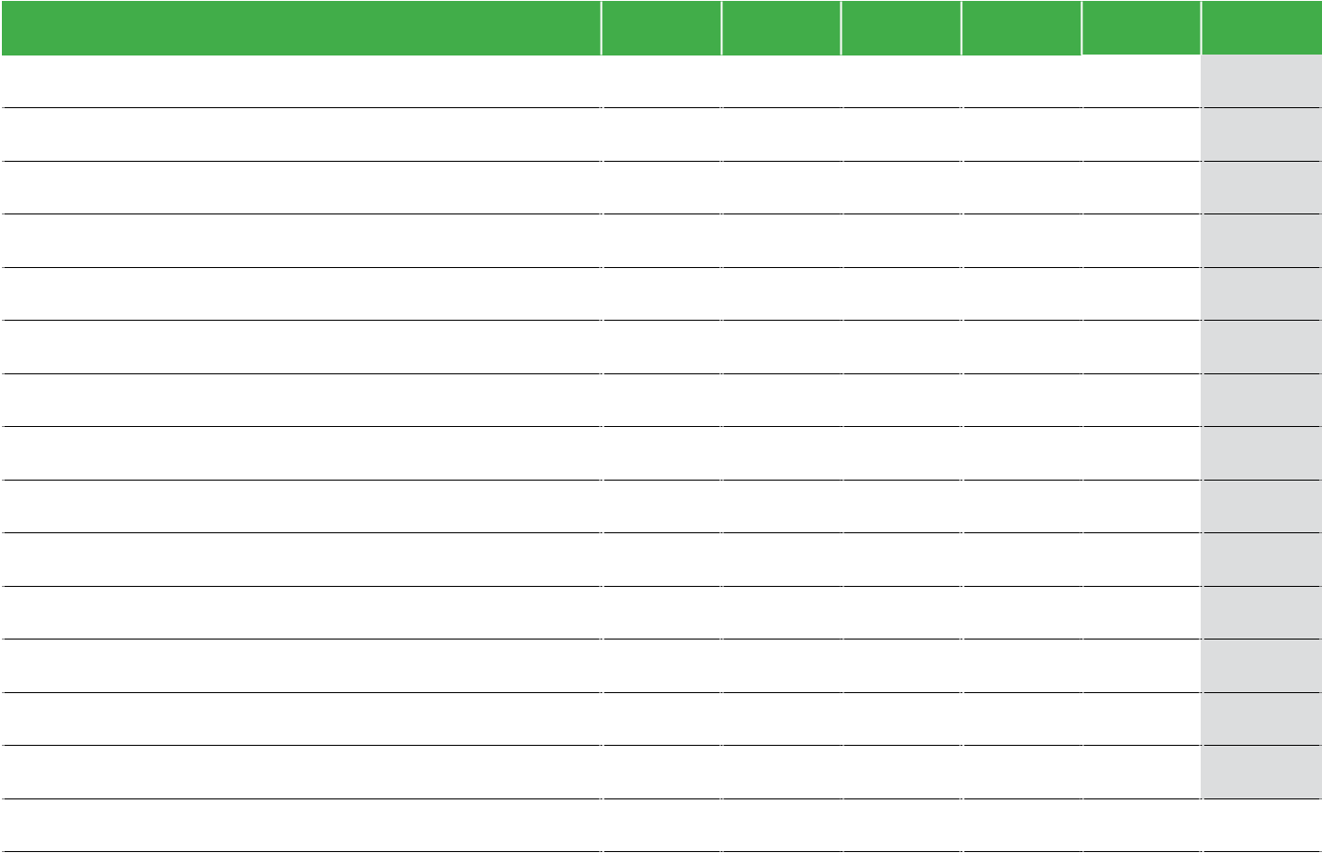

|  |  |  |  |  |  |  |
| --- | --- | --- | --- | --- | --- | --- |
| **Indicator** (VND billion) | **2014** | **2015** | **2016** | **2017** | **2018** | **2019** |
| **Current liabilities** | **2,140** | **4,559** | **5,494** | **8,559** | **8,851** | **7,710** |
| Accounts payable | 976 | 1,962 | 3,228 | 4,631 | 5,813 | 4,571 |
| Prepayment to suppliers | 78 | 1,108 | 796 | 1,408 | 671 | 721 |
| Taxes and other payables to Treasury | 73 | 117 | 244 | 354 | 165 | 88 |
| Accrued expenses | 768 | 1,098 | 822 | 1,639 | 1,760 | 2,102 |
| Unearned revenue | 19 | 24 | 95 | - | 5 | 55 |
| Other short-term payables | 125 | 122 | 147 | 281 | 204 | 42 |
| Short-term provision | 62 | 71 | 60 | 77 | 76 | 65 |
| Bonus and welfare fund | 39 | 57 | 102 | 169 | 157 | 66 |
| **Non-current liabilities** | **15** | **13** | **12** | **11** | **9** | **19** |
| Other long-term payables | 14 | 2 | 2 | 1 | 1 | 1 |
| Deferred tax liabilities | - | - | - | - | - | 12 |
| Long-term provision | 1 | 11 | 10 | 10 | 8 | 6 |
| **Total liabilities** | **2,155** | **4,572** | **5,507** | **8,570** | **8,861** | **7,729** |

86 STAND FIRM IN CHALLENGES 87

**THE REPORT OF**



**THE BOARD OF MANAGEMENT**



**OUTSTANDING IMPROVEMENTS IN 2019**

The Board of Management carried out a series of new improvements to improve the Company’s management system and to increase the labour productivity. Specifically:

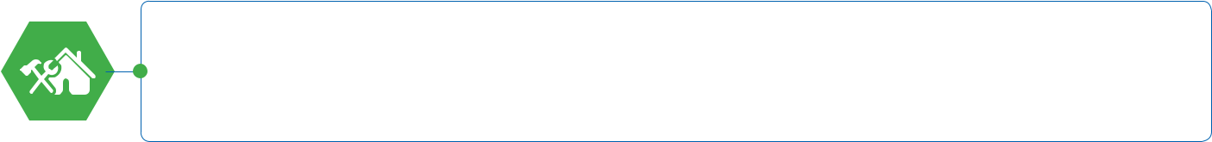

Establish­ the Company’s Reform Committee including the Reform Subcommittees on Construction, Finance, Equipment, M&E, Human Resources and Salaries to review and evaluate all aspects of the Company’s activities, identify inappropriateness and make changes to adapt to the market situation.



Update­ procedures and the financial management software to accelerate the payment for subcontractors and suppliers as well as to reduce the processing time of records and related contracts.



Perform a comprehensive review over all purchasing activities between construction sites and the Procurement department to optimize finance.

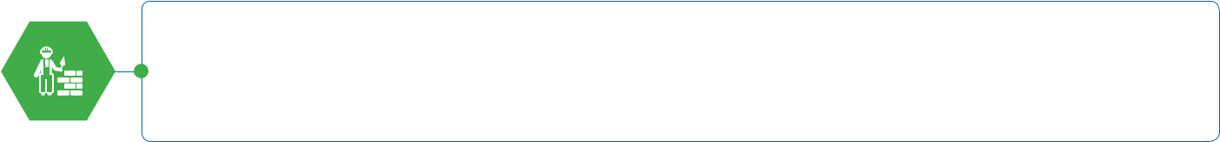

Promote­ the innovation within the Service and Warranty Department, strengthen the link between construction sites and customers’ building management offices in order to improve service quality, timely handle customers’ comments as a way to enhance the Company’s reputation.

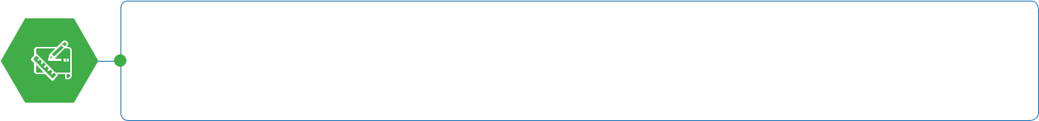

Standardise and apply information technology in archiving scientifically and systematically construction and design records which can be easily and conveniently retrieved and to ensure the accuracy and completeness of the records.

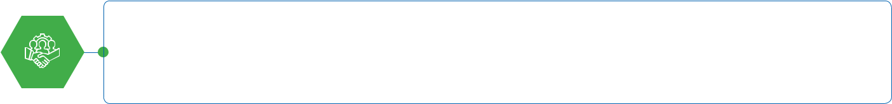

The­ Technical Division and the Safety Department have strengthened a series of processes and regulations about implementing technical innovation, improving construction quality standards and ensuring safety at the highest level.

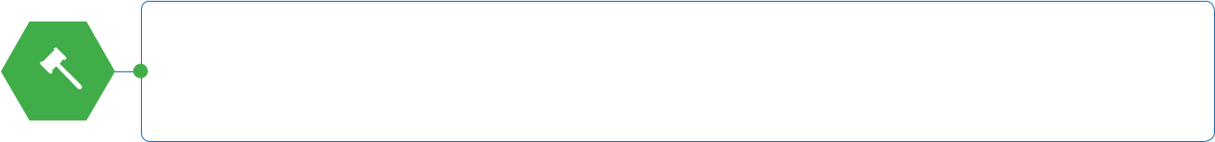

Tighten­ the financial management of the construction site, especially the settlement process and additional works management to ensure full revenue recognition and create a solid legal basis for receivables collection.

**Diamond Island**

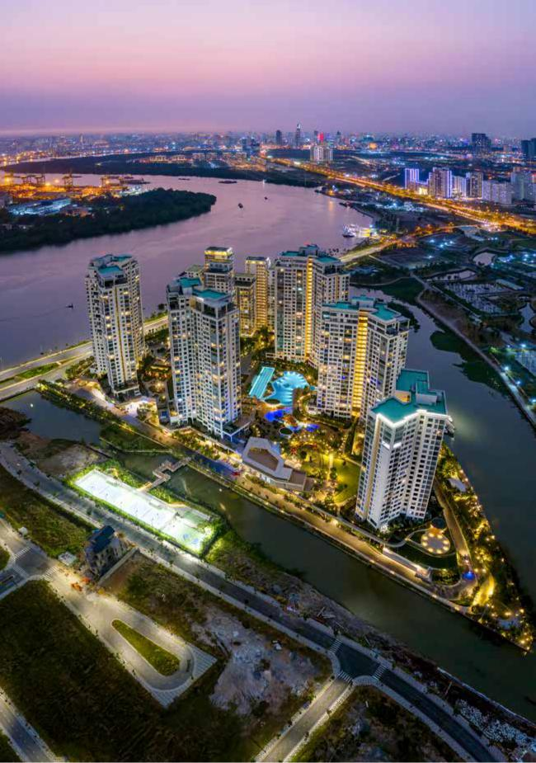

Ho Chi Minh City

88 STAND FIRM IN CHALLENGES 89

**THE REPORT OF**



**THE BOARD OF MANAGEMENT**



**EVALUATION OF RESOURCE MANAGEMENT AND IMPLEMENTATION OF WELFARE POLICY**

The pressure from the strictly controlled policy of licensing of construction investment projects, from the asynchrony of legal system related to the real estate market and from the difficulty of real estate enterprises in accessing the capital... has led to the decline in size of the real estate market in major cities. The business of hundreds of construction companies has become stagnant. The real estate market also recorded the highest number of businesses dissolved last year. Although many developers still choose Coteccons for their eligible projects thanks to its prestige, the consequences of some projects temporarily suspended due to the above reasons have significant impact on revenue and growth of Coteccons. The pressure of finance balancing, transferring equipment, staffing, etc. is a problem that needs to be solved later.



**OPTIMIZE THE COMPANY’S RESOURCE**

The Coteccons’ Board of Management focused on directing the specialized departments to review the workload, rearrange the personnel system, working with multi-tasks, perform lean management and reduce intermediate levels of procedures.

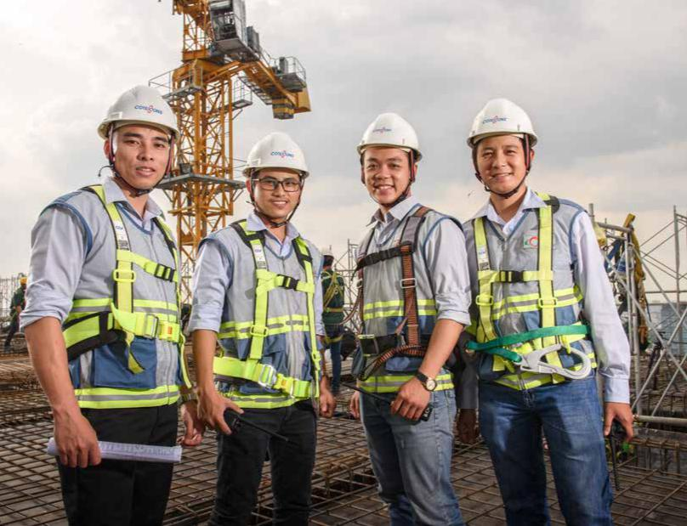

Continue to strengthen the operating system of the Company under the functional division model including: Technical Division; Internal Affairs Division; Investment Division; Economics Finance Division; M&E Division and two (02) project management divisions. To optimize resources, the Company merged the M&E Tender Department and the M&E Technical and Quality Management Department into the M&E Tender and Technical Department and merged the Purchasing Department into the Cost and Contract Management Department. In addition, the functional division model has helped the operation to be lean, works to be handled at a faster pace, thereby contributing to improving the overall working efficiency of the whole Company.



A thorough review of all staff from the office to construction sites has been carried out seriously over the past year. Together with Unicons, Coteccons Group has balanced the resources, tightened new recruitment, relocated personnel from the office to construction sites and arranged different jobs for competent but temporarily out of work personnel to maintain high quality resources. For those employees who do not meet the requirements, they will continue their training or agree to terminate the labor contract in accordance with provisions of the law.



Upgrade the staffing software which is based on the salary budget of site management committees. This software is updated monthly with information of the personnel number, salary and bonus costs. This creates a basis to adjust and optimize the personnel of any construction site that exceeds its budget taking into account the construction progress and the project size.



Increasing internal training is one of the supportive ways to optimize resources. Application of technology in human resource training is strongly paid attention and properly invested by Coteccons. Coteccons Training Academy has implemented many intensive courses via direct method and e-learning in the last year.



Inheriting the HR ranking system built in 2018, the HR Department has researched and improved comprehensive ranking criteria for each Division/ Department, organized and ranked employees according to their ability and in an appropriation that balances the number of employees in each ranking group and suits the current business performance.

90 STAND FIRM IN CHALLENGES 91

**THE REPORT OF**

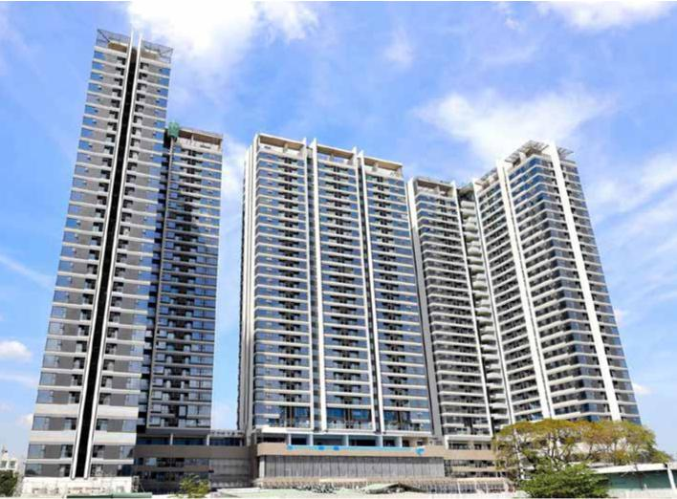

**THE BOARD OF MANAGEMENT**



**CONSOLIDATED HUMAN RESOURCES STRUCTURE**



NUMBER OF EMPLOYEES



2,272

PEOPLE

**HUMAN RESOURCE STRUCTURE BY GENDER**

7.3%

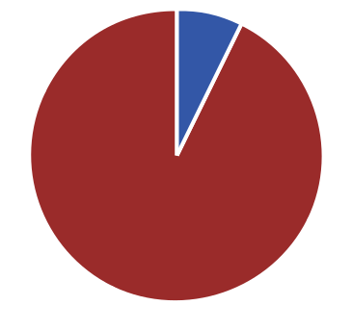

UNDER THE COMPANY’S BUSINESS SITUATION, COTECCONS SEPARATELY REDUCED 220 EMPLOYEES IN 2019, ACCOUNTING FOR 13% OF TOTAL NUMBER OF EMPLOYEES.

THE CONSOLIDATED NUMBER OF EMPLOYEES OF COTECCONS AS AT 31 DEC 2019 IS 2,272 PEOPLE, DECREASED BY 448 PEOPLE, EQUIVALENT TO 16.5% OF THE FIGURE AS OF THE BEGINNING OF 2019.



**HUMAN RESOURCE STRUCTURE**



**BY ACADEMIC LEVEL**

12.9% 1.6%

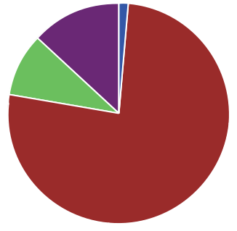

9.2%

**Kingdom 101**

Ho Chi Minh City

|  |  |  |  |  |  |
| --- | --- | --- | --- | --- | --- |
| **HUMAN RESOURCE STRUCTURE** | | **HUMAN RESOURCE STRUCTURE** | | |  |
| **BY SENIORITY** |  | **BY POSITION** |  |  |  |
| 11.5% | | 0.4% | | 11.2% |  |
| 33.2% |  | 56.2% | |  |  |
|  |  |  |  |

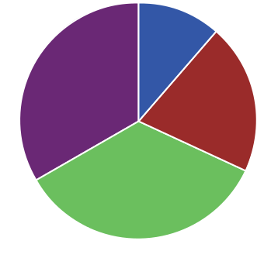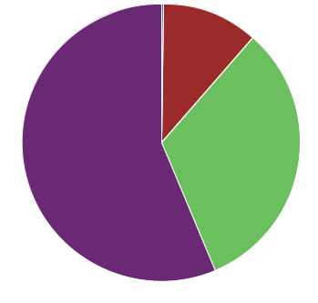

20.6%

32.2%

92.7% 76.3%



|  |  |  |  |  |  |  |  |
| --- | --- | --- | --- | --- | --- | --- | --- |
| Male | 2,104 people | **92.7%** |  | Post-graduate | 37 people | **1.6%** |  |
|  |  |
|  |  |
| Female | 168 people | **7.3%** |  | Graduate | 1,734 people | **76.3%** |  |
|  |  |
|  |  |
|  |  |  |  | College | 209 people | **9.2%** |  |
|  |  |  |  |  |
|  |  |  |  | Others | 292 people | **12.9%** |  |
|  |  |  |  |  |



34.7%



|  |  |  |  |  |  |  |  |
| --- | --- | --- | --- | --- | --- | --- | --- |
| Under 2 years | 263 people | **11.5%** |  | Management Board | 10 people | **0.4%** |  |
|  |  |
| From 2 years to unders 3 years | 469 people | **20.6%** |  | Managerial | 255 people | **11.2%** |  |
|  |  |
| From 3 years to under 5 years | 789 people | **34.7%** |  | Senior associate & | 732 people | **32.2%** |  |
|  |  |
| Over 5 years | 751 people | **33.2%** |  | Main Senior associate |  |
|  |  | **56.2%** |  |
|  | Associate | 1,275 people |  |
|  |  |  |  |  |

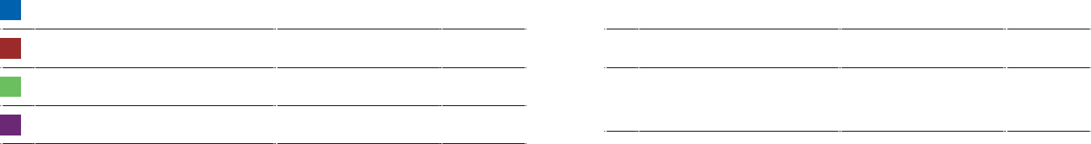

92 STAND FIRM IN CHALLENGES 93

**THE REPORT OF**



**THE BOARD OF MANAGEMENT**



**MAINTAIN WELFARE POLICY FOR EMPLOYEES**

Coteccons has always focused on taking care of the material and spiritual life of employees. Despite the difficult business situation in the past year, the employees’ welfare policy has been maintained and fully implemented.



**SALARIES AND BONUSES**

Salaries and bonuses paid to employees are based on job performance evaluation and position. In addition to salaries and periodic bonuses, the Company maintains its bonuses on public holidays, Lunar New Year, extraordinary bonuses, and rewards for collectives or individuals that have initiatives in business activities.



**ANNUAL LEAVE**

Allowing employees to take time off during off-peak time, together with the travel policy enables employees to re-create working strength and have time with their families while reduces expenses on paying leave according to regulations.



**ANNUAL TRAVEL POLICY**

In order for employees to proactively arrange appropriate travel times during the year, the Company cooperate with reputable tour operators to issue travel vouchers of which value is based on the accumulated travel allowance of staff.



**EDUCATION SPONSORSHIP**

This welfare sponsorship has been maintained since 2016 to support employees’ children on education costs. Depending on the annual business results, the educational sponsorship expenses are calculated and deducted from the welfare fund.



**HEALTH INSURANCE FOR EMPLOYEES**

In addition to the compulsory health insurance, all employees and their relatives according to the employee ranking policy are also bought the comprehensive health insurance package from the reputable insurance company. At the same time, the Company continues to cooperate with major hospitals such as Vietnam - France, University of Medicine, Thu Cuc and Vinmec Hospital...

to provide periodic health check-ups to help employees have more useful information to take care of themselves.



**UNION ACTIVITIES AND INITIATIVES**

Develop policies to support employees and their relatives who are seriously ill or in difficult circumstances, to timely visit and give gifts on birthdays, wedding, etc. Also, there are sports and arts events, other activities organized on holidays and anniversaries of the year such as International Women’s Day 8/3, Vietnamese Women’s Day 20/10, New Year... to create exchanges and cohesion among staff.

WITH THE DECENT WELFARE POLICY AND THE SINCERE CARE OF THE BOARD OF MANAGEMENT IN THE IMPROVEMENT OF PERSONNEL POLICIES SO THAT EMPLOYEES CAN FEEL SECURED TO WORK AND CONTRIBUTE FOR A LONG TIME, COTECCONS HAS BEEN AWARDED BY ANPHABE AS THE BEST PLACE TO WORK FOR IN VIETNAMESE CONSTRUCTION INDUSTRY AND BEEN AMONG TOP 100 BEST PLACES TO WORK FOR IN VIETNAM.

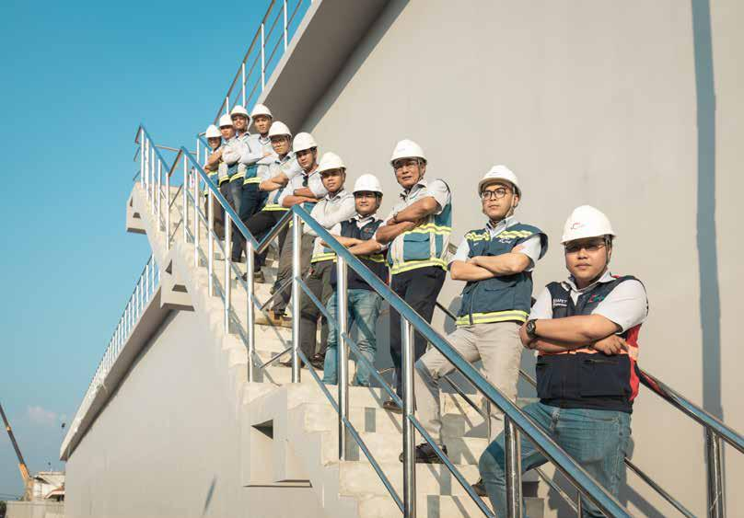

94 STAND FIRM IN CHALLENGES 95

**THE REPORT OF**



**THE BOARD OF MANAGEMENT**



**TRAINING**



DURING THE YEAR, COTECCONS TRAINING ACADEMY HAS IMPLEMENTED MANY INTENSIVE COURSES IN THE FORM OF DIRECT CLASSROOM WITH COTECCONS’ EXECUTIVE AND MANAGEMENT OFFICERS AS THE MAIN TEACHING STAFF. THE DIVERSE PROFESSIONAL KNOWLEDGE, LONG WORKING EXPERIENCE AND ENTHUSIASM ALL TOGETHER HAVE HELPED TO MAINTAIN THE UNIQUE CULTURAL IDENTITY OF COTECCONS.



**TRAINING PROGRAM**

|  |  |  |  |  |  |  |  |  |  |  |  |  |  |  |  |  |  |  |  |  |  |  |  |  |  |  |  |  |  |  |  |  |  |  |  |  |
| --- | --- | --- | --- | --- | --- | --- | --- | --- | --- | --- | --- | --- | --- | --- | --- | --- | --- | --- | --- | --- | --- | --- | --- | --- | --- | --- | --- | --- | --- | --- | --- | --- | --- | --- | --- | --- |
| 350 | Hours | | | |  |  |  |  |  |  |  |  |  |  |  |  |  |  |  |  | **1,277 training hours in total** | | | | | | | | | | | | | | |  |
|  |  |  |  |  |  |  |  |  |  |  |  |  |  |  |  |  |  |  |  |  |  |  |  |  |  |  |  |  |  |  |  |
|  |  |  |  |  |  |  |  |  |  |  |  |  |  |  |  |  |  |  |  |  |  |  |  |  |  |  |  | 310 | | | | |  |  |  |
| 300 |  |  |  |  |  |  |  |  |  |  |  |  |  |  |  |  |  |  |  |  |  |  |  |  |  |  |  |  |  |  |  |
|  |  |  |  |  |  |  |  |  |  |  |  |  |  |  |  |  |  |  |  |  |  |  |  |  |  |  |  |  |  |  |  |  |  |  |  |
|  |  |  |  |  |  |  |  |  |  |  |  |  |  |  |  |  |  |  |  |  |  |  |  |  |  |  |  |  |  |  |  |  |  |  |  |
|  |  |  |  |  |  |  |  |  |  |  |  |  |  |  |  |  |  |  |  |  |  |  |  |  |  |  |  |  |  |  |  |  |  |  |  |
| 250 |  |  |  |  |  |  |  |  |  |  |  |  |  |  |  |  |  |  |  |  |  |  |  |  |  |  |  |  |  |  |  |  |  |  |  |  |
|  |  |  |  |  |  |  |  |  |  |  |  |  |  |  |  |  | 216 | |  |  |  |  |  |  |  |  |  |  |  |  |  |  |  |  |  |
|  |  |  |  |  |  |  |  |  |  |  |  |  |  |  |  |  |  |  |  |  |  |  |  |  |  |  |  |  |  |  |  |  |  |  |
| 200 |  |  |  |  |  |  |  |  |  |  |  |  |  |  |  |  |  |  |  |  |  |  |  |  |  |  |  | | |  |  |  |  |  |  |  |
|  |  |  |  |  |  |  |  |  |  |  |  |  |  |  |  |  |  |  |  |  |  |  |  |  |  |  |  |  |  |  |  |  |  |  |  |
|  |  |  |  |  |  |  |  |  |  |  |  |  |  |  |  |  |  |  |  |  |  |  |  |  |  | 176 | | |  |  |  |  |  |  |  |
| 150 |  |  |  |  |  |  |  |  | 148 | | | |  | 129 | | |  |  |  |  |  |  |  |  |  |  |  |  |  |  |  |  |  |  |  |  |
|  |  |  |  |  |  |  |  |  |  |  |  |  |  |  |  |  |  |  |  |  |  |  |  |  |  |  |  |  |
|  |  |  |  |  |  |  |  |  |  |  |  |  |  |  |  |  |  |  |  |  |  |  |  |  |  |  |  |  |  |  |  |  |
|  |  |  |  |  |  |  |  |  |  |  |  |  |  |  |  | 114 | | |  |  |  |  |  |  |  |  |  |  |  |  |  |  |
| 100 |  |  |  |  |  |  |  |  |  |  |  |  |  |  |  |  |  |  |  |  |  |  |  |  |  |  |  |  |  |  |  |  |  |
|  |  |  |  |  |  |  |  |  |  |  |  |  |  |  |  |  |  |  |  |  |  |  |  |  |  |  |  |  |  |  |  |  |
|  |  |  |  |  |  |  |  |  |  |  |  |  |  |  |  |  |  |  |  |  |  |  | | |  |  |  |  |  |  |  |  |  |  |  |
|  |  |  |  |  |  |  |  |  |  |  |  |  |  |  |  |  |  |  |  |  |  |  |  |  |  |  |  |  |  |  |  |  |  |  |  |
|  |  |  |  |  |  |  |  |  |  |  |  |  |  |  |  |  |  |  |  |  |  | 72 | | |  |  |  |  | 56 | |  |  |  |  |  |
| 50 |  |  | 20 | | |  |  | 36 |  |  |  |  |  |  |  |  |  |  |  |  |  |  |  |  |  |  |  |  |  |  |  |  |  |  |
|  |  |  |  |  |  |  |  |  |  |  |  |  |  |  |  |  |  |  |  |  |  |  |  |  |  |  |  |  |  |  |  |
|  |  |  |  |  |  |  |  |  |  |  |  |  |  |  |  |  |  |  |  |  |  |  |  |  |  |  |  |  |  |  |  |
| 0 |  |  |  |  |  |  |  |  |  |  |  |  |  |  |  |  |  |  |  |  |  |  |  |  |  |  |  |  |  |  |  |  |  |  |  |
|  |  |  |  |  |  |  |  |  |  |  |  |  |  |  |  |  |  |  |  |  |  |  |  |  |  |  |  |  |  |  |  |  |  |  |  |
|  |  |  |  |  |  |  |  |  |  |  |  |  |  |  |  |  |  |  |  |  |  |  |  |  |  |  |  |  |  |  |  |  |  |  |  |
|  |  |  |  |  |  |  |  |  |  |  |  |  |  |  |  |  |  |  |  |  |  |  |  |  |  |  |  |  |  |  |  |  |  |  |  |
| Executives | | | |  |  |  | departments | | | |  |  |  |  |  |  |  |  |  |  | supervisors | | | Soft | |  |  | Secretary Others | | | | | | |  |
|  |  |  |  |  |  |  |  |  |  |  |  |  |  |  |  |  |
| Senior |  |  | Project | | Manager | | | |  |  |  | Managers Managers Managers | | | | | | | | | | |  |  | skills | |  |
|  |  |  |  |  |  |  |  |  |  |  |  |  |  |  |  |  | site | |  |  |  |  |  |  |  |  |  |  |  |  |  |
|  |  | heads | | of |  | Site | | |  |  | Site | | | | Site | |  |  |  |  |  |  |  |  |  |  |  |  |  |  |  |
|  |  |  | Deputy | | Construction | | | | Deputy | | |  |  | Deputy | |  | Chief |  |  |  |  |  |  |  |  |  |  |  |  |  |  |  |  |  |
| Heads/ | | |  |  |  | M&E | | | |  |  |  |  |  |  |  |  |  |  |  |  |  |  |  |  |  |  |  |  |  |
|  |  |  |  |  |  |  |  |  |  |  |  |  |  |  |  |  |  |  |  |  |  |  |  |  |  |  |  |  |  |



96 STAND FIRM IN CHALLENGES

**TRAINING PARTICIPANTS**



|  |  |  |  |  |  |  |  |  |  |  |  |  |  |  |  |  |  |  |  |  |  |  |  |  |  |  |  |  |  |  |  |  |  |  |  |  |  |  |  |  |  |  |  |  |  |  |  |  |  |  |  |  |  |  |  |  |  |  |  |  |  |  |  |  |
| --- | --- | --- | --- | --- | --- | --- | --- | --- | --- | --- | --- | --- | --- | --- | --- | --- | --- | --- | --- | --- | --- | --- | --- | --- | --- | --- | --- | --- | --- | --- | --- | --- | --- | --- | --- | --- | --- | --- | --- | --- | --- | --- | --- | --- | --- | --- | --- | --- | --- | --- | --- | --- | --- | --- | --- | --- | --- | --- | --- | --- | --- | --- | --- | --- |
| 1000 | Participants | | | | | | | | | |  |  |  |  |  |  |  |  |  |  |  |  |  |  |  |  |  |  |  |  |  |  |  |  |  |  |  |  |  |  |  | **4,306 training hours in total** | | | | | | | | | | | | | | | | | | | | | |  |
|  | | | | | | | | | | | | | | | | | | | | | | | | | | | | | | | | | | | | | | | | | | | | | | | | | | | | | | | | | | | | | | |  |
| 941 | | | | | | | | | | | | | | | | | | | | | | | | | | | | | | | | | | | | | | | | | | | | | | | | | | | | | | | | | | | | | | |  |
| 800 | 805 | | | | | | | | | | | | | | | | | | | | | | | | | | | | | | | | | | | | | | | | | | | | | | | | | | | | | | | | | | | | | | |  |
|  | | | | | | | | | | | | | | | | | | | | | | | | | | | | | | | | | | | | | | | | | | | | |  | |  | | | | | |  | | |  | | | | | | |  |
| 600 | 588 | | | | | | | | | | | | | | | | | | | | | | | | | | | | | | | | | | | | | | | | | | | | |  | |  | | | | | |  | | |  | | | | | | |  |
| 400 |  | | | | | | | | | | | | | | | | | | | | | | | | | | | | | | | | | | | | | | | | | | | | | | | | | 411 | |  | | | | | | | | | | | |  |
|  | | | | | | | | | | | | | | | | | | | | | | | | | | | | | | | | | | | | | | | |  |  | | | |  | |  | |  | |  | | |  | | | | | | |  |
|  | | | | | | | | | | | | 304 | | | | |  | | | | | | | | | | | | | | | | | | | | | | | |  | | | | | | | | | | | | | | | | | | | | | |  |
|  | | | | | | | | | | | | |  | | | | | | | | | | | | | | | | | | | | | | | |  | | | | | | | | | | | | | | | | | | | | | |  |
| 200 |  | | | | | | | | | | | | | | | | |  | 201 | | | |  | | | | | | | | | | | | | | | | | | | 229 | | | | | | | | | | | | | | | | | | | | | |  |
|  | | | | | | | | | | | | |  | | | |  |  | | | | | | | | | | | | | | | | | |  |  | | | |  | |  | |  | |  | |  | | |  |  |  | | | | |  |
|  |  |  |  |  | 101 | | |  |  |  |  |  |  |  |  |  |  |  |  |  |  |  |  |  | 128 | | | 69 | | | |  |  | 87 |  |  |  |  |  |  | 115 | |  |  |  |  |  |  |  |  |  |  |  |  |  |  |  |  | 108 | |  |  |  |
|  |  |  |  |  |  |  |  |  |  |  |  |  |  |  |  |  |  |  |  |  |  |  |  |  |  |  |  |  |  |  |  |  |  |  |  |  |  |  |  |  |  |  |  |  |  |  |  |  |
|  |  |  |  |  |  |  |  |  |  |  |  |  |  |  |  |  |  |  |  |  |  |  |  |  |  |  |  |  |  |  |  |  |  |  |  |  |  |  |  |  |  |  |  |  |  |  |  |  |  |
| 0 |  | | | 22 |  | |  |  |  |  | | |  |  | | | |  |  | | | |  | | |  | | |  | | | 27 | | |  | |  |  |  |  | |  | |  | |  | |  | |  | | |  |  |  | |  |  | |  |
|  | | |  | | |  | | | | |  | | | | |  | | | | | | | | | | | | | |  |  | | |  | | |  | | | | | | | | | | | | | | | | |  | | | | |  |
|  | | |  | | | |  | | | | |  | | | | |  | | | | | | | | | | | | | |  |  | | |  | |  |  | | |  | | | | | | | | | | | | | | | | |  | | | | |  |
|  | Managers departments | | | | | | Managers Managers | | | | | | | | |  |  |  | supervisors | | | | | | |  |  |  |  |  | Secretary | | | |  |  | - boarding | | | |  | E |  |  |  | for | |  |  | 2019 | |  |  | supervisors | | | |  |  |  |  |  |  |
|  |  |  |  |  |  |  |  |  |  |  |  |  |  |  |  |  | & ME | | QS | | |  |  |  | Shopdrawing | | | | | | |  |  |  |  | keepers | | | | | | Revit -learning | | | | |  |  | office | |  |  | CPL | | | | | | QA | - QC | | | |  |
|  |  |  |  |  |  |  |  |  |  |  |  |  |  |  |  |  |  |  |  |  |  |  | Warehouse | | | |  |  |  |  |  |  |  |  |  |  |  |  |  |  |  |
|  |  | heads | of |  |  | Site | |  | Site | |  |  |  |  |  |  |  |  |  |  |  |  |  |  |  |  | On | | | |  |  |  | skills | |  |  |  | ME | chief | | site | |  |  |  |  |  |  |  |  |  |  |
| Project | |  |  |  |  |  | Deputy Construction | | | | | | | | | Safety | | |  |  |  |  |  |  |  |  |  |  |  |  |  |  |  |  |  |  |  | Soft | |  |  |  |  |  |  |  |  |  |  |  |  |  |  |  |  |  |
| Heads/Deputy | | Construction | | | & | ME | |  | | | | | | | | | | | | | | | | | | | | | | | | | | | | | | | | | | | | Construction | | | | | & |  | | | | | | | | | | | | | |  |
|  | |  | | | | | | | | | | | | | | | | | | | | | | | | | | | | | | | | | | | |  | | | | | | | | | | | | | |  |
|  | |  | | | | | | | | | | | | | | | | | | | | | | | | | | | | | | | | | | | | | |  | | | | | | | | | | | | | | |  |
|  | |  | | | | | | | | | | | | | | | | | | | | | | | | | | | | | | | | | | | | | | |  | | | | | | | | | | | | | | |  |
| **TRAINED EMPLOYEES** | | | | | | | | | |  | | | | | | | | | | | | | | | | | | | | | | | | | | | | | | | | | | | | | | | | | | | | | | | | | | | | |  |  |
|  |  |  |  |  |  |  | Employees | | | | | | | | | | | |  |  |  |  |  |  |  |  |  | **1,632 trained employees in total** | | | | | | | | | | | | | | | | | | | | | | | | | | | | | | |  |  |  |  |  |  |
|  | | | 1000 | | | | |  | | | | | | | | | | | | | | | | | | | | | | | | | | | | | | | | | | | | | | | | | | | | | | | |  | | | | | | | |  |
|  | | |  | | | | | | | | | | | | | | | | | | | | | | | | | | | | 849 | | |  | | | | | | | | | | | | | | | | | | | | | | | | |  |
|  | | | | 800 | | | |  | | | | | | | | | | | | | | | | | | | | | | | | | | | |  | | | | | | | | | | | | | | | | | | | | | | | | |  |
|  | | | |  | | | | | | | | | | | | | | | | | | | | | | | | | | | | |  | |  | | | | | | | | | | | | | | | | |  | | | | | | | |  |
|  | | | |  | | | | | | | | | | | | | | | | | | | | | | | | | | | | | | | | | | | | | | | | | | | | | | | | | | | | | | | |  |
|  | | | | 600 | | | |  | | | | | | | | | | | | | | | | | | | | | | | | | | | | |  | |  | | | | | | | | | | | | | | | | |  | | | | | | | |  |
|  | | | |  | | | | | | | | | | | | | | | | | | | | | | | | | | | | | | | | | | | | | | | | | | | | | | | | | | | | | | | |  |
|  | | | | 400 | | | |  | | | | | | | | | | | | | | | | | | | | | | | | | | | | |  | |  | | | | | | | | | | | | | | | | |  | | | | | | | |  |
|  | | | |  | | | | | | | | | | | | | | | | | | | | | | | | | | | | | | | | | | | | | | | | | | | | | | | | | | | | | | | |  |
| 200 | | | | | | | | 143 | | | | | | | | | | | | | | | | | | | | | | | | | | | | |  | | 180 | | | | | | | | | | | | | | | | |  | | | | | | | |  |
|  |  |  |  |  | 0 | | |  |  |  |  |  | 21 | |  |  | 63 | | |  |  |  | 28 | | | |  |  |  |  |  |  |  | 108 | |  |  | | 113 | | |  |  |  | 127 | | |  |  |  |  |  |  |  |  |  |  |  |  |  |  |  |  |  |
|  |  |  |  |  |  |  |  |  |  |  |  |  |  |  |  |  |  |  |  |  |  |  | |  |  |  |  |  |  |  |  |  |  |  |  |  |  |  |  |  |  |  |  |
|  | | | | |  | | | | |  | |  | |  | | |  | |  | |  | |  |  | |  |  | |  |  |  | |  | |  | | | | | | | | | | | | | | | |  |
|  | | | | |  | | | |  |  |  | |  | | |  |  |  | |  | |  | |  | |  |  | |  |  | |  |  |  | |  | |  | | | | | | | |  | | | | | | | |  |
|  |  |  |  |  |  | Managersdepartments Managers | | | | | | | | | | | | | | | |  |  |  |  |  | Site | |  |  | QS | |  |  |  |  |  |  |  |  |  |  |  |  |  |  |  |  |  |  |  |  |  |  |  |  |  |  |  |  |  |
|  |  |  |  |  |  |  |  |  |  |  |  |  |  |  |  |  |  |  |  |  |  |  |  |  |  |  |  |  |  |  |  |  |  |  |  |  |  |  |  |  |  |  |  |  |
|  |  |  |  |  |  |  |  |  | Deputy Managers | | | | | | |  |  | supervisors Secretary keepers | | | | | | | | | | Others | | |  |  |  |  |  |  |  |  |  |  |  |  |  |  |  |  |  |  |
|  |  |  |  |  |  |  | Project Heads | | | |  |  |  |  |  |  |  |  |  |  |  |  |  |  |  |  |  |  |  | Chief | | |  |  |  |  |  | Warehouse | | | |  |  |  |  |  |  |  |  |  |  |  |  |  |  |  |  |  |  |  |  |
|  |  |  |  |  |  |  | of | |  |  |  |  | Site | |  |  |  | & ME | | |  |  |  |  |  | site |  |  |  |  |  |  |  |  |  |  |  |  |  |  |  |  |  |  |  |  |  |  |  |  |  |  |  |
|  |  |  |  |  |  |  |  |  |  |  |  |  |  | Construction | | | | | | | |  |  |  |  |  |  |  |  |  |  |  |  |  |  |  |  |  |  |  |  |  |  |  |  |  |  |  |  |  |  |  |  |  |  |  |  |  |  | 97 | | | |  |

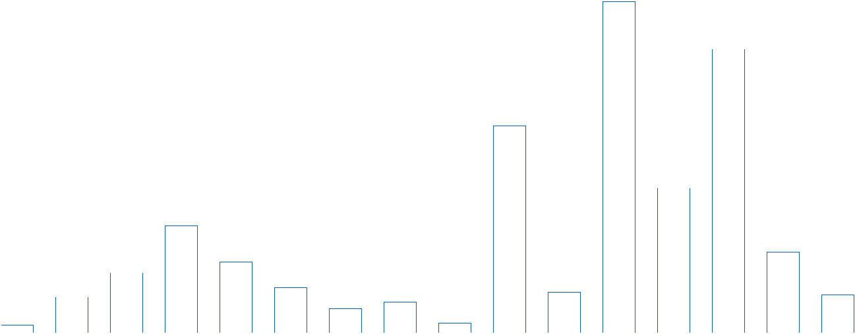

**THE REPORT OF**



**THE BOARD OF MANAGEMENT**



**SYSTEM IMPROVEMENTS**

**ESTABLISHMENT OF INSPECTION BOARD – INTERNAL AFFAIRS DIVISION** 



The addition of the Inspection Board to the Internal Affairs Division aims to enhance the inspection and supervision of the Company’s activities. Duties of the Inspection Board is to control the system compliance, internal regulations and the provisions of law, to detect risks related to finance, service and product quality...

to analyze the cause and to timely support on finding solutions and improving internal control system. **SUPPLEMENT AND UPDATE THE INTERNAL REGULATIONS**

In 2019, the Company amended the key rules and regulations which affect the Company’s operating activities, such as: Financial management regulation, Supplier/ Subcontractor contract signing and liquidation regulations... as well as modified the Regulations on operation and organization of Divisions and Departments of the Company such as: M&E Technical and Tender Department, Equipment Department, Cost and Contract Management Department... in order to building a new framework for all activities of the Company which intends to reduce time, optimizing processes and procedures to ensure a fast, simple yet controlled and effective work.

Especially, the Company has built and upgraded an online internal document management system (Portal) with scientific utilities and features, significantly reducing the time to search and download internal management documents.



**ENHANCE FEATURES OF COTECCONS CORE SYSTEM**

To digitize operations, Coteccons has invested in applications related directly to the operation of departments and construction sites such as: online organizational chart of site management committees, construction workforce management software, construction documents management software, weekly report software, logistics software in equipment transport and many other applications. These applications combined with Coteccons core system which have been invested since 2018 including e - office software, accounting and finance core, cost & contract management core, material and equipment management core... have formed a centralized applications connection, fully accommodating the professional and management tasks of Company’s departments.

**GENERATING GENERAL REPORTS AND ANALYZING RESOURCES DATA** 

For the resources management and planning purpose, Coteccons has built an analysis report on human resource information - summarizing assessments of competency, working process, professionalism and specific training which helps the personnel mobilization and planning process.

In addition to information on human resources, the information on finance in combination with data on construction workforces produces labor productivity analysis reports of construction sites and the whole Company.



**ENHANCE SYSTEM AND INFORMATION SECURITY**

Acknowledging the great importance to the intellectual property of the Company, in the past year, Coteccons has invested in a new intrusion prevention system (IPS) which protects the Coteccons’ network from hundreds of outside attacks from hackers around the world everyday.

Simultaneously, the systems of data loss prevention, firewalls, email security systems, antivirus systems are always maintained to ensure the highest level of safety of information and data assets of the Company.



98 STAND FIRM IN CHALLENGES 99

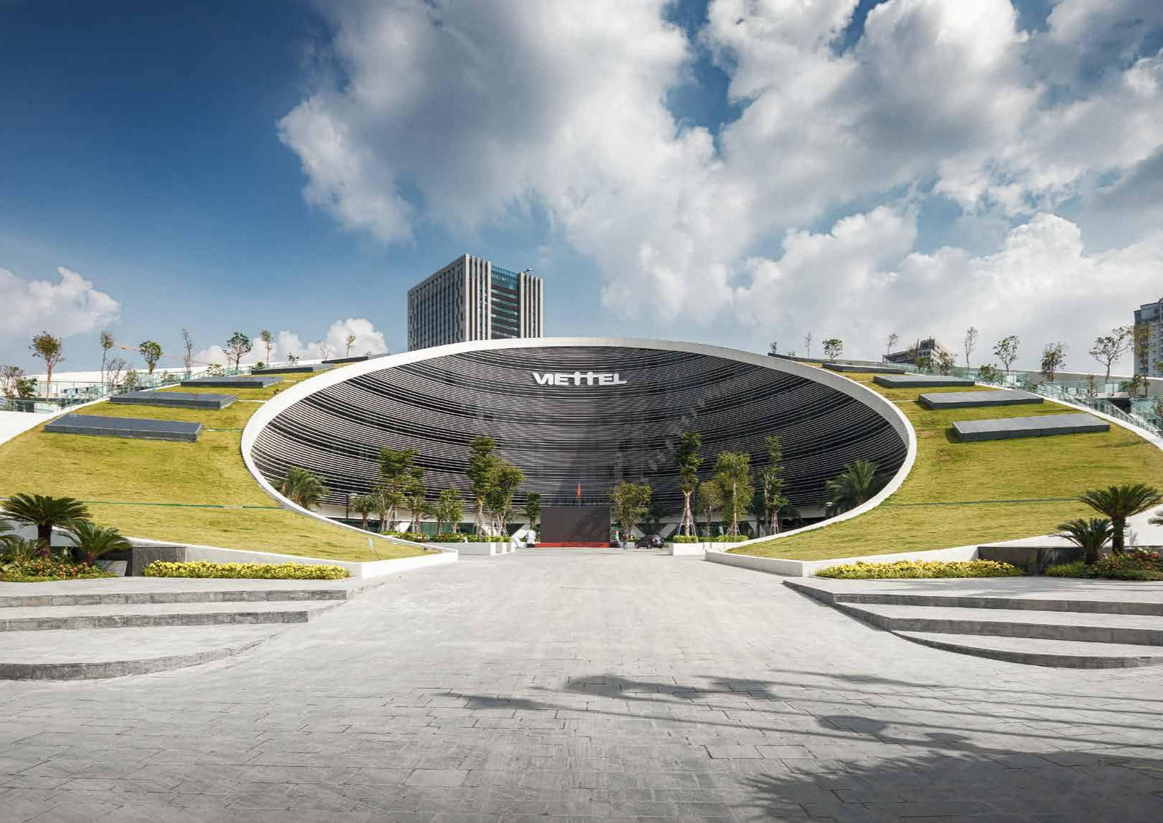**AFFIRM OUR**

**OUTSTANDING CAPACITY**

**Viettel**100 **Military**STANDFIRM**-run**INCHALLENGES**Industry and Telecommunications Group Headquarter** 101

**THE REPORT OF**



**THE BOARD OF MANAGEMENT**



**DIVERSIFY DESIGN AND BUILD PROJECTS (D&B)**

Aiming at providing D&B services for a variety of project types, Coteccons’ D&B team constantly improves its capacity and expertise. Coteccons’ D&B segment marked its first millstone in 2014 with high-rise buildings, and in 2016 expanded into the field of resort apartments, hotels and heavy industrial factories, in 2017 to office buildings. The peak of Coteccons’ D&B service from 2018-2019 encroaches on the type of complex building. In order to continuously improve this service, Coteccons does not only perform D&B but the 2020 plan will be to provide consultancy on legal procedures related to investment and project development, especially projects with foreign invested capital.



**COMPETE BY EQUIPMENT CAPACITY**

Continuing to be the pioneer in the construction industry and conquering major projects by applying modern equipment solutions, such as: applying weight to tower cranes at Golden Hill project (District 1) to reduce foundation construction cost; climbing formwork for the Vinhomes City project (District 9) to ensure the safety and quality of concrete surface outside the house; improve shading cover system for high-rise projects with tight spaces such as Times Squares (Da Nang), Friendship Tower (District 1), The Marq (District 3)... and modify a series of difficult components for key projects to boost clients’ confidence.

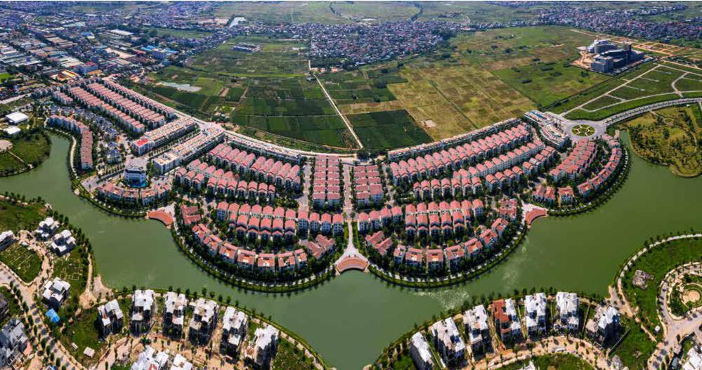

**Vinhomes Thang Long**

Hanoi

102 STAND FIRM IN CHALLENGES

**CONTINUOUSLY IMPROVE CONSTRUCTION METHODS,**



**IMPROVE PRODUCT QUALITY**

Wall cracking is a long lasting problem in construction, Coteccons’ in-depth research to adjust the morphology and distribution of cement bricks - concrete bricks has significantly reduced this situation in the past year; Applying and installing the acotec precast concrete wall panels; Also researching insulation solutions for concrete walls; Finding solutions to limit seepage risks in projects Applying ready mixed mortar at factory for plastering and rolling work to control mortar quality, material loss and ensure environmental sanitation ...

For M&E work: The use of BIM/ REVIT construction tools to check installation spaces as well as collisions right from the design stage helps to optimize installation space, save materials and prevent operational risks.

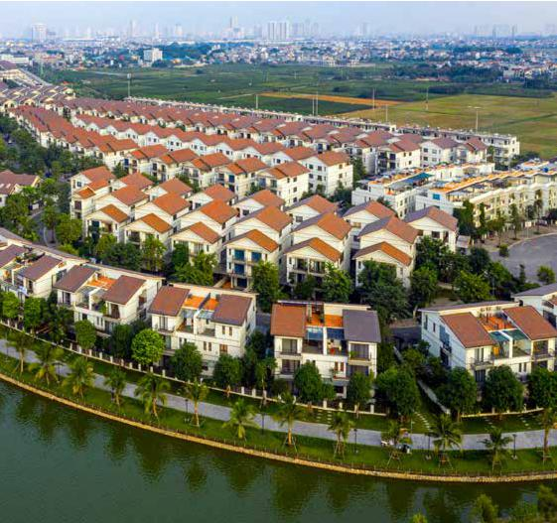

103

**THE REPORT OF**



**THE BOARD OF MANAGEMENT**



**MASTERING BIM TECHNOLOGY**

In 2019, although the number of projects has decreased, the requirement for BIM application from clients increased in bid-build projects. In BIM implemented projects, the created efficiency in work coordination has helped the Site Management Committee to clearly identify problems to thoroughly solve; limit errors, reduce rework costs and quicken progress. Typical projects include Viettel Headquarters (Hanoi), Casino Nam Hoi An Resort (Quang Nam), One Venrandah Luxury Apartment (District 2)...

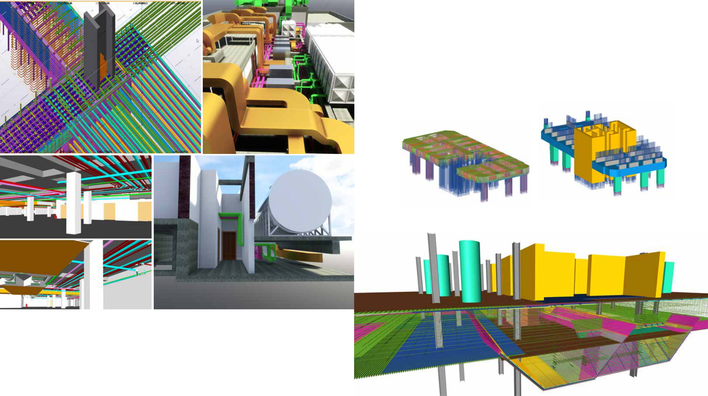

Not only developing BIM applications internally, Coteccons is often invited to attend seminars to share BIM experiences with other construction and design companies. Coteccons is currently a highly active member of Vietnam BIM Steering Committee, working with partners of Institute of Construction Economics and software companies to update new features.

104 STAND FIRM IN CHALLENGES 105

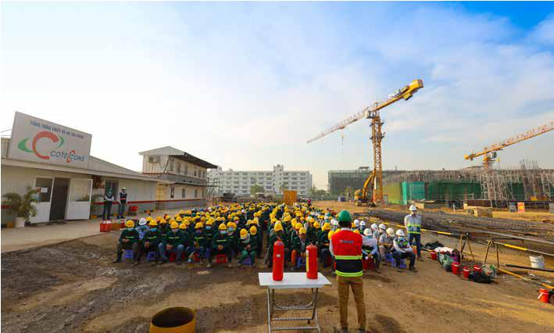**THE REPORT OF**

**THE BOARD OF MANAGEMENT**



**ACTIVITIES OF COMPANY’S FUNCTIONAL DIVISIONS**

Implementing the general policy of the Company, in the past years, the Departments/ Boards of the functional divisions have operated in the spirit of optimizing resources, improving the procedures, reducing expenditure... but still ensuring the achievement of targets.



**TECHNICAL DIVISIONS**



**SAFETY DEPARTMENT**

The high-end projects implemented by Coteccons always require fast schedule with a huge amount of work but still have to ensure quality which makes the implementation of safety measures in projects a great challenge. Therefore, the occupational safety system continuously introduces improvements and adjustments to suit the actual conditions and ensure that no serious accidents occur, minimizing light accidents.

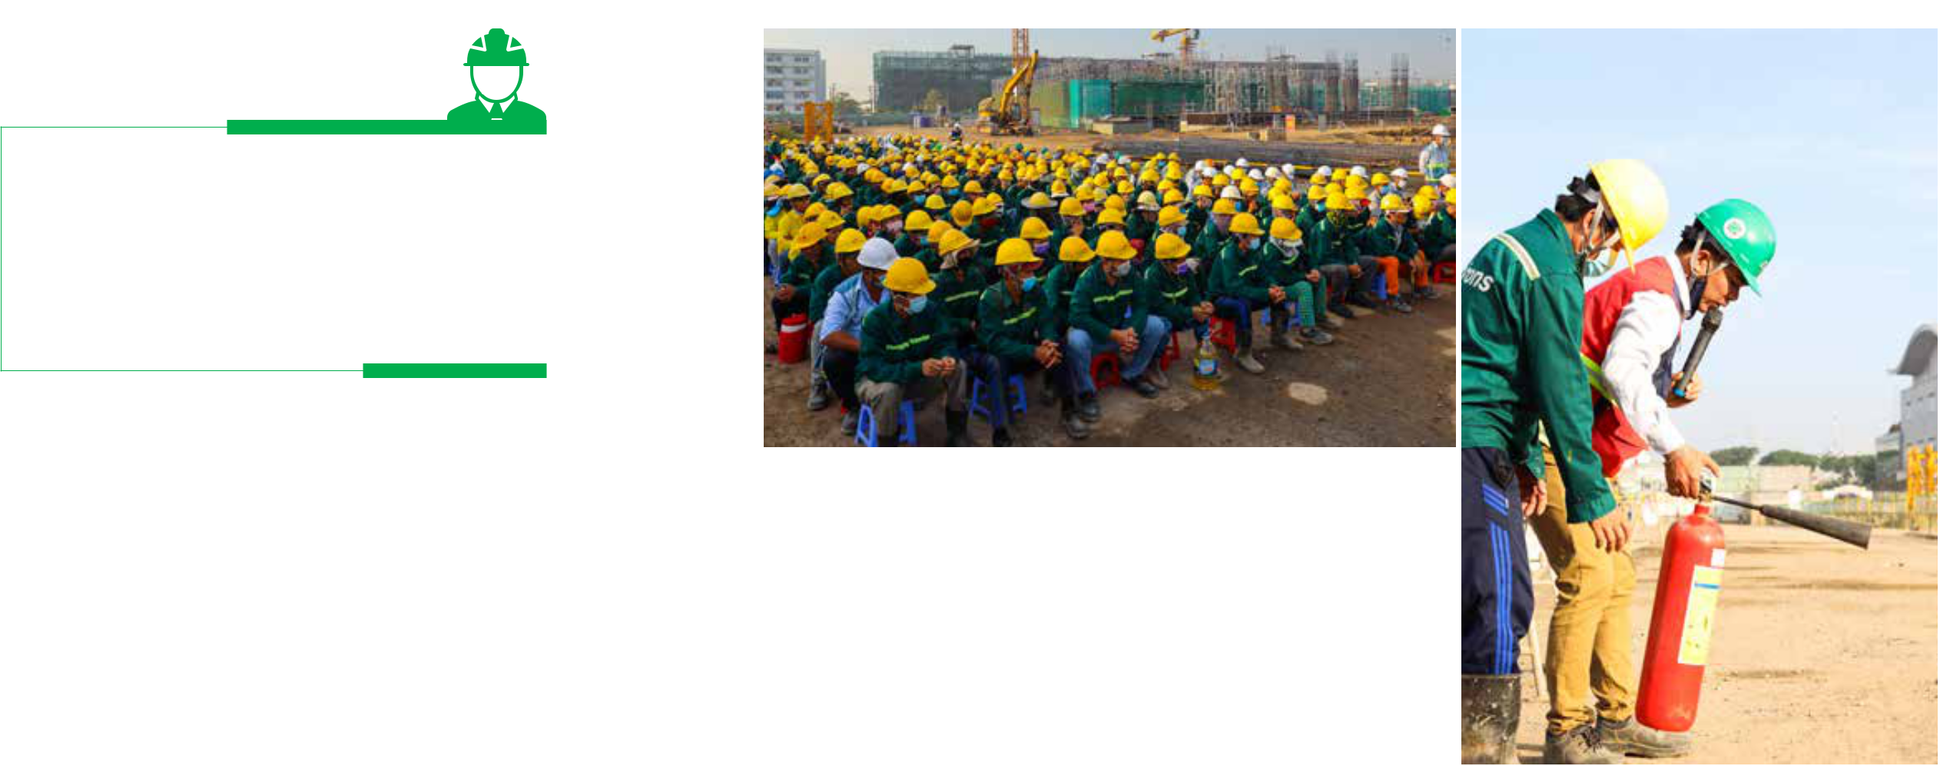

*In 2019 the construction sites had a total of 37,680,072 hours of safety established with 169,512 workers. To achieve that goal, the Safety Department has closely conducted the following tasks:*



Maintain and improve the labor safety system

Standardize the safety image of Coteccons projects according to the criteria for each type of project: factory, villas - apartments, constructions of basement and high-rise buildings...

**169,512** WORKERS

REACHING

**37,680,072**

HOURS OF SAFETY



Maintain monthly assessment and inspection, timely intervene, punish and monitor the risk response of projects with high level of potential safety risks.



Specific planning before construction

Before being executed, every job, even the smallest work, must be studied, evaluated carefully, thereby obtaining the best preparation for construction safety measures.



Raising awareness about occupational safety

In addition to the training of labor safety through the form of centralized training and e-learning, Safety Department also creates short videos of thematic safety instructions to maintain the labor safety at all times and all places.

Prioritize practical innovation

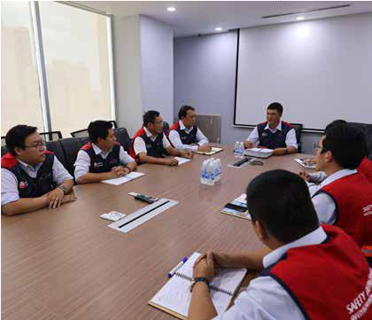

The switch from fluorescent light bulbs to led bulbs, other than to minimize the cost of supplies, also aims to reduce the risk of electric shock due to the use of lighting wires.

Installation of upgraded electric cabinets to reduce the damage to the plugs and to decrease the risk of electric shock which is caused by unqualified equipment during construction.

Organizing exercise activities, Greenday, for all construction sites which creates a team spirit and helps improve the health of workers.

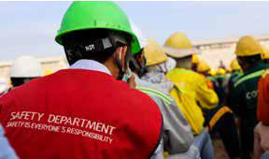

106 STAND FIRM IN CHALLENGES 107

**THE REPORT OF**



**THE BOARD OF MANAGEMENT**



**TECHNICAL AND CONSTRUCTION MANAGEMENT DEPARTMENT**

***Continuously improving, researching and applying advanced technology in construction, confirming the superior capability is the top goal of the technical department. In 2019, the technical and construction management departments have proposed the application of construction and control solutions to reduce costs but still guarantee the quality and safety of construction works.***

Developing Quality Control Regulation together with the application of Quality control e-Office software encourages the interaction between the Technical Division and the Site Management Committee, saving 30% of the processing time for reports and creating a database that can be easily extracted when needed. The shop drawing libraries related to structure and finishing are created on the Company’s online portal which helps the site have quick access to standardization requirements while optimize resources for shopdrawing.

Improving the method of concreting the foundation - the basement of the whole block, assembling the steel cage for the wall and column, the method of constructing the topdown column without using non-shrink mortar, using thermal insulation foam roll for large concrete... have promoted efficiency, helping to speed up construction progress, decrease costs, present a neater construction ground.

Apply measures to reduce wall cracking, minimize the risk of seepage cracking at projects and schedule appropriate time to water-paint to avoid the impact of rework which causes additional unnecessary costs.

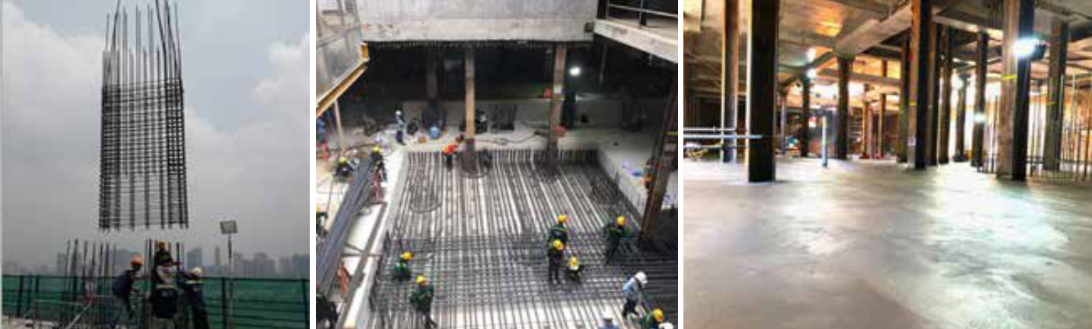

**SERVICES AND WARRANTY DEPARTMENT**



***As one of the very few Construction Contractors with a specialized after-sales department, not only aiming for performing warranty and maintenance work professionally work after the project is handed over, Coteccons also highlights business culture “consistent before and after”, contributing to the prestige of Coteccons brand and maintaining the quality of works for clients.***

With a team of dynamic, enthusiastic and constantly innovating spirit, in 2019 the Services and Warranty Department has combined and built the collection of warranty errors and effective solutions, most significantly for example is the use of Epoxy glue to handle peeling off tiles that saves up to 70% of processing time and costs.

Besides, the coordination with the clients’ project management office to inspect and control the warranty and maintenance work and to warn the inappropriate project use that may affect the quality of works, bringing the peace and satisfaction for Clients and end-users.

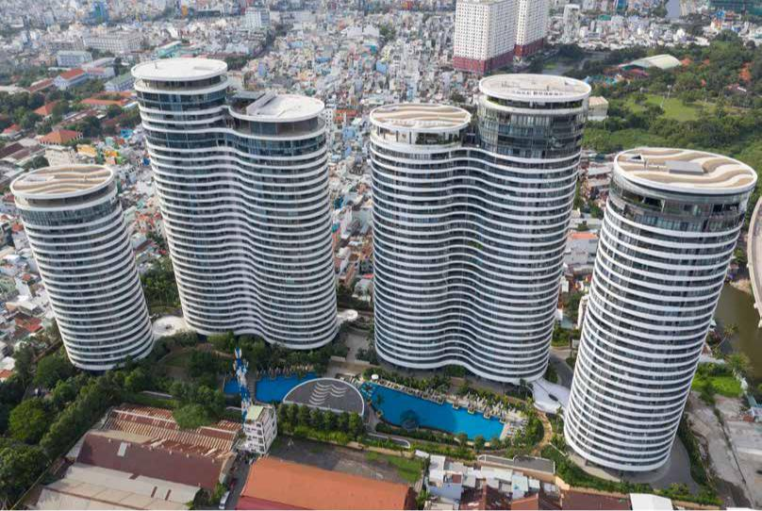

**SECURITY DEPARTMENT**

***Along with the refinement of office personnel, in 2019, the Security Department has reviewed and minimized the construction site security guards but still ensured the KPIs.***

Site security guards were reduced from 250 to 190 people (down by 24%) at the end of 2019.

Combine the model of internal security personnel and professional security personnel to be flexible in personnel arrangement, create internal competition and enhance quality.

Quarterly, coordinate with site managers to review premises and security situation in construction sites and surrounding areas to make the most appropriate and effective security plan and personnel arrangement plan.

Develop regulations to guide security procedures to help security forces easily deploy work in newly established projects.

Drastically handle violations of security regulations. Refine personnel that do not meet the job requirements.

**City Garden**

Ho Chi Minh City

108 STAND FIRM IN CHALLENGES 109

**THE REPORT OF**



**THE BOARD OF MANAGEMENT**



**EQUIPMENT DEPARTMENT**

***In 2019, the Equipment Department focuses on consolidating the system, personnel restructuring and management model. The operating system is standardized on all Coteccons construction sites, the equipment management is compiled into a management manual and operational handbook to help the site management committees easily look up; equipment costs have been effectively controlled and especially the staff structure is streamlined to be more refined and skilful which has brought about good efficiency in equipment management over the past year:***

* Reduce the cost of equipment/revenue compared to the average in 2018 (13%);
* Reduce the cost of transporting equipment/revenue compared to the average in 2018 (19%);
* Reduce 60% of maintenance costs;
* Increase the rate of internal equipment usage, thereby reducing outsourced equipment.
* Propose to invest in IT applications, transport management software to help the equipment management more optimal in order to strictly control equipment at the construction sites as well as monitor equipment wastage.
* Coordinate closely with the Tender Department, CCM Department in price quotation of equipment as well as strengthen the control of equipment costs at construction sites.

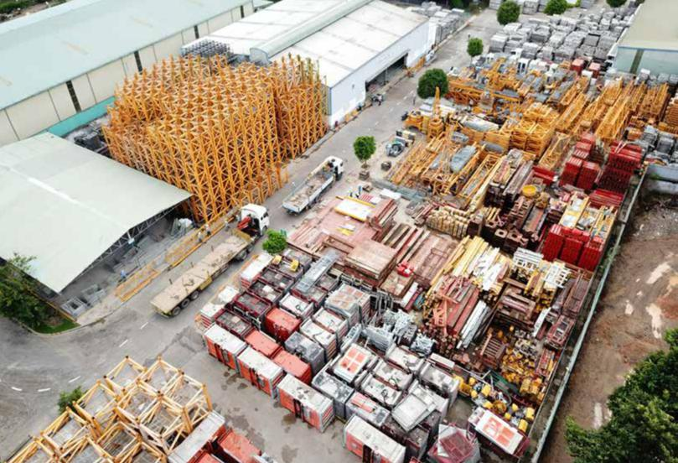

**ECONOMIC – FINANCE DIVISION**



**TENDER DEPARTMENT – COST AND CONTRACT MANAGEMENT DEPARTMENT**

Tender Department



In 2019, Tender Department has been delegated to support bidding process, ensuring project risks are managed from bidding stage to contract drafting and signoff. In effect, risk management is more completed and consistent during contract signoff process.

VB.Net programming language, which was implemented to improve mass calculation and automatic financial planning software, has resulted in:

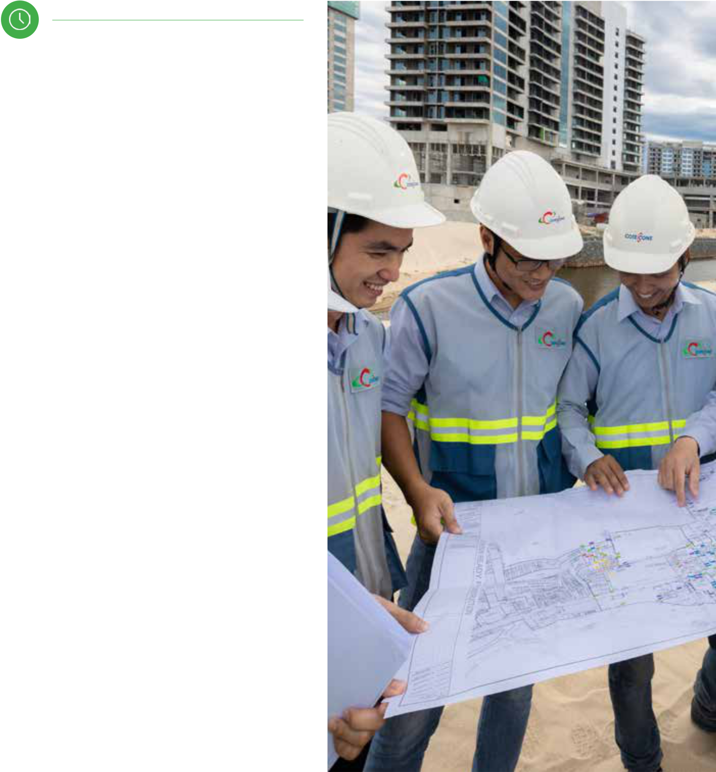

Reducing calculating time of project mass for bidding and quotation



Quickly identifying project’s profit area



Interfacing with Centre of Design

Management to utilise project mass in

D&B project



Interfacing with Purchasing Team and delegating centralised procurement strategy for construction sites



Software training for construction sites’ QS so that project mass is calculated faster and more accurately. Henceforth, collaboration between Tender Department and construction sites is more effective and efficient.

110 STAND FIRM IN CHALLENGES 111

**THE REPORT OF**



**THE BOARD OF MANAGEMENT**



Cost and Contract Management and Procurement Department

With their important role in managing costs and contracts; in 2019, Cost and Contract Management (CCM) has realising their annual plan by:



Consolidating personnel responsible for cost and contract management with Procurement Department. Assigning works more efficiently and using computer software to prevent human errors and to optimize human resources



Increasing collaborations with other Departments and site management committees in

managing risks incurring during constructing process.



Conducting training for QS to increase operations efficiency in

construction sites’ financial management.



Continuing supplier and vendor assessment to build a competitive logistics chain

to maximize profit margin.

**FINANCE AND ACCOUNTING DEPARTMENT**



Accounting has been performed in full manner and in compliance with Company’s policies and accounting law. The Department has been advising and proposing solutions towards capital management, cash flow management in Company’s operations.

Cooperating with other Business Operations departments within Economic Division to manage finance at individual departments and construction sites.

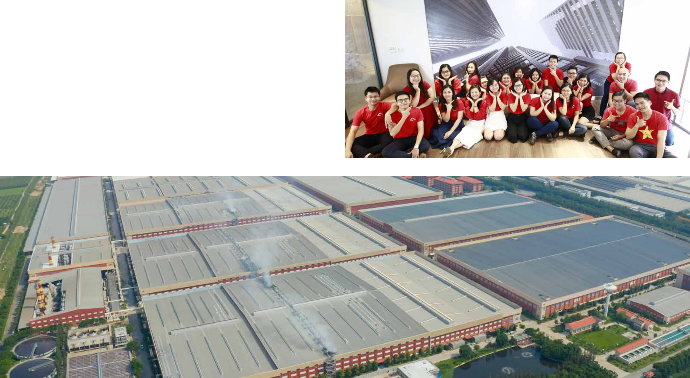

**Gain Lucky factory**

112 STAND FIRM IN CHALLENGES 113

Tay Ninh

**THE REPORT OF**



**THE BOARD OF MANAGEMENT**



**CONSTRUCTION WORKFORCE BUILDING AND DEVELOPMENT DEPARTMENT**

***Project’s progress and quality heavily depend on competency and skills of construction workers. Facing current difficult market situation, The Department’s main objective for 2019 is to search for and build up a competent subcontractor network. Henceforth, The Department has been working on:***

Searching for new construction resources networks.



Maintaining resources management by using centralised software, thus being able to monitor the effectiveness of work allocation to subcontractors.



Frequently communicating with site management committees. Organising weekly meetings to update status on construction sites to ensure immediate resource aid, preventing congestion.



With competent subcontractors who have been committed to the Company’s works, The Department is proposing support to organisational development, increase management’s capability and to allocate more works to ensure mutual relationship between The Company and these subcontractors are maintained and strengthened. Incompetent subcontractors with ‘short-term’ mind-set will be gradually eliminated from Coteccons’ subcontractor network.

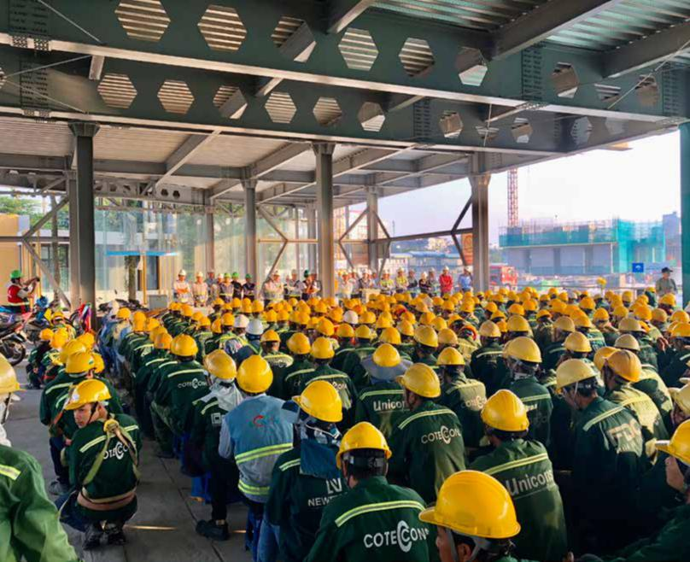

**INVESTMENT DIVISION**



**INVESTMENT BOARD**

***In 2019, through Covestcons, the Board of Investment continues to promote investment research activities and has attracted many partners with rich potential projects. However, due to many objective and subjective factors, these investment opportunities have not been realized successfully. Specifically:***

In 2019, reputable big partners in the real estate market such as Tuan Chau Group actively sought Covestcons to explore cooperation opportunities. The projects of those developers are highly feasible in the short term and in line with the demand of Coteccons. The Investment Board has also submitted suitable proposals to the Investment Subcommittee of the Board of Directors for direction and approval.



Besides, the Company continues to invest more than VND 100 billion in assets, machinery, equipment and construction tools to meet the needs of projects construction.

Plan of 2020 is to take advantage of the construction capacity and quality of works associated with the

Coteccons brand to capture investment projects, the Investment Board will focus on:

Researching on expanding large-scale land bank with appropriate location for long-term projects.



Promote the negotiation for cooperation and development of real estate investment projects with great location and complete legal status for early execution.



114 STAND FIRM IN CHALLENGES 115

**THE REPORT OF**



**THE BOARD OF MANAGEMENT**



**DESIGN MANAGEMENT CENTER (DMC)**

***In 2019, DMC has implemented 30 D&B projects with a variety of construction types: high-rise buildings, condominiums, hotels, luxury resorts and industrial factories...***

Construction revenue from D&B projects in 2019 of Coteccons alone is VND 6,567 billion, lower than in 2018 (VND 10,146 billion). One of the above-mentioned elements are the strict urban planning & development management policy, the condotel / officetel investment model without a full legal corridor, many projects subject to temporary suspension, delay or even cancelation. However, the big change of Design Management Center in the past year was about the team quality. In 2019, many large projects of the concept team were highly appreciated by clients and partners and selected for investment and implementation such as:

**SEA STAR HOTEL HA LONG PHASE 2**

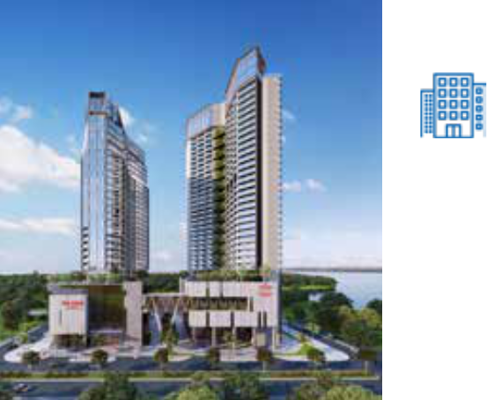

5-star hotel, 35 floors, 2 basements, 450 rooms



60,000m2 of construction floorg



Ha Long City, Quang Ninh Province

**THAO DIEN GREEN Q2**

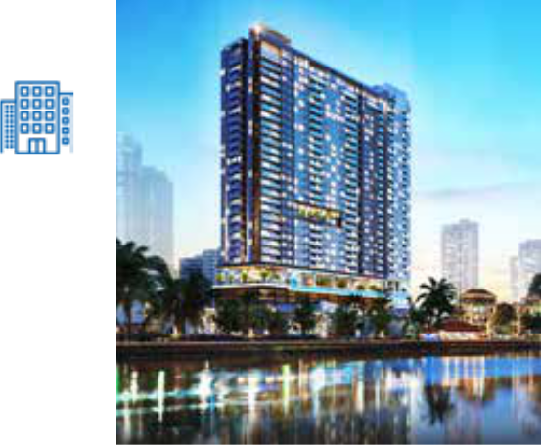

High-class serviced apartment building,

25 floors, 2 basements



45,000m2 of construction floor



Thao Dien, District 2, Ho Chi Minh City

**LE PHONG BD CONDOMINIUM**

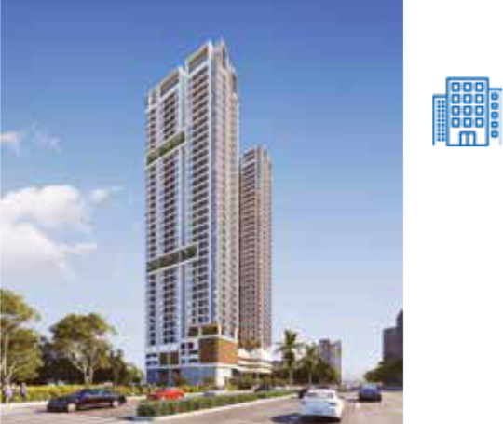

High-rise apartment building, 1300 high-quality apartments, 40 floors, 2 basements



130,000m2 of construction floor



Binh Duong

116 STAND FIRM IN CHALLENGES

The 2020 objectives of Design Management Center are to continue to change drastically to adapt to market fluctuations, meet clients’ needs, make the difference in products and services. Developing relationships with authorities and state agencies to accelerate investment and legal procedures.

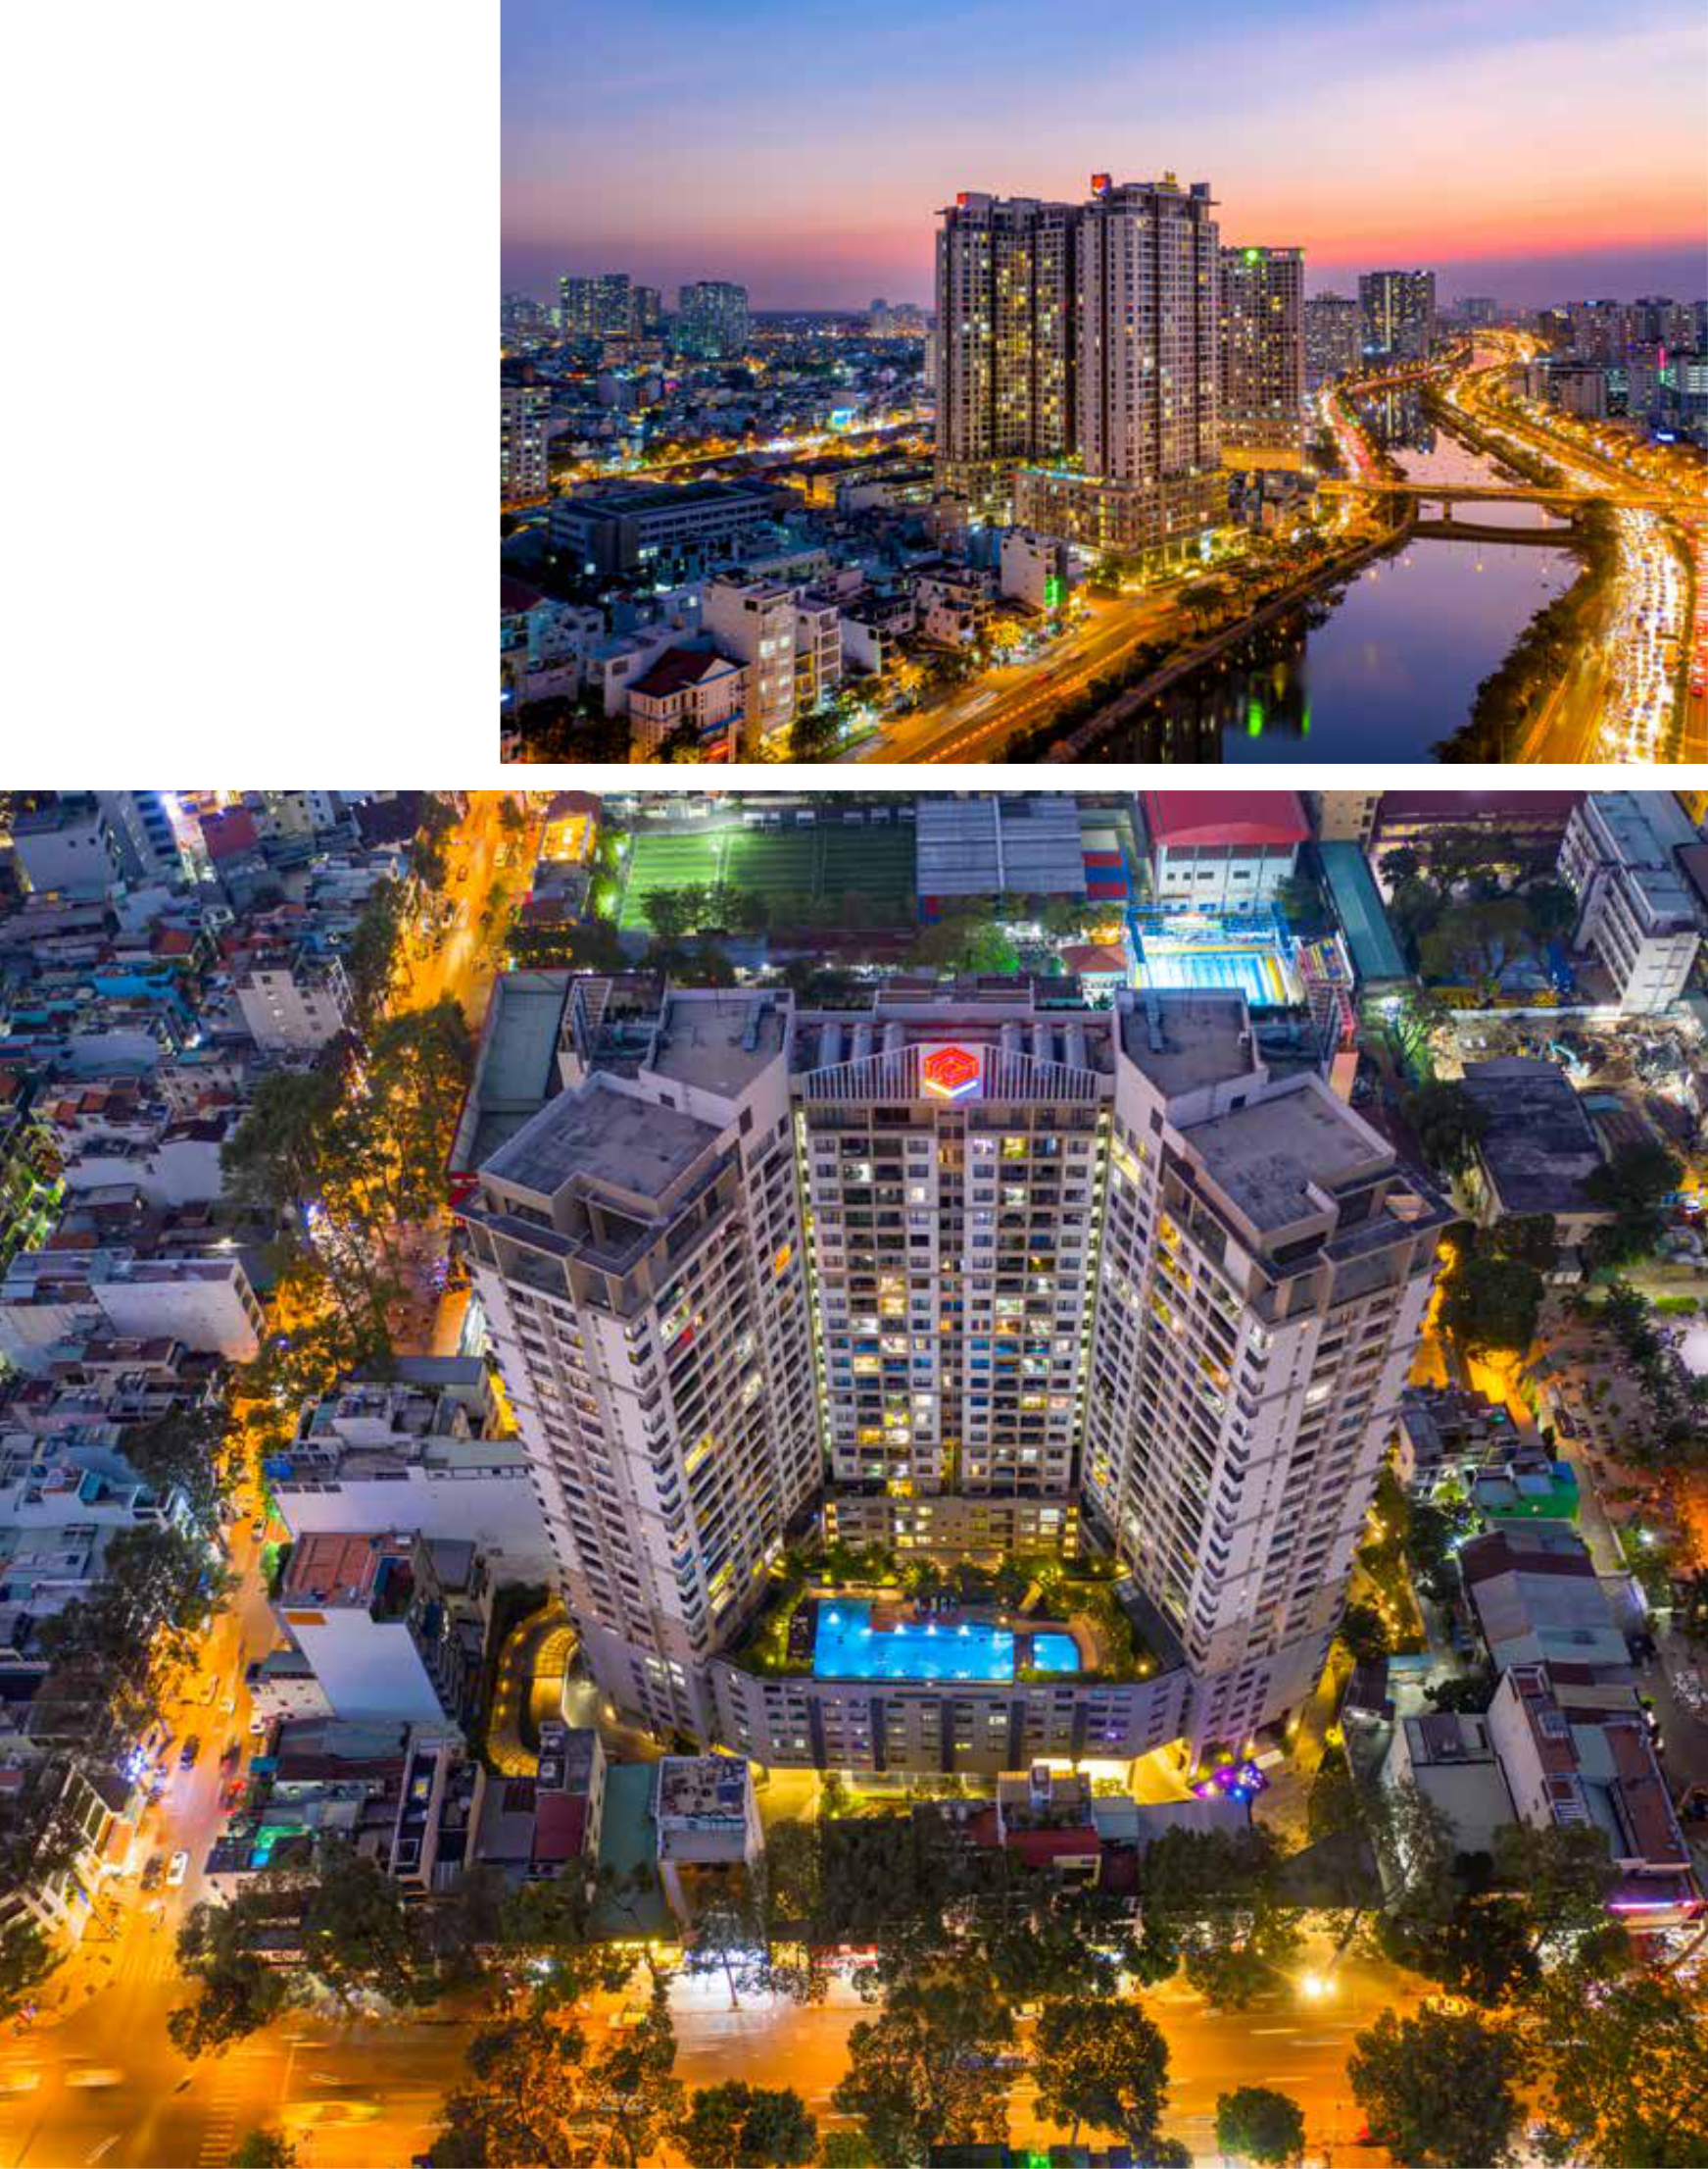

**EverRich Infinity**

Ho Chi Minh City

117

**THE REPORT OF**



**THE BOARD OF MANAGEMENT**



**BIM BOARD**

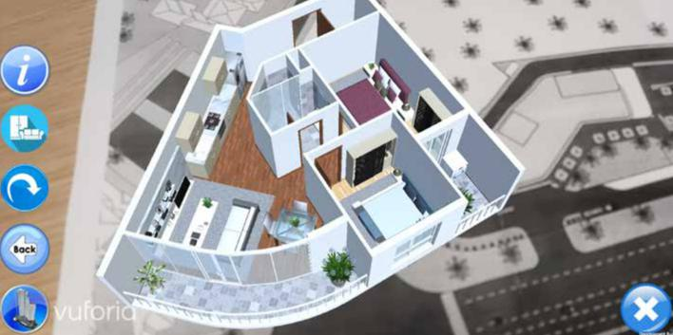

***Coteccons’ BIM has been continually updated. Projects in which BIM is implemented at construction sites (focusing on MEP cooperation, complex steel construction, etc.) have seen improvements in quality control and faster progress.***

Besides, BIM Team has been researching and developing following applications:

**** Virtual reality (VR) and Augmented reality (AR)

**** In-house modelling tools in Revit – Tekla and Civil 3D to save time in project modelling

Continually improving BIM, BIM Team is going to provide trainings to skilled staff to improve BIM’s literacy, providing essential operations information in project documentation, engaging in more complex projects by using advanced technology: VR/AR, 3D scanning, geo-locating and Robotic total station.

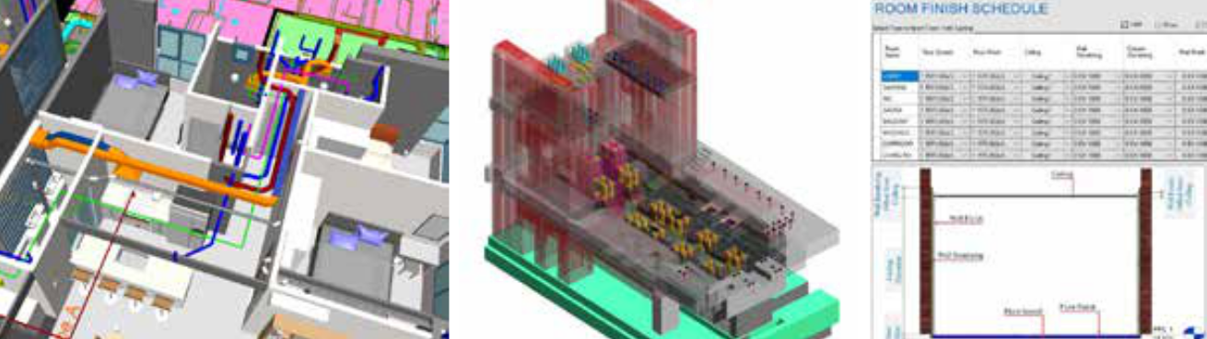

**M&E DIVISION**



***In like manner of current difficult market situation, value of M&E contracts in 2019 and forwarding contracts for upcoming years have decreased substantially. Thereupon, M&E has made adjustments in management practice and construction technicality in order to cut costs:***

Restructuring governance, especially key staff, to innovate M&E’s workflow

Merging M&E Tender Department and M&E Technical Management Department into M&E Tender and Technical Department. Hence, resource management is more effective, workflow’s information is more in a timely manner and consequently, increase control over construction guideline and technical solutions of bidding projects

Intensive trainings for engineers by using E-learning system and technical standards published by M&E Technical Department

Technical solutions and construction guideline have also been revised with visual aids to optimize firefighting & prevention design and control, reducing risks at construction sites

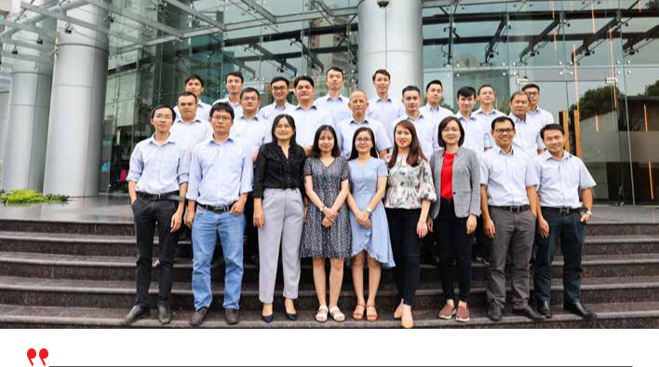

WITH IMMENSE EFFORT IN 2019, M&E HAS COMPLETED A TOTAL CONTRACT VALUE OF VND 3,800 BILLION (ACHIEVING 84.4% OF INITIAL TARGET) AND CONTRIBUTED TO THE COMPANY’S CONSOLIDATED REVENUE.



118 STAND FIRM IN CHALLENGES 119

**THE REPORT OF**



**THE BOARD OF MANAGEMENT**



**INTERNAL AFFAIRS DIVISION**

***In duty of internal assessment functions and business support, The Division’s Departments have been reducing their workforce and operational costs. In 2019, The Division’s workforce size has shrunk by 15% compared to that of 2018. The Division continues its focus on the following objectives:***



**LEGAL BOARD**

Proactively cooperating with constructions’ committees to assess and evaluate legal risks to prepare and propose preventive legal responses to these risks. The Board is now in part of controlling and negotiating contracts with clients.



**INSPECTION BOARD**

Organising regular on-site examinations to identify, evaluate and propose mitigating responses to risks relating to finance, project management and compliance to the Company’s policies and the law.



**HR DEPARTMENT**

Advising Executive Board in human resource planning, salary and benefit schemas; supervising payrolls at Departments and construction sites (*detailed organisational* *structure provided at page 92 - 93*); maintaining regular performance evaluation every 3months, based on which employee benefit policy and layoff are executed.

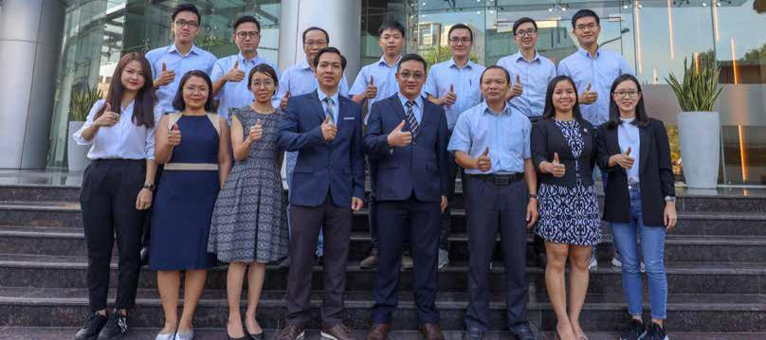

**IT DEPARTMENT**



Several initiatives have been rolled out to ensure continual IT development. This includes process and procedure automation, strengthening cybersecurity and introduction of cloud computing through: Coteccons Core system, business analytics, as well as upgrading infrastructure and cybersecurity practice to be cloud-ready.



**ADMINISTRATIVE DEPARTMENT/**

**REPRESENTATIVE OFFICE IN HANOI**

Maintaining the digitalisation of document and post management, which reduces manual, human-error prone works. Administrating The Company’s offices, houses and organising convenient and friendly working environments for internal staff, as well as maintaining The Company’s professional image in front of clients and visitors. Organising Company’s events in 2019 accordingly to allocated budget. Cooperating with labour unions to take care of staff’s physical, mental and health-related needs.

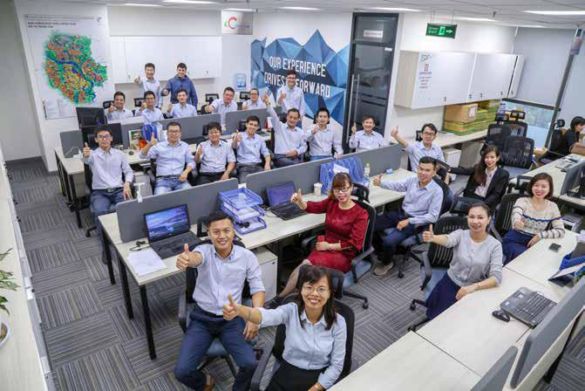

120 STAND FIRM IN CHALLENGES 121

**THE REPORT OF**



**THE BOARD OF MANAGEMENT**



**ORIENTATION FOR BUSINESS**

**OPERATION IN 2020**

Challenges of the real estate - construction market and legal bottlenecks are expected to continue in 2020 and have high probability of restraining new projects. Especially recently, the coranavirus (Covid-19) pandemic has also negatively affected the behaviour of homebuyers and developers, particularly hospitality project developers, which made finding new jobs becomes extremely difficult. With the goal of continuous improvement to uphold the position in the market and fulfilling targets set by the Board of Directors in 2020, solutions of the Board of Management on management and operation of the Company include:

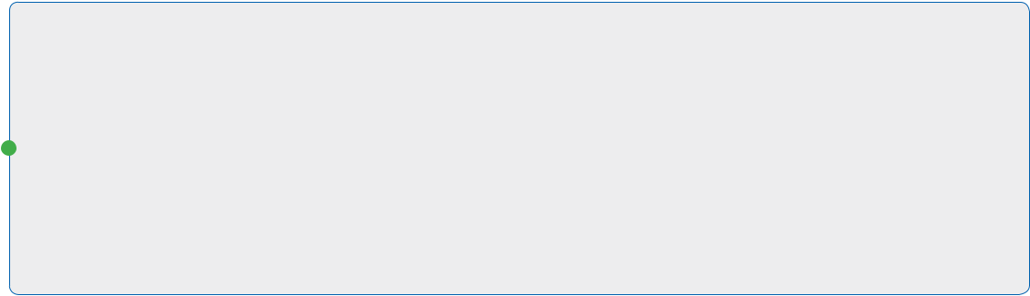

|  |  |  |  |
| --- | --- | --- | --- |
|  |  | Streamlining and strengthen the organizational structure of the Company to enhance work |  |
| 1 |  | efficiency on the basis of improving labor productivity and optimizing salary fund on revenue. |  |
|  | The departments are merged and reorganized which promotes multi-tasking, the staff is |  |
|  |  |  |
|  |  | rotated to train and improve capacity, refine the human resources that are not suitable in the |  |
|  |  |  |
|  |  | working environment. In addition, the direct reporting model from Site Manager to the Board of |  |
|  |  | Management via minimizing the intermediate management steps is also promoted to enhance |  |
|  |  | working efficiency. |  |
| 2 |  | Actively and proactively seek sources of work from both new and existing Clients. The most |  |
|  | important factor is to focus on sincere and reputable clients instead of obtaining jobs by all |  |
|  |  |
|  | means and failing to recover debts and creating the chain of consequences later. |  |
|  |  | As quality is the core in every project, Coteccons is determined to maintain its flagship |  |
| 3 |  | in safe and efficient construction techniques which bring the highest added value |  |
|  | to clients. Innovation related to the construction methods of equipment, structure, |  |
|  | finishing and ME of which effectiveness is proven will be applied on a large scale with |  |
|  |  |
|  | strict supervision. Besides, the Company is continuously investing in R&D and linking |  |
|  |  | with suppliers and universities to research green building materials and aiming to |  |
|  |  | increase the value for the whole community. |  |
| 4 |  | The Investment Board of the Company continues to seek and realize investment |  |
|  | opportunities including real estate and corporate bond to improve financial advantages |  |
|  |  |
|  | and bring added value to shareholders. |  |
|  |  |  |
| 5 |  | Continuously innovate and complete the Design & Build model, perform QA/QC to |  |
|  | each technical part of the drawing and accelerate the application of BIM (“Building |  |
|  | Information Modelling”) in the design to minimize errors. The controls are focus |  |
|  | into the design lead from the construction to finishing to optimize information |  |
|  | and orientation, ensuring the project is completed with the fastest schedule and |  |

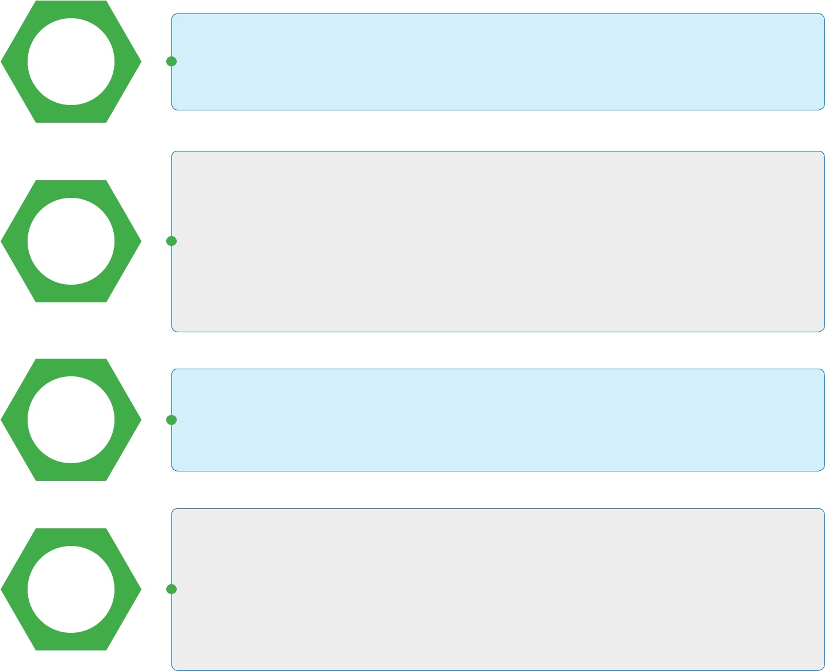

the best quality.

6

7

Strengthen the application of information technology in management and operation, thereby not only increasing labor productivity, reducing the volume of direct workloads but also improving information security, preventing loss of important business data.

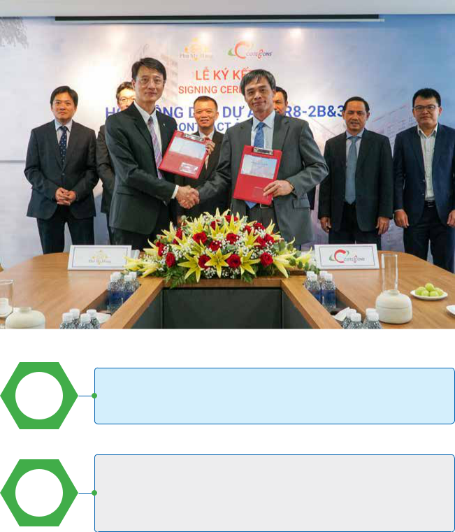

The period of economic crisis in 2012 is a testament about opportunities hidden in difficulties when Coteccons has made use of it to become a leading construction company. Taking advantage of and exploring potential opportunities on work and investment in the difficult period of the real estate market cycle is what the Board of Management aims to stand firm in the challenge.

122 STAND FIRM IN CHALLENGES 123

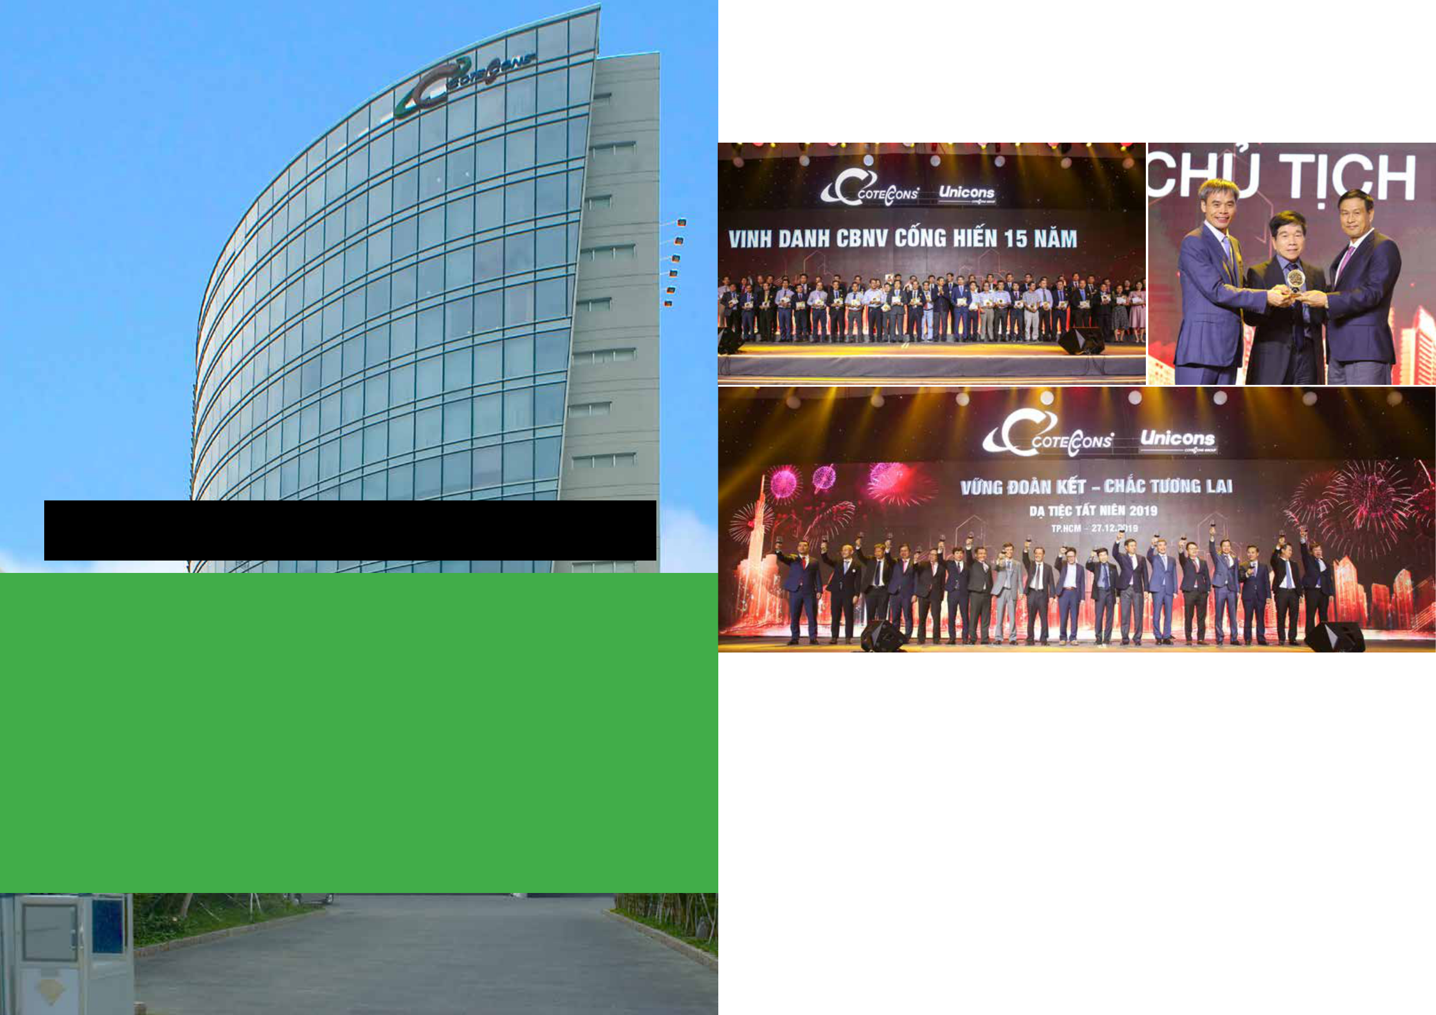

**2019**

**THE IMPRINT OF 15 YEARS OF ESTABLISHMENT AND DEVELOPMENT**

*15 years are just the beginning for a human life, but for an organization, it is a journey with many unique challenges to overcome and survive.*

*Coteccons is no exception. It was established in August 2004 with about 50 employees, and has experienced many ups and downs of the real estate market, especially the 2008 period when*

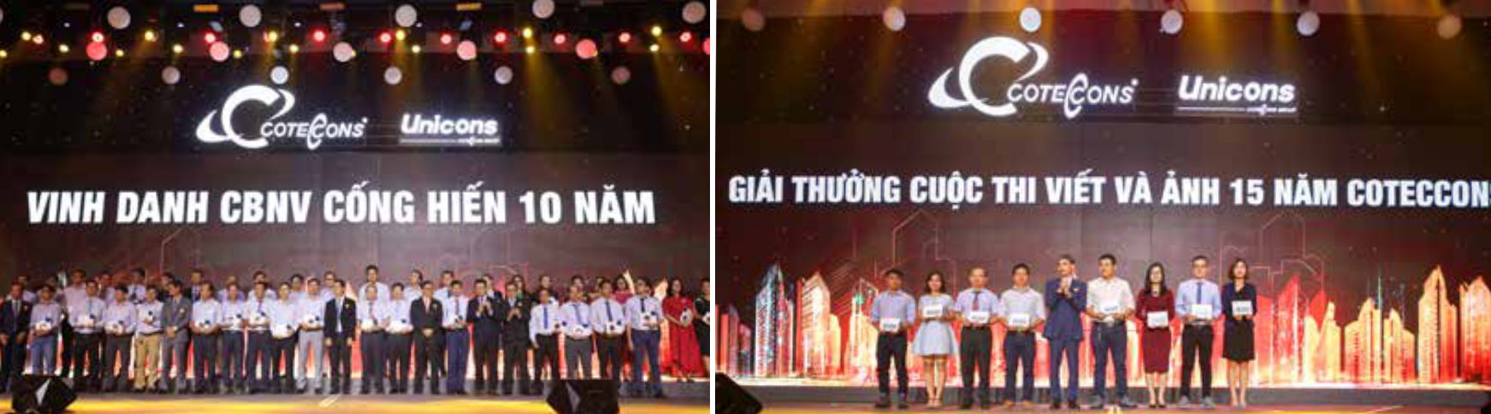

*the global financial crisis made the domestic real estate market free fall and stagnate in the following years. Despite that, Coteccons has been “****steadfast beyond challenges****” and de-*

*veloped to become a construction group with approximately 2,300 highly qualified employees (Unicons included) and created jobs for tens of thousands of workers. Coteccons brand is well known and highlighted throughout key projects within major cities, contributing to changing the face of the country. Success only comes from having the right strategy from the Board of Di-*

*rectors, and the contribution of all employees who are hard working and innovative. Moreover, the collective has formed a corporate solidarity culture of “****more than a family****” which is the*

*crucial difference that makes Coteccons’ success today.*

*With the 15 -year journey closed, Coteccons ushers in a new era with new missions and strong beliefs: We* ***CAN DO****, robust solidarity ensure the future. That is also the message of Coteccons 15th Anniversary Ceremony (2004 - 2019).*

124 STAND FIRM IN CHALLENGES 125

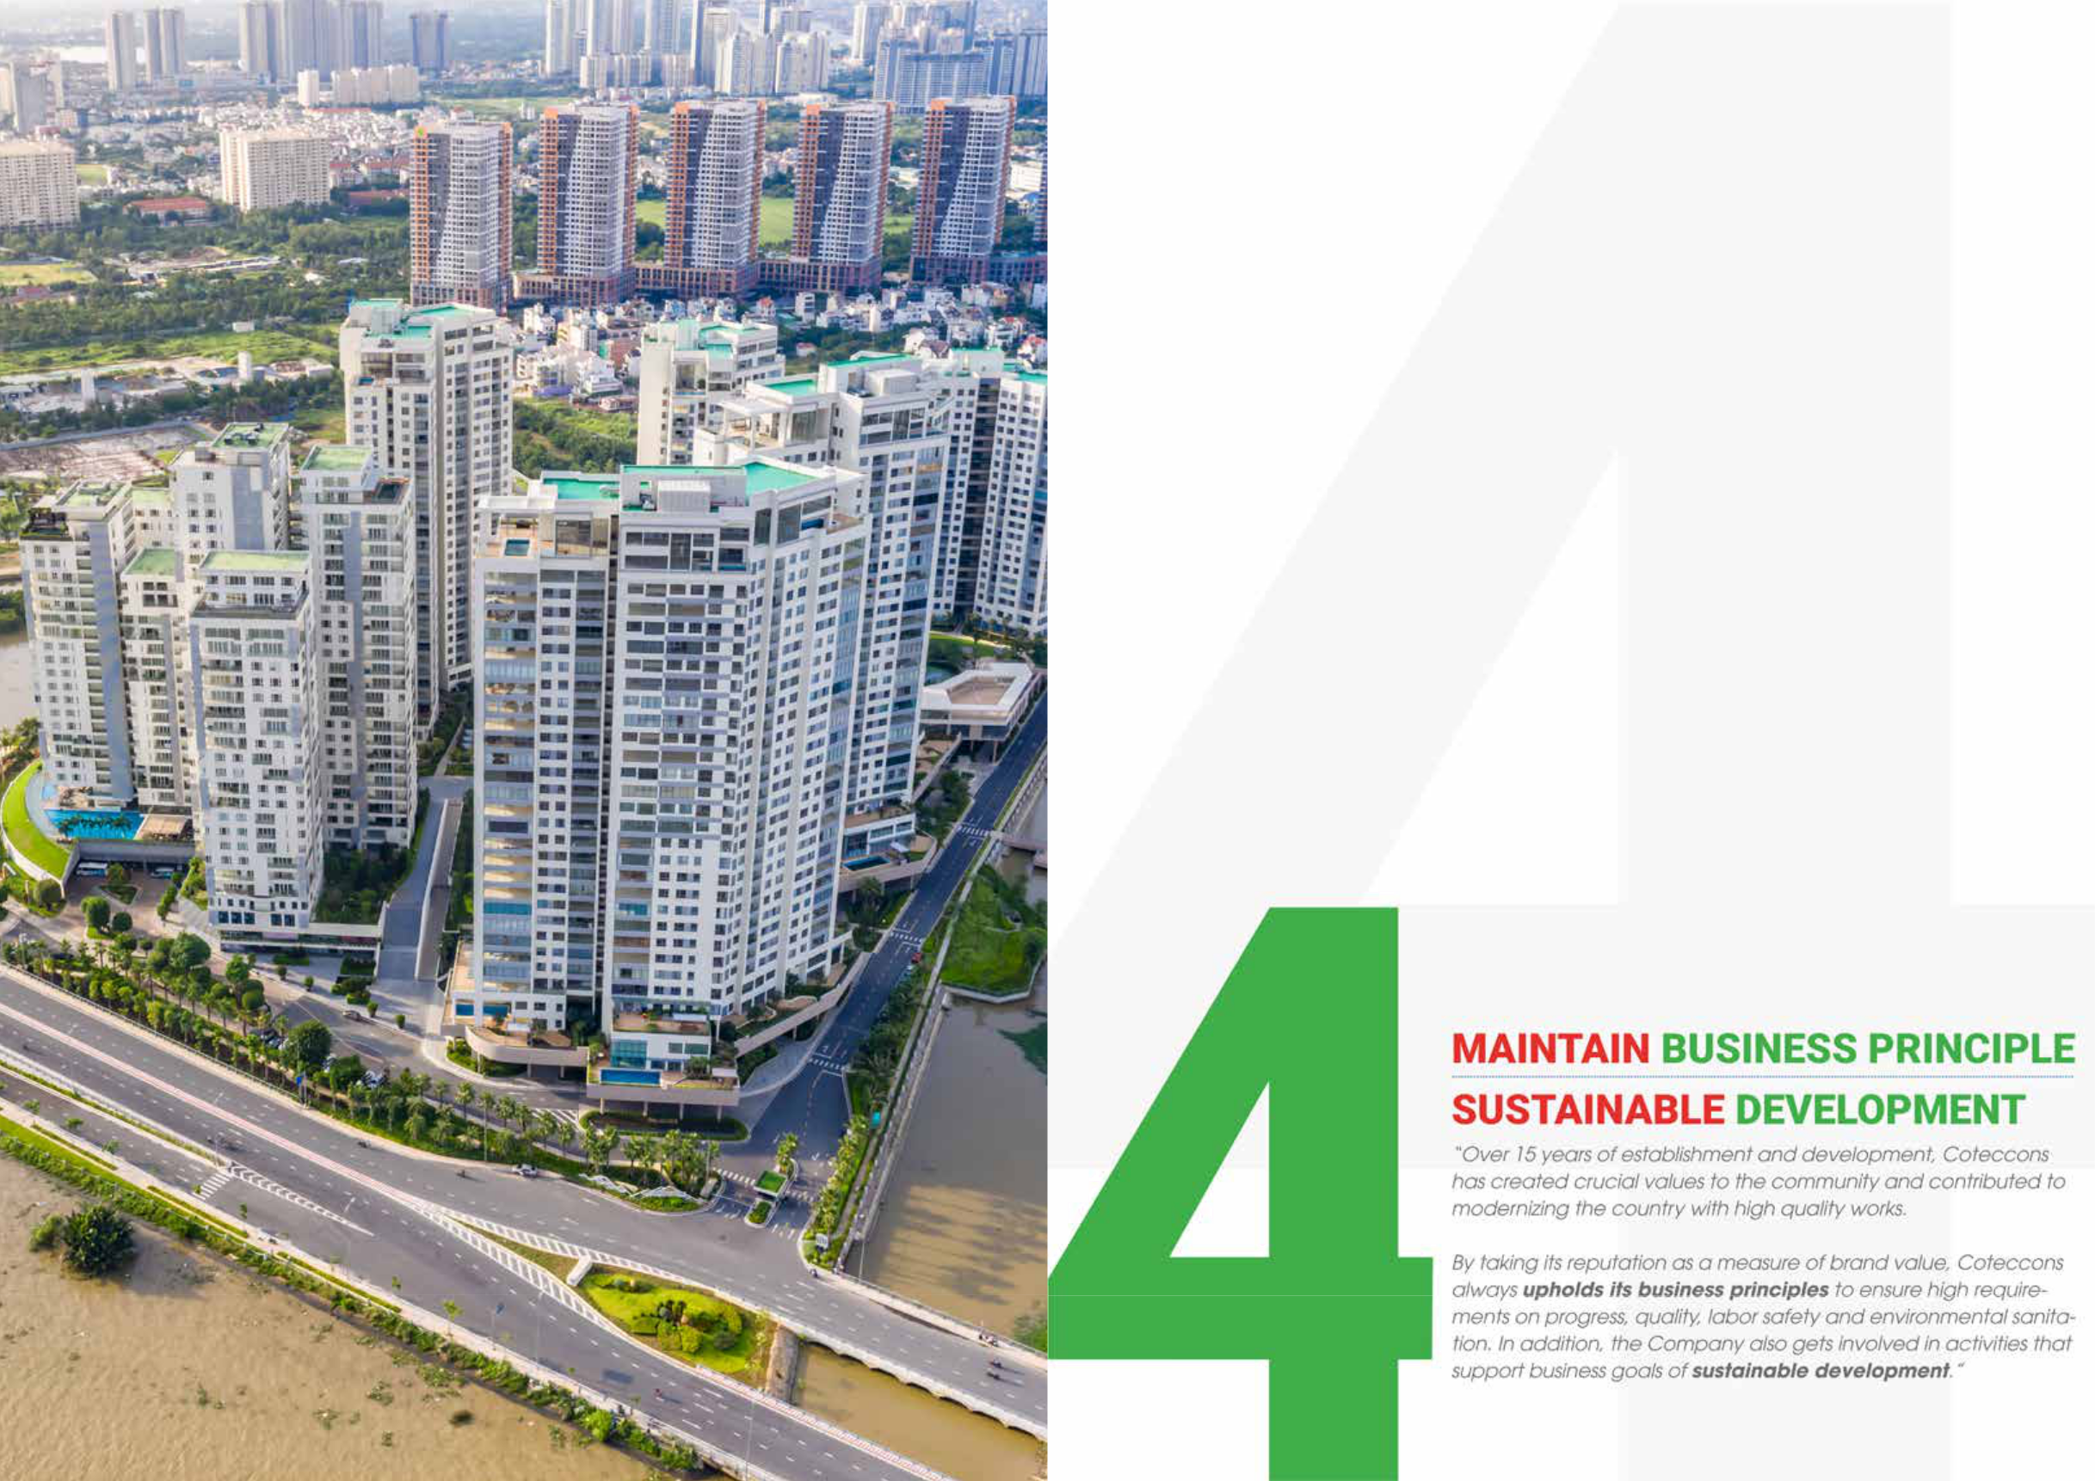

|  |  |  |
| --- | --- | --- |
| **Diamond Island** | 127 |  |
| 126 STAND FIRM IN CHALLENGES |  |
| Ho Chi Minh City |  |  |

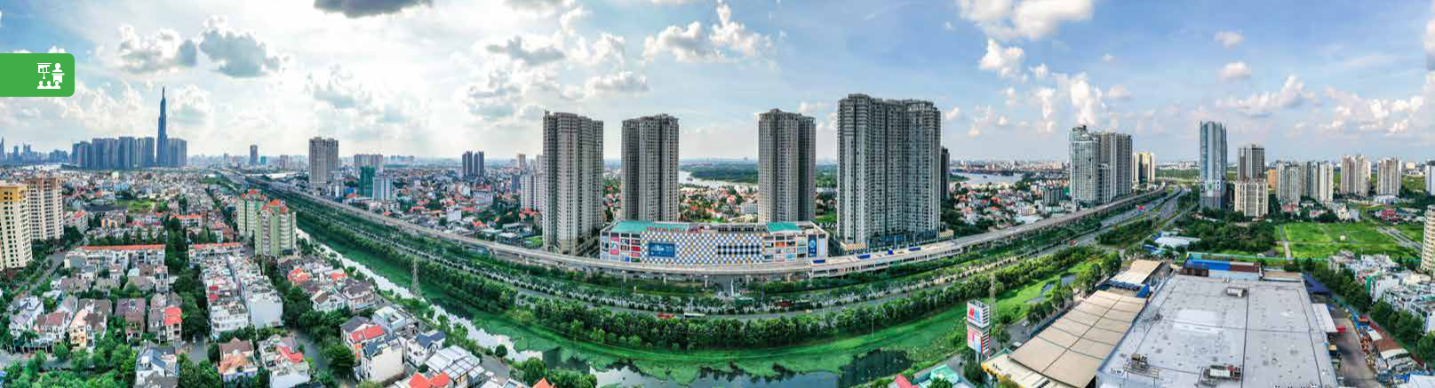

**SUSTAINABLE DEVELOPMENT**

**REPORT**



**REPORT CONTENTS**

Over 15 years of establishment and development in the construction industry, Coteccons is always aware of the importance of relationships with stakeholders to achieve sustainable development.

In 2019, Coteccons continues to actively assess the list of factors affecting the Company’s operations and relationships with related stakeholders including clients, investors, employees, authorities, partners, community, etc. and then implement action plans according to each level of influence. The identification of priority areas helps Coteccons increasingly improve its management and control regarding to specific issue to ensure the harmony of interests among stakeholders.

The 2019 Sustainable Development Report of Coteccons Construction Joint Stock Company and its affiliates reflects the key activities implemented during the year, the medium and long-term strategy under the. sustainable development orientation that the Board of Directors has established. The report’s approach is derived from the Company’s long-term economic growth goals combined with social development and environmental protection goals.

**Masteri Thao Dien**

Ho Chi Minh City

**PRINCIPLES OF THE REPORT’S CONTEXT**



»» Connecting stakeholders »» Materiality

»» Sustainable development context »» Completeness

**PRINCIPLES OF THE REPORT’S QUALITY**

|  |  |  |  |
| --- | --- | --- | --- |
| »» | Accuracy | »» | Comparableness |
| »» | Symmetry | »» | Reliability |
| »» | Clarity | »» | Timely manner |



**SCOPE OF THE REPORT**

The report made in Vietnam, specializing in the construction industry, and presenting activities of Coteccons Joint Stock Construction Corporate and the Company’s Affiliates.

Reporting period: from 01/01/2019 to the end of 31/12/2019.

The financial figures in the report referenced from the Consolidated Financial Statements in 2019. The report published online at the website portal: www.coteccons.vn.



**CONTACT INFORMATION**

Sustainable development is a key strategy of the Company, affecting other relevant stakeholders. Should you have any constructive ideas or concerns related to the Company’s sustainability, please kindly send to:

**COTECCONS COMMUNICATION BOARD**

Email : bantruyenthong@coteccons.vn

Telephone : (84-28) 3514 22 55 66

Address : 236/6 Dien Bien Phu Street, Ward 17, Binh Thanh District, Ho Chi Minh City

128 STAND FIRM IN CHALLENGES 129

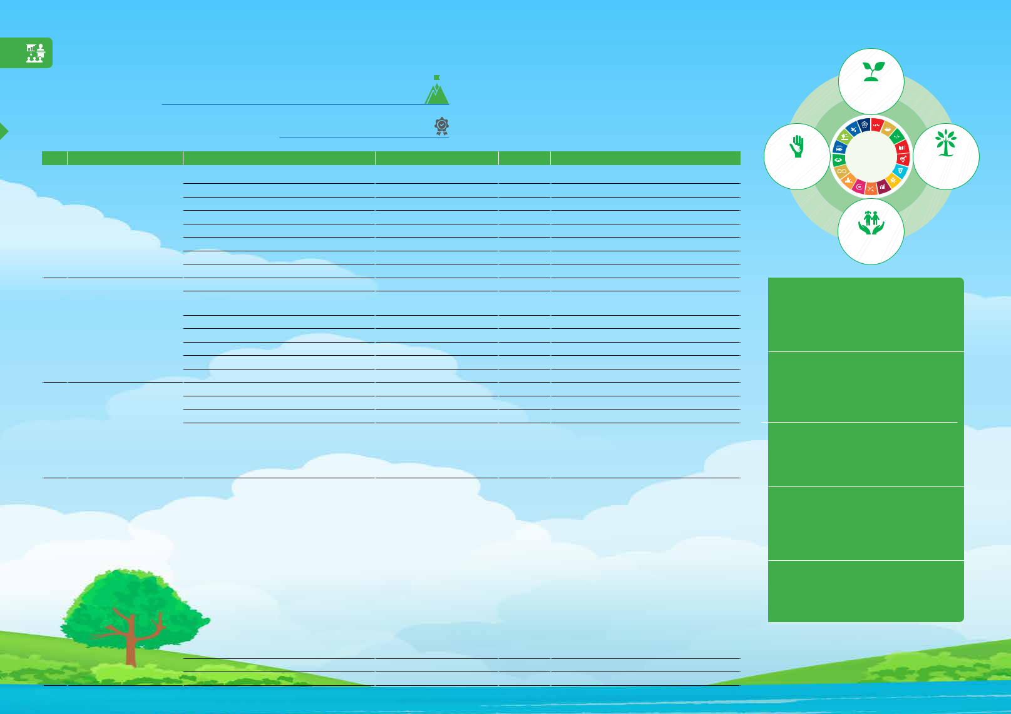**SUSTAINABLE DEVELOPMENT**

**REPORT**

**REPORT CONTENTS**

**SUSTAINABLE DEVELOPMENT INDEXES IN 2019**

|  |  |  |  |  |  |  |
| --- | --- | --- | --- | --- | --- | --- |
| **No.** | **Section** | **Content** | **Data** | **Note(s)** | |  |
|  |  | Revenue | VND 23,733 billion |  |  |  |
|  |  | Profit after tax | VND 711 billion |  |  |  |
|  |  | Taxes paid to Treasury: | VND 751 billion |  |  |  |
| 1 | **SUSTAINABLE** | *Corporate income tax* | *VND 208 billion* |  |  |  |
| **ECONOMIC GROWTH** | *Value added tax* | *VND 388 billion* |  |  |  |
|  |  |  |  |
|  |  | *Personal income tax* | *VND 148 billion* |  |  |  |
|  |  | *Other tax* | *VND 7 billion* |  |  |  |
|  |  | 2018 dividend payments | VND 229 billion |  |  |  |
|  |  | Total safety time in con-struction sites | 37.7 million hours |  |  |  |
|  |  | 5S program promotion | Sort, Sustain, Set, Shine, |  |  |  |
|  |  | Standardize |  |  |  |
|  | **LABOUR SAFETY,** |  |  |  |  |
| 2 | Total cost of environment treatment | VND 29.5 billion |  |  |  |
|  | **ENVIRONMENT** | Training on fire protection; Training on labour safety | VND 211 million |  |  |  |
|  | **PROTECTION** |  |  |  |
|  | Costs for labour safety | VND 88 billion |  |  |  |
|  |  |  |  |  |
|  |  | Cost for work wear | VND 17.7 billion |  |  |  |
|  |  | Cost of labor safety and hygiene risk assessment | VND 12.8 billion |  |  |  |
|  |  | Completed training time | 31,600 hours |  |  |  |
|  |  | Number of personnel trained in class | 1,632 people |  |  |  |
|  | **HUMAN RESOURCES** | Number of personnel trained via e-learning | 1,100 people |  |  |  |
| 3 |  |  | Including: | |  |
| **DEVELOPMENT** |  |  |  |
|  |  |  | »» 1 High-level training courses. | |  |
|  |  |  |  |  |
|  |  | Number of conducted training courses | 50 courses | »» | 10 middle-level training courses. |  |
|  |  |  |  | »» | 13 Professional training course for construction site. |  |
|  |  |  |  | »» 26 soft skills courses. | |  |
|  |  |  |  | Including: | |  |
|  |  |  |  | »» Support **VND 2 billion** for the city to fight | |  |
|  |  |  |  |  | Covid-19 pandemic. |  |
|  |  |  |  | »» Sponsor eye surgeries at a cost of over **VND 330** | |  |
|  |  |  |  |  | **million**. |  |
|  |  |  |  | »» Sponsor for poor patients in Oncology Hospital | |  |
|  |  |  |  |  | at a cost of **VND 322 million**. |  |
|  |  |  |  | »» Sponsor relatives of employees with difficult | |  |
|  | **UNITE FOR THE** | Contribution to the Community | VND 4 billion | »» | backgrounds at a cost of **VND 395 million**. |  |
| 4 |  |  | Sponsor gifts for employees who participated in |  |
| **COMMUNITY** |  |  |  | blood donation at a cost of **VND 20 million**. |  |
|  |  |  |  |  |
|  |  |  |  | »» Join the rescue of agricultural products - buy | |  |
|  |  |  |  |  | watermelon to donate to workers with the |  |
|  |  |  |  |  | budget of **VND 200 million**. |  |
|  |  |  |  | »» Funding cardiac surgery for poor children with | |  |
|  |  |  |  |  | congenital heart defects at a cost of **VND 230** |  |
|  |  |  |  |  | **million**. |  |
|  |  | Jobs created and people under safety training | More than 28.000 people |  |  |  |
|  |  | University partners | 5 prestigious universities |  |  |  |

SUSTAINABLE

ECONOMIC GROWTH

|  |  |  |
| --- | --- | --- |
| UNITE FOR THE | LABOUR SAFETY, |  |
| ENVIRONMENT |  |
| COMMUNITY |  |
| PROTECTION |  |
|  |  |

HUMAN RESOURCES

DEVELOPMENT

**TOTAL COST OF**

**ENVIRONMENT TREATMENT**

**29.5 BILLION**

VND

**COMPLETED TRAINING TIME**

**31,600**

HOURS

**CONTRIBUTION TO THE COMMUNITY**

**4 BILLION**

VND

**JOBS CREATED AND PEOPLE UNDER**

**SAFETY TRAINING**

**28,000**

PEOPLE

**37.7 MILLION**

SAFETY HOURS

130 STAND FIRM IN CHALLENGES 131

**SUSTAINABLE DEVELOPMENT**



**REPORT**



**REPORT CONTENTS**



**SUSTAINABLE RELATIONS BETWEEN STAKEHOLDERS**

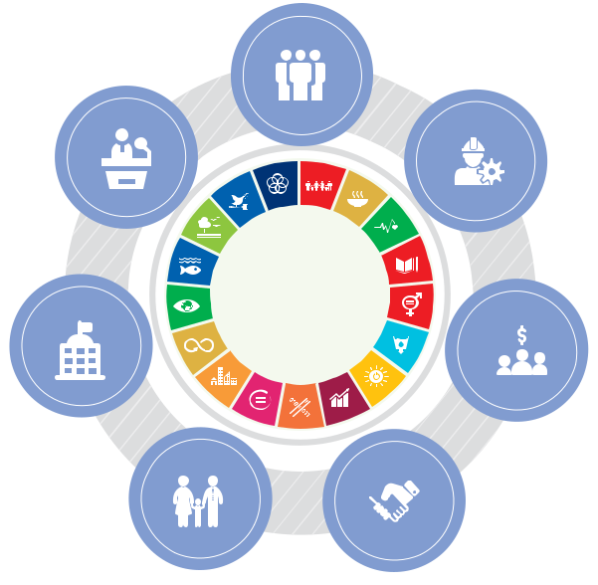

As being a company operating in construction industry,

Coteccons’ benefits are associated with several stakeholders

including clients, shareholders, sub-contractors, suppliers,

workforce and employee, the Government, and the

community. Our core business values of transparency,

cooperation, conscientiousness, commitment, and

creativity have been the principles to build a sustainable

relationship between Coteccons with relevant stakeholders

to create long-term values and benefits in the last 15 years.



**WITH CUSTOMERS**

Our commitment to sustainable engagement with customers is based on our reputation and quality of work. Coteccons has continuously strived to apply world-class technology and technique in its projects in order to deliver quality works meeting highest requirements from clients. Client’s interests is always the Company’s, its sub-contractors’, and suppliers’ top priority in order to develop a sustainable and long-term partnership.



**WITH EMPLOYEES**

As its business culture of ‘Coteccons – more than a family’, Coteccons always determined its human resources as the most valuable assets of the Company. Coteccons has built a professional and enthusiastic team of employees which will lift the Company to a new level. The Board of Management always listens to and appreciates all feedback and recommendations of Coteccons employees, then makes appropriate adjustments to welfare policies. That is the reason why Coteccons is always on the list of businesses with best working condition and is ranked at the first place among construction industry.

**WITH SHAREHOLDERS AND INVESTORS**



Coteccons is aware of fulfilling the information disclosure procedures in accordance with the regulations of the Ministry of Finance and the Stock Exchange, to ensure stakeholders and investors are provided transparent and timely information. Implementing the policy of information exchange and disclosure, ensuring equal investment opportunities for all investors. At the same time, proactively disclosing important information, which is likely to affect interests and decisions of investors, helping shareholders and investors to follow the Company’s operations.



**WITH PARTNERS**

In relation to business partners, Coteccons builds the principles of fair competition, mutually beneficial cooperation and ensuring harmony of interests for customers. With a long-standing reputation in the construction industry, Coteccons has built a close relationship with thousands of subcontractors, suppliers and construction teams. They are always willing to accompany Coteccons on the journey to conquer international-scale buildings with fast progress but ensuring and maintaining outstanding quality.



**WITH THE COMMUNITY AND SOCIETY**

A sustainable business cannot separate the common interests of society. Every year, Coteccons creates several thousand jobs helping improve living standards to thousands of families. The Company has always been a pioneer in social charity activities in order to contribute to a sustainable and developed community. Additionally, Coteccons also pays attention to construction technique improvement with the purpose of reducing negative impact to environment during construction process.



**WITH AUTHORIES AND THE GOVERNMENT**

Coteccons strictly adheres to the current regulations and standards of Vietnamese law in all activities. At the same time, Coteccons is constantly pursuing higher and higher standards in the construction industry with the aim of completing sustainable projects. The company actively cooperates with local authorities in the construction implementation, contributes to the State budget, and follows the State’s guidelines in each stage of development.



**WITH MEDIA**

Coteccons builds good relationships with communication agencies based on equality, transparency and legitimacy. Messages and information provided to the media always ensure the accuracy, clarity, completeness and objectivity, providing the reliable source of information about the Company’s operation situation. In addition, Coteccons also carefully resolves media crisis, calmly correcting false information as well as giving appropriate, thoroughly considered and accurate statements for the media.

132 STAND FIRM IN CHALLENGES 133

**SUSTAINABLE DEVELOPMENT**



**REPORT**



**REPORT CONTENTS**



**FEEDBACK COLLECTING SYSTEM FOR STAKEHOLDERS**



COTECCONS HAS EFFECTIVELY DEVELOPED A STRONG SYSTEM THAT IMPROVES THE INFORMATION

**Stakeholder**

**PARTNERS**



**Approach**



»» Direct meetings and communication »» Meetings and workshops

»» Year-end party for suppliers, subcontractors, construction teams

»» Other channels: website, email, etc.



**Concerns**

»» Selection process for subcontractors,suppliers and construction teams.

»» Payment process for subcontractors,suppliers and construction teams.

»» Long-term source of works

»» Transparency and equality

»» Collaborative development



EXCHANGE PROCESS. MANY INTERACTION CHANNELS HAVE BEEN ESTABLISHED AND ENHANCED IN ORDER TO ENSURE OUR PROACTIVITY, COMPREHENSIVENESS, CLOSENESS AND TIMELINESS IN RECEIVING FEEDBACKS FROM STAKEHOLDERS. BASED ON RECEIVED FEEDBACK, COTECCONS SHALL DEVELOP OUR BUSINESS ACTIVITIES ACCORDINGLY TOWARDS THE SUSTAINABLE DEVELOPMENT GOAL.



**COMMUNITY,**

**SOCIETY**



**GOVERNMENT**

»» Volunteering campaigns for a loving and shared community.

»» Continuation of associating programs with universities.



»» Coordination with local authorities in fire prevention and fighting, environmental

»» Linking responsibilities to the community, contributing to building a more humane society.

»» Create jobs for students and attractyoung talents.



»» Stringent compliance with Regulations, Laws, and Instructions of authorized

**Stakeholder**

**CLIENTS - DEVELOPERS**



|  |  |  |
| --- | --- | --- |
| **Approach** | **Concerns** | |
| »» Direct meeting and communication, | »» Quality is the first criterion. | |
| contact via phone, email with the | »» | Reputation and prestige. |
| developer. | »» | Construction progress. |
| »» Consultancy conferences on construction | »» | Cost of construction. |
| techniques. | »» | Construction techniques. |
| »» Training courses on guiding skills | »» | Construction team. |
| in implementing Labour safety in | »» | Work safety |
| construction. |  |  |
| »» Coteccons website, social network: |  |  |
| Facebook, forum... |  |  |

protection, construction safety.



»» Joining industry-related associations and

seminars.

»» Comment on inadequacies in the

implementation of State policies and

regulations.

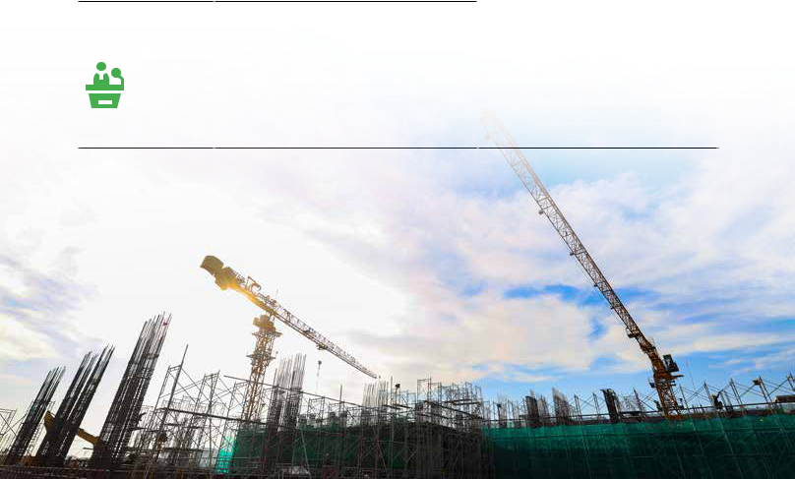

bodies.

»» Ensuring construction safety issues for all projects.

»» Minimization of adverse effects to the environment.

»» Join the Association of constructioncontractors, Steering Committee BIM..



**ENDING BUYERS**



|  |  |  |  |  |
| --- | --- | --- | --- | --- |
| »» Market research survey... | |  |  |  |
| »» | Direct meeting and communication, contact | »» | The experience of user on the quality |  |
|  | via phone, email with endcustomers after | »» | of the project. |  |
| »» | the project is handed over. | Real safety and effectiveness. |  |
| Coteccons website, social network: |  |  |  |



Facebook, forum...

»» Market research survey



|  |  |  |  |
| --- | --- | --- | --- |
| **MEDIA,** | »» Promptly and accurately disclosure of | »» | Information delivered accurately |
| **COMMUNICATION** | information on public. |  | and clearly. |
|  | »» Timely and transparent financial statements | »» Transparent and timely financial | |
|  | announcement. |  | figures disclosures. |
|  | »» Press releases when events occur. | »» | Good relationships with |
|  |  |  | communication agencies |

**EMPLOYEES**



»» Surveys with all employees about the working environment, remuneration plan, benefit packages, the job, supervisors, colleagues, etc.

»» Internal announcements, newsletter, phone, e-mail, etc.

»» Internal and external training



»» Professional stability, career progression, work environment

»» Salary, benefits and welfare packages »» Training and development »» Seniority scheme

»» Safe working environment



|  |  |  |  |  |
| --- | --- | --- | --- | --- |
| **SHAREHOLDERS,** | »» | Direct communication and consultation | »» | Business effectiveness |
| **INVESTORS** | »» | Meetings and workshops | »» | Shareholders’ rights |
|  | »» | Annual General Meeting | »» | Equality and fairness |
|  | »» Other channels: website, email, phone, etc. | | »» Transparent, comprehensive and accurate | |
|  |  |  |  | information |



134 STAND FIRM IN CHALLENGES 135

**SUSTAINABLE DEVELOPMENT**



**REPORT**

**REPORT CONTENTS**



**EVALUATION ON THE KEY ISSUES**

**KEY ISSUES**

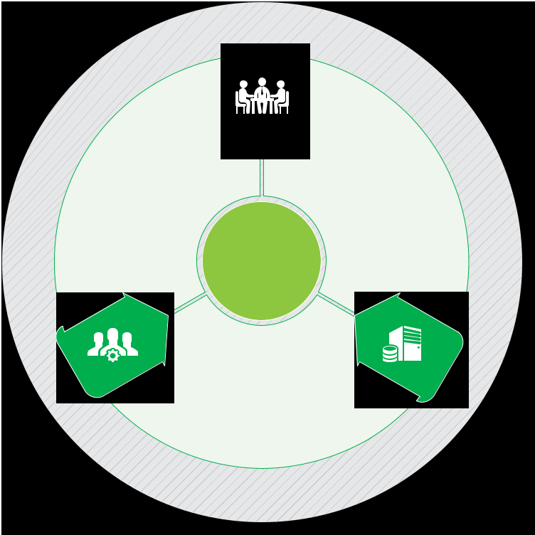

**A MATRIX OF IMPORTANCE**



A matrix evaluating the High - Low levels of the “Importance towards stakeholders” and the “Importance towards Coteccons”

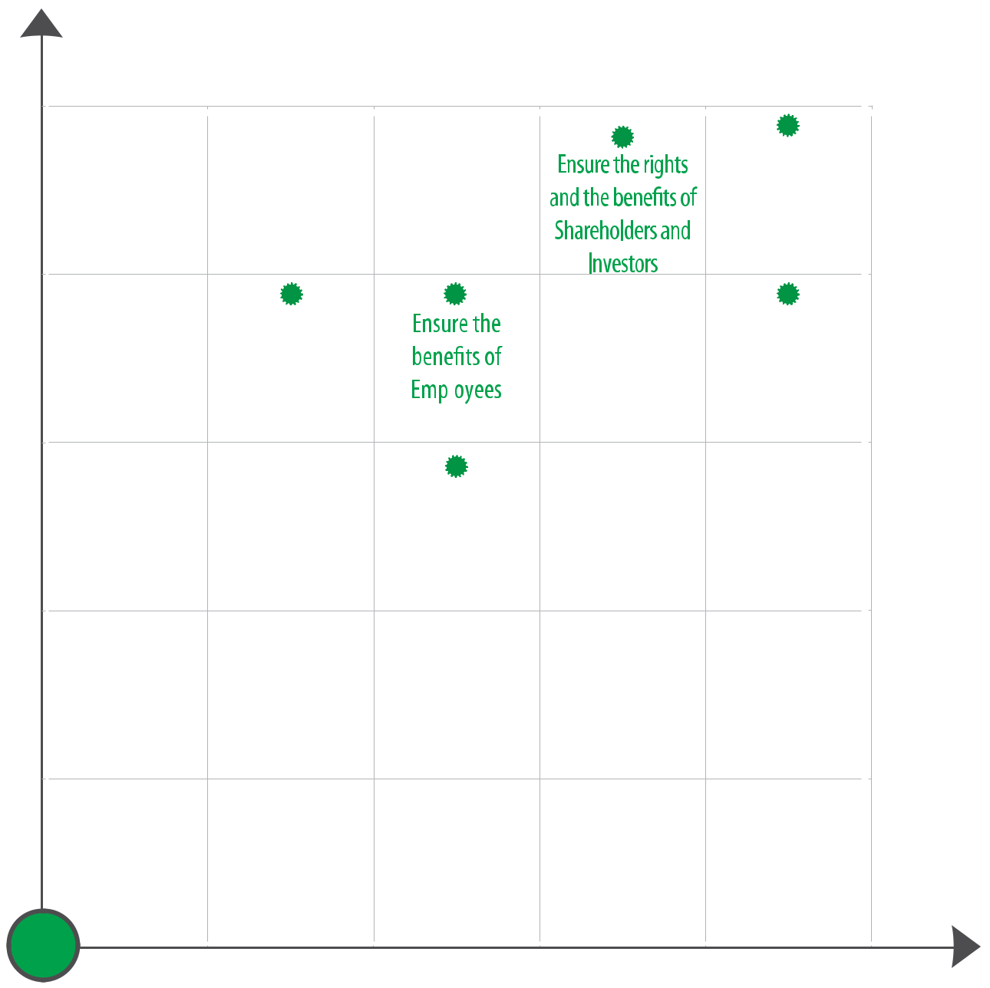

**a** **l**

**c** **i**

**o**

|  |
| --- |
| **S** |

**C**

**g**

**l** **o**

**a** **t** **a**

**E** **c** **o** **n**

**o**

**m**

**i**

**c**

**s**

**C**

**a**

**t**

**a**

|  |
| --- |
| **l** |

**o**

**g**

HIGH

Sustainability

oriented

management

Contribute to the

|  |  |  |  |  |  |  |  |  |  |  |
| --- | --- | --- | --- | --- | --- | --- | --- | --- | --- | --- |
| **E** |  |  |  |  |  |  |  |  | **g** |  |
| **n** | |  |  |  |  |  |  | **o** | |  |
|  | **v** | |  |  |  |  | **l** | | |  |
|  |  | **i** | |  |  | **a** | | |  |  |
|  |  |  | **r** | |  | **t** | |  |  |  |
|  |  |  |  | **o** |  | **C** |  |  |  |  |
|  |  |  |  |  | **nment** | **a** |  |  |  |  |
|  |  |  |  |  |  |  |  |  |  |



|  |  |  |  |  |  |  |
| --- | --- | --- | --- | --- | --- | --- |
|  | **ECONOMICS** | **ENVIRONMENTAL** | | **SOCIAL CATALOG** | |  |
|  | **CATALOG** |  | **CATALOG** |  |
|  |  |  |  |  |
| »» | Economic operational | »» | Environmental | »» | Jobs |  |
| »» | effectiveness | »» | protection | »» | Occupational health |  |
| Indirect economic | Management of | »» | and safety |  |
|  | impacts | »» | materials | Education and |  |
|  |  | Technical and | »» | training |  |
|  |  |  | material solutions | Local community |  |
|  |  |  | involving the | »» | Association with |  |
|  |  |  | environment |  | universities |  |

|  |  |  |  |  |
| --- | --- | --- | --- | --- |
| towards stakeholders | development of |  | Build corporate |  |
|  | culture |  |
| local communities |  |  |
|  |  |  |
|  | Protect | |  |
| Importance |  |  |
|  | environment | |  |
|  |  |  |  |

LOW

LOW Importance towards Coteccons HIGH

136 STAND FIRM IN CHALLENGES 137

**SUSTAINABLE DEVELOPMENT**



**REPORT**



**SUSTAINABILITY ORIENTATION**



**CORPORATE SUSTAINABILITY**

**ORIENTATION**

During 15 years of development, Coteccons has always associated economic growth with environmental protection and social responsibility which is the foundation for the Company’s long-term sustainable development orientation.

The implementation of the economic objectives combined with the implementation of other social and environmental objectives ensures the balance between the benefits of the stakeholders involved at present and in the future, as well as guarantees the long-term and sustainable development strategy for Coteccons.



**CORPORATE SUSTAINABILITY**

***Improving the corporate governance system***



In 2019, the Company’s operation was affected by macro and market factors, Coteccons strongly applied a change strategy across the Company to improve the system, eliminate and adjust the processes and procedures that were no longer appropriate with the current activity to adapt to the difficult situation of the market. In addition, the Internal Audit Board also promoted activities to detect, prevent risks, non-conformance issues, ensure compliance of the system during the operation of all construction sites, divisions and departments of the Company.

***Risk management***



The Company’s risk management system has been developed in recent years. Risk management is focused and implemented throughout the bidding, project operations until the end of the warranty period. Each department, construction site has established procedures, forms to detect and manage risks early. The real estate and construction market is expected to face many difficulties in year 2020, the Company continues to promote the ranking and risk assessment of the construction sites, departments, divisions to have a timely response plan, to prevent and minimize the impact on the Company’s business operations.

***Investors relation***



Coteccons Investors Relation department is an important information bridge to connect the Company to shareholders and investors. In 2019, the Company continues to organize meetings to introduce and provide information to domestic and foreign investors.

***Dividend payouts***



Coteccons performs annual dividend payouts in a stable manner. (See details about the dividend payout policy in Annual Report page 78, 86).

***Sustainable economic development***



With the difficult situation of macro and market factors in year 2019, the Company still maintains a high value of revenue and profit for shareholders, confirming Coteccons’ leading position in the Vietnam market.

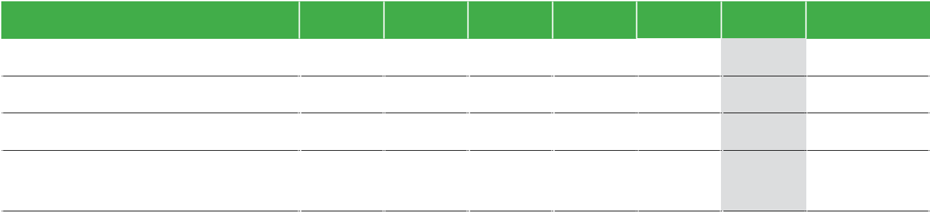

**Indicator (VND billion)**

Revenue

Profit before tax

Profit after tax

Profit after tax attributable to Shareholders of the Parent company

|  |  |  |  |  |  |  |
| --- | --- | --- | --- | --- | --- | --- |
| **2014** | **2015** | **2016** | **2017** | **2018** | **2019** | **CAGR** |
| 7,634 | 13,699 | 20,783 | 27,177 | 28,561 | 23,733 | 25% |
| 464 | 927 | 1,762 | 2,060 | 1,873 | 891 | 14% |
| 357 | 733 | 1,422 | 1,653 | 1,510 | 711 | 15% |
| 327 | 666 | 1,422 | 1,653 | 1,510 | 711 | 17% |

138 STAND FIRM IN CHALLENGES 139

**SUSTAINABLE DEVELOPMENT**



**REPORT**

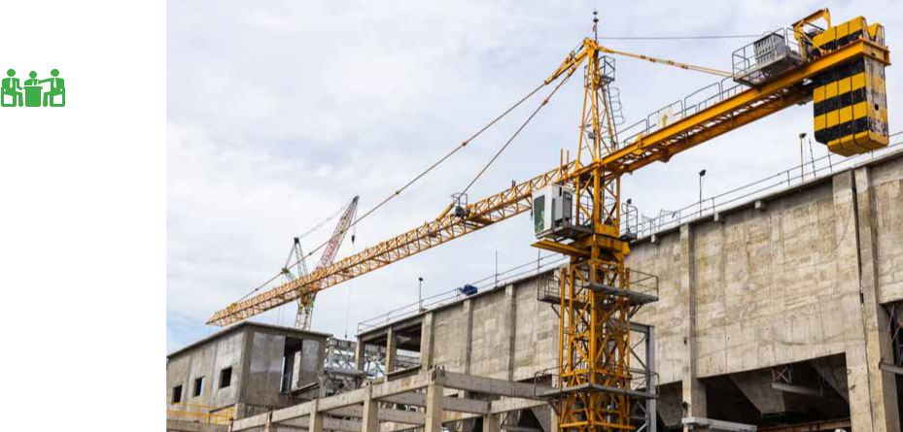

**SUSTAINABILITY ORIENTATION**



**CORPORATE SUSTAINABILITY**

**HUMAN RESOURCE DEVELOPMENT**

Building strong, experienced, effective – engaged human resources is Coteccons’ competitive advantage. In the strategy of human resource management, the Board of Management focuses on solutions for building, training and developing highly qualified personnel in key areas.

In addition to the full benefit package of remuneration, insurance and welfare policies for employees; Coteccons continues to research and improve welfare policies for employees in year 2019, including:

* Comprehensive health insurance for employees and family members.
* Cooperating with prestigious hospitals, continuing to conduct periodic health check for employees with expanded health list, increasing benefits for employees.
* Conducting supporting programs and find capable and enthusiastic candidates right from the university.

**MANAGEMENT OF PRODUCTS**

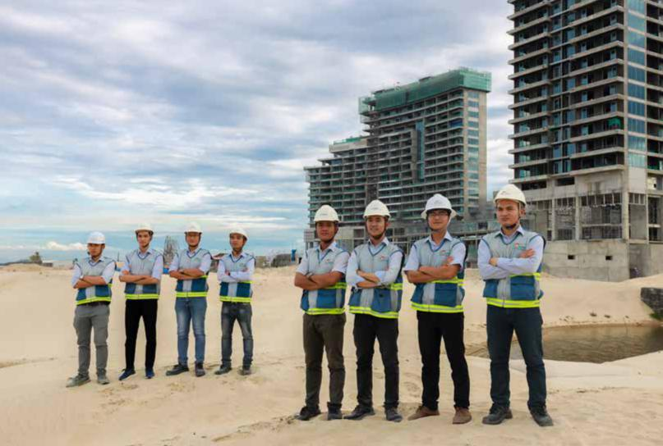

 ***Materials***

All input materials checked and evaluated by Technical Division and Site Management Committees of Coteccons, through the supplier selection stage, in order to meet project’s requirements. These materials have to go through different stages and revaluation before being massively applied on construction sites. In regards to new materials, Technical Division along with a strong network of specialists proposes timely technical solutions to enable Site Management Committees more initiative to work and consulting clients and suppliers to meet a variety of stringent requirements about quality and progress of any project. Coteccons has developed a supplier, subcontractor evaluation checklist to help on periodically examining and evaluating significant supplier, subcontractor to optimize the Company’s selection of high-quality suppliers, bringing the optimal-quality end products for both investors and customers. In 2020, Coteccons shall continue to develop more materials standardization and reducing deviation among projects branded under Coteccons Group, improving the Company’s reputation to clients and customers.

 ***Project’s quality control process***

The application of BIM to Coteccons’ projects has enabled effective control and compatibility of Architectural, Base and Electricity blueprints. Meanwhile, the application has allowed us to identify anomalies in a timely manner to drive suitable mitigation solutions. During the construction time, Coteccons has frequently supervised, supported, trained and evaluated the project quality (Technical Division, Equipment Department, Safety Board, Risk Control Board, etc.). Apart from proceeding systems provided by Consultants, and the Developer’s Project Management Board, Coteccons has established independent inspection units that reports to senior executives to lay a foundation for suitable and timely adjustments and awards.

140 STAND FIRM IN CHALLENGES 141

**SUSTAINABLE DEVELOPMENT**



**REPORT**

**SUSTAINABILITY ORIENTATION**



**ENVIRONMENTAL PROTECTION ACTIVITIES**



**USE OF MATERIALS AND TECHNICAL SOLUTIONS**



**TO ENVIRONMENTAL PROTECTION**

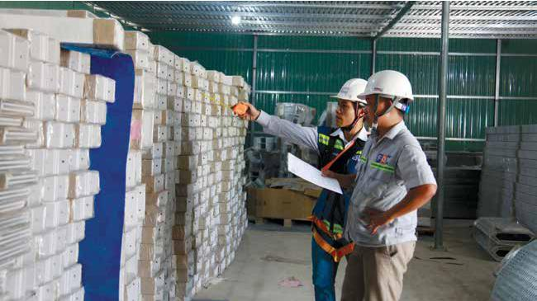

**AT CONSTRUCTION SITES**

»» Strictly apply labor code of protection and general hygiene procedures at construction sites according to the Company’s regulations.

»» Communicate with construction workers to use materials, fuel, electricity and water effectively and to avoid wastage.

»» Shield dusty areas and water traffic roads during the dry season by water trucks. All material-transporting vehicles are covered with tarpaulins to limit the

**AT THE OFFICE**

»» Promote 5S program (Sort, Sustain, Set, Shine, Standardize) in order to build a green, clean and scientific working environment.

»» Encourage the reuse of stationery and one-sided paper, saving printing papers…

»» Minimize the amount of unnecessary printing documents, encourage the exchange of work via e-mail, technological devices ...

THE USE OF ENVIRONMENTALLY FRIENDLY MATERIALS (GREEN MATERIALS) IS BECOMING AN ESSENTIAL TREND AND THE GOAL OF THE WHOLE CONSTRUCTION INDUSTRY. GREEN MATERIAL PRODUCTS MUST MEET TWO REQUIREMENTS: CONSUMING LESS ENERGY THAN THE AMOUNT TO CREATE IT, AND SAVING POWER CONSUMPTION WHEN PUT INTO USE.



**In order to contribute to the environmental protection, Coteccons has implemented:**

impact on the environment.

»» Install noise reduction equipment for machines that produce high level of noise such as generators, compressors...

»» Sign contracts with agencies with the function of collecting, transporting and treating wastes which are likely to impact the environment.

»» Turn off electrical equipment and air-conditioners when no longer in use.

»» Substitute baked clay bricks with new materials such as assembled Acotec wall panels, coarse-grained cement bricks, AAC bricks... to minimize environmental impacts.

»» Actively coordinate with concrete suppliers to increase the content of fly ash (recycled materials), apply mass concrete construction methods for most of Coteccons Group’s projects.

In 2019, Coteccons continued to promote the application of unburnt or assembling materials in replacement of clay bricks, encouraging the usage level of environmentally friendly materials. Researching and applying green materials to Coteccons Group’s project as a premise to popularize these materials in construction industry.

142 STAND FIRM IN CHALLENGES 143

**SUSTAINABLE DEVELOPMENT**

**REPORT**

**ORGANIZE UNION ACTIVITIES TO IMPROVE THE SPIRITUAL AND CULTURAL LIFE FOR EMPLOYEES**

**COTECCONS GAMES**

*Coteccons Games is held every year to create a lively atmosphere, enhance solidarity between individuals and division in the Company thereby promoting the physical training movement of employees. In 2019, the Coteccons Games was held in the North and the South with 5 sports: football, tug of war, relay run, bag jumping and slow bicycle, which gathered nearly 1,000 employees and that is the most awaited festival of the year.*

**YEAR-END PARTY**

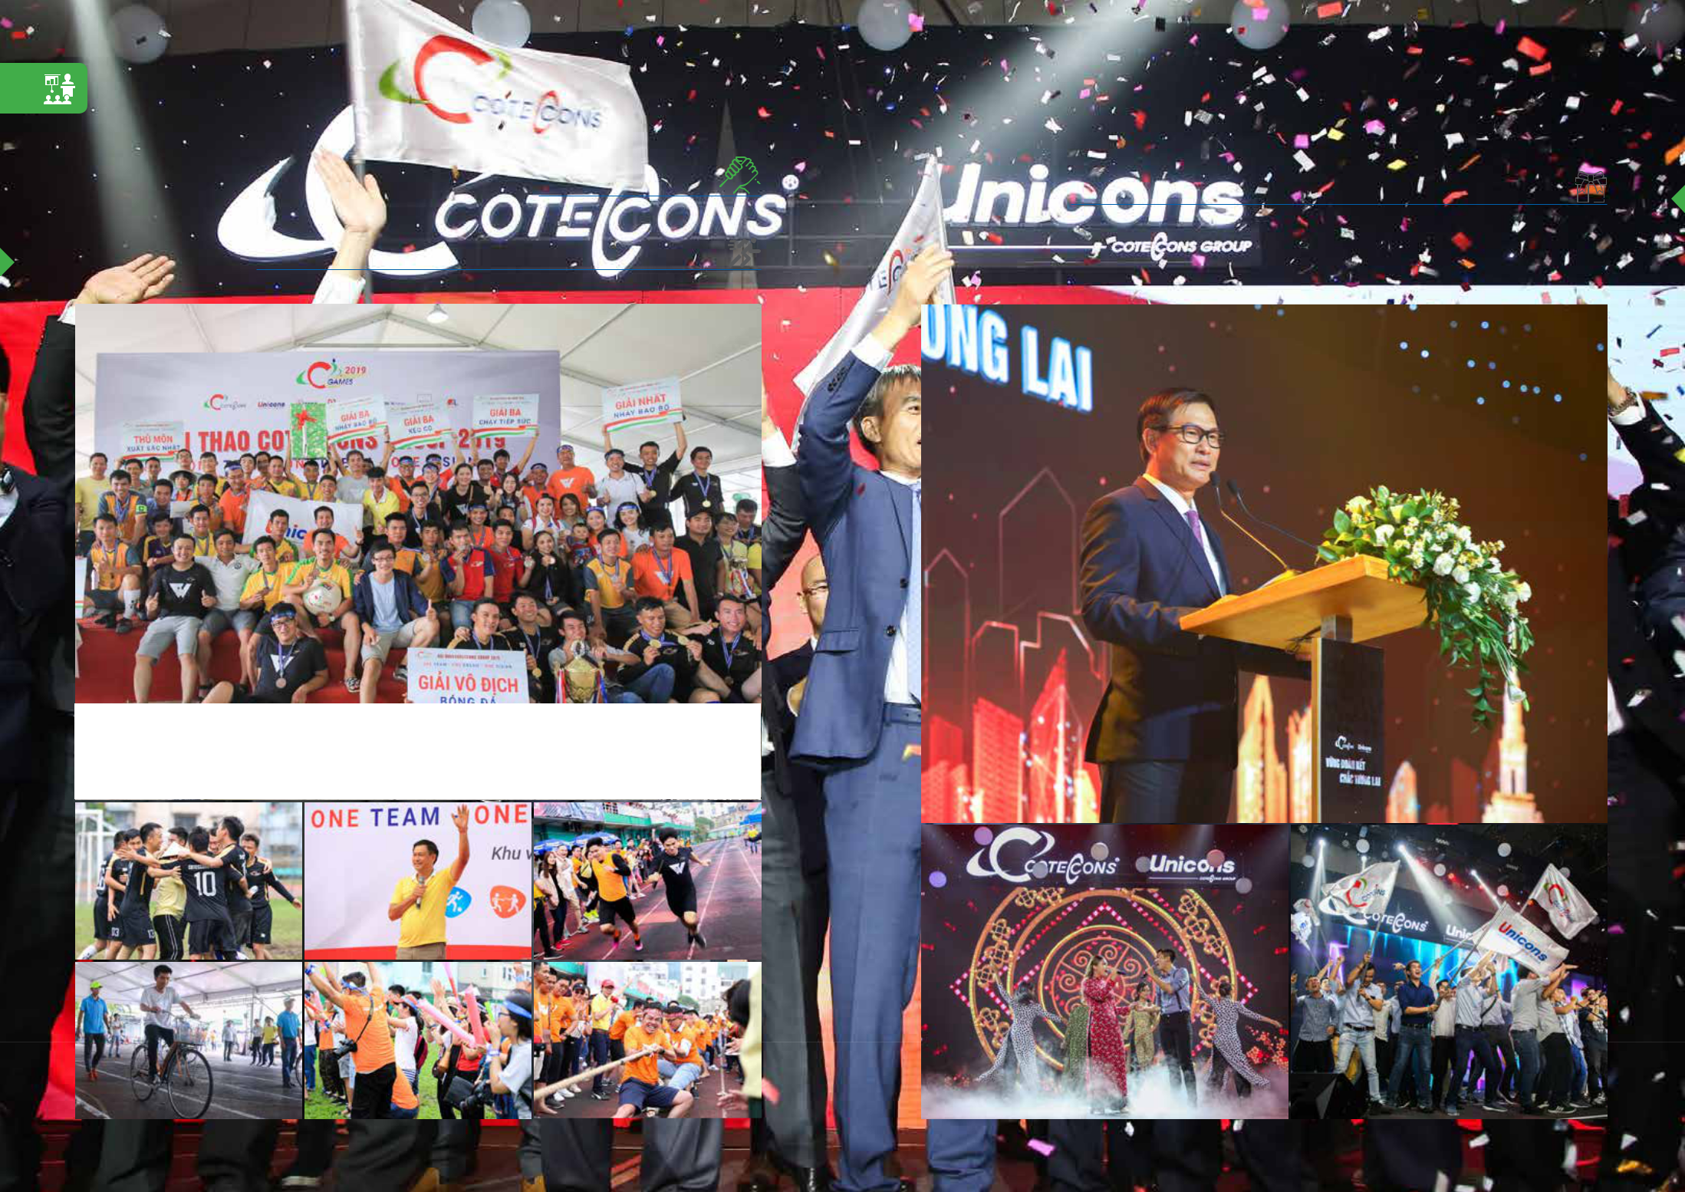

*Year-end party is place for all Coteccons employees working in divisions, construction sites across the country to converge after a year hard work. In addition to sharing the Company’s business activities for the year and orienting for a new year, employees also enjoy entertainment programs to enrich the spiritual cultural activities of Coteccons-er.*

144 STAND FIRM IN CHALLENGES 145

**SUSTAINABLE DEVELOPMENT**



**REPORT**



**CONTRIBUTION TO THE SOCIAL DEVELOPMENT**



**CONTRIBUTING TO THE NATIONAL BUDGET**



IN 2019, COTECCONS GROUP CONTRIBUTED VND 208 BILLION FOR THE NATIONAL BUDGET, ALONGSIDE WITH OTHER ECONOMIC VALUES THE GROUP BROUGHT TO ITS CUSTOMERS, COMMUNITY AND THE SOCIETY



CONTRIBUTING**208**



VND BILLION

FOR THE NATIONAL BUDGET



**GENERATING JOBS FOR LOCAL WORKERS**

In 2019, with more than 30 simultaneous projects, Coteccons has employed more than 28,000 construction workers nationwide, generating long-term jobs for a massive group of local workers, providing stable salaries for thousands of households, contributing to the development of the society. Aside, Coteccons has collaborated with more than 1,500 construction units to provide training to improve skills, passion and productivity for all workers.

COLLABORATING**1**WITH**.500**MORETHAN CONSTRUCTION UNITS

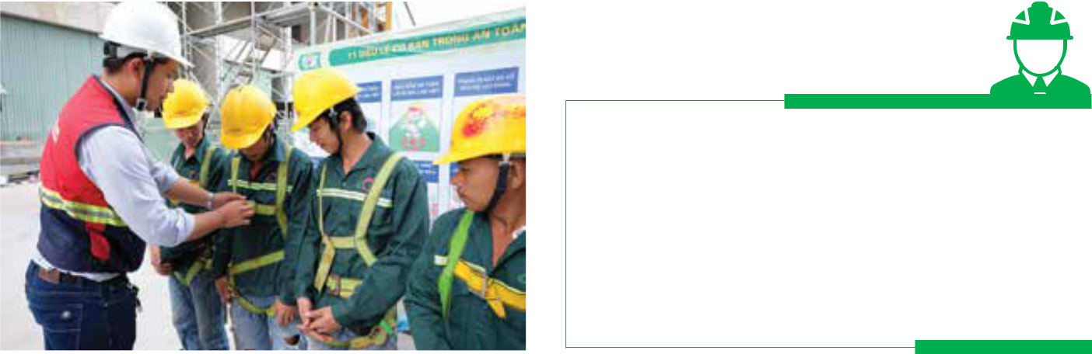

146 STAND FIRM IN CHALLENGES

**DEVELOPING LONG-TERM PARTNERSHIPS**

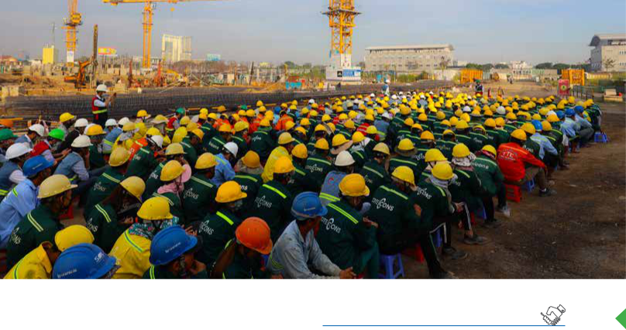

During the development process, Coteccons has built partners, suppliers, subcontractors with a professional working style and expanding the scale of operations. Our partners, during their partnership with Coteccons, showed a consensus on the role of Coteccons in supporting them improving system and human resource, not only in skills but also in their passion, professionalism, initiatives and internal bonding.



**COLLABORATION WITH UNIVERSITIES**

Coteccons is proud that a majority of our managerial executive and high-level employees are former students of prestigious universities in the country, such as University of Polytechnic, University of Architecture, University of Construction, etc. Working with Universities through education sponsorships generates a high-quality skilled workforce for the society and our strong commitment and relationships with universities continues to provide more job opportunities for new graduates.

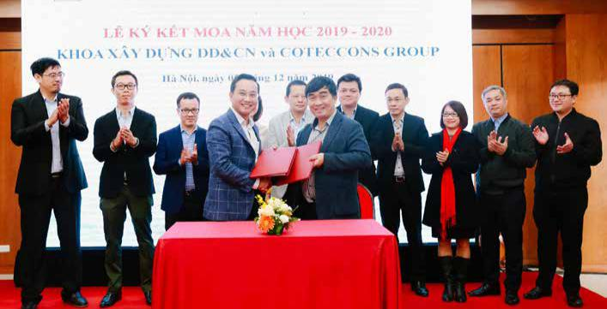

147

**SUSTAINABLE DEVELOPMENT**

**REPORT**

**CONTRIBUTION TO THE SOCIAL DEVELOPMENT**

**SOCIAL AND COMMUNITY ACTIVITIES**

**In 2019, Coteccons has supported the community with the contribution of nearly VND 4 billion, including the following activities:**

Support for 330 cases eye surgeries at a cost of **VND 330 million**.



­Support for patients in Oncology Hospital for poor patients at a cost of **VND 322 million**.



148 STAND FIRM INCHALLENGES



Sponsoring­ heart surgery for poor children with congenital hearts totaling **VND 230 million**.

Support for relatives of employees with difficult circumstances **VND 395 million.**

149

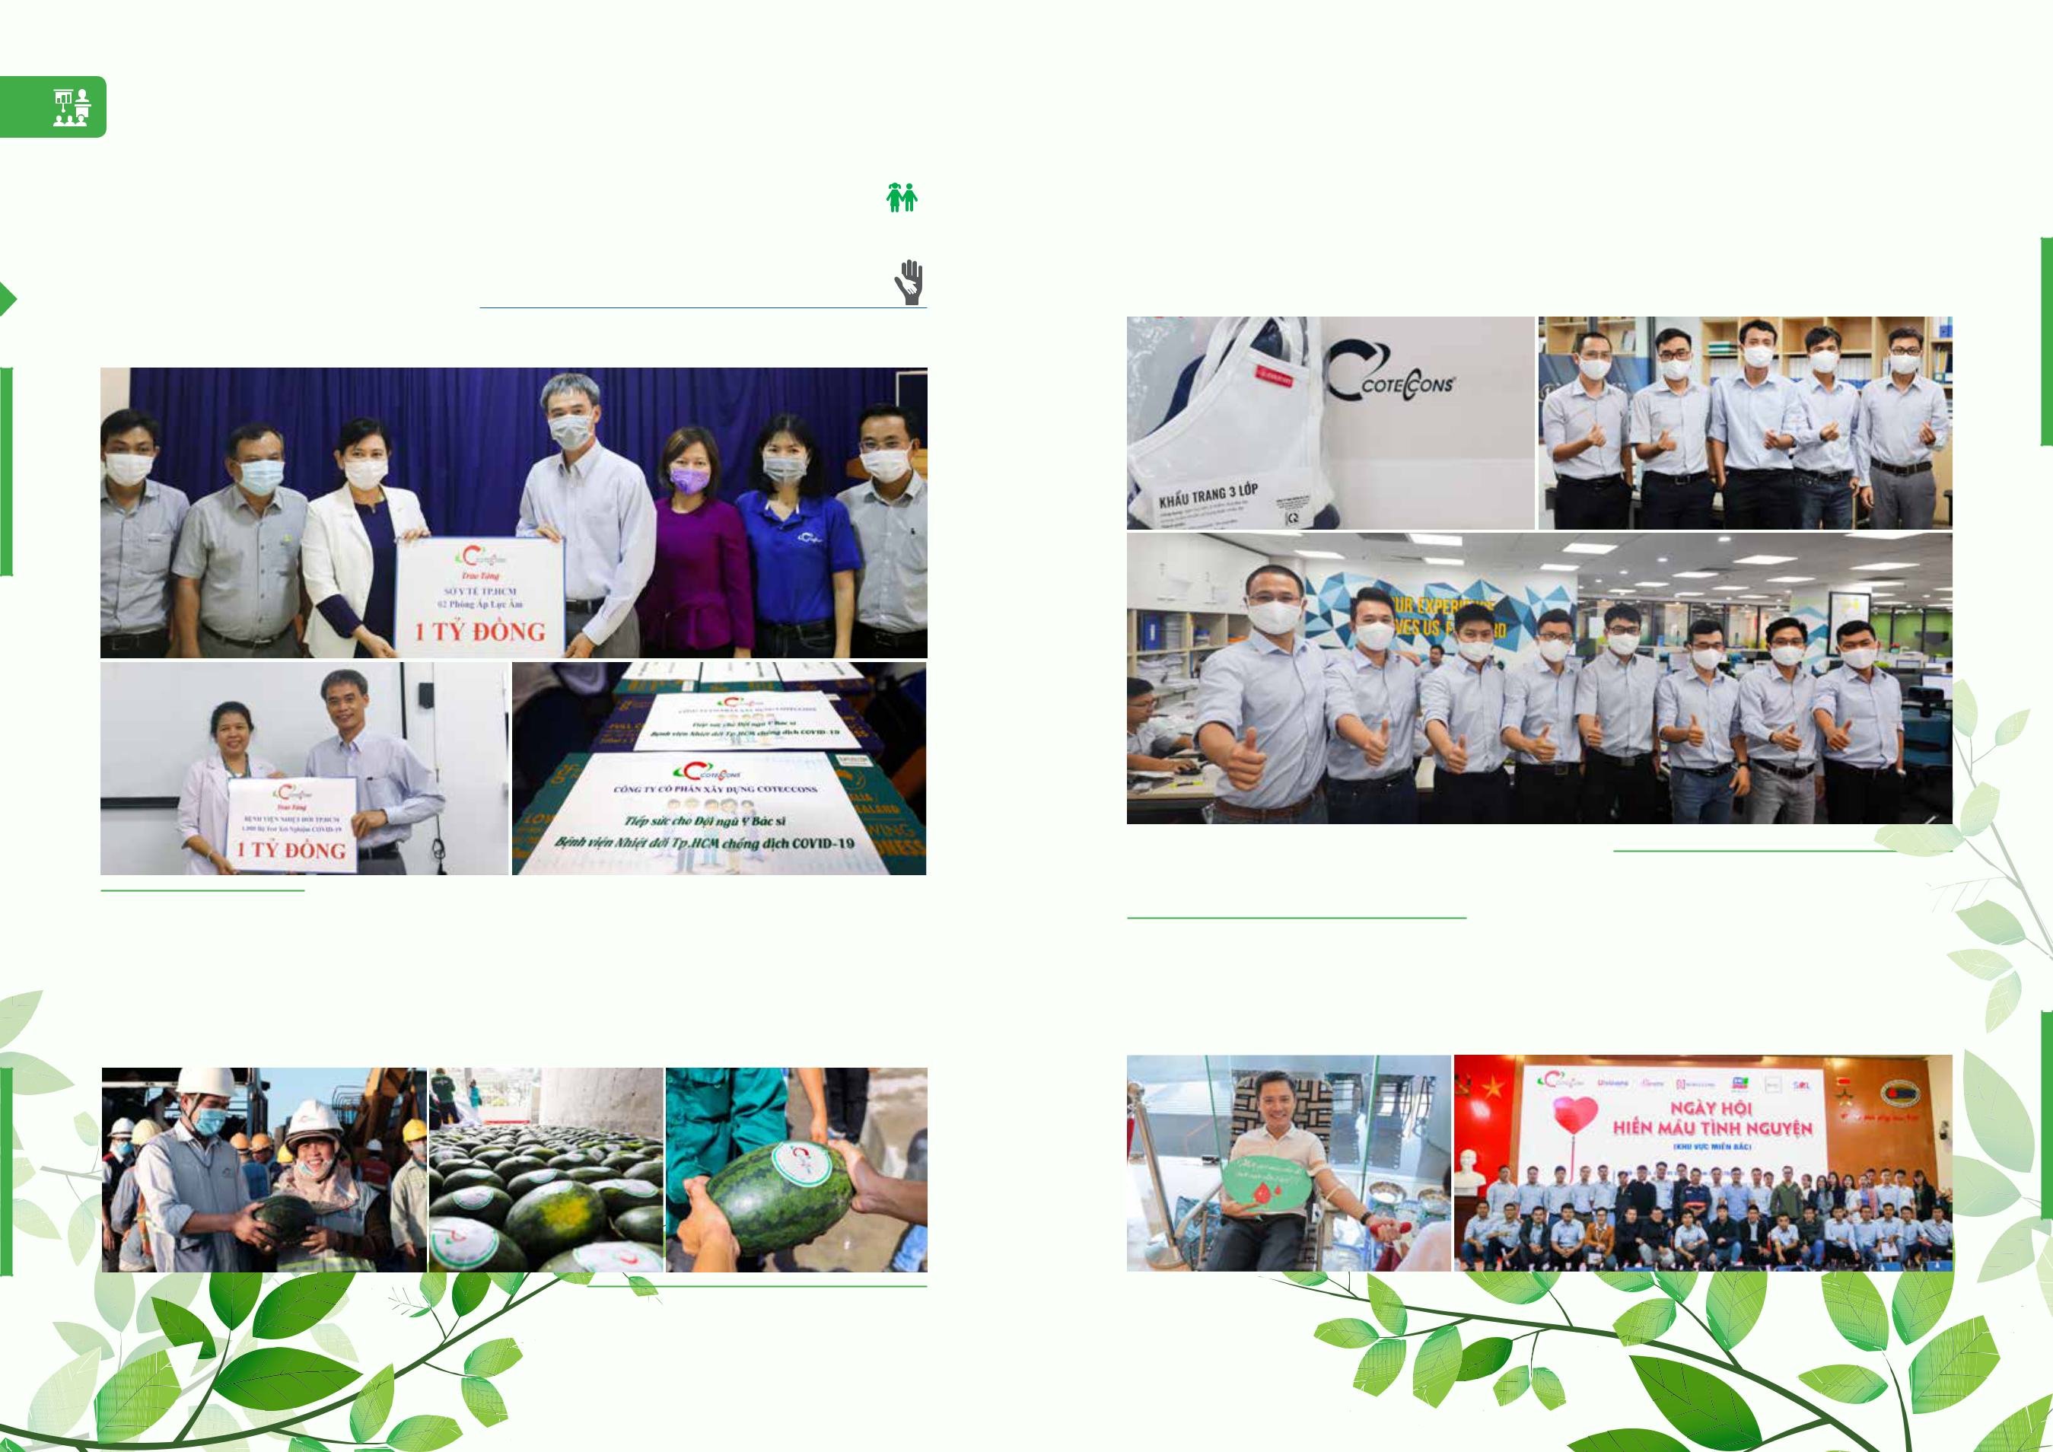**SUSTAINABLE DEVELOPMENT**

**REPORT**

**CONTRIBUTION TO THE SOCIAL DEVELOPMENT**

**SOCIAL AND COMMUNITY ACTIVITIES**

Responding to the Prime Minister’s call “All people support for the prevention of Covid-19”, Coteccons promptly supported more than **VND 2 billion** to equip supplies and equipment for virus treatment and testing. Follow which awarded the Department of Health Ho Chi Minh City 02 negative pressure rooms, worth VND 1 billion and Tropical Hospital Ho Chi Minh City 1,000 test suites testing equivalent to VND 1 billion, in addition to empowering the frontline team of doctors 30 crates of fresh milk to increase strengthening health in the battle against Covid-19.

Also relatedto the effects of the Covid-19, Coteccons bought **30 tons** **of****watermelon** to support farmers inrescuing agricultural products and giving free to workers at construction sites.



150 STAND FIRM IN CHALLENGES



Awarding **6,000 masks** to employees contributing to the prevention of Covid-19, worth VND 60 million.

Propaganda campaign to participate in “Coteccons Voluntary Blood Donation Day” held on November 2nd,  2019 with 450 employees participated, each employee donated from 250-450 ml of blood donated to the  Humanitarian Blood Donation Center Ho Chi Minh City and the Ha Noi Central Institute of Blood Transfusion  and Hematology and contributed to the City’s general blood fund for life saving treatment. 

151

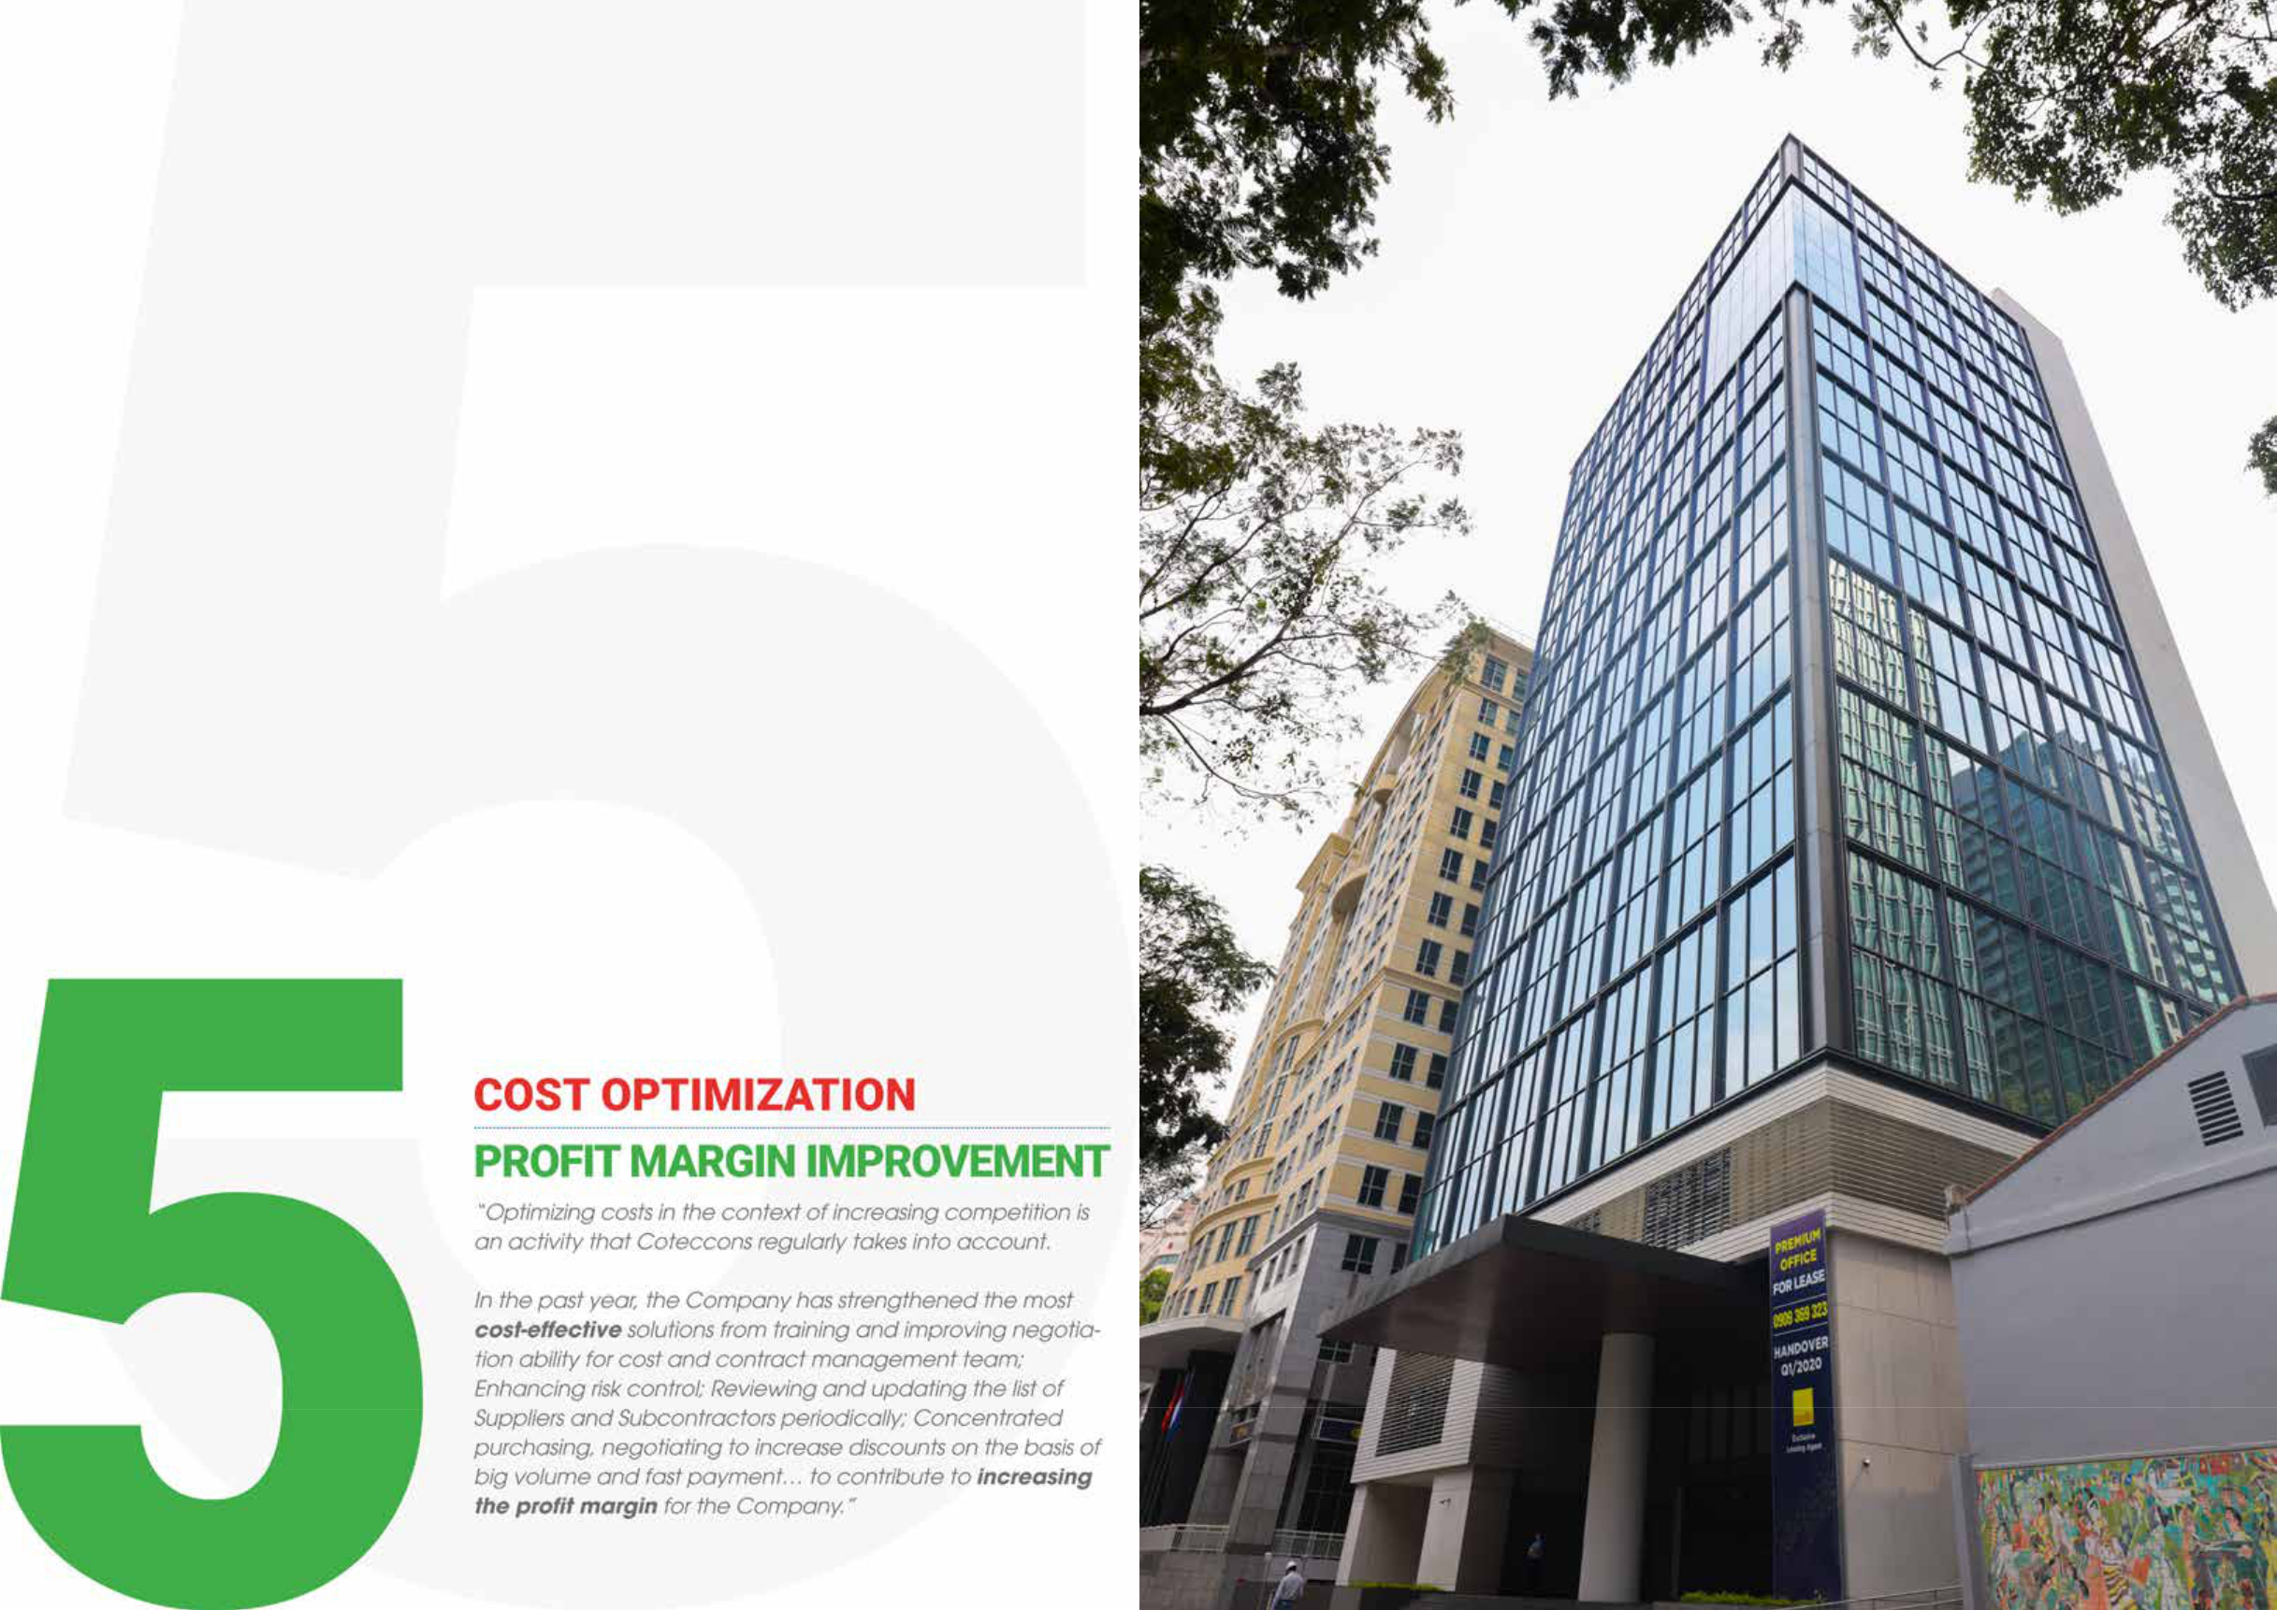

|  |  |  |  |
| --- | --- | --- | --- |
| 152 STAND FIRM IN CHALLENGES | **Friendship Tower** | 153 |  |
| Ho Chi Minh City |  |
|  |  |  |

**COTECCONS CONSTRUCTION JOINT STOCK COMPANY**

CONSOLIDATED FINANCIAL STATEMENTS

FOR THE YEAR ENDED 31 DECEMBER 2019

|  |  |
| --- | --- |
| **TABLE OF CONTENTS** | **PAGE** |
| Corporate information | 155 |
| Statement by the Board of Management | 156 |
| Independent auditor’s report | 157 |
| Consolidated balance sheet (Form B 01a – DN/HN) | 159 |
| Consolidated income statement (Form B 02a – DN/HN) | 161 |
| Consolidated cash flow statement (Form B 03a – DN/HN) | 162 |
| Notes to the consolidated financial statements (Form B 09a – DN/HN) | 164 |

|  |  |  |
| --- | --- | --- |
|  |  | **CORPORATE** |
|  |  | INFORMATION |
| **ENTERPRISE REGISTRATION** | Business Registration Certificate No. 4103002611 dated 24 August 2004 | |
| **CERTIFICATE** | issued by the Department of Planning and Investment of Ho Chi Minh | |
|  | City and subsequent amended Enterprise Registration Certificate No. | |
|  | 0303443233 dated 23 August 2010 and its latest amended Enterprise | |
|  | Registration Certificate dated 8 March 2019. |  |
| **BOARD OF DIRECTORS** | **Mr. Nguyen Ba Duong** | Chairman |
|  | **Mr. Nguyen Sy Cong** | Member |
|  | **Mr. Tran Quyet Thang** | Member |
|  | **Mr. Nguyen Quoc Hiep** | Member |
|  | **Mr. Talgat Turumbayev** | Member |
|  | **Mr. Tan Chin Tiong** | Member |
|  | **Mr Yerkin Tatishev** | Member |
| **BOARD OF SUPERVISION** | **Mr. Luis Fernando Garcia Agraz** | Head |
|  | **Mr. Dang Hoai Nam** | Member |
|  | **Mr. Nguyen Minh Nhut** | Member |
| **BOARD OF MANAGEMENT** | **Mr. Nguyen Sy Cong** | General Director |
|  | **Mr. Tran Quang Quan** | Deputy General Director |
|  | **Mr. Tu Dai Phuc** | Deputy General Director |
|  | **Mr. Tran Van Chinh** | Deputy General Director |
|  | **Mr. Vo Thanh Liem** | Deputy General Director |
| **LEGAL REPRESENTATIVE** | **Mr. Nguyen Ba Duong** | Chairman |
| **REGISTERED OFFICE** | 236/6 Dien Bien Phu, Ward 17, Binh Thanh |  |
|  | District, Ho Chi Minh City, Vietnam |  |
| **AUDITOR** | PwC (Vietnam) Limited |  |

154 STAND FIRM IN CHALLENGES 155

STATEMENT

**OF THE BOARD OF MANAGEMENT**

**STATEMENT OF RESPONSIBILITY OF THE BOARD OF MANAGEMENT OF THE COMPANY IN RESPECT OF THE CONSOLIDATED FINANCIAL STATEMENTS**

The Chairman has authorized the Board of Management of Coteccons Construction Joint Stock Company (“the Company”) to be responsible for preparing the consolidated financial statements of the Company and its subsidiaries (together, “the Group”) which give a true and fair view of the consolidated financial position as at 31 December 2019, and of the consolidated results of its operations and its consolidated cash flows for the year then ended. In preparing these consolidated financial statements, the Board of Management is required to:

* select suitable accounting policies and then apply them consistently;
* make judgments and estimates that are reasonable and prudent; and
* prepare the consolidated financial statements on a going concern basis unless it is inappropriate to presume that the Group will continue in business.

The Board of Management is responsible for ensuring that proper accounting records are kept which disclose, with reasonable accuracy at any time, the consolidated financial position of the Group and which enable consolidated financial statements to be prepared which comply with the basis of accounting set out in Note 2 to the consolidated financial statements. The Board of Management is also responsible for safeguarding the assets of the Group and hence for taking reasonable steps for the prevention and detection of fraud or errors.

**APPROVAL OF THE CONSOLIDATED FINANCIAL STATEMENTS**

We hereby approve the accompanying consolidated financial statements as set out on pages 159 to 195 which give a true and fair view of the consolidated financial position of the Group as at 31 December 2019, and of the consolidated results of its operations and its consolidated cash flows for the year then ended in accordance with Vietnamese Accounting Standards, the Vietnamese Corporate Accounting System and applicable regulations on preparation and presentation of consolidated financial statements.

On behalf of the Board of Management



**Nguyen Sy Cong**

General Director

Ho Chi Minh City, SR Vietnam

27 March 2020

**INDEPENDENT AUDITOR’S REPORT**

**INDEPENDENT AUDITOR’S REPORT TO THE SHAREHOLDERS OF COTECCONS CONSTRUCTION JOINT STOCK COMPANY**

We have audited the accompanying consolidated financial statements of Coteccons Construction Joint Stock Company (“the Company”) and its subsidiaries (together, “the Group”) which were prepared on 31 December 2019 and approved by the Board of Management on 27 March 2020. These consolidated financial statements include the consolidated balance sheet as at 31 December 2019, the consolidated income statement and consolidated cash flow statement for the year then ended, and notes to these consolidated financial statements, as set out on pages 159 to 195.

The Board of Management’s Responsibility

The Board of Management of the Company is responsible for the preparation and the true and fair presentation of the consolidated financial statements in accordance with Vietnamese Accounting Standards, the Vietnamese Corporate Accounting System and applicable regulations on preparation and presentation of consolidated financial statements and for such internal control which the Board of Management determines is necessary to enable the preparation and fair presentation of consolidated financial statements that are free from material misstatement, whether due to fraud or error.

Auditor’s Responsibility

Our responsibility is to express a conclusion on consolidated financial statements based on our audit. We conducted our audit in accordance with Vietnamese Standards on Auditing. Those standards require that we comply with ethical standards and requirements and plan and perform the audit in order to obtain reasonable assurance as to whether the consolidated financial statements are free from material misstatement.

An audit involves performing procedures to obtain audit evidence about the amounts and disclosures in the consolidated financial statements. The procedures selected depend on the auditor’s judgment, including an assessment of the risks of material misstatement of the consolidated financial statements, whether due to fraud or error. In making those risk assessments, the auditor considers internal control relevant to the Group’s preparation and true and fair presentation of the consolidated financial statements in order to design audit procedures that are appropriate in the circumstances, but not for the purpose of expressing an opinion on the effectiveness of the Group’s internal control. An audit also includes evaluating the appropriateness of accounting policies used and the reasonableness of accounting estimates made by the Board of Management, as well as evaluating the overall presentation of the consolidated financial statements.

156 STAND FIRM IN CHALLENGES 157

**INDEPENDENT AUDITOR’S REPORT**

(CONTINUED)

Auditor’s Opinion

In our opinion, the consolidated financial statements present fairly, in all material respects, the consolidated financial position of the Group as at 31 December 2019, its consolidated financial performance and consolidated cash flows for the year then ended in accordance with Vietnamese Accounting Standards, the Vietnamese Corporate Accounting System and applicable regulations on the preparation and presentation of consolidated financial statements.

Auditor’s Opinion

The independent auditor’s report is prepared in Vietnamese and English. Should there be any conflict between the Vietnamese and English copies, the Vietnamese copy shall take precedence.



For and on behalf of PwC (Vietnam) Limited



**Mai Viet Hung Tran** **Tran Van Thang**

Audit Practising Licence No. Audit Practising Licence No.

0048-2018-006-1 3586-2017-006-1

Authorised signatory

Report reference number: HCM9180

Ho Chi Minh City, 27 March 2020

**CONSOLIDATED**

|  |  |  |  |  |  |
| --- | --- | --- | --- | --- | --- |
| Form B 01 – DN/HN | |  | BALANCE SHEET | | |
|  |  |  |  | |  |
|  |  |  | **As at 31 December** | | |
|  |  |  |  |  |  |
|  |  |  | **2019** | **2018** | |
| **Code** | **ASSETS** | **Note** | **VND** |  | **VND** |
| **100** | **CURRENT ASSETS** |  | **14,727,405,324,722** |  | **15,323,459,276,998** |
| **110** | **Cash and cash equivalents** | **3** | **800,791,418,362** | **552,833,230,980** | |
| 111 | Cash |  | 116,191,418,362 | 149,333,230,980 | |
| 112 | Cash equivalents |  | 684,600,000,000 | 403,500,000,000 | |
| **120** | **Short-term investment** |  | **3,241,650,000,000** | **3,907,058,000,000** | |
| 123 | Investments held to maturity | 4 | 3,241,650,000,000 | 3,907,058,000,000 | |
| **130** | **Short-term receivables** |  | **8,797,679,575,624** | **9,053,952,559,022** | |
| 131 | Short-term trade accounts receivable | 5 | 8,416,090,588,256 | 8,583,155,443,151 | |
| 132 | Short-term prepayments to suppliers | 6 | 397,567,198,072 | 408,522,628,085 | |
| 136 | Other short-term receivables | 7 | 198,529,552,115 | 272,136,385,866 | |
| 137 | Provision for doubtful debts – short-term | 8 | (214,507,762,819) | (209,861,898,080) | |
| **140** | **Inventory** |  | **1,626,319,466,015** | **1,443,523,976,605** | |
| 141 | Inventory | 9 | 1,626,319,466,015 | 1,443,523,976,605 | |
| **150** | **Other current assets** |  | **260,964,864,721** | **366,091,510,391** | |
| 151 | Short-term prepaid expenses | 10(a) | 3,456,235,463 | 3,715,158,612 | |
| 152 | Value Added Tax (“VAT”) to be reclaimed |  | 257,508,629,258 | 362,376,351,779 | |
| **200** | **LONG-TERM ASSETS** |  | **1,471,429,330,005** | **1,499,602,669,344** | |
| **220** | **Fixed assets** |  | **704,482,424,910** | **743,708,162,486** | |
| 221 | Tangible fixed assets | 11(a) | 606,653,633,812 | 648,195,904,621 | |
| 222 | Historical cost |  | 1,055,852,299,665 | 1,033,129,306,154 | |
| 223 | Accumulated depreciation |  | (449,198,665,853) | (384,933,401,533) | |
| 227 | Intangible fixed assets | 11(b) | 97,828,791,098 | 95,512,257,865 | |
| 228 | Historical cost |  | 118,687,800,078 | 111,780,039,500 | |
| 229 | Accumulated amortisation |  | (20,859,008,980) | (16,267,781,635) | |
| **230** | **Investment properties** | **12** | **49,603,357,264** | **52,358,883,694** | |
| 231 | Historical cost |  | 69,677,550,622 | 69,677,550,622 | |
| 232 | Accumulated depreciation |  | (20,074,193,358) | (17,318,666,928) | |
| **240** | **Long-term assets in progress** |  | **161,115,839,300** | **1,005,828,500** | |
| 241 | Long-term work in progress | 13 | 160,541,000,000 | - | |
| 242 | Construction in progress |  | 574,839,300 | 1,005,828,500 | |
| **250** | **Long-term investment** |  | **394,287,974,564** | **350,744,031,635** | |
| 252 | Investments in associates | 14 | 394,287,974,564 | 350,744,031,635 | |
| **260** | **Other long-term assets** |  | **161,939,733,967** | **351,785,763,029** | |
| 261 | Long-term prepaid expenses | 10(b) | 161,939,733,967 | 348,602,442,291 | |
| 262 | Deferred income tax assets | 33 | - | 3,183,320,738 | |
| **270** | **TOTAL ASSETS** |  | **16,198,834,654,727** | **16,823,061,946,342** | |
|  |  |  |  |  |  |



*The notes on pages 164 to 195 are an integral part of these consolidated financial statements.*

158 STAND FIRM IN CHALLENGES 159

**CONSOLIDATED**

|  |  |  |  |  |
| --- | --- | --- | --- | --- |
| BALANCE SHEET (CONTINUED) | |  |  | Form B 01 – DN/HN |
|  |  |  |  |  |
|  |  |  | **As at 31 December** | |
|  |  |  |  |  |
|  |  |  | **2019** | **2018** |
| **Code** | **RESOURCES** | **Note** | **VND** | **VND** |
|  |  |  |  |  |
| **300** | **NỢ PHẢI TRẢ** |  | **7,729,313,976,168** | **8,860,568,747,448** |
| **310** | **Short-term liabilities** |  | **7,710,283,750,131** | **8,851,372,781,946** |
| 311 | Short-term trade accounts payable | 15 | 4,571,387,201,404 | 5,813,051,490,169 |
| 312 | Short-term advances from customers | 16 | 720,914,499,291 | 671,428,472,219 |
| 313 | Tax and other payables to the State | 17 | 87,849,950,894 | 164,994,438,949 |
| 315 | Short-term accrued expenses | 18 | 2,102,171,113,108 | 1,759,584,094,811 |
| 318 | Short-term unearned revenue | 19 | 54,781,130,228 | 5,135,013,358 |
| 319 | Other short-term payables | 20(a) | 41,603,836,458 | 204,297,216,319 |
| 321 | Provision for short-term liabilities | 21(a) | 65,205,053,085 | 75,606,055,937 |
| 322 | Bonus and welfare fund | 22 | 66,370,965,663 | 157,276,000,184 |
| **330** | **Long-term liabilities** |  | **19,030,226,037** | **9,195,965,502** |
| 337 | Other long-term payables | 20(b) | 542,006,657 | 662,352,826 |
| 341 | Deferred income tax liabilities | 33 | 12,177,967,496 | - |
| 342 | Provision for long-term liabilities | 21(b) | 6,310,251,884 | 8,533,612,676 |
| **400** | **OWNERS’ EQUITY** |  | **8,469,520,678,559** | **7,962,493,198,894** |
| **410** | **Capital and reserves** |  | **8,469,520,678,559** | **7,962,493,198,894** |
| 411 | Owners’ capital | 23, 24 | 792,550,000,000 | 783,550,000,000 |
| *411a* | *- Ordinary shares with voting rights* | *23, 24* | *792,550,000,000* | *783,550,000,000* |
| 412 | Share premium | 24 | 3,038,990,175,385 | 2,997,645,175,385 |
| 415 | Treasury shares | 24 | (443,424,538,999) | (439,558,938,999) |
| 418 | Investment and development fund | 24 | 3,998,330,960,122 | 3,016,565,960,122 |
| 421 | Undistributed earnings | 24 | 1,029,019,001,156 | 1,604,291,002,386 |
| *421a - Undistributed earnings of the previous years* | | *24* | *318,128,283,386* | *93,883,453,112* |
| *421b* | *- Post-tax profit of current year* | *24* | *710,890,717,770* | *1,510,407,549,274* |
| 429 | Non-controlling interests | 24 | 54,055,080,895 | - |
| **440** | **TOTAL RESOURCES** |  | **16,198,834,654,727** | **16,823,061,946,342** |
|  |  |  |  |  |



**Ha Thi Thuy Hang** **Vu Thi Hong Hanh** **Nguyen Sy Cong**

Preparer Chief Accountant General Director

27 March 2020

*The notes on pages 164 to 195 are an integral part of these consolidated financial statements.*

**CONSOLIDATED**

Form B 02 – DN/HN INCOME STATEMENT

**For the year ended 31 December**



|  |  |  |  |  |
| --- | --- | --- | --- | --- |
|  |  |  | **2019** | **2018** |
| **Code ITEMS** | | **Note** | **VND** | **VND** |
|  |  |  |  |  |
| **01** | **Revenue from sales of goods and rendering of services** |  | **23,733,028,252,165** | **28,560,857,297,395** |
| 02 | Less deductions |  | - | - |
| **10** | **Revenue from sales of goods and rendering of services** | 27 | **23,733,028,252,165** | **28,560,857,297,395** |
| **11** | **Cost of goods sold and services rendered** | 28 | **(22,684,921,110,980)** | **(26,727,845,024,426)** |
| **20** | **Gross profit from sales of goods and rendering of services** |  | **1,048,107,141,185** | **1,833,012,272,969** |
| 21 | Financial income | 29 | 263,864,493,550 | 321,096,425,107 |
| 22 | Financial expenses |  | (9,346,944) | (256,508,001) |
| 24 | Share of profit of investments in associates | 14 | 4,069,273,547 | 97,618,204,914 |
| 26 | General and administration expenses | 30 | (458,979,143,450) | (505,217,213,266) |
| **30** | **Net operating profit** |  | **857,052,417,888** | **1,746,253,181,723** |
| 31 | Other income | 31 | 41,825,059,246 | 141,186,784,790 |
| 32 | Other expenses | 31 | (8,146,550,269) | (14,465,680,949) |
| **40** | **Net other income** |  | **33,678,508,977** | **126,721,103,841** |
| **50** | **Net accounting profit before tax** |  | **890,730,926,865** | **1,872,974,285,564** |
| **51** | **Business income tax (“BIT”) - current** | **32** | **(164,453,039,966)** | **(362,105,809,452)** |
| **52** | **BIT - deferred** | **32, 33** | **(15,361,288,234)** | **(460,926,838)** |
| **60** | **Net profit after tax** |  | **710,916,598,665** | **1,510,407,549,274** |
|  | **Attributable to:** |  |  |  |
| **61** | **Shareholders of the company** |  | **710,890,717,770** | **1,510,407,549,274** |
| **62** | **Non-controlling interests** |  | **25,880,895** | **-** |
| **70** | **Basic earnings per share** | **34** | **8,859** | **18,357** |
| **71** | **Diluted earnings per share** | **34** | **8,859** | **18,357** |
|  |  |  |  |  |

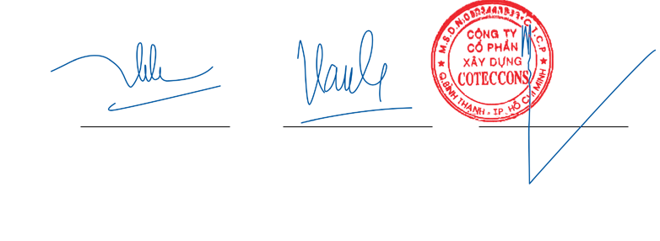

**Ha Thi Thuy Hang** **Vu Thi Hong Hanh** **Nguyen Sy Cong**

Preparer Chief Accountant General Director

27 March 2020

*The notes on pages 164 to 195 are an integral part of these consolidated financial statements.*

160 STAND FIRM IN CHALLENGES 161

**CONSOLIDATED**

CASH FLOW STATEMENT

(Indirect method) Form B 03 – DN/HN

**For the year ended 31 December**



|  |  |  |  |  |
| --- | --- | --- | --- | --- |
|  |  |  | **2019** | **2018** |
| **Code** | **ITEMS** | **Note** | **VND** | **VND** |
|  |  |  |  |  |
|  | **CASH FLOWS FROM OPERATING ACTIVITIES** |  |  |  |
| **01** | **Net accounting profit before tax** |  | **890,730,926,865** | **1,872,974,285,564** |
|  | Adjustments for: |  |  |  |
| 02 | Depreciation and amortisation |  | 108,513,963,904 | 93,961,932,263 |
| 03 | Reversal of provisions |  | (6,825,375,905) | (2,334,235,286) |
| 04 | Unrealised foreign exchange (gains)/losses |  | (636,401,875) | 177,561,364 |
| 05 | Profits from investing activities |  | (273,887,773,585) | (420,738,017,892) |
| **08** | **Operating profit before changes in working capital** |  | **717,895,339,404** | **1,544,041,526,013** |
| 09 | Decrease/(increase) in receivables |  | 311,858,953,486 | (2,797,703,359,814) |
| 10 | (Increase)/decrease in inventories |  | (182,795,489,410) | 430,287,773,421 |
| 11 | (Decrease)/increase in payables |  | (997,251,807,534) | 331,806,119,643 |
| 12 | Decrease in prepaid expenses |  | 186,921,631,473 | 55,321,720,026 |
| 15 | BIT paid |  | (207,963,845,299) | (386,537,444,561) |
| 17 | Other payments on operating activities |  | (167,578,157,521) | (111,107,156,003) |
| **20** | **Net cash outflows from operating activities** |  | **(338,913,375,401)** | **(933,890,821,275)** |
|  | **CASH FLOWS FROM INVESTING ACTIVITIES** |  |  |  |
| 21 | Purchases of fixed assets |  | (76,630,918,237) | (134,239,595,441) |
| 22 | Proceeds from disposals of fixed assets |  | 9,545,855,152 | 17,589,916,354 |
| 23 | Term deposits |  | (4,708,893,000,000) | (4,352,058,000,000) |
| 24 | Term deposits collections |  | 5,374,301,000,000 | 5,163,527,000,000 |
| 25 | Investments in associates |  | (163,516,404,212) | (40,590,000,000) |
| 27 | Dividends and interest received |  | 334,358,499,651 | 366,917,856,522 |
| **30** | **Net cash inflows from investing activities** |  | **769,165,032,354** | **1,021,147,177,435** |
|  | **CASH FLOWS FROM FINANCING ACTIVITIES** |  |  |  |
| 31 | Proceeds from issuance of shares and sales of treasury shares |  | 50,345,000,000 | 73,236,000,000 |
| 32 | Payments for share repurchases |  | (3,865,600,000) | (437,817,478,999) |
| 36 | Dividends paid |  | (229,028,397,550) | (390,953,176,000) |
| **40** | **Net cash outflows from financing activities** |  | **(182,548,997,550)** | **(755,534,654,999)** |
| **50** | **Net increase/(decrease) in cash and cash equivalents** |  | **247,702,659,403** | **(668,278,298,839)** |
| **60** | **Cash and cash equivalents at beginning of year** | **3** | **552,833,230,980** | **1,221,114,590,570** |
| 61 | Effect of foreign exchange differences |  | 255,527,979 | (3,060,751) |
| **70** | **Cash and cash equivalents at end of year** | **3** | **800,791,418,362** | **552,833,230,980** |
|  |  |  |  |  |

*The notes on pages 164 to 195 are an integral part of these consolidated financial statements.*

**CONSOLIDATED**

CASH FLOW STATEMENT

Form B 03 – DN/HN (Indirect method - continued)

Major non-cash transactions during the year are mainly sales of fixed assets amounting to VND5,190,836,657 which have not been collected as at 31 December 2019 (as at 31 December 2018: VND1,690,909,091), and purchases of fixed assets amounting to VND764,507,000 which have not been paid as at 31 December 2019 (as at 31 December 2018: VND4,399,656,194).

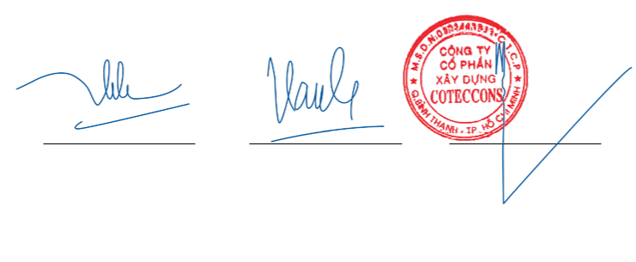

**Ha Thi Thuy Hang** **Vu Thi Hong Hanh** **Nguyen Sy Cong**

Preparer Chief Accountant General Director

27 March 2020

*The notes on pages 164 to 195 are an integral part of these consolidated financial statements.*

162 STAND FIRM IN CHALLENGES 163

NOTES

**THE CONSOLIDATED FINANCIAL STATEMENTS**

For the year ended 31 December 2019 Form B 09 – DN/HN

**1** **GENERAL INFORMATION**

Coteccons Construction Joint Stock Company (“the Company”) is a joint stock company established in SR Vietnam pursuant to Business Registration Certificate No. 4103002611 dated 24 August 2004 issued by the Department of Planning and Investment of Ho Chi Minh City, and subsequent amended Enterprise Registration Certificate No. 0303443233 dated 23 August 2010 and its latest 22nd amended Enterprise Registration Certificate dated 8 March 2019, approving for increase in its charter capital to VND792,550,000,000.

The Company’s shares were listed in the Ho Chi Minh City Stock Exchange with trading code “CTD” in accordance with the Decision No. 155/QĐ-SGDHCM dated 9 December 2009 issued by the Ho Chi Minh City Stock Exchange.

The Group’s principal activities of the Group are to provide design and construction services, equipment installation, interior decoration and office leasing, real estate and construction materials trade.

The normal business cycle of the Group is 12 months.

As at 31 December 2019, the Group had 2 direct subsidiaries which are Unicons Investment Construction Company Limited (“Unicons”) and Covestcons Company Limited (“Covestcons”); and 1 indirect subsidiary is Phu Nhuan 168 Joint Stock Company (“Phu Nhuan 168”) and 4 direct associates as presented in Note 14 and 2 indirect associates are Riland Investment Joint Stock Company (“Riland”) and Quihub Industrial Development and Investment Joint Stock Company (“Quihub”).

1. Unicons, a wholly owned subsidiary of the Company, is a one-member limited liability company established in Ho Chi Minh City pursuant to Business Registration Certificate No. 4103005020 dated 14 July 2006 issued by the Department of Planning and Investment of Ho Chi Minh City, subsequently changed to Enterprise Registration Certificate No. 0304472276 dated 22 June 2018. The principal activities are construction and equipment installation services.
2. Covestcons, a wholly owned subsidiary of the Company, is a one-member limited liability company established in Ho Chi Minh City pursuant to Enterprise Registration Certificate No. 0314326002 dated 31 March 2017 issued by the Department of Planning and Investment of Ho Chi Minh City. The principal activities are engaged in real estate, owned, used and leased land use right business.
3. Phu Nhuan 168, a subsidiary of Covestcons owned 69.98% of charter capital, is a joint stock company astabilished in Ho Chi Minh City pursuant to Enterprise Regestration Certificate No. 0315807693 dated 22 July 2019 issued by the Department of Planning and Investment of Ho Chi Minh City. The principal activities are engaged in real estate, owned, used and leased land use right business.
4. Riland, a 98%-owned subsidiary of Ricons Construction Investment Joint Stock Company (“Ricons”), is a joint stock company established in Ho Chi Minh City pursuant to Enterprise Registration Certificate No. 0315066903 dated 23 May 2018 issued by the Department of Planning and Investment of Ho Chi Minh City. The principal activities are engaged in real estate, owned, used and leased land use right business and construction material trading.
5. Quihub, a 97%-owned subsidiary of Ricons, is a joint stock company established in Binh Dinh Province pursuant to Enterprise Registration Certificate No. 4101553128 dated 4 November 2019 issued by the Department of Planning and Investment of Binh Dinh Province. The principal activities are engaged in real estate, owned, used and leased land use right business.

As at 31 December 2019, the Group had 2,272 employees (as at 31 December 2018: 2,720 employees).

NOTES

**THE CONSOLIDATED FINANCIAL STATEMENTS**

Form B 09 – DN/HN For the year ended 31 December 2019 - Continued

**2** **SUMMARY OF SIGNIFICANT ACCOUNTING POLICIES**

2.1 Basis of preparation of consolidated financial statements

The consolidated financial statements have been prepared in accordance with Vietnamese Accounting Standards, the Vietnamese Corporate Accounting System and applicable regulations on preparation and presentation of consolidated financial statements. The consolidated financial statements have been prepared under the historical cost convention except for investments in associates, and business combinations as presented in Note 2.5.

The accompanying consolidated financial statements are not intended to present the consolidated financial position and consolidated results of operations and its consolidated cash flows in accordance with accounting principles and practices generally accepted in countries and jurisdictions other than Vietnam’s. The accounting principles and practices utilised in Vietnam may differ from those generally accepted in countries and jurisdictions other than Vietnam’s.

The consolidated financial statements in Vietnamese language are the official statutory consolidated financial statements of the Group. The consolidated financial statements in English language have been translated

from the Vietnamese version.

2.2 Fiscal year

The Group’s fiscal year is from 1 January to 31 December.

2.3 Currency

The consolidated financial statements are measured and presented in Vietnamese Dong (“VND”). The Company and its subsidiaries determine their accounting currencies based on the currencies which are mainly used in sales of goods and rendering of services, which have a significant impact on selling prices of goods and services, which are normally used to list selling prices and receive payments; which are mainly used in purchases of goods or services, which have a significant impact on costs of labor, materials and other production or operating costs and normally used as payments for those costs.

Additionally, the Company and its subsidiaries also use these currencies to raise financial resources (such as via issuance of shares or bonds) and/or regularly collect these currencies from business operations and

savings.

2.4 Exchange rates

Transactions arising in foreign currencies are translated at exchange rates ruling at the transaction dates. Foreign exchange differences arising from these transactions are recognised in the consolidated income statement.

Monetary assets and liabilities denominated in foreign currencies at the consolidated balance sheet date are respectively translated at the buying and selling exchange rates at the consolidate balance sheet date of the commercial bank where the Group regularly trades. Foreign currencies deposited in bank at the consolidated balance sheet date are translated at the buying exchange rate of the commercial bank where the Group opens the foreign currency accounts. Foreign exchange differences arising from these translations are recognised in

the consolidated income statement.

2.5 Basis of consolidation

Subsidiaries

Subsidiaries are all entities over which the Group has the power to govern the financial and operating policies in order to gain future benefits from their activities generally accompanying a shareholding of more than one half of the voting rights. The existence and effect of potential voting rights that are currently exercisable or

164 STAND FIRM IN CHALLENGES 165

NOTES

**THE CONSOLIDATED FINANCIAL STATEMENTS**

For the year ended 31 December 2019 - Continued Form B 09 – DN/HN

convertible are considered when assessing whether the Group controls another entity. Subsidiaries are fully consolidated from the date on which control is transferred to the Group. They are de-consolidated from the date that control ceases.

The purchase method of accounting is used to account for the acquisition of subsidiaries by the Group. The cost of an acquisition is measured as the fair value of the assets given, equity instruments issued and liabilities incurred or assumed at the date of exchange, plus costs directly attributable to the acquisition. Identifiable assets acquired and liabilities and contingent liabilities assumed in a business combination are measured initially at their fair values at the acquisition date, irrespective of the extent of any non-controlling interest. The excess of the cost of acquisition over the fair value of the Group’s share of the identifiable net assets acquired is recorded as goodwill. If the cost of acquisition is less than the fair value of the net assets of the subsidiary acquired, the difference is recognised directly in the consolidated income statement.

Inter-company transactions, balances and unrealised gains and losses on transactions between group companies are eliminated. Accounting policies of subsidiaries have been changed where necessary to ensure consistency with the policies adopted by the Group.

The financial statements of the Group’s subsidiaries are prepared for the same accounting period. If there are differences in end dates, the gap must not exceed 3 months. Adjustments are made to reflect impacts of significant transactions and events occurring between the end dates of the subsidiaries’ accounting period and that of the Group’s. The length of the reporting period and differences in reporting date must be consistent between periods.

Non-controlling transactions and interests

The Group applies a policy for transactions with non-controlling interests as transactions with external parties to the Group.

Non-controlling interests (“NCI”) are measured at their proportionate share of the acquiree’s identifiable net assets at date of acquisition.

Associates

Associates are all entities over which the Group has significant influence but not control, generally accompanying a shareholding of between 20% and 50% of the voting rights. Investments in associates are accounted for using the equity method of accounting and are initially recognised at cost. The Group’s investment in associates includes goodwill identified on acquisition, net of any accumulated impairment loss.

The Group’s share of its associates’ post-acquisition profits or losses is recognised in the consolidated income statement, and its share of post-acquisition movements in reserves is recognised in consolidated reserves. The cumulative post-acquisition movements are adjusted against the carrying amount of the investment. When the Group’s share of losses in associates equals or exceeds its interest in associates, the Group does not recognise further losses, unless it has incurred obligations or made payments on behalf of the associates.

Accounting policies of associates have been changed where necessary to ensure consistency with the policies adopted by the Group.

Unrealised gains and losses on transactions between the Group and its associates are eliminated to the extent of the Group’s interest in the associates. Accounting policies of the associates have been changed where necessary to ensure consistency with the policies adopted by the Group.

2.6 Cash and cash equivalents

NOTES

**THE CONSOLIDATED FINANCIAL STATEMENTS**

Form B 09 – DN/HN For the year ended 31 December 2019 - Continued

Cash and cash equivalents comprise cash on hand, cash at bank and other short-term investments with an original maturity of three months or less.

2.7 Trade receivables

Receivables represent trade receivables from customers arising from sales of goods and rendering of services or non-trade receivables from others and are stated at cost. Provision for doubtful debts is made for each outstanding amount based on overdue days in payment according to the initial payment commitment (exclusive of the payment rescheduling between parties) or based on the expected loss that may arise. Bad debts are written off when identified.

Receivables are classified into long-term and short-term receivables on the consolidated balance sheet based on the remaining period from the consolidated balance sheet date to the maturity date.

2.8 Inventories

Construction works-in-progress are stated at the lower of cost and net realisable value. Cost comprises the original cost of purchase plus the cost of bringing the construction materials and construction costs to their present location and condition. Net realisable value is the estimated selling price in the normal course of business, less the estimated costs of completion and necessary estimated hand-over expenses.

2.9 Investments held-to-maturity

Investments held-to-maturity are investments which the Board of Management has a positive intention and ability to hold until maturity.

Investments held-to-maturity include term deposits, treasury bills, bonds, commercial bill, preference shares which the issuer is required to buy back in the future, lendings held to maturity for interest earning, and other investments held-to-maturity. Those investments are initially accounted for at cost. Subsequently, the Board of Management reviews all outstanding investments to determine the amount of provision to recognise at the year end.

Provision for diminution in value of investments held-to-maturity is made when there is evidence that the investment is uncollectible in whole or in part. Changes in the provision balance during the accounting fiscal year are recorded as an increase or decrease in financial expenses. A reversal, if any, is made only to the extent the investment is restored to its original cost.

2.10 Fixed assets

*Tangible and intangible fixed assets*

Fixed assets are stated at historical cost less accumulated depreciation/amortisation. Historical cost includes expenditure that is directly attributable to the acquisition of the fixed assets bringing them to their suitable conditions for their intended use. Expenditure incurred subsequently which has resulted in an increase in the future economic benefits expected to be obtained from the use of fixed assets, can be capitalised as an additional historical cost. Otherwise, they are charged to the consolidated income statement when incurred.

*Depreciation and amortisation*

Fixed assets are depreciated and amortised using the straight-line method so as to write off the historical cost of the fixed assets over their estimated useful lives as follows:

166 STAND FIRM IN CHALLENGES 167

NOTES

**THE CONSOLIDATED FINANCIAL STATEMENTS**

|  |  |  |  |
| --- | --- | --- | --- |
| For the year ended 31 December 2019 - Continued | | Form B 09 – DN/HN | |
|  |  |  | |
|  |  | *Year* | |
|  |  |  |  |
|  | Buildings and structures | 6 | - 45 |
|  | Machinery and equipment | 3 | - 10 |
|  | Motor vehicles |  | 6 - 8 |
|  | Office equipment |  | 3 - 5 |
|  | Software |  | 3 |
|  | Others |  | 5 - 6 |
|  | Land use rights | 45 | - 49 |
|  |  |  |  |

Land use right with indefinite useful life is recorded at historical cost and is not amortised.

*Disposals*

Gains or losses on disposals are determined by comparing net disposal proceeds with the carrying amount of the fixed assets and are recognised as income or expense in the consolidated income statement.

2.11 Investment properties held for lease

The historical cost of an investment property represents the amount of cash or cash equivalents paid or the fair value of other consideration given to acquire the investment property at the time of its acquisition or completion of construction. Expenditure incurred subsequently which has resulted in an increase in the expected future economic benefits from the use of investment properties can be capitalised as an additional historical cost. Otherwise, they are charged to the consolidated income statement when incurred.

*Depreciation*

Investment properties held for lease are depreciated under the straight-line method to write off the historical cost of the assets over their estimated useful lives as follows:

|  |  |
| --- | --- |
|  | *Year* |
|  |  |
| Office buildings | 30 - 45 |
| Others | 25 |
|  |  |

*Disposals*

Gains or losses on disposals are determined by comparing net disposal proceeds with the carrying amount of investment properties and are recognised as income or expense in the consolidated income statement.

2.12 Leased assets

Leases where a significant portion of the risks and rewards of ownership are retained by the lessor are classified as operating leases. Payments made under operating leases are charged to the consolidated income statement on a straight-line basis over the term of the lease.

2.13 Prepaid expenses

Prepaid expenses include short-term and long-term prepayments on the consolidated balance sheet. Prepaid

NOTES

**THE CONSOLIDATED FINANCIAL STATEMENTS**

Form B 09 – DN/HN For the year ended 31 December 2019 - Continued

expenses are recorded at historical cost and allocated on the straight-line basis over estimated useful lives.

2.14 Payables

Classifications of payables are based on their nature as follows:

»*»* Trade accounts payable are trade payables arising from purchase of goods and services.

»*»* Other payables are non-trade payables, and not relating to purchases of goods and services.

Payables are classified into long-term and short-term payables on the consolidated balance sheet based on remaining period from the consolidated balance sheet date to the maturity date.

2.15 Accrued expenses

Accrued expenses include liabilities for goods and services received in the period but not yet paid for due to pending invoice or insufficient records and documents. Accrued expenses are recorded as expenses in the reporting period.

2.16 Provisions

Provisions are recognised when the Group has a present legal or constructive obligation as a result of past events; it is probable that an outflow of resources will be required to settle the obligation and the amount has been reliably estimated. Provision is not recognised for future operating losses.

Provisions are measured at the expenditures expected to be required to settle the obligation. If the time value of money is material, provision will be measured at the present value using a pre-tax rate that reflects current market assessments of the time value of money and the risks specific to the obligation. The increase in the provision due to passage of time is recognised as a financial expense. Changes in the provision balance during the accounting fiscal year are recorded as an increase or decrease in operating expenses.

2.17 Provision for severance allowances

In accordance with Vietnamese labour laws, employees of the Group who have worked regularly for full 12 months or longer, are entitled to a severance allowance. The working period used for the calculation of severance allowance is the period during which the employee actually works for the Group less the period during which the employee participates in the unemployment insurance scheme in accordance with the labour regulations and the working period for which the employee has received severance allowance from the Group.

The severance allowance is accrued at the end of the reporting period on the basis that each employee is entitled to half of an average monthly salary for each working year. The average monthly salary used for calculating the severance allowance is the employee contract’s average salary for the period prior to the consolidated balance sheet date.

This allowance will be paid as a lump sum when the employees terminate their labour contracts in accordance with current regulations.

2.18 Unearned revenue

Unearned revenue mainly comprises the amounts that customers paid in advance for one or many accounting periods for revenues corresponding to the value of goods, services. The Group records unearned revenue for the future obligations that the Group has to fulfill. Once recognition criteria have been satisified, unearned

168 STAND FIRM IN CHALLENGES 169

NOTES

**THE CONSOLIDATED FINANCIAL STATEMENTS**

For the year ended 31 December 2019 - Continued Form B 09 – DN/HN

revenue will be recognised as revenue in the income statement3 to the extent that it has met the recognition criteria.

2.19 Capital and reserves

Owners’ capital is recorded according to the actual amounts contributed and is recorded according to the par value of the shares.

Share premium is the difference between the par value and the issue price of shares and the difference between the repurchase price and re-issuing price of treasury shares.

Treasury shares are shares issued by the Company and bought-back by itself, but these are not cancelled and may be re-issued subsequently in accordance with the Law on securities.

Undistributed earnings record the Group’s consolidated results after business income tax at the reporting date.

2.20 Appropriation of profit

Profit after BIT could be distributed to shareholders after approval at the Annual General Meeting, and after appropriation to other funds in accordance with the Group’s charter and Vietnamese regulations.

1. Development and investment fund

Development and investment fund is appropriated from profit after BIT of the Group and subject to shareholders’ approval at the Annual General Meeting of shareholders. The fund is set aside for the use in the Group’s expansion of its operation or in-depth investments.

1. Bonus and welfare fund

Bonus and welfare fund is appropriated from the Group’s profit after BIT and subject to shareholders’ approval at the Annual General Meeting of shareholders. This fund is presented as a liability on the consolidated balance sheet. The fund is set aside for the purpose of pecuniary rewarding and encouragement, common benefits and improvement of the employees’ benefits.

1. Dividend distribution

Dividend of the Company is recognised as a liability in the consolidated financial statements in the period in which the dividends are approved by the shareholders at the General Meeting of shareholders.

2.21 Revenue recognition

1. Revenue from sale of goods

Revenue from sale of goods is recognised in the consolidated income statement when all five (5) following conditions are satisfied:

»*»* The Group has transferred to the buyer the significant risks and rewards of ownership of the goods;

NOTES

**THE CONSOLIDATED FINANCIAL STATEMENTS**

Form B 09 – DN/HN For the year ended 31 December 2019 - Continued

»*»* The Group retains neither continuing managerial involvement to the degree usually associated with ownership nor effective control over the goods sold;

»*»* The amount of revenue can be measured reliably;

»*»* It is probable that the economic benefits associated with the transaction will flow to the Group; and

»*»* The costs incurred or to be incurred in respect of the transaction can be measured reliably.

No revenue is recognised if there are significant uncertainties regarding recovery of the consideration due or the possible return of goods.

Revenue is recognised in accordance with the “substance over form” principle and allocated to each sales obligation. In cases where the Group gives promotional goods to customers associated with their purchases, the Group allocates the total considerations received between goods sold and promotional goods. The cost of promotional goods is recognised as cost of sales in the consolidated income statement.

1. Revenue from rendering of services

Revenue from rendering of services is recognised in the consolidated income statement when the services are rendered, by reference to completion of the specific transaction assessed on the basis of the actual service provided as a proportion of the total services to be provided. Revenue from rendering of services is only recognised when all four (4) following conditions are satisfied:

»*»* The amount of revenue can be measured reliably;

»*»* It is probable that the economic benefits associated with the transaction will flow to the Group

»*»* The percentage of completion of the transaction at the consolidated balance sheet date can be measured reliably; and

»*»* The costs incurred for the transaction and the costs to complete the transaction can be measured reliably.

1. Revenue from construction contracts

A construction contract is a contract specifically negotiated for the construction of an asset or a combination of assets that are closely interrelated or interdependent in terms of their design, technology and functions or their ultimate purpose of use.

When the outcome of a construction contract can be estimated reliably, revenue and costs are recognised by reference to the amount of work completed and certified by customers. Claimable receivable and other receivable are included in revenue to the extent that they have been agreed and verified by the customers.

When the outcome of a construction contract cannot be reliably estimated, contract revenue is recognised to the extent of contract costs incurred where it is probable those costs will be recoverable. Contract costs are only recognised when incurred during the year.

1. Interest income

Interest income is recognised on an earned basis.

1. Dividend income

Income from dividend is recognised when the Group has established the receiving right from investees.

170 STAND FIRM IN CHALLENGES 171

NOTES

**THE CONSOLIDATED FINANCIAL STATEMENTS**

For the year ended 31 December 2019 - Continued Form B 09 – DN/HN

**2** **SUMMARY OF SIGNIFICANT ACCOUNTING POLICIES (CONTINUED)**

2.22 Cost of goods sold and services rendered

Cost of goods sold and services rendered are cost of materials sold or services provided during the year, and recorded on the basis of matching with revenue and on prudent concept.

2.23 General and administration expenses

General and administration expenses represent expenses for administrative purposes which mainly include salary expenses of administrative staffs; social insurance, medical insurance, labour union fees, unemployment insurance of administrative staff, expenses of office materials, tools and supplies, depreciation of fixed assets used for administration, provision for doubtful debts, outside services and other expenses.

2.24 Current and deferred income tax

Income taxes include all income taxes which are based on taxable profits including profits generated from production and trading activities in other countries with which the Socialist Republic of Vietnam has not signed any double taxation agreement. Income tax expense comprises current tax expense and deferred tax expense.

Current income tax is the amount of income taxes payable or recoverable in respect of the current year taxable profits at the current year tax rates. Current and deferred tax should be recognised as an income or an expense and included in the profit or loss of the period, except to the extent that the tax arises from a transaction or event which is recognised, in the same or a different period, directly in equity.

Deferred income tax is provided in full, using the liability method, on temporary differences arising between the tax bases of assets and liabilities and their carrying amounts in the consolidated financial statements. Deferred income tax is not accounted for if it arises from initial recognition of an asset or liability in a transaction other than a business combination that at the time of occurrence affects neither the accounting nor the taxable profit or loss. Deferred income tax is determined at the tax rates that are expected to apply to the financial year when the asset is realised or the liability is settled, based on tax rates that have been enacted or substantively enacted by the consolidated balance sheet date.

Deferred income tax assets are recognised to the extent that it is probable that future taxable profit will be available against which the temporary differences can be utilised.

2.25 Related parties

Enterprises and individuals that directly, or indirectly through one or more intermediaries, control, or are controlled by, or are under common control with the Group, including holding companies, subsidiaries and fellow subsidiaries are related parties of the Group. Associates and individuals owning, directly or indirectly, an interest in the voting power of the Group that gives them significant influence over the Group, key management personnel, including directors of the Group and close members of the family of these individuals and companies associated with these individuals also constitute related parties.

In considering the related party relationship, the Group considers the substance of the relationship not merely the legal form.

2.26 Segment reporting

NOTES

**THE CONSOLIDATED FINANCIAL STATEMENTS**

Form B 09 – DN/HN For the year ended 31 December 2019 - Continued

A segment is a component which can be separated by the Group engaged in providing products or services (“business segment”), or providing products or services within a particular economic environment (“geographical segment”). Each segment is subject to risks and returns that are different from those of other segments. A reportable segment is the Group’s business segment.

Segment reporting is prepared and presented in accordance with accounting policies applied to the preparation and presentation of the Group’s consolidated financial statements in order to help users of consolidated financial statements understand and evaluate the Group’s operations in a comprehensive way.

2.27 Use of estimates

The preparation of consolidated financial statements in conformity with Vietnamese Accounting Standards, the Vietnamese Corporate Accounting System and applicable regulations on preparation and presentation of consolidated financial statements requires the Board of Management to make estimates and assumptions that affect the reported amounts of assets, liabilities and disclosures of contingent assets and liabilities at the date of the consolidated financial statements and the reported amounts of revenues and expenses during the financial year.

Such estimates and assumptions are continually evaluated. They are based on historical experience and other factors, including expectations of future events that may have a financial impact on the Company and that are believed to be reasonable under the circumstances.

|  |  |  |  |  |
| --- | --- | --- | --- | --- |
| **3** | **CASH AND CASH EQUIVALENTS** | |  |  |
|  |  |  |  |  |
|  |  |  | **2019** | **2018** |
|  |  |  | **VND** | **VND** |
|  |  |  |  |  |
|  | Cash on hand | | 1,985,476,702 | 829,504,253 |
|  | Cash at bank | | 114,205,941,660 | 148,503,726,727 |
|  | Cash equivalents (*) | | 684,600,000,000 | 403,500,000,000 |
|  |  |  | 800,791,418,362 | 552,833,230,980 |
|  |  |  |  |  |

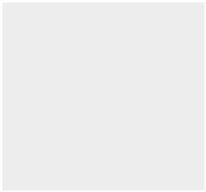

* Including term deposits with original maturity of less than 3 months, earning applicable interest rates.

**4** **INVESTMENTS HELD-TO-MATURITY**

|  |  |  |  |  |
| --- | --- | --- | --- | --- |
|  | **2019** |  | **2018** |  |
|  |  |  |  |  |
|  | **Cost** | **Book value** | **Cost** | **Book value** |
|  | **VND** | **VND** | **VND** | **VND** |
|  |  |  |  |  |
| Term deposits (i) | 3,241,650,000,000 | 3,241,650,000,000 | 3,707,058,000,000 | 3,707,058,000,000 |
| Bonds | - | - | 200,000,000,000 | 200,000,000,000 |
|  | 3,241,650,000,000 | 3,241,650,000,000 | 3,907,058,000,000 | 3,907,058,000,000 |
|  |  |  |  |  |



1. Including term deposits with original maturity of more than 3 months and less than 12 months, earning applicable interest rates.

172 STAND FIRM IN CHALLENGES 173

NOTES

**THE CONSOLIDATED FINANCIAL STATEMENTS**

For the year ended 31 December 2019 - Continued Form B 09 – DN/HN

|  |  |  |  |
| --- | --- | --- | --- |
| **5** | **SHORT-TERM TRADE ACCOUNTS RECEIVABLE** |  |  |
|  |  |  |  |
|  |  | **2019** | **2018** |
|  |  | **VND** | **VND** |
|  | Third parties (*) | 8,239,982,359,374 | 8,582,384,080,678 |
|  | Related parties (Note 37(b)) | 176,108,228,882 | 771,362,473 |
|  |  | 8,416,090,588,256 | 8,583,155,443,151 |
|  |  |  |  |

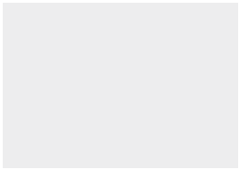

* As at 31 December 2019, details for customers accounting from 10% or more of the total balance of short-term trade accounts receivable – third parties are as follows:



|  |  |  |  |  |  |  |
| --- | --- | --- | --- | --- | --- | --- |
|  |  |  | **2019** |  | **2018** |  |
|  |  |  | **VND** | | **VND** | |
|  |  |  |  |  |  |  |
|  | Hoi An South Development Limited | | 1,052,674,643,124 |  | 46,657,905,845 |  |
|  |  |  |  |  |  |  |
| **6** | **SHORT-TERM PREPAYMENTS TO SUPPLIERS** | |  |  |  |  |
|  |  |  |  |  |  |  |
|  |  |  | **2019** |  | **2018** |  |
|  |  |  | **VND** |  | **VND** | |
|  | Third parties |  | 397,567,198,072 |  | 408,522,628,085 |  |
|  |  |  |  |  |  |  |

As at 31 December 2019, details for suppliers accounting from 10% or more of the total balance of short-term prepayments to suppliers are as follows:



|  |  |  |
| --- | --- | --- |
|  | **2019** | **2018** |
|  | **VND** | **VND** |
|  |  |  |
| An Gia Real Estate Investment and Develop-ment Corporation | 130,000,000,000 | 130,000,000,000 |
| TTT Corporation | 68,336,868,742 | - |
| Bao Thach International Corporation | 45,520,372,208 | - |
|  |  |  |

|  |  |  |  |
| --- | --- | --- | --- |
| **7** | **OTHER SHORT-TERM RECEIVABLES** |  |  |
|  |  |  |  |
|  |  | **2019** | **2018** |
|  |  | **VND** | **VND** |
|  |  |  |  |
|  | Interest receivable | 143,191,829,835 | 191,758,223,203 |
|  | Advances to construction teams and employees | 19,678,975,560 | 54,822,089,532 |
|  | Short-term deposits | 33,114,069,591 | 23,465,571,821 |
|  | Others | 2,544,677,129 | 2,090,501,310 |
|  |  | 198,529,552,115 | 272,136,385,866 |
|  |  |  |  |



NOTES

**THE CONSOLIDATED FINANCIAL STATEMENTS**

Form B 09 – DN/HN For the year ended 31 December 2019 - Continued

1. **PROVISION FOR DOUBTFUL DEBTS – SHORT-TERM**

Movements of provision for doubtful debts – short-term during the year are as follows:



|  |  |  |  |  |  |  |
| --- | --- | --- | --- | --- | --- | --- |
|  |  |  |  | **2019** | **2018** |  |
|  |  |  |  | **VND** | **VND** | |
|  |  |  |  |  |  |  |
|  | Opening balance | | | 209,861,898,080 | 209,861,898,080 |  |
|  | Increase | | | 4,645,864,739 | - |  |
|  | Closing balance | | | 214,507,762,819 | 209,861,898,080 |  |
|  |  |  |  |  |  |  |
| **9** |  |  | **INVENTORY** |  |  |  |
|  |  |  |  |  |  |  |
|  |  |  |  | **2019** | **2018** |  |
|  |  |  |  | **VND** | **VND** | |
|  |  |  | Construction works in process | 1,626,319,466,015 | 1,443,523,976,605 |  |
|  |  |  | |  |  |  |
| **10** | **PREPAID EXPENSES** | | |  |  |  |
| (a) | Short-term | | |  |  |  |
|  |  |  |  |  |  |  |
|  |  |  |  | **2019** | **2018** |  |
|  |  |  |  | **VND** | **VND** | |
|  |  |  | |  |  |  |
|  | Office tools and equipment | | | 3,456,235,463 | 2,264,893,751 |  |
|  | Construction tools and equipment | | | - | 1,450,264,861 |  |
|  |  |  |  | 3,456,235,463 | 3,715,158,612 |  |
|  |  |  |  |  |  |  |
| (b) |  |  | Long-term |  |  |  |
|  |  |  |  |  |  |  |
|  |  |  |  | **2019** | **2018** |  |
|  |  |  |  | **VND** | **VND** | |
|  |  | |  |  |  |  |
|  | Construction tools and equipment | | | 130,882,866,044 | 311,190,894,485 |  |
|  | Operating leases and office tools and equipment | | | 31,056,867,923 | 37,411,547,806 |  |
|  |  |  |  | 161,939,733,967 | 348,602,442,291 |  |
|  |  |  |  |  |  |  |

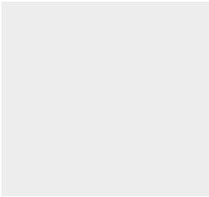

Movements of long-term prepaid expenses during the year are as follows:

|  |  |  |
| --- | --- | --- |
|  | **2019** | **2018** |
|  | **VND** | **VND** |
| Opening balance | 348,602,442,291 | 397,566,418,597 |
| Increase | 77,095,873,506 | 173,115,059,891 |
| Allocation and disposal | (263,758,581,830) | (222,079,036,197) |
| Closing balance | 161,939,733,967 | 348,602,442,291 |
|  |  |  |



174 STAND FIRM IN CHALLENGES 175

|  |
| --- |
| **CONSOLIDATED FINANCIAL STATEMENTS** |

|  |
| --- |
| **THE** NOTES |

|  |  |  |  |  |  |  |  |  |  |  |  |  |  |  |  |  |  |  |  |
| --- | --- | --- | --- | --- | --- | --- | --- | --- | --- | --- | --- | --- | --- | --- | --- | --- | --- | --- | --- |
| - Continued Form B 09 – DN/HN |  |  | **TotalVND** |  | 229,123,237,453 729,958,612,062 39,275,238,504 31,722,501,844 3,049,716,291 1,033,129,306,154 | 9,480,219,170 40,248,619,405 12,062,627,273 4,727,531,817 - 66,518,997,665 | - (41,982,125,479) (943,797,875) (870,080,800) - (43,796,004,154) | 238,603,456,623 728,225,105,988 50,394,067,902 35,579,952,861 3,049,716,291 1,055,852,299,665 |  | (71,901,077,746) (261,040,951,286) (26,393,308,581) (22,548,347,629) (3,049,716,291) (384,933,401,533) | (13,337,852,058) (77,422,016,504) (5,371,231,882) (5,036,109,685) - (101,167,210,129) | - 35,135,350,578 943,797,875 822,797,356 - 36,901,945,809 | (85,238,929,804) (303,327,617,212) (30,820,742,588) (26,761,659,958) (3,049,716,291) (449,198,665,853) |  | 157,222,159,707 468,917,660,776 12,881,929,923 9,174,154,215 - 648,195,904,621 | 153,364,526,819 424,897,488,776 19,573,325,314 8,818,292,903 - 606,653,633,812 |  | depreciated tangible fixed assets but still in use was VND135,254,518,736 (as at 31 December 2018: VND152,776,936,179). |  |
|  |  | **Buildings and Machineries and Motor Officestructuresequipmentvehilesequipment OthersVNDVNDVNDVNDVND** |  |  |  |  |  |
| year ended 31 December 2019 | **FIXED ASSETS** | Tangible fixed assets |  | **Historical cost** | As at 1 January 2019 | New purchases | Disposals | As at 31 December 2019 | **Accumulated depreciation** | As at 1 January 2019 | Charge for the year | Disposals | As at 31 December 2019 | **Net book value** | As at 1 January 2019 | As at 31 December 2019 |  | December 2019, historical cost of fully |  |
| For the |  |  |
| **11** | (a) |  |  |  |  |  |  |  |  |  |  |  |  |  |  |  | As at 31 |  |

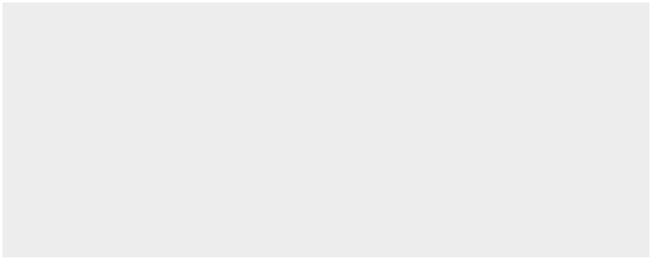

NOTES

**THE CONSOLIDATED FINANCIAL STATEMENTS**

Form B 09 – DN/HN For the year ended 31 December 2019 - Continued

|  |  |  |  |  |  |  |
| --- | --- | --- | --- | --- | --- | --- |
| **11** |  | **FIXED ASSETS (CONTINUED)** |  |  |  |  |
| (b) | Intangible fixed assets | |  |  |  |  |
|  |  |  |  |  |  |  |
|  |  |  | **Land use rights** | **Software** | | **Total** |
|  |  |  | **VND** | **VND** | | **VND** |
|  |  | **Historical cost** |  |  |  |  |
|  |  | As at 1 January 2019 | 94,881,924,366 | 16,898,115,134 |  | 111,780,039,500 |
|  |  | New purchases | - | 5,331,880,578 |  | 5,331,880,578 |
|  |  | Transfers from construction in progress | - | 1,575,880,000 |  | 1,575,880,000 |
|  |  | As at 31 December 2019 | 94,881,924,366 | 23,805,875,712 |  | 118,687,800,078 |
|  |  | **Accumulated amortisation** |  |  |  |  |
|  |  | As at 1 January 2019 | (6,068,832,197) | (10,198,949,438) |  | (16,267,781,635) |
|  |  | Charge for the year | (611,035,860) | (3,980,191,485) |  | (4,591,227,345) |
|  |  | As at 31 December 2019 | (6,679,868,057) | (14,179,140,923) |  | (20,859,008,980) |
|  |  | **Net book value** |  |  |  |  |
|  |  | As at 1 January 2019 | 88,813,092,169 | 6,699,165,696 |  | 95,512,257,865 |
|  |  |  |  |  |  |  |
|  |  | As at 31 December 2019 | 88,202,056,309 | 9,626,734,789 |  | 97,828,791,098 |
|  |  |  |  |  |  |  |



As at 31 December 2019, historical cost of fully amortised intangible fixed assets as at 31 December 2019 was VND8,820,466,435 (as at 31 December 2018 was VND5,920,076,435).

|  |  |  |  |  |  |
| --- | --- | --- | --- | --- | --- |
| **12** | **INVESTMENT PROPERTIES HELD FOR LEASE** |  |  |  |  |
|  |  |  |  |  |  |
|  |  | **Office** |  |  |  |
|  |  | **buildings** | **Others** | **Total** |  |
|  |  | **VND** | **VND** | **VND** |  |
|  | **Historical cost** |  |  |  |  |
|  | As at 1 January 2019 and | 51,057,186,713 | 18,620,363,909 | 69,677,550,622 |  |
|  | 31 December 2019 |  |
|  |  |  |  |  |
|  | **Accumulated depreciation** |  |  |  |  |
|  | As at 1 January 2019 | (13,493,216,576) | (3,825,450,352) | (17,318,666,928) |  |
|  | Charge for the year | (2,010,711,858) | (744,814,572) | (2,755,526,430) |  |
|  | As at 31 December 2019 | (15,503,928,434) | (4,570,264,924) | (20,074,193,358) |  |
|  | **Net book value** |  |  |  |  |
|  | As at 1 January 2019 | 37,563,970,137 | 14,794,913,557 | 52,358,883,694 |  |
|  | As at 31 December 2019 | 35,553,258,279 | 14,050,098,985 | 49,603,357,264 |  |



The income and expenses from renting investment properties during the year are as follows:



|  |  |  |
| --- | --- | --- |
|  | **2019** | **2018** |
|  | **VND** | **VND** |
|  |  |  |
| Income from renting investment properties | 11,983,510,668 | 11,903,425,626 |
| Expenses regarding investment properties’ renting | 5,501,858,231 | 5,534,480,905 |
|  |  |  |

176 STAND FIRM IN CHALLENGES 177

|  |  |  |  |
| --- | --- | --- | --- |
| 178 STAND |  | **13** | theFor |
| CHALLENGESINFIRM | .purposebusinessrentingandsaleforlandthisonbuildingofficeanconstructtoplansGroup The.CityMinhChiHoofCommitteePeople’sthebyissued2013August28datedcertificaterightuselandthetoaccordingm23.1,504ofareaanwithCityMinhChiHoDistrict,NhuanPhu4,WardStreet,DucQuangThich168,.NoBĐĐC,-11Map54,Lotatrightsuselandrepresentsbalancethe2019,December31atAs | **PROGRESSINWORKTERM-LONG** | DN/HN–09BFormContinued-2019December31endedyear |

|  |
| --- |
| NOTES **THE** |

NOTES

**THE CONSOLIDATED FINANCIAL STATEMENTS**

|  |  |  |  |  |  |  |  |  |  |  |
| --- | --- | --- | --- | --- | --- | --- | --- | --- | --- | --- |
| For the year ended 31 December 2019 - Continued | | | |  |  |  | Form B 09 – DN/HN | | |  |
| **14** |  | **INVESTMENTS IN ASSOCIATES** |  |  |  |  |  |  |  |  |
|  |  |  |  |  |  |  |  |  |  |  |
|  |  |  |  | **2019** |  |  | **2018** |  |  |  |
|  |  |  |  |  |  |  |  |  |  |  |
|  | **Company name** | | **Percentage of** | **Percentage of** | **Cost** | **Percentage of** | **Percentage of** | **Cost** |  |
|  | **ownership** | **voting rights** | **VND** | **ownership** | **voting rights** | **VND** | |  |
|  |  |  |  |
|  |  |  |  |  |  |  |  |  |  |  |
|  |  | Ricons Construction Investment Joint Stock Company (i) | 14.30 | 23.11 | 301,605,477,459 | 14.87 | 24.03 | 286,190,247,872 |  |  |
|  |  | FCC Infrastructure Investment Joint Stock Company (ii) | 42.36 | 42.36 | 90,000,220,565 | 35.00 | 35.00 | 61,933,245,486 |  |  |
|  |  | Quang Trong Commercial Joint Stock Company (iii) | 36.00 | 36.00 | 145,332,815 | 36.00 | 36.00 | 147,269,515 |  |  |
|  |  | Hiteccons Investment Joint Stock Company (iv) | 31.00 | 31.00 | 2,536,943,725 | 31.00 | 31.00 | 2,473,268,762 |  |  |
|  |  |  |  |  | 394,287,974,564 |  |  | 350,744,031,635 |  |  |
|  |  |  |  |  |  |  |  |  |  |  |

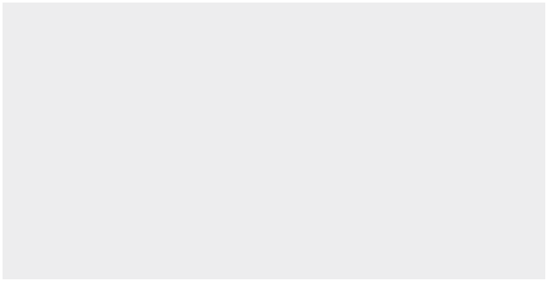

1. Ricons Construction Investment Joint Stock Company, a joint stock company established in Ho Chi Minh City pursuant to Business Registration Certificate No. 4103002810 dated 27 October 2004 issued by the Department of Planning and Investment of Ho Chi Minh City, which was subsequently amended with the Enterprise Registration Certificate No. 0303527596 dated 9 June 2011. The principal activities are civil and industrial construction services, trading of construction materials and real estate.
2. FCC Infrastructure Investment Joint Stock Company, a joint stock company established in Ha Noi City pursuant to Enterprise Registration Certificate No. 0106605407 dated 21 July 2014 issued by the Department of Planning and Investment of Ha Noi City. The principal activities are civil and industrial project constructions.
3. Quang Trong Commercial Joint Stock Company, a joint stock company established in Ba Ria Vung Tau Province pursuant to Business Registration Certificate No. 4903000474 dated 18 December 2007 issued by the Department of Planning and Investment of Ba Ria Vung Tau Province, which was subsequently amended to Enterprise Registration Certificate No. 3500740022. The principal activities are real estate business and provision of project management services.
4. Hiteccons Investment Joint Stock Company, a joint stock company established in Ha Noi City pursuant to Enterprise Registration Certificate No. 0108007089 dated 2 October 2017 issued by the Department of Planning and Investment of Ha Noi City. The principal activities are real estate business and constructions.

As at 31 December 2019, the Group was unable to determine its investments in associates’ fair value as those investments are not listed on the stock exchange market, therefore, there was no available fair value information of those investments.

|  |
| --- |
| 179 |

NOTES

**THE CONSOLIDATED FINANCIAL STATEMENTS**

|  |  |  |  |  |  |  |  |  |
| --- | --- | --- | --- | --- | --- | --- | --- | --- |
| For the year ended 31 December 2019 - Continued | | | | |  |  | Form B 09 – DN/HN |  |
| **14** | **INVESTMENTS IN ASSOCIATES (CONTINUED)** | | |  |  |  |  |  |
|  |  |  |  |  |  |  |  |  |
|  |  |  |  |  |  |  | **VND** |  |
|  |  |  |  |  |  |  |  |  |
|  | **Cost of investments** | |  |  |  |  |  |  |
|  | As at 1 January 2019 | |  |  |  |  | 176,750,000,000 |  |
|  | Captial contributions to associates | |  |  |  |  | 61,600,000,000 |  |
|  | As at 31 December 2019 | |  |  |  |  | 238,350,000,000 |  |
|  | **Accumulated profits shared after the acquisition** | | |  |  |  |  |  |
|  | As at 1 January 2019 | |  |  |  |  | 173,994,031,635 |  |
|  | Share of profit of investments in associates | | |  |  |  | 4,069,273,547 |  |
|  | Dividend from an associate | |  |  |  |  | (22,680,000,000) |  |
|  | Net unrealised profits during the year | | |  |  |  | 554,669,382 |  |
|  | As at 31 December 2019 | |  |  |  |  | 155,937,974,564 |  |
|  | **Value** | |  |  |  |  |  |  |
|  | As at 1 January 2019 | |  |  |  |  | 350,744,031,635 |  |
|  | As at 31 December 2019 | |  |  |  |  | 394,287,974,564 |  |
|  |  |  |  |  |  |  |  |  |
| **15** | **ACCOUNTS PAYABLE** | |  |  |  |  |  |  |
|  |  |  |  |  |  | | |  |
|  |  |  | **2019** |  | **2018** | | |  |
|  |  |  |  |  |  |  |  |  |
|  |  |  |  | **Able-to-pay** |  |  | **Able-to-pay** |  |
|  |  |  | **Book value** | **amount** | **Book value** | | **amount** |  |
|  |  |  | **VND** | **VND** | **VND** | | **VND** |  |
|  |  |  |  |  |  | |  |  |
|  | Third parties (*) | | 3,822,501,234,309 | 3,822,501,234,309 | 3,764,218,694,747 | | 3,764,218,694,747 |  |
|  | Related parties | | 748,885,967,095 | 748,885,967,095 | 2,048,832,795,422 | | 2,048,832,795,422 |  |
|  | (Note 37(b)) | |  |
|  |  |  |  |  |  |  |
|  |  |  | 4,571,387,201,404 | 4,571,387,201,404 | 5,813,051,490,169 | | 5,813,051,490,169 |  |
|  |  |  |  |  |  |  |  |  |



* As at 31 December 2019, there is no supplier accounting from 10% or more of the total balance of short-term trade accounts payable – third parties.

**16** **SHORT-TERM ADVANCES FROM CUSTOMERS**



|  |  |  |
| --- | --- | --- |
|  | **2019** | **2018** |
|  | **VND** | **VND** |
|  |  |  |
| Third parties (*) | 720,914,499,291 | 655,423,317,361 |
| Related parties (Note 37(b)) | - | 16,005,154,858 |
|  | 720,914,499,291 | 671,428,472,219 |
|  |  |  |

* As at 31 December 2019, details for customers accounting from 10% or more of the total balance of short-term advances from customers – third parties are as follows:



|  |  |  |
| --- | --- | --- |
|  | **2019** | **2018** |
|  | **VND** | **VND** |
|  |  |  |
| Phương Nam 3A-2 Real Estate Trading Joint Stock Company | 114,618,345,120 | 30,660,106,030 |
| Nam Long Investment Joint Stock Company | 81,985,535,472 | 6,149,022,000 |
| Thai Son Investment Construction Joint Stock Company | 76,609,584,169 | - |
|  |  |  |

|  |
| --- |
| **CONSOLIDATED FINANCIAL STATEMENTS** |

|  |
| --- |
| **THE** NOTES |

|  |  |  |  |  |  |  |  |  |  |
| --- | --- | --- | --- | --- | --- | --- | --- | --- | --- |
| B 09 – DN/HN |  | **Closing** | **balanceVND** | 47,889,740,881 | 39,960,210,013 | - | - | 87,849,950,894 |  |
| Form |  |  |  |  |  |  |  |  |  |
|  |  |  | |  |  |  |  | (751,405,782,602) |  |
|  |  | **PaidduringtheyearVND** | | (207,963,845,299) | (148,114,230,307) | (388,356,997,780) | (6,970,709,216) |  |
|  |  | **Net-offduringtheyearVND** | | - | - | (1,985,463,575,781) | - | (1,985,463,575,78) |  |
|  |  | **PayableduringtheyearVND** | | 171,637,517,330 | 147,370,082,522 | 2,333,746,561,260 | 6,970,709,216 | 2,659,724,870,328 |  |
|  |  | **Opening** | **balanceVND** | 84,216,068,850 | 40,704,357,798 | 40,074,012,301 | - | 164,994,438,949 |  |
| 2019 - Continued | **TO THE STATE** |  |  |  |  |  |  |  |  |
| year ended 31 December | **TAX AND OTHER PAYABLES** |  |  | Business income tax | Personal income tax | Value added tax | Others |  |  |
| For the | **17** |  |  |  |  |  |  |  |  |



180 STAND FIRM IN CHALLENGES 181

NOTES

**THE CONSOLIDATED FINANCIAL STATEMENTS**

For the year ended 31 December 2019 - Continued Form B 09 – DN/HN

|  |  |  |  |
| --- | --- | --- | --- |
| **18** | **SHORT-TERM ACCRUED EXPENSES** |  |  |
|  |  |  |  |
|  |  | **2019** | **2018** |
|  |  | **VND** | **VND** |
|  |  |  |  |
|  | Construction costs | 2,099,811,113,108 | 1,759,584,094,811 |
|  |  |  |  |
|  | Others | 2,360,000,000 | - |
|  |  |  |  |
|  |  | 2,102,171,113,108 | 1,759,584,094,811 |
|  |  |  |  |



|  |  |  |  |
| --- | --- | --- | --- |
| **19** | **SHORT-TERM UNEARNED REVENUE** |  |  |
|  |  |  |  |
|  |  | **2019** | **2018** |
|  |  | **VND** | **VND** |
|  |  |  |  |
|  | Unearned revenue from constructions | 54,781,130,228 | 5,135,013,358 |
|  |  |  |  |
| **20** | **PHẢI TRẢ KHÁC** |  |  |

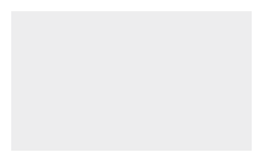

1. Ngắn hạn



|  |  |  |
| --- | --- | --- |
|  | **2019** | **2018** |
|  | **VND** | **VND** |
|  |  |  |
| Payables to construction teams and employees | 28,265,070,533 | 189,807,201,010 |
| Allowance for the Board of Directors and Board of Supervision | 600,000,000 | 8,062,530,000 |
| Dividend payable | 697,164,375 | 847,842,925 |
| Others | 12,041,601,550 | 5,579,642,384 |
|  | 41,603,836,458 | 204,297,216,319 |
|  |  |  |

1. Long-term



|  |  |  |  |  |  |  |
| --- | --- | --- | --- | --- | --- | --- |
|  |  | **2019** | | **2018** | |  |
|  |  |  | **VND** |  | **VND** |  |
|  |  |  |  |  |  |  |
|  | Deposits | 542,006,657 | | 662,352,826 | |  |
|  |  |  |  |  |  |  |
| **21** | **PROVISION FOR LIABILITIES** |  |  |  |  |  |
| (a) | Short-term |  |  |  |  |  |
|  |  |  | |  |  |  |
|  |  | **2019** | | **2018** | |  |
|  |  |  | **VND** |  | **VND** |  |
|  |  |  |  |  |  |  |
|  | Provision for construction warranty | 65,205,053,085 | | 75,606,055,937 | |  |
|  |  |  |  |  |  |  |

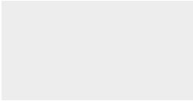

Movements of provision for construction warranty during the year are as follows:

NOTES

**THE CONSOLIDATED FINANCIAL STATEMENTS**

Form B 09 – DN/HN For the year ended 31 December 2019 - Continued

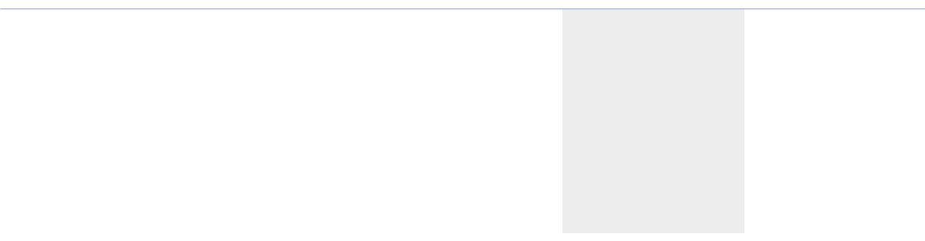

|  |  |  |  |  |
| --- | --- | --- | --- | --- |
|  |  |  | **2019** | **2018** |
|  |  |  | **VND** | **VND** |
|  |  |  |  |  |
|  | Opening balance | | 75,606,055,937 | 76,554,779,913 |
|  | Increase | | 31,764,428,200 | 42,500,017,018 |
|  | Reversal | | (16,881,423,182) | (11,140,154,153) |
|  | Utilisation | | (25,284,007,870) | (32,308,586,841) |
|  | Closing balance | | 65,205,053,085 | 75,606,055,937 |
|  |  |  |  |  |
| (b) |  | Long-term |  |  |
|  |  |  |  |  |
|  |  |  | **2019** | **2018** |
|  |  |  | **VND** | **VND** |
|  |  |  |  |  |
|  | Provision for severance allowance | | 6,310,251,884 | 8,533,612,676 |
|  |  |  |  |  |

Movements of provision for severance allowance during the year are as follows:



|  |  |  |
| --- | --- | --- |
|  | **2019** | **2018** |
|  | **VND** | **VND** |
|  |  |  |
| Opening balance | 8,533,612,676 | 10,249,956,011 |
| Reversal | (1,070,237,792) | (1,385,511,310) |
| Utilisation | (1,153,123,000) | (330,832,025) |
| Closing balance | 6,310,251,884 | 8,533,612,676 |
|  |  |  |

1. **BONUS AND WELFARE FUND**

Movements of bonus and welfare fund during the year are as follows:



|  |  |  |
| --- | --- | --- |
|  | **2019** | **2018** |
|  | **VND** | **VND** |
|  |  |  |
| Opening balance | 157,276,000,184 | 169,473,324,162 |
| Increase | 75,520,000,000 | 98,579,000,000 |
| Utilisation | (166,425,034,521) | (110,776,323,978) |
| Closing balance | 66,370,965,663 | 157,276,000,184 |
|  |  |  |

182 STAND FIRM IN CHALLENGES 183

NOTES

**THE CONSOLIDATED FINANCIAL STATEMENTS**

For the year ended 31 December 2019 - Continued Form B 09 – DN/HN

|  |  |  |  |  |  |  |  |  |
| --- | --- | --- | --- | --- | --- | --- | --- | --- |
| **23** | **OWNERS’ CAPITAL** |  |  |  |  |  |  |  |
| (a) | Number of shares |  |  |  |  |  |  |  |
|  |  |  |  |  |  |  |  |  |
|  |  |  |  | **2019** | |  | **2018** |  |
|  |  |  |  | **Ordinary shares** | | **Ordinary shares** | |  |
|  |  |  |  |  |  |  |  |  |
|  | Number of shares registered |  |  | 79,255,000 | |  | 78,355,000 |  |
|  | Number of shares issued |  |  | 79,255,000 | |  | 78,355,000 |  |
|  | Number of shares repurchased/resold |  |  | (2,962,427) | |  | (2,876,127) |  |
|  | Number of existing shares in circulation |  |  | 76,292,573 | |  | 75,478,873 |  |
|  |  |  |  |  |  |  |  |  |
| (b) | Details of owners’ shareholding |  |  |  |  |  |  |  |
|  |  |  |  |  |  |  |  |  |
|  |  | **2019** |  |  |  | **2018** |  |  |
|  |  |  | |  |  |  |  |  |
|  |  | **Ordinary** | |  |  | **Ordinary** |  |  |
|  |  | **shares** | | **%** |  | **shares** | **%** |  |
|  |  |  | |  |  |  |  |  |
|  | Kustocem Pte Ltd. | 13,906,666 | | 18.23 |  | 13,906,666 | 18.42 |  |
|  | Success Investment and Business One Member | 11,192,652 | | 14.67 |  | 11,192,652 | 14.83 |  |
|  | Limited Company |  |  |
|  |  |  |  |  |  |  |  |
|  | Others | 51,193,255 | | 67.10 |  | 50,379,555 | 66.75 |  |
|  |  | 76,292,573 | | 100 |  | 75,478,873 | 100 |  |
|  |  |  |  |  |  |  |  |  |



1. Movement of share capital

|  |  |
| --- | --- |
|  | **Shares** |
|  |  |
| As at 1 January 2018 | 77,050,000 |
| New shares issued | 1,305,000 |
| As at 31 December 2018 | 78,355,000 |
| New shares issued | 900,000 |
| As at 31 December 2019 | 79,255,000 |
|  |  |

Par value per share: VND10,000.

|  |  |  |  |  |  |  |  |  |  |  |  |  |  |  |  |  |  |  |  |  |  |  |  |  |
| --- | --- | --- | --- | --- | --- | --- | --- | --- | --- | --- | --- | --- | --- | --- | --- | --- | --- | --- | --- | --- | --- | --- | --- | --- |
| **MOVEMENTS IN OWNERS’ EQUITY** | **Investment andOwners’Sharedevelopment Undistributed Non-controllingcapitalpremiumTreasurysharesfundearningsinterests TotalVNDVNDVNDVNDVNDVNDVND** |  | As at 1 January 2018 770,500,000,000 2,958,550,175,385 (22,832,460,000) 1,858,988,669,927 1,741,481,463,307 - 7,306,687,848,619 | New shares issued 13,050,000,000 39,095,000,000 52,145,000,000 | Net profit during the year 1,510,407,549,274 - 1,510,407,549,274 | Sales of treasury shares 21,091,000,000 21,091,000,000 | Shares repurchases (437,817,478,999) (437,817,478,999) | Appropriation to investment and development fund 1,157,577,290,195 (1,157,577,290,195)--- - - | Appropriation to bonus and welfare fund (98,579,000,000) - (98,579,000,000) | Dividend declared (391,441,720,000) - (391,441,720,000) | As at 31 December 2018 783,550,000,000 2,997,645,175,385 (439,558,938,999) 3,016,565,960,122 1,604,291,002,386 - 7,962,493,198,894 | 50,345,000,000Newsharesissued(i)9,000,000,00041,345,000,000 | Net profit during the year 710,890,717,770 25,880,895 710,916,598,665 | Accquisition of a subsidiary 43,829,200,000 43,829,200,000 | Capital contribution to a subsidiary 10,200,000,000 10,200,000,000 | Shares repurchases (3,865,600,000) (3,865,600,000) | Appropriation to investment and development fund (ii) 981,765,000,000 (981,765,000,000)--- - - | Appropriation to bonus and welfare fund (ii) (75,520,000,000) - (75,520,000,000) | Dividend declared (ii) (228,877,719,000) - (228,877,719,000) | As at 31 December 2019 792,550,000,000 3,038,990,175,385 (443,424,538,999) 3,998,330,960,122 1,029,019,001,156 54,055,080,895 8,469,520,678,559 |  | (i) According to Resolution No. 01/2018/NQ-ĐHCĐ dated 2 June 2018, the General Meeting of shareholders approved the Employee Stock Ownership Plan (“ESOP”) for theCompany’semployeeswithtotalordinarysharesof900,000sharesattheissuepriceofVND56,000pershare. | (ii) According to Resolution No. 01/2019/NQ-ĐHCĐ dated 9 April 2019, the General Meeting of shareholder approved the appropriation of the investment and developmentfund,bonusandwelfarefund,anddeclareddividendfromthe2018post-taxundistributedearningswiththerespectiveamountsofVND981,765,000,000,VND75,520,000,000andVND229,136,619,000. |  |
|  |  |  |
| **24** |  |  |  |  |  |  |  |  |  |  |  |  |  |  |  |  |  |  |  |  |  |  |  |  |



184 STAND FIRM IN CHALLENGES 185

NOTES

**THE CONSOLIDATED FINANCIAL STATEMENTS**

For the year ended 31 December 2019 - Continued Form B 09 – DN/HN

**24** **MOVEMENTS IN OWNERS’ EQUITY (CONTINUED)**

Utilisation of New Share Capital

As at 31 December 2019, the Company has managed the remaining capital from the new share issuance during the period from 18 October 2016 to 16 November 2016 as follows:



|  |  |  |
| --- | --- | --- |
|  |  | **Amount** |
| **No** | **Items** | **VND** |
|  |  |  |
| A | Total capital resulting from new share issuance | 1,761,910,813,520 |
| B | Issuance fee | 17,619,108,135 |
| C | Net capital resulting from new share issuance | 1,744,291,705,385 |
| D | Remaining capital as at 11 March 2017 | 1,744,291,705,385 |
|  | Utilised for: |  |
| 1 | Capital contribution to a newly established entity for business expansion purposes (*) | 1,328,897,025,832 |
| 3 | Purchases of machinery and equipment for busi-ness operation purposes | 415,394,679,553 |
| E | Accumulated capital expenditure from 11 March 2017 to 31 December 2019 | 1,744,291,705,385 |
| F | Remaining capital as at 31 December 2019 | - |
|  |  |  |

* Capital contribution to a newly established entity during the year are as follows:
* The Company has made capital contributions to Covestcons Company Limited, a wholly owned subsdiary, with an amount of VND1,267,297,025,832 from the share issuance.
* The Company has made capital contribution with an amount of VND61,600,000,000 to FCC Infrastructure Investment Joint Stock Company, an associate.

|  |  |
| --- | --- |
| **25** | **DIVIDENDS** |

NOTES

**THE CONSOLIDATED FINANCIAL STATEMENTS**

Form B 09 – DN/HN For the year ended 31 December 2019 - Continued

**26** **OFF CONSOLIDATED BALANCE SHEETS ITEMS**

1. Foreign currency

As at 31 December 2019, included in cash and cash equivalents are balances held in foreign currency of USD 752,648.47 (as at 31 December 2018: USD1,128,534.26).

1. Commitments under operating leases

As at 31 December 2019 and 31 December 2018, the future minimum lease receipts under non-cancellable operating leases were presented in Note 39(a).

1. Capital contribution commitments

As at 31 December 2019 and 31 December 2018, the Group had capital obligations which were presented in Note 39(b).

**27** **NET REVENUE FROM SALES OF GOODS AND RENDERING OF SERVICES**



|  |  |  |
| --- | --- | --- |
|  | **2019** | **2018** |
|  | **VND** | **VND** |
|  |  |  |
| Net revenue from constructions (*) | 23,619,283,888,092 | 28,526,690,225,430 |
| Net revenue from investment property | 11,983,510,668 | 11,903,425,626 |
| Net revenue from leasing out construction equipment | 5,699,361,534 | 7,888,773,343 |
| Net revenue from sales of construction materials, tools and equipment | 96,061,491,871 | 14,374,872,996 |
|  | **23,733,028,252,165** | **28,560,857,297,395** |
|  |  |  |

(*) Net revenue from constructions are as follows:

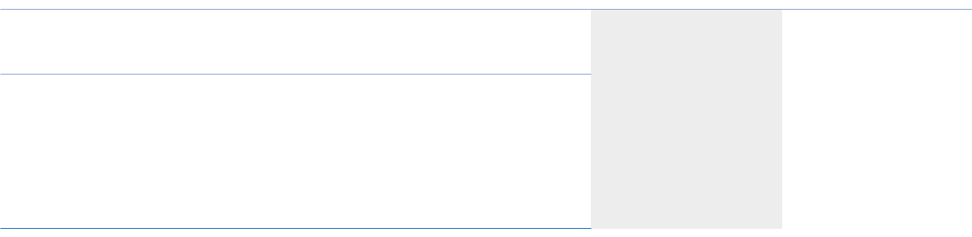

|  |  |  |
| --- | --- | --- |
| Movements of dividends payable during the year are as follows: |  |  |
|  |  |  |
|  | **2019** | **2018** |
|  | **VND** | **VND** |
|  |  |  |
| Opening balance | 847,842,925 | 359,298,925 |
| Dividend declared | 228,877,719,000 | 391,441,720,000 |
| Dividends paid in cash | (229,028,397,550) | (390,953,176,000) |
| Closing balance | 697,164,375 | 847,842,925 |
|  |  |  |



Net revenue from outstanding construction contracts recognised during the year

Net revenue from completed construction contracts recognised during the year

|  |  |
| --- | --- |
| **2019** | **2018** |
| **VND** | **VND** |
|  |  |
| 22,092,156,759,821 | 27,866,183,379,608 |
| 1,527,127,128,271 | 660,506,845,822 |
| 23,619,283,888,092 | 28,526,690,225,430 |
|  |  |

|  |  |  |  |
| --- | --- | --- | --- |
|  | **2019** | **2018** |  |
|  | **VND** | **VND** |  |
| Net accumulated revenue from outstanding construction contracts up | 67,155,159,766 | 54,137,132,918,522 |  |
| to end of this year |  |
|  |  |  |
|  |  |  |  |

186 STAND FIRM IN CHALLENGES 187

NOTES

**THE CONSOLIDATED FINANCIAL STATEMENTS**

For the year ended 31 December 2019 - Continued Form B 09 – DN/HN

|  |  |  |  |  |
| --- | --- | --- | --- | --- |
| **28** | **COST OF GOODS SOLD AND SERVICES RENDERED** |  |  |  |
|  |  |  |  |  |
|  |  | **2019** | **2018** |  |
|  |  | **VND** | **VND** |  |
|  |  |  |  |  |
|  | Cost of construction contracts | 22,586,608,633,250 | 26,707,460,016,608 |  |
|  | Cost of investment property activities | 5,501,858,231 | 5,534,480,905 |  |
|  | Cost of construction equipment leased out | 3,551,644,401 | 6,275,376,091 |  |
|  | Cost of construction materials, tools and equipment sold | 89,258,975,098 | 8,575,150,822 |  |
|  |  | 22,684,921,110,980 | 26,727,845,024,426 |  |
|  |  |  |  |  |
| **29** | **FINANCIAL INCOME** |  |  |  |
|  |  |  |  |  |
|  |  | **2019** | **2018** |  |
|  |  | **VND** | **VND** |  |
|  |  |  |  |  |
|  | Interest income | 254,817,694,365 | 320,894,817,797 |  |
|  | Net gains from investment | 8,294,411,918 | - |  |
|  | Realised foreign exchange gains | 115,985,392 | 171,866,664 |  |
|  | Unrealised foreign exchange gains | 636,401,875 | 29,740,646 |  |
|  |  | 263,864,493,550 | 321,096,425,107 |  |
|  |  |  |  |  |
| **30** | **GENERAL AND ADMINISTRATION EXPENSES** |  |  |  |
|  |  |  |  |  |
|  |  | **2019** | **2018** |  |
|  |  | **VND** | **VND** |  |
|  |  |  |  |  |
|  | Salary expenses | 324,052,057,490 | 344,573,390,651 |  |
|  |  |  |  |
|  | Depreciation and amortisation | 34,344,122,138 | 27,499,694,439 |  |
|  |  |  |  |
|  | Reversal of provision for severance al-lowances | (1,070,237,792) | (1,385,511,310) |  |
|  |  |  |  |
|  | Provision for short-term doubtful debts | 4,645,864,739 | - |  |
|  |  |  |  |
|  | Outside service expenses | 42,773,397,376 | 49,428,109,832 |  |
|  |  |  |  |
|  | Other expenses | 54,233,939,499 | 85,101,529,654 |  |
|  |  |  |  |
|  |  | 458,979,143,450 | 505,217,213,266 |  |
|  |  |  |  |  |



NOTES

**THE CONSOLIDATED FINANCIAL STATEMENTS**

Form B 09 – DN/HN For the year ended 31 December 2019 - Continued

|  |  |  |  |  |
| --- | --- | --- | --- | --- |
| **31** | **OTHER INCOME AND OTHER EXPENSES** | |  |  |
|  |  |  |  |  |
|  |  |  | **2019** | **2018** |
|  |  |  | **VND** | **VND** |
|  |  |  |  |  |
|  | **Other income** | |  |  |
|  | Reversal of provision for construction warranty | | 16,881,423,182 | 11,140,154,153 |
|  | Reversal of over-accrued contructions costs | | 12,067,878,931 | 120,114,919,748 |
|  | Net gains from disposal of fixed assets | | 6,151,724,373 | 3,285,957,391 |
|  | Others | | 6,724,032,760 | 6,645,753,498 |
|  |  |  | 41,825,059,246 | 141,186,784,790 |
|  | **Other expense** | |  |  |
|  | Construction warranty expenses | | 8,146,550,269 | 14,438,531,365 |
|  | Others | | - | 27,149,584 |
|  |  |  | 8,146,550,269 | 14,465,680,949 |
|  |  |  |  |  |



1. **BIT**

The reconciliation of business income tax (“BIT”) with the net accouting profit before tax using the applicable tax rate of 20% are as follows:



|  |  |  |
| --- | --- | --- |
|  | **2019** | **2018** |
|  | **VND** | **VND** |
|  |  |  |
| Net accounting profit before tax | 890,730,926,865 | 1,872,974,285,564 |
| Tax calculated at a rate of 20% | 178,146,185,373 | 374,594,857,113 |
| Effect of: |  |  |
| Income not subject to tax | (813,854,709) | (19,523,640,983) |
| Non-deductible expenses | 2,594,091,331 | 3,667,960,716 |
| (Over)/under-provision in previous years | (112,093,795) | 3,827,559,444 |
| BIT charge | 179,814,328,200 | 362,566,736,290 |
| Charged to consolidated income statement: |  |  |
| BIT – current | 164,453,039,966 | 362,105,809,452 |
| BIT – deferred | 15,361,288,234 | 460,926,838 |
| BIT charge | 179,814,328,200 | 362,566,736,290 |
|  |  |  |

188 STAND FIRM IN CHALLENGES 189

NOTES

**THE CONSOLIDATED FINANCIAL STATEMENTS**

For the year ended 31 December 2019 - Continued Form B 09 – DN/HN

The BIT charge for the year is based on estimated taxable income and is subject to review and possible adjustments by the tax authorities.

1. **DEFERRED INCOME TAX**

Movements in the deferred income tax assets/(liabilities) during the year are as follows:



|  |  |  |
| --- | --- | --- |
|  | **2019** | **2018** |
|  | **VND** | **VND** |
|  |  |  |
| Opening balance | 3,183,320,738 | 3,644,247,576 |
| Credit to the consolidated income statement | (15,361,288,234) | (460,926,838) |
| Closing balance | (12,177,967,496) | 3,183,320,738 |
|  |  |  |
| Details of deferred income tax are as follows: |  |  |

|  |  |  |
| --- | --- | --- |
|  | **2019** | **2018** |
|  | **VND** | **VND** |
| Provision for long-term investments | (13,997,620,725) | (76,576,360) |
|  |  |  |
| Taxable temporary differences | (6,801,121) | (6,801,121) |
|  |  |  |
| Deductible temporary differences | 1,826,454,350 | 3,266,698,219 |
|  |  |  |
|  | (12,177,967,496) | 3,183,320,738 |
|  |  |  |

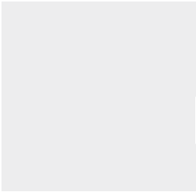

Deductible temporary differences mainly comprise provision for severance allowance.

The Group uses tax rate of 20% for determining deferred income tax.

Deferred income tax are recognised to the extent that it is probable that future taxable profit will be available against which the temporary differences can be utilised.

**34** **EARNINGS PER SHARE**

1. Basic earnings per share

Basic earnings per share is calculated by dividing the net profit attributable to shareholders after deducting the bonus and welfare fund by the weighted average number of ordinary shares outstanding during the year, excluding ordinary shares repurchased by the Company and held as treasury shares.

The details were as follows:

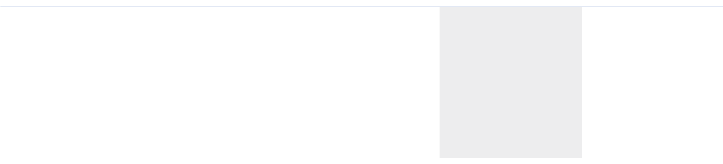

|  |  |  |
| --- | --- | --- |
|  | **2019** | **2018** |
|  |  |  |
| Net profit attributable to shareholders (VND) | 710,890,717,770 | 1,510,407,549,274 |
| Less amount allocated to bonus and welfare fund (VND) (*) | (35,544,535,889) | (75,520,377,464) |
|  | 675,346,181,881 | 1,434,887,171,810 |

NOTES

**THE CONSOLIDATED FINANCIAL STATEMENTS**

|  |  |  |  |  |
| --- | --- | --- | --- | --- |
| Form B 09 – DN/HN | | For the year ended 31 December 2019 - Continued | | |
|  | Weighted average number of ordinary shares in issue (shares) | | 76,232,012 | 78,167,792 |
|  | Basic earnings per share (VND) |  | 8,859 | 18,357 |
|  |  |  |  |  |



* + Estimated amounts appropriated to bonus and welfare fund for the year 2019 are determined based on the 2019 profit distribution plan of the Group approved by shareholders at General Meeting of shareholders.

1. Diluted earnings per share

Diluted earnings per share is calculated by dividing the net profit attributable to shareholders, which already subtracted the bonus and welfare fund, by the weighted average number of ordinary shares outstanding during the year and the ordinary shares expected to be issued.

During the year and up to the date of these consolidated financial statements, there is no potential ordinary shares. Potential ordinary shares shall be treated as dilutive when, and only when, their conversion to ordinary shares would decrease earnings per share or increase loss per share.

1. **COSTS OF OPERATION BY FACTORS**

Costs of operation by factor represent all costs incurred during the year, excluding cost of merchandises for trading activities. The details are as follows:



|  |  |  |
| --- | --- | --- |
|  | **2019** | **2018** |
|  | **VND** | **VND** |
|  |  |  |
| Raw materials | 6,570,708,886,147 | 7,094,996,010,251 |
| Salary expenses | 1,324,689,003,789 | 2,840,294,383,515 |
| Tools and supplies | 322,965,271,017 | 375,613,096,276 |
| Depreciation and amortisation | 108,513,963,904 | 93,969,492,263 |
| Outside service expenses | 14,625,860,046,650 | 16,046,325,576,984 |
| Other expenses | 284,699,597,235 | 351,575,904,982 |
|  | 23,237,436,768,742 | 26,802,774,464,271 |
|  |  |  |

190 STAND FIRM IN CHALLENGES 191

|  |  |  |  |  |  |  |  |  |  |  |  |  |  |  |
| --- | --- | --- | --- | --- | --- | --- | --- | --- | --- | --- | --- | --- | --- | --- |
| Form B 09 – DN/HN | **constructionmaterials,toolsandequipment TotalVNDVND** |  | | **(22,684,921,110,980)**(89,258,975,098) | **1,048,107,141,185**6,802,516,773 |  | **constructionmaterials,toolsandequipment TotalVNDVND** |  | **28,560,857,297,395**14,374,872,996 | **(26,727,845,024,426)**(8,575,150,822) | **1,833,012,272,969**5,799,722,174 |  | geographicalsegment. |  |
|  | **23,733,028,252,165**96,061,491,871 |  |  |  |  |
|  |  |  |  |  |  |



NOTES

**THE CONSOLIDATED FINANCIAL STATEMENTS**

Form B 09 – DN/HN For the year ended 31 December 2019 - Continued

**37** **RELATED PARTY DISCLOSURES**

The Company is a joint stock company. Details of the shareholders are presented in Note 23.

1. Related party transactions

During the year, the following transactions are carried out with related parties:

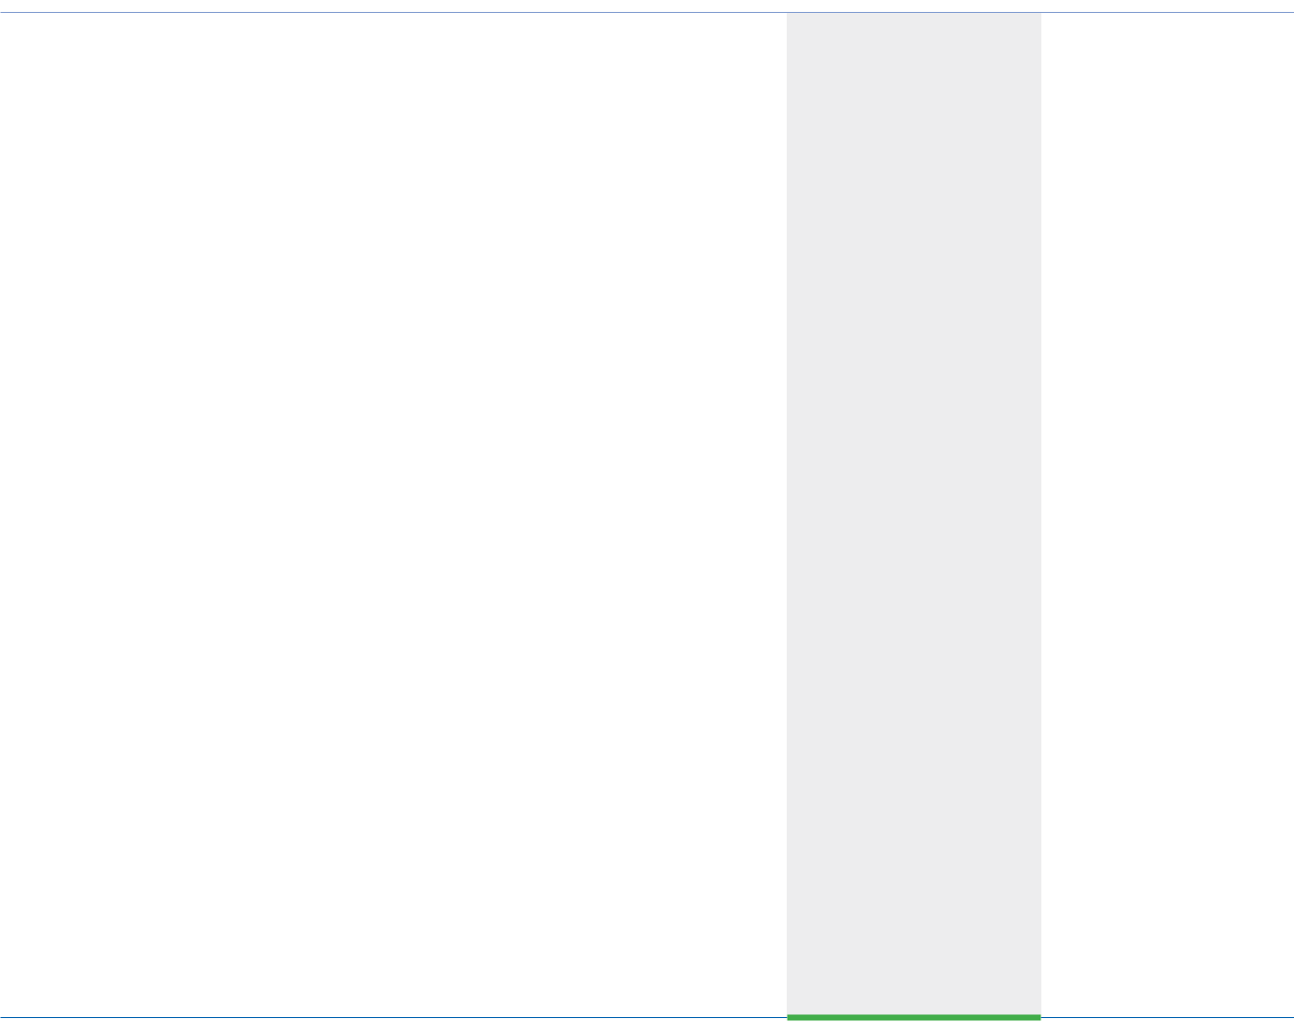

|  |  |  |
| --- | --- | --- |
|  | **2019** | **2018** |
|  | **VND** | **VND** |
|  |  |  |
| **i) Sales of goods and rendering of services** |  |  |
| Ricons Construction Investment Joint Stock Company | 335,687,193,182 | 75,806,841,033 |
| **ii) Purchases of goods and services** |  |  |

|  |
| --- |
| **STATEMENTS** |

|  |  |  |  |  |  |  |  |  |  |  |  |  |  |  |  |  |
| --- | --- | --- | --- | --- | --- | --- | --- | --- | --- | --- | --- | --- | --- | --- | --- | --- |
|  | **Selling** |  |  |  |  |  |  |  | **Selling** |  |  |  |  |  |  |  |
| **2019** | **Leasing out** | **construction** | **equipment** | **VND** | 5,699,361,534 | (3,551,644,401) | 2,147,717,133 | **2018** | **Leasing out** | **construction** | **equipment** | **VND** | 7,888,773,343 | (6,275,376,091) | 1,613,397,252 | Group did not present |
| Continued |  | **Investment** | **properties activities** | **VND VND** | 11,983,510,668 | (5,501,858,231) | 6,481,652,437 |  |  | **Investment** | **properties activities** | **VND VND** | 11,903,425,626 | (5,534,480,905) | 6,368,944,721 | inVietnamonly. Therefore, the |

Ricons Construction Investment Joint Stock Company

Riland Investment Joint Stock Company

1. **Dividend received**

Ricons Construction Investment Joint Stock Company

1. **Capital contribution to associates**

FCC Infrastructure Investment Joint Stock Company Ricons Construction Investment Joint Stock Company Hiteccons Investment Joint Stock Com-pany

1. **Remuneration of the Board of Directors, Board of Supervision and salaries, bonus of Board of Management**

1,332,912,181,478 4,033,847,895,182

459,551,718,277 -

22,680,000,000 13,608,000,000

61,600,000,000 -

* 37,800,000,000
* 2,790,000,000

47,400,067,41346,401,475,416

|  |
| --- |
| **CONSOLIDATED FINANCIAL** |

|  |
| --- |
| **THE** NOTES |

|  |  |  |  |  |  |  |  |  |  |  |  |  |  |
| --- | --- | --- | --- | --- | --- | --- | --- | --- | --- | --- | --- | --- | --- |
| year ended 31 December 2019 - |  |  | **Constructionservices** | 23,619,283,888,092 | (22,586,608,633,250) | 1,032,675,254,842 | **Constructionservices** | 28,526,690,225,430 | (26,707,460,016,608) | 1,819,230,208,822 |  | The Group’s business activities are engaged |  |
| **SEGMENT REPORT** | Business segment: | Net revenue from sales of goodsandrenderingofservices | Cost of goods sold andservicesrendered | Gross profit from sales of goodsandrenderingofservices | Net revenue from sales of goodsandren-deringofservices | Cost of goods sold andservicesrendered | Gross profit from sales of goodsandren-deringofservices | Geographical segment |  |
| For the | **36** |  |  |  |  |  |  |  |  |  |  |  |  |

|  |  |  |  |
| --- | --- | --- | --- |
| (b) | Year end balances with related parties |  |  |
|  |  |  |  |
|  |  | **2019** | **2018** |
|  |  | **VND** | **VND** |
|  |  |  |  |
|  | **Short-term trade accounts receivable (Note 5)** |  |  |
|  | Ricons Construction Investment Joint Stock Company | 176,108,228,882 | 771,362,473 |
|  | **Short-term trade accounts payable (Note 15)** |  |  |
|  | Ricons Construction Investment Joint Stock Company | 594,123,185,007 | 2,048,832,795,422 |
|  | Riland Investment Joint Stock Company | 154,762,782,088 | - |
|  |  | 748,885,967,095 | 2,048,832,795,422 |
|  | **Short-term advances from customers (Note 16)** |  |  |
|  | Ricons Construction Investment Joint Stock Company | - | 16,005,154,858 |
|  |  |  |  |



192 STAND FIRM IN CHALLENGES 193

NOTES

**THE CONSOLIDATED FINANCIAL STATEMENTS**

For the year ended 31 December 2019 - Continued Form B 09 – DN/HN

1. **BUSINESS COMBINATION**

As at 24 August 2019, Covestcons Company Limited, a subsidiary of the Company, acquired 69.98% of shares in Phu Nhuan 168 Joint Stock Company with a consideration of VND102,170,800,000.

This business combination impacts to the net assets of the Group at the acquisition date are as follows:



|  |  |
| --- | --- |
|  | **Giá trị hợp lý ghi nhận** |
|  | **tại ngày 24 tháng 8 năm 2019** |
|  | **VND** |
|  |  |
| **Assets** | **160,845,100,000** |
| Cash | 254,395,788 |
| Land use right | 160,541,000,000 |
| Other assets | 49,704,212 |
| **Liabilities** | **14,845,100,000** |
| **Total identifiable net assets** | **146,000,000,000** |
| Non-controlling interests | (43,829,200,000) |
| Consideration transfered | 102,170,800,000 |
| Cash acquired | (254,395,788) |
| **Net cash out flows** | **101,916,404,212** |
|  |  |

**39** **COMMITMENTS**

1. Commitments under operating lease

The Group has been leasing out Coteccons building in accordance with operating lease contract. The future minimum receivables under non-cancellable lease contracts are as follows:



|  |  |  |
| --- | --- | --- |
|  | **2019** | **2018** |
|  | **VND** | **VND** |
|  |  |  |
| Within 1 year | 9,098,747,924 | 5,744,036,100 |
| From 1 to 5 years | 32,788,984,563 | 6,642,765,000 |
|  | 41,887,732,487 | 12,386,801,100 |
|  |  |  |

|  |
| --- |
| **CONSOLIDATED FINANCIAL STATEMENTS** |

|  |
| --- |
| **THE** NOTES |

|  |  |  |  |  |  |  |  |  |  |  |  |  |
| --- | --- | --- | --- | --- | --- | --- | --- | --- | --- | --- | --- | --- |
| Form B 09 – DN/HN |  |  |  | **To be** | **contributed** | **VND** | 90,210,000,000 | 50,000,000,000 | 140,210,000,000 |  |  |  |
| year ended 31 December 2019 - Continued | Capital contribution commitments | The Group had the capital contribution obligations as follows: | **As at 31 December 2019 and 31 December 2018** | **Charter Committed Contributed** | **Investee name capital amount amount** | **VND VND % VND** | Hiteccons Investment Joint Stock Company 300,000,000,000 93,000,000,000 31 2,790,000,000 | Nguyen Kim – Cong Truong Quoc Te Company Limited 100,000,000,000 50,000,000,000 50 - | 400,000,000,000 143,000,000,000 2,790,000,000 | (c) Other commitments | As at 31 December 2019, the Group had outstanding guarantees with the banks with total amount of VND5,671,532,491,240. | The consolidated financial statements were approved by the Board of Management on 27 March 2020. |
| For the | (b) |  |  |  |  |  |  |  |  | (c) |  |  |

|  |
| --- |
| GeneralDirector |

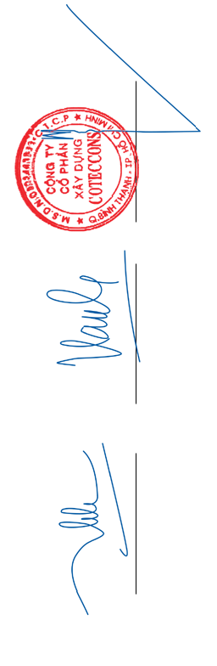

|  |
| --- |
| **Nguyen Sy Cong** |

|  |
| --- |
| ChiefAccountant |

|  |
| --- |
| **Vu Thi Hong Hanh** |

|  |
| --- |
| Preparer |

|  |
| --- |
| **Ha Thi Thuy Hang** |

194 STAND FIRM IN CHALLENGES 195

 **2019 SIGNIFICANT PROJECTS**

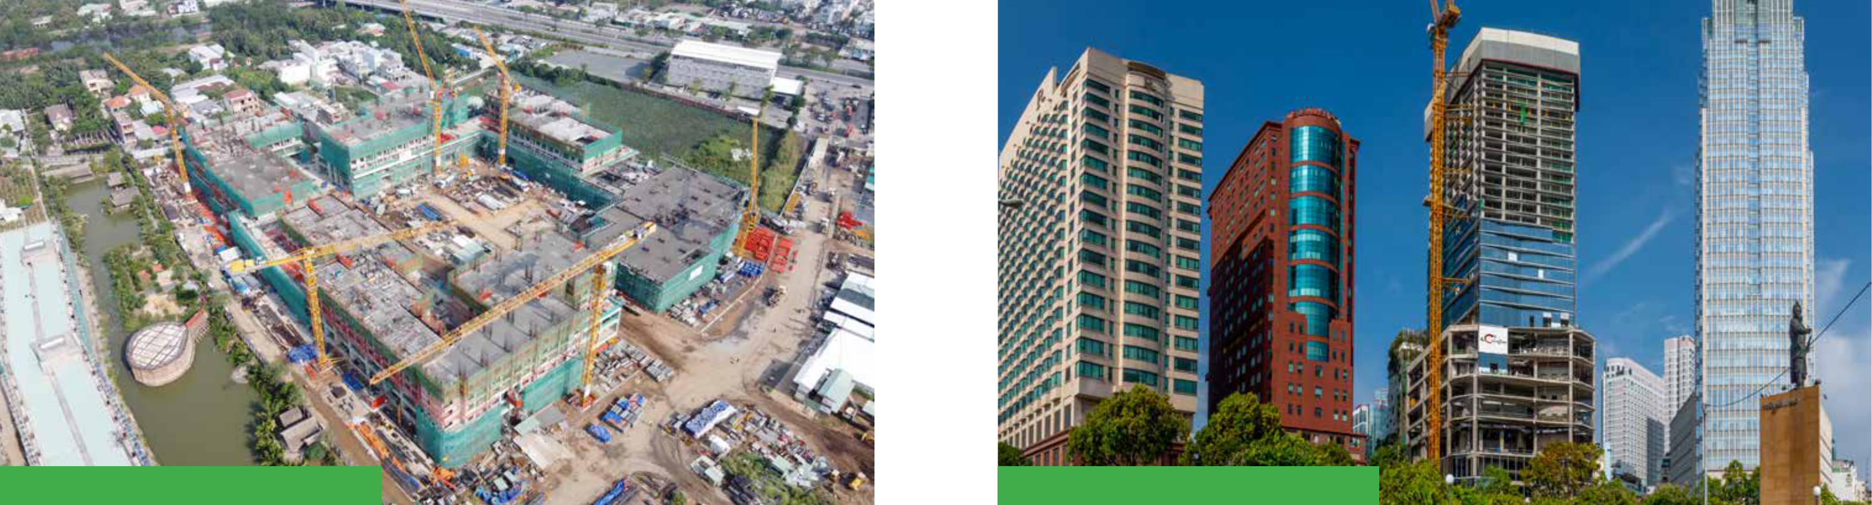

**AKARI CITY** **HILTON HOTEL SAIGON**

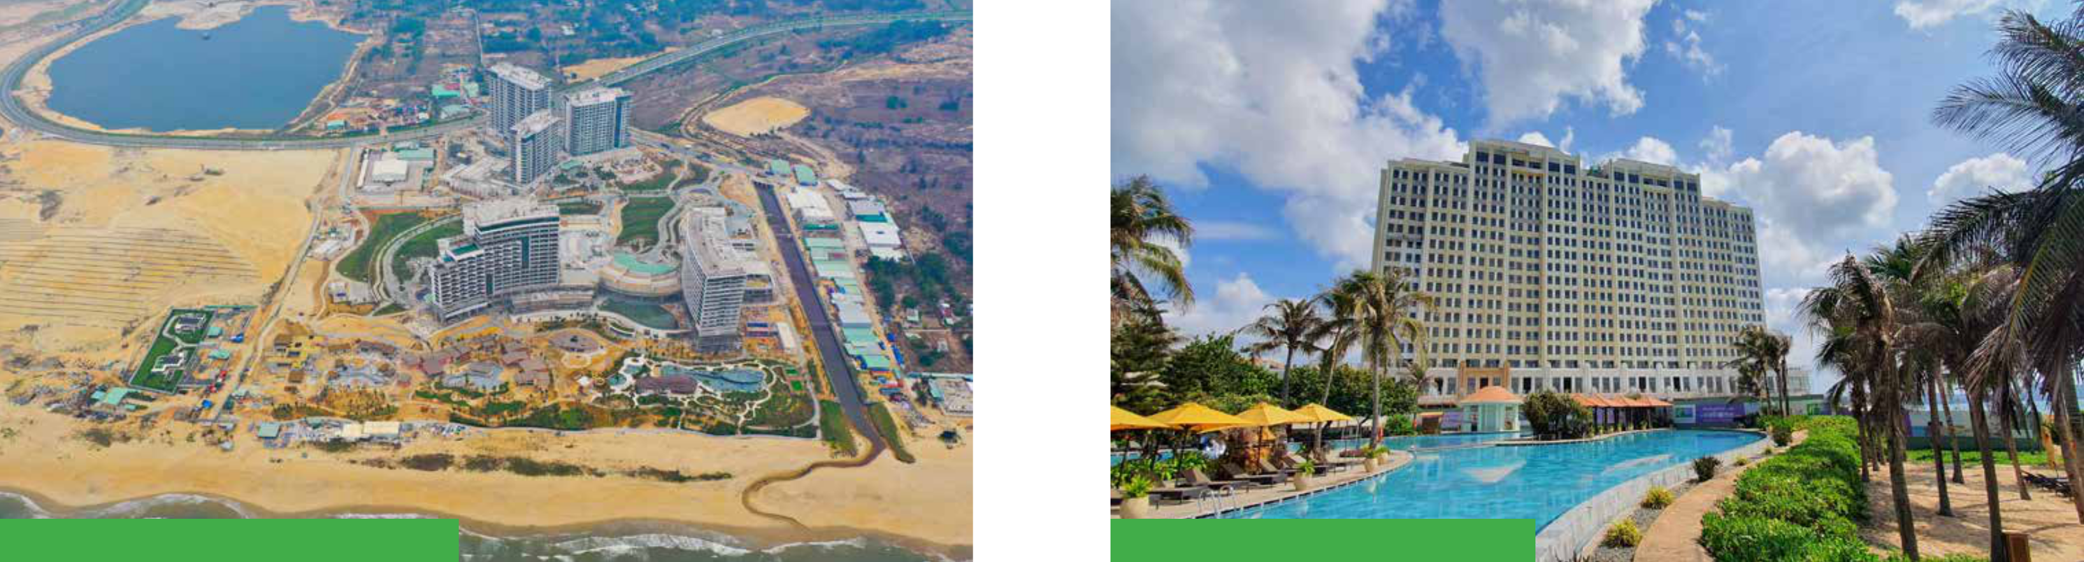

**HOI AN SOUTH DEVELOPMENT** **HO TRAM STRIP PHASE II**

196 STAND FIRM IN CHALLENGES 197

 **2019 SIGNIFICANT PROJECTS**

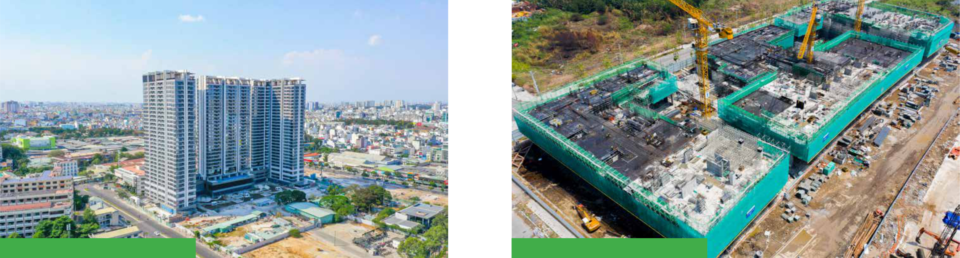

**KINGDOM 101** **THE METROPOLE THU THIEM**

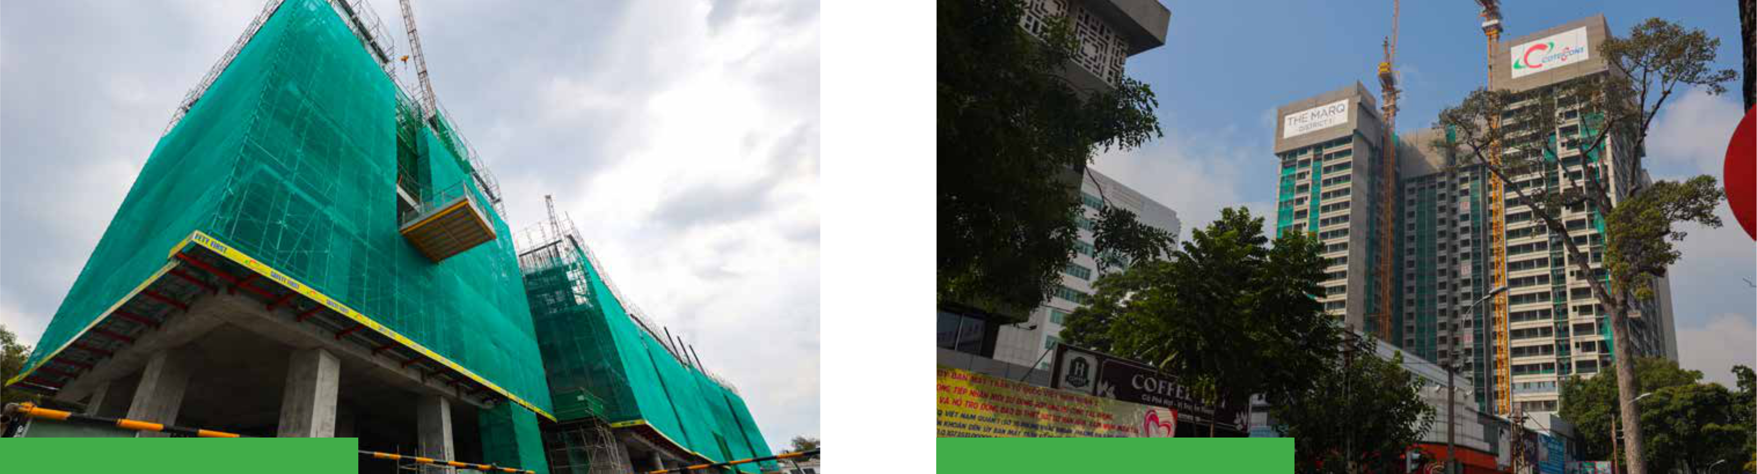

**THE SPIRIT OF SAIGON** **THE MARQ**

198 STAND FIRM IN CHALLENGES 199

 **2019 SIGNIFICANT PROJECTS**

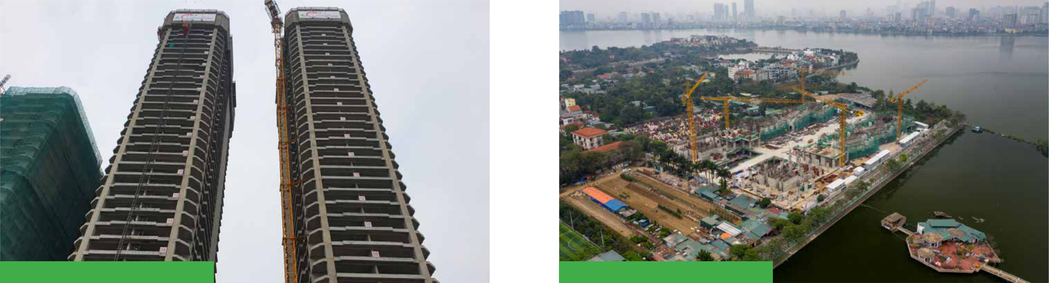

**DA NANG TIMES SQUARE** **58 TAY HO**

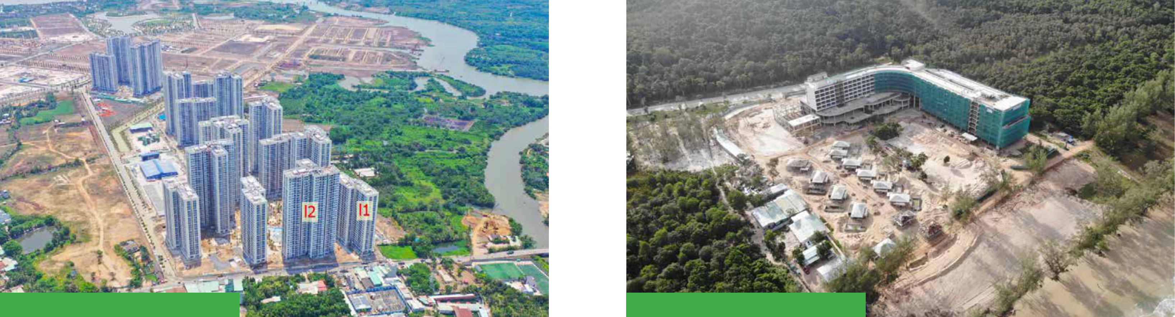

**VINHOMES GRANDPARK** **CROWNE PHU QUOC**

200 STAND FIRM IN CHALLENGES 201

 **2019 SIGNIFICANT PROJECTS**

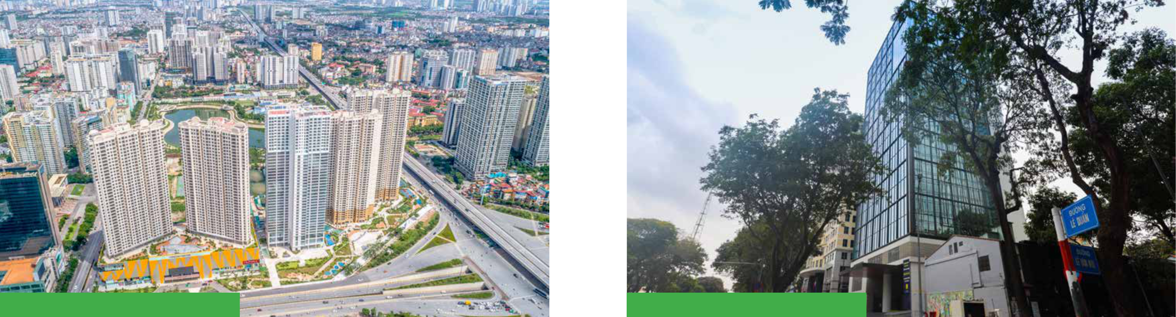

**D’CAPITALE** **FRIENDSHIP TOWER**

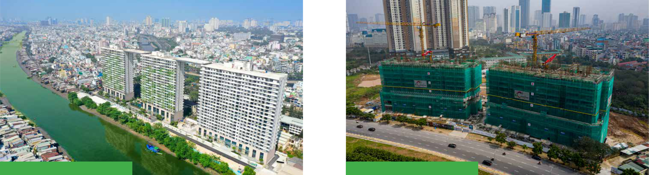

**DIAMOND LOTUS** **THE MATRIX ONE**

202 STAND FIRM IN CHALLENGES 203

 **2019 SIGNIFICANT PROJECTS**

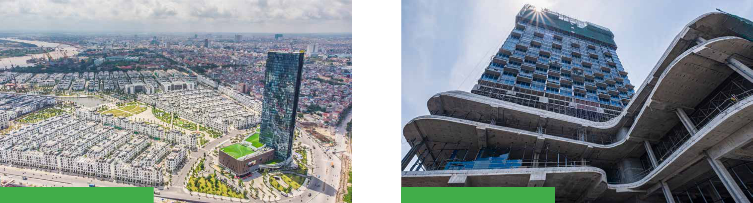

**VINHOMES IMPERIA** **PULLMAN HOTEL HAI PHONG**

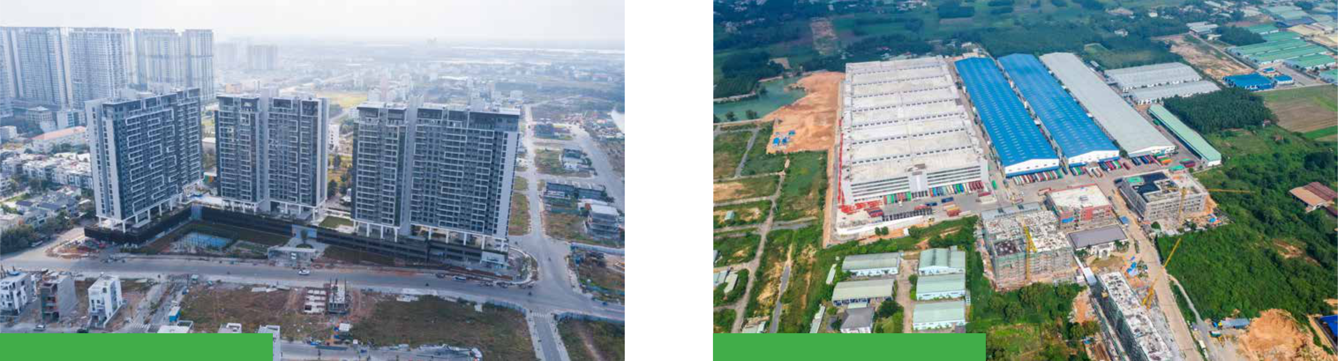

**ONE VERANDAH** **TIMBERLAND MANWAH**

204 STAND FIRM IN CHALLENGES 205

 **2019 SIGNIFICANT PROJECTS**

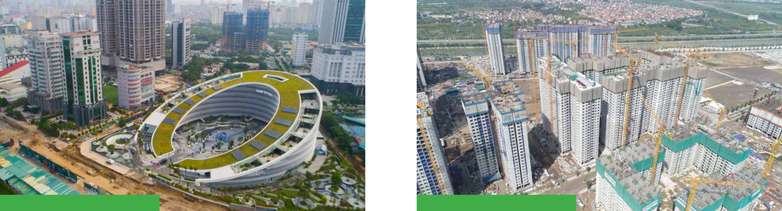

**VIETTEL HEADQUARTER** **VINHOMES OCEANPARK**

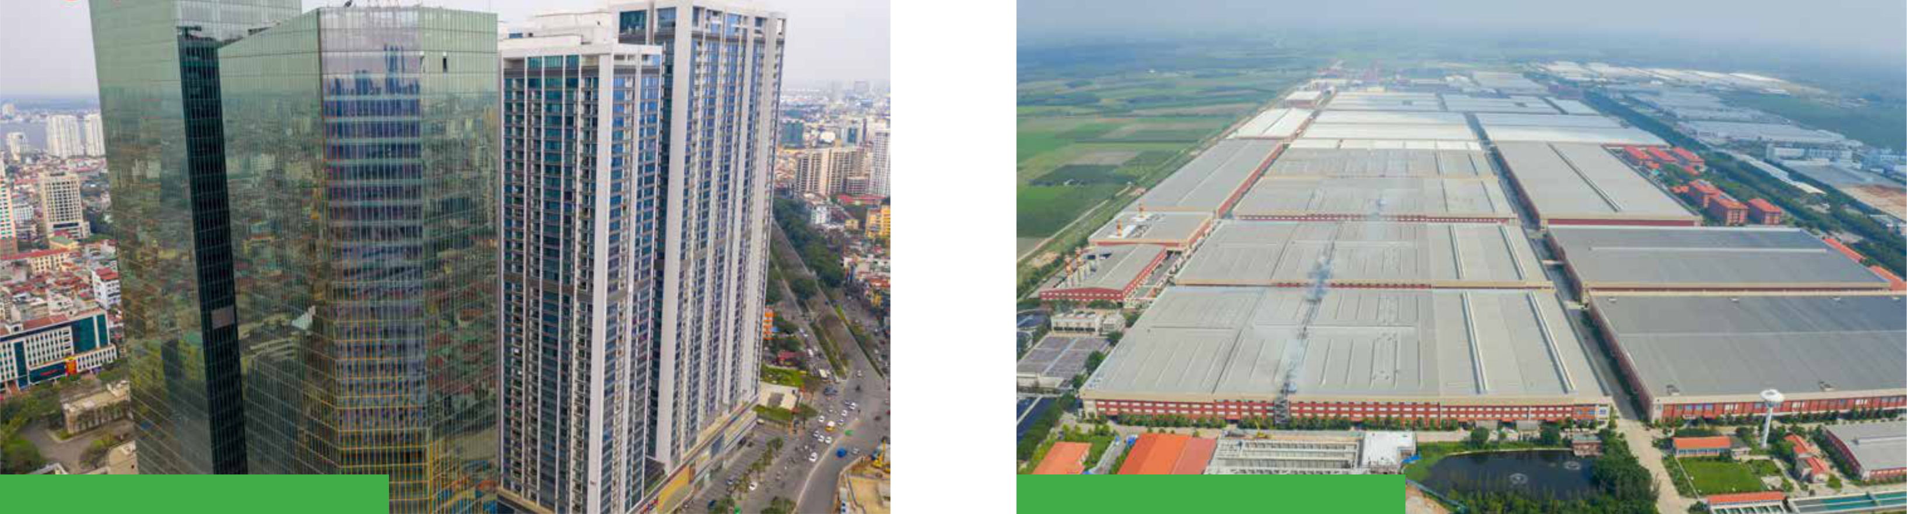

**VINHOMES METROPOLIS** **GAIN LUCKY**

206 STAND FIRM IN CHALLENGES 207



**COTECCONS CONSTRUCTION JOINT STOCK COMPANY**

No.236/6 Dien Bien Phu Str., Ward 17 Binh Thanh Dist, HCMC

1. (84) (28) 3514 2255 - 3514 2266
2. (84) (28) 3514 2277
3. contact@coteccons.vn
4. www.coteccons.vn